**Contents**

| **Book** | **Chap** | **Title** | **Starting Page** |
| --- | --- | --- | --- |
| Douglas Hall | 1 | Computer Number systems, codes and digital devices |  |
| Douglas Hall | 2 | Computers, Micro-computers and microprocessor -introduction |  |
| Marutt | 1 | Microcomputer system |  |
| Marutt | 2 | Representation of Number and characters |  |
| Marutt | 3 | Organization of IBM Personal Computers |  |
| Marutt | 4 | Introduction to Assembly language |  |
| Marutt | 5 | Processor status and flag registers |  |
| Marutt | 6 | Flow control instructions |  |
| Marutt | 7 | Logic, shift, rotate instruction |  |
| Marutt | 8 | Stack and introduction to procedures |  |
| Marutt | 10 | Arrays and addressing |  |
| Marutt | 11 | String Instructions and Macros |  |
|  |  | Microprocessor Configuration |  |
|  |  | 8085 microprocessor |  |
|  |  | 8086 microprocessor timing diagram |  |
|  |  | Bus Timing Diagram |  |
|  |  | Tri-State Logic |  |
|  |  | 8086 interrupt system |  |
|  |  | Interfacing |  |
|  |  | DMA with Diagram |  |
|  |  | Instruction Sets |  |
|  |  | Labs |  |
|  |  | Previous Year Questions-Answers |  |

**Computer Number systems, codes and digital devices**

**Microcomputer System**

The Components of a Microcomputer System =>

Introduction :

* Keyboard, display screen, and disk drives are examples of input/output (1/0) devices.These devices are also known as peripheral devices or peripherals.
* Integrated-circuit (IC) chips contain hundreds or thousands of transistors used in computer circuits.IC circuits operate on discrete voltage signal levels represented by high and low voltages, typically denoted by the symbols 1 and 0, respectively.These symbols are called binary digits or bits.
* All information processed by the computer is represented by bit strings consisting of 1s and 0s.
* Computer circuits are divided into three main parts: the central processing unit (CPU), memory circuits, and input/output (1/0) circuits.
* In a microcomputer, these three parts are typically integrated onto a single microchip called a microprocessor.The CPU is responsible for controlling all operations in the computer and acts as the "brain" of the system. The memory circuits are used to store information that the CPU needs to perform its operations. The 1/0 circuits are used to communicate with input/output devices such as keyboards, displays, and disk drives.

The System Board :

* The main circuit board inside the system unit is called the system board, or motherboard.
* The system board contains the microprocessor and memory circuits, as well as expansion slots.
* Expansion slots are connectors on the motherboard used for additional circuit boards called add-in boards or add-in cards.
* Input/output (1/0) circuits are often located on add-in cards, which can be added or removed to provide additional functionality to the computer.
* The system board and add-in cards work together to provide the necessary components and functionality for the computer system.

Memory =>

Bytes and Words :

* Information processed by the computer is stored in its memory, which is made up of memory circuit elements that can store one bit of data each.
* Memory circuits are typically organized into groups of eight bits, called bytes, and each byte is identified by a unique number called its address.
* The contents of a memory byte are referred to as its bytes or data values.
* The address of a memory byte is fixed and unique to that byte, while the contents are subject to change as they represent the data currently stored.
* The number of bits used in an address varies depending on the processor, with some using 20-bit addresses and others using 24-bit addresses.
* The number of bits used in the address determines the number of bytes that can be accessed by the processor. For example, the Intel 8086 microprocessor assigns a 20-bit address, and the Intel 80286 microprocessor uses a 24~bit address

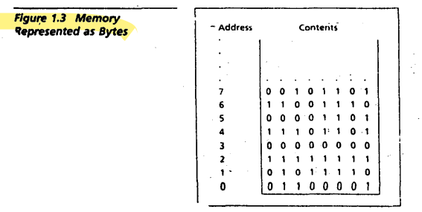

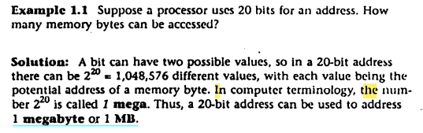

* In a typical microcomputer, two bytes form a word.The IBM PC allows any pair of successive memory bytes to be treated as a single unit called a memory word. The lower address of the two memory bytes is used as the address of the memory word.For example, the memory word with the address 2 is made up of the memory bytes with addresses 2 and 3. This allows for more efficient storage and retrieval of data in the computer's memory.

Bit position

* The bit positions are numbered from right to left, starting with 0.
* In a word, the bits 0 to 7 form the low byte and the bits 8 to 15 form the high byte.
* For a word stored in memory, its low byte comes from the memory byte with the lower address, and its high byte comes from the memory byte with the higher address.
* This organization of bits and bytes is important for manipulating data stored in memory, as well as for transferring data between different devices and systems.

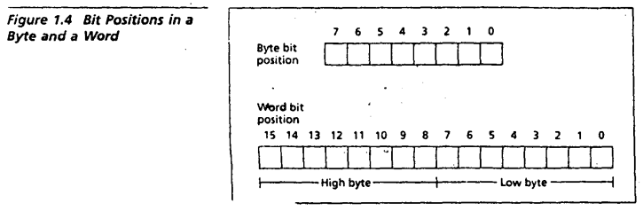

Memory Position

* The processor can perform two operations on memory: read and write.
* In a read operation, the processor gets a copy of the data from a memory location without changing its original contents.
* In a write operation, the data written becomes the new contents of the memory location, replacing the original contents.

RAM and ROM

* There are two types of memory circuits: random access memory (RAM) and read-only memory (ROM).
* RAM locations can be both read and written, while ROM locations can only be read.
* The contents of RAM memory are lost when the power is turned off, so anything valuable in RAM must be saved on a disk or printed out beforehand.
* ROM circuits retain their values even when the power is off, and are used by computer manufacturers to store system programs, known as firmware.
* Firmware is responsible for loading the operating system from disk as well as for self-testing the computer when it is turned on.

Buses

* A processor communicates with memory and I/O circuits using signals that travel along a set of wires or connections called buses.
* There are three types of signals: address, data, and control.
* There are three types of buses: address bus, data bus, and control bus.
* The processor places the address of the memory location on the address bus to read its contents and receives the data on the data bus.
* A control signal is required to inform the memory to perform a read operation, and it is sent by the CPU on the control bus.

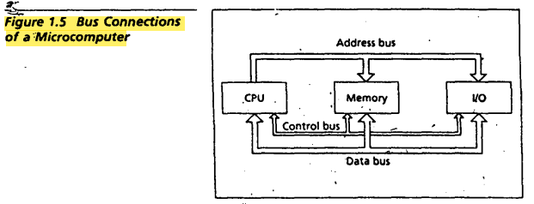

The CPU =>

Introduction

* Each institution that the CPU executes Is a bit string (for the Intel 8086, instructions are from one to six bytes long). This language of O's and 1 's is called machine language.
* The instructions executed by a CPU are called its instruction set.
* Machine language instructions are designed to be simple to keep the cost of computers down.
* The Intel 8086 microprocessor will be used as an example of a CPU.
* The Intel 8086 microprocessor has two main components: the execution unit and the bus interface unit.

Execution Unit :

* The Execution Unit (EU) is a component of the CPU that executes instructions.
* It contains the Arithmetic and Logic Unit (ALU) that can perform arithmetic (+, -, x, /) and logic (AND, OR, NOT) operations.
* The EU has eight registers for storing data: AX, BX, CX, DX, SI, DI, BP, and SP.
* Registers are similar to memory locations, but they are referred to by name rather than number.
* The EU also has temporary registers for holding operands for the ALU.
* The FLAGS register contains individual bits that reflect the result of a computation.

Bus Interface Unit

* The Bus Interface Unit (BIU) facilitates communication between the EU and memory or I/O circuits.
* The BIU transmits addresses, data, and control signals on the buses.
* The BIU registers are named CS, DS, ES, SS, and IP, which hold addresses of memory locations.
* The IP (Instruction Pointer) contains the address of the next instruction to be executed by the EU.
* The BIU and the EU are connected by an internal bus and work together.
* The BIU fetches up to six bytes of the next instruction and places them in the instruction queue while the EU is executing an instruction. This operation is called instruction prefetch.
* The BIU suspends instruction prefetch and performs the necessary operations if the EU needs to communicate with memory or peripherals.

I/O Ports :

* 1/0 devices are connected to the computer through 1/0 circuits.
* Each 1/0 circuit contains several registers called 1/0 ports.
* Some 1/0 ports are used for data while others are used for control commands.
* I/O ports have addresses and are connected to the bus system.
* These addresses are known as I/O addresses and can only be used in input or output instructions.
* 1/0 ports function as transfer points between the CPU and 1/0 devices.
* Data to be input from a 1/0 device are sent to a port where they can be read by the CPU.
* On output, the CPU writes data to an 1/0 port and the 1/0 circuit transmits the data to the 1/0 device.

Serial and Parallel Ports :

* Data transfer between I/O port and device can be serial or parallel
* Serial transfer happens 1 bit at a time, while parallel transfer happens 8 or 16 bits at a time
* Parallel ports require more wiring connections, while serial ports tend to be slower
* Slow devices like keyboards usually connect to serial ports, and fast devices like disk drives usually connect to parallel ports
* Some devices like printers can connect to either serial or parallel ports.

Instruction Execution :

A machine instruction has two parts: an opcode and operands.

The opcode specifies the type of operation, and the operands are often given as memory addresses to the data to be operated on.

The CPU goes through the following steps to execute a machine instruction (the fetch-execute cycle):

Fetch

1. Fetch an instruction from memory.

2. Decode the Instruction to determine the operation.

3. · Fetch data from memory if necessary

Execute

4. Perform the operation on the data.

5.. Store the result in memory if needed.

Explanation of each steps :

To see what this entails, let's trace through the execution of a typical machine language instruction for the 8086. Suppose we look at the instruction that adds the contents of register AX to the contents of the memory word at address 0. The CPU actually adds the two numbers in the ALU and then stores the result back to memory word O. The machine code is 00000001 00000110 00000000 00000000 Before execution, we assume that the first byte of the Instruction is stored at the location indicated by the IP.

1. Fetch: The instruction is fetched from memory by the Bus Interface Unit (BIU), which places a memory read request on the control bus and the address of the instruction on the address bus. The memory responds by sending the instruction code over the data bus. The CPU accepts the data and updates the instruction pointer (IP) to point to the next instruction.
2. Decode: A decoder circuit in the Execution Unit (EU) decodes the instruction and determines the operation to be performed.
3. Fetch data from memory: If necessary, the EU requests data from memory by informing the BIU to get the contents of the specified memory address. The BIU sends the address over the address bus and a memory read request over the control bus. The data is sent back over the data bus and placed in a holding register.
4. Execute/Perform Operation: The contents of the holding register and any necessary CPU registers are sent to the Arithmetic Logic Unit (ALU) circuit, which performs the required operation and holds the result.
5. Store the result: If necessary, the EU directs the BIU to store the result in memory. The BIU sends a memory write request over the control bus, the address to be written over the address bus, and the result over the data bus. The previous contents of the memory word at that address are overwritten by the result.

The cycle is repeated for the next instruction, whose address is contained in the IP.

Timing :

1. The execution of machine instructions is complex and requires order to be carried out properly.
2. A clock circuit controls the processor by generating clock pulses at a regular interval, known as the clock period.
3. The clock rate or clock speed is the number of clock pulses per second, measured in megahertz (MHz).
4. Each computer circuit is activated by the clock pulses, and operations are performed only when a clock pulse is present.
5. Each step in the instruction fetch and execution cycle requires one or more clock periods.
6. The clock speed can be increased to make a processor operate faster, but each processor has a rated maximum clock speed beyond which it may not function properly.

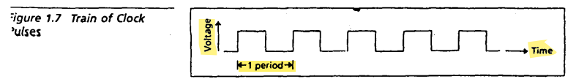

I/O Devices =>

The primary 1/0 devices are magnetic disks, the keyboard, the display monitor, and the printer

Magnetic Disk

* Magnetic disks are used for permanent storage of programs and data.
* There are two types of magnetic disks: floppy disks and hard disks.
* Floppy disks come in two sizes: 5.25-inch and 3.5-inch. They are portable and can store from 360 kilobytes to 1.44 megabytes of data.
* Hard disks are enclosed in a container that is not removable from the computer and can store much more data than floppy disks, typically from 20 gigabytes to over 100 gigabytes.
* Programs can access information on a hard disk much faster than on a floppy disk.

Keyboard :

* The keyboard is used to input information into the computer.
* It has keys that are similar to those found on a typewriter, as well as control and function keys.
* The keyboard has its own microprocessor that sends a coded signal to the computer when a key is pressed or released.
* When a key is pressed, the corresponding key character is displayed on the screen, but there is no direct connection between the keyboard and the screen.
* The data from the keyboard is received by the current running program, which must send the data to the screen before a character is displayed.

Monitor :

* Display monitor is the standard output device of the computer.
* The information displayed on the screen is generated by a circuit in the computer called a video adapter.
* Most adapters can generate both text characters and graphics images.
* Some monitors are capable of displaying in color.

Printers

* Printers provide more permanent output compared to display monitors
* Printer outputs are known as hardcopies
* Three common kinds of printers are daisy wheel, dot matrix, and inkjet printers
* Daisy wheel printers produce output similar to a typewriter
* Dot matrix printers print characters composed of dots and can generate near-letter-quality printing
* Dot matrix printers can print characters with different fonts and graphics
* Laser printers also print characters composed of dots but have high resolution (300 dots per inch) resulting in typewriter quality printing
* Laser printers are expensive but indispensable in the field of desktop publishing
* Laser printers are quieter compared to other printers.

Programming Languages =>

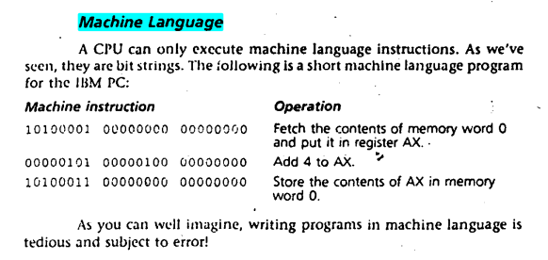

Assembly Language :

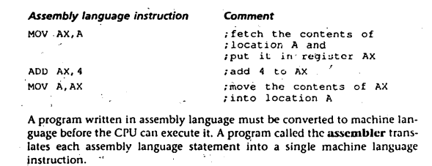

High Level Languages

* Assembly language is easier than machine language, but still difficult due to the primitive instruction set.
* High-level programming languages, such as FORTRAN and C, were developed to make programming easier and more readable for humans.
* Different high-level languages are designed for different applications and have syntax that resembles natural language text.
* A compiler is needed to translate a high-level language program into machine code.
* Compilation is more complex than assembly because it involves translating complex mathematical expressions and natural language commands into simple machine operations.
* A single high-level language statement typically translates into multiple machine language instructions.

Advantages Of High Level Languages

* High-level languages are closer to natural languages, making it easier to convert a natural language algorithm to a high-level language program.
* High-level language programs are easier to read and understand than assembly language programs.
* Assembly language programs generally contain more statements than equivalent high-level language programs, requiring more time to code.
* Assembly language programs are limited to one machine due to each computer having its own unique assembly language, while high-level language programs can be executed on any machine with a compiler for that language.

Disadvantages Of High Level Languages

1. Slower execution time: High-level languages are generally slower than assembly language because they require more time to translate into machine code.
2. Larger memory footprint: High-level languages often require more memory than assembly language because of their syntax and built-in libraries.
3. Limited low-level control: High-level languages abstract away many of the low-level details of the computer, which can make it difficult to write code that interacts directly with hardware or memory.
4. Learning curve: High-level languages can have a steeper learning curve than assembly language
5. Compatibility issues: High-level languages may not be compatible with all systems or architectures, which can limit their usefulness in certain environments. For example, some high-level languages may not be compatible with embedded systems or real-time applications.

Advantages Of Assembly Language

* Assembly language programs are written for efficiency, as they produce faster and shorter machine language programs.
* Some operations can be easily done in assembly language but may be impossible at a higher level.
* High-level languages can accept subprograms written in assembly language, allowing crucial parts of a program to be written in assembly language.
* Learning assembly language can help understand how the computer works and why certain things happen the way they do.
* High-level languages tend to obscure the details of the compiled machine language program that the computer actually executes.
* Disadvantages Of Assembly Language

1. Assembly language programs are typically longer and more complex than equivalent programs written in high-level languages.
2. Assembly language is machine-dependent, which means that programs written in assembly language are specific to the particular hardware architecture for which they were written.
3. Assembly language is less expressive than high-level languages. Writing complex algorithms in assembly language can be a difficult and time-consuming process.
4. Assembly language programming requires a deep understanding of computer architecture and low-level programming concepts.
5. Assembly language programs are less portable and less modular than high-level language programs.
6. Assembly language programs are less readable and maintainable than programs written in high-level languages.

Assembly Vs High Level Language

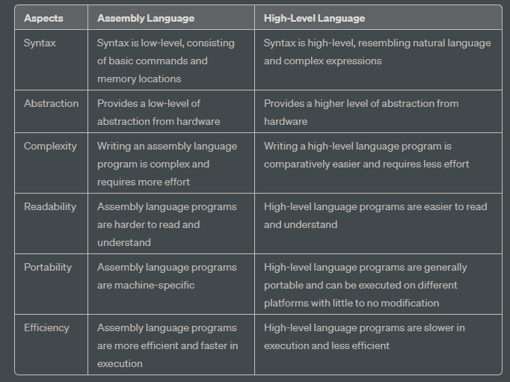

Microprocessor vs Microcontroller

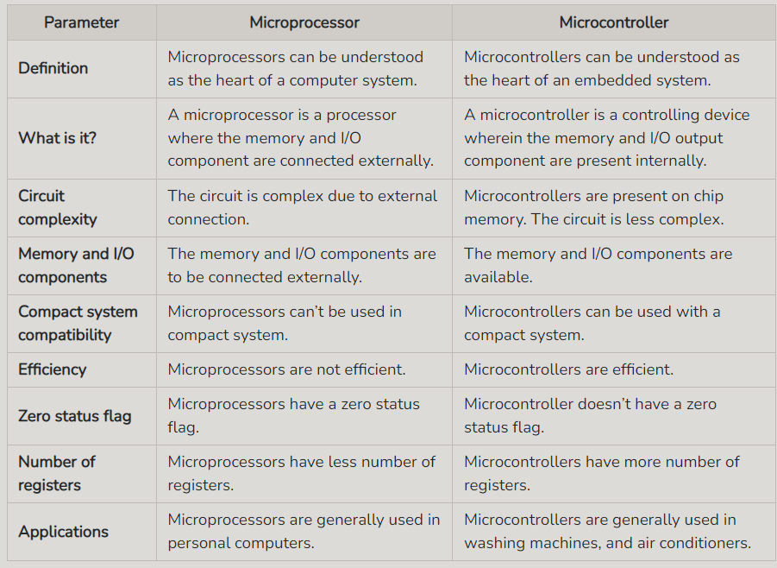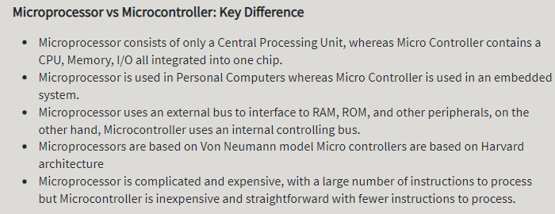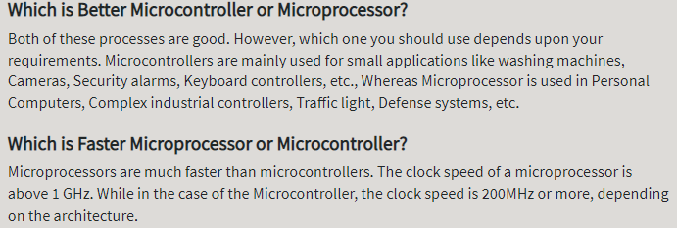

Assembly Language Code Inspection :

* Assembly language programs consist of statements, which are either instructions or directives for the assembler.For example, .MODEL SMALL is an assembler directive that specifies the size of the progr.IWi. MOV AX,A is an Instruction. Anything that follows a semicolon Is a comment, and Is ignored by the assembler.
* Comments in assembly language programs are ignored by the assembler and are used to provide information to the programmer.
* Programs are divided into three segments: the stack segment, the data segment, and the code segment.
* The stack segment is used for temporary storage, and it must be declared even if the program doesn't use a stack.
* Variables are declared and initialized in the data segment using directives like DW (define word).
* Instructions are placed in the code segment and are organized into procedures.
* Procedures are defined using the PROC and ENDP directives.
* The main procedure is a special procedure that initializes the DS register and returns to the DOS operating system.

=> Define bus, address bus, control and address bus in 8086

1. Bus: A bus is a set of physical lines (wires) used for communication between different components of a computer system. In the 8086 microprocessor, three types of buses are used: the data bus, the address bus, and the control bus.
2. Address Bus: The address bus is a set of physical lines used to specify the memory location or input/output port that the microprocessor wants to read from or write to. In the 8086 microprocessor, the address bus is 20 bits wide, allowing the processor to address up to 2^20 (1,048,576) memory locations or ports.
3. Data Bus: The data bus is a set of physical lines used to transfer data between the microprocessor and memory or input/output devices. In the 8086 microprocessor, the data bus is 16 bits wide, allowing the processor to transfer 2 bytes (16 bits) of data at a time.
4. Control Bus: The control bus is a set of physical lines used to control the flow of data and signals between the microprocessor and other components of the computer system. In the 8086 microprocessor, the control bus includes several signals such as the read/write signal, the memory enable signal, the input/output enable signal, and others. These signals control the flow of data between the microprocessor and memory or input/output devices.

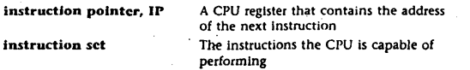

Exercise

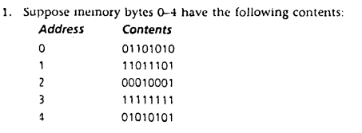

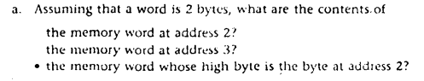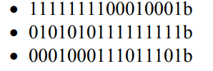

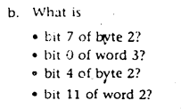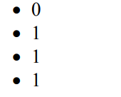

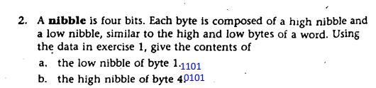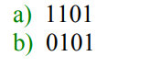

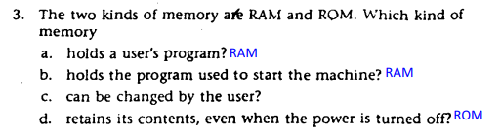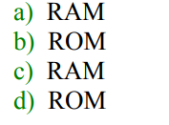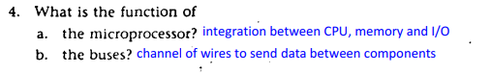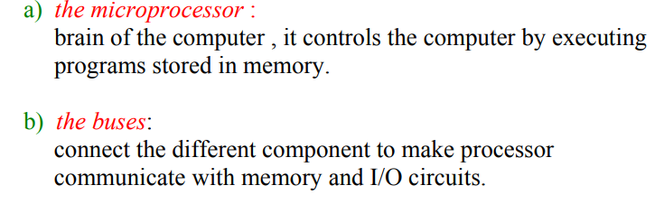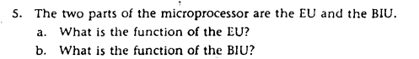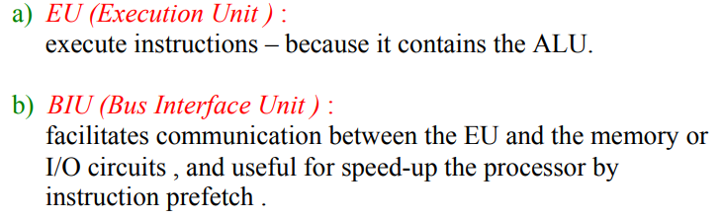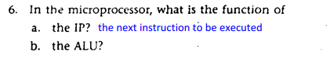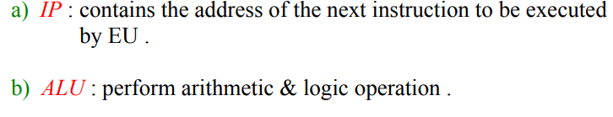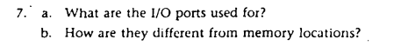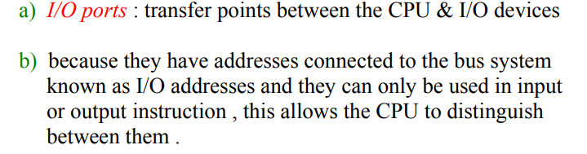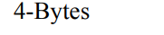

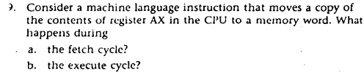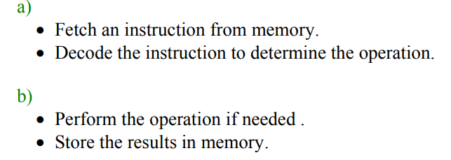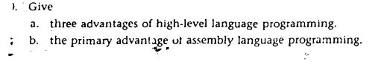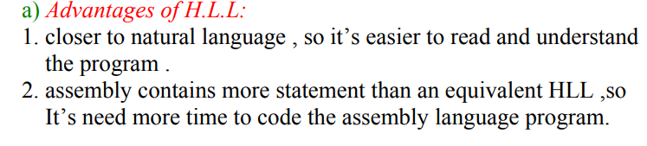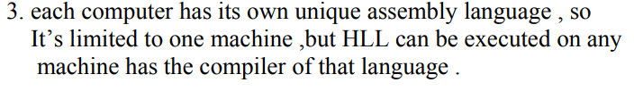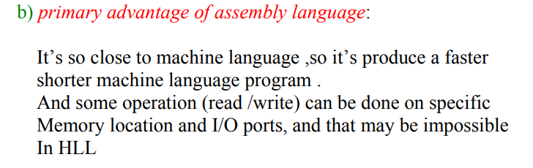

**Representation of Number and characters**

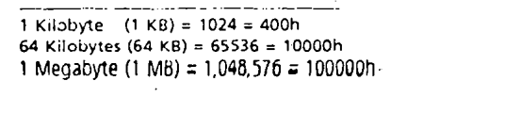

#What's a positional number system ?

A positional number system is a mathematical system for representing numbers using a fixed set of symbols, where the value of each symbol depends on its position within the number.

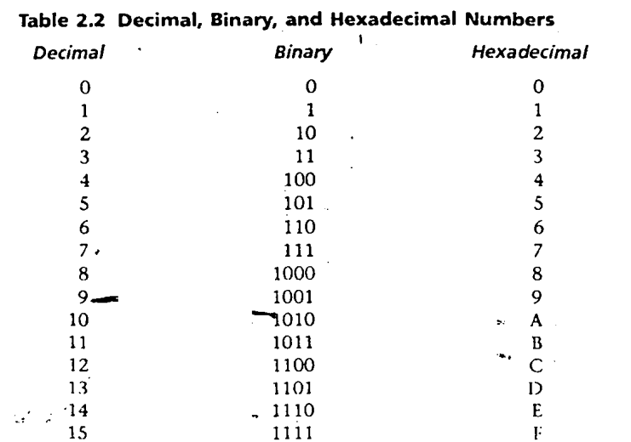

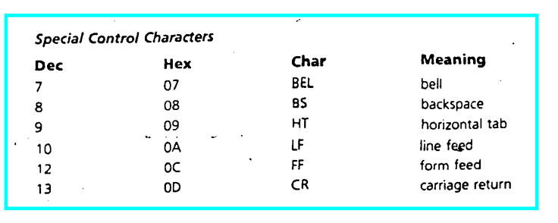

#How Integers Are Represented in the Computer ?

The hardware of a computer necessarily restricts th" 51.ZC' of numbers that can be stored in a register or memory location. The most significant bit, or msb, is the leftmost bit. In a word, the msb is bit 15; in a byte, it is bit 7. Similarly, the least significant bit, or lsb, is the rightmost bit; that is, Oit 0 .

* An unsigned integer is an integer that represents a magnitude, so it is never negative. Use of it are : such as addresses of memory locations, counters, and ASCII character codes
* In signed integers, The most significant bit is reserved for the sign: 1 means negative and 0 means positive,significant bit is reserved for the sign: 1 means negative and 0 means positive. Negative integers are stored in the computer in a special way known as two's complement
* The advantage ol two's complement representation of negative integers·rs in the computer " that subtraction can be done by bit complement and addition And the circuit that can add and complement bits is easy to design.

#Decimal interpretation :

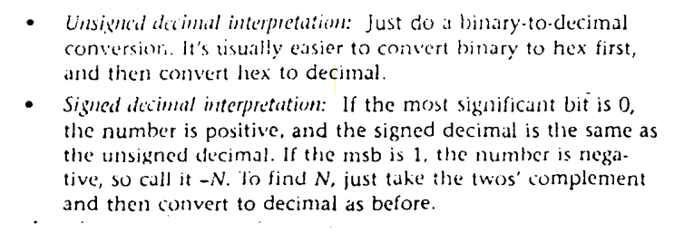#ASCII Code :

* ASCII (American Standard Code for Information Interchange) is the most popular encoding scheme for characters.
* Originally used in communications by teletype, ASCII code is now used by all personal computers today.
* ASCII code uses 7 bits to code each character, resulting in a total of 128 ASCII codes.
* Of these, only 95 codes (from 32 to 126) are considered to be printable characters, while the codes 0 to 31 and 127 are used for communication control purposes and do not produce printable characters.
* Most microcomputers use only the printable characters and a few control characters such as LF, CR, BS, and Bell.
* Each ASCII character is coded by only seven bits, so the code of a single character fits into a byte, with the most significant bit set to zero.
* The printable characters can be displayed on the video monitor or printed by the printer, while the control characters are used to control the operations of these devices.
* To display a character on the screen, a program sends the corresponding ASCII code to the screen, and to control the operations of the device, control characters such as CR (carriage return) and LF (line feed) are sent.

Keyboard :

* Early microcomputers used ASCII keyboards where a key press was identified by its corresponding ASCII code.
* Modern keyboards have many control and function keys in addition to ASCII character keys, so other encoding schemes are used.
* For the IBM PC, each key is assigned a unique number called a scan code.
* When a key is pressed on an IBM PC keyboard, the keyboard sends the key's scan code to the computer.
* The computer's keyboard controller translates the scan code into a code called a virtual key code.
* The virtual key code is then translated into a character code or a control code, depending on the context in which the key was pressed.
* The character or control code is then passed to the application that has the input focus.

#Extra :

* If A and B are stored in integers,-the processors computes A - B by adding the two's complement of B to A

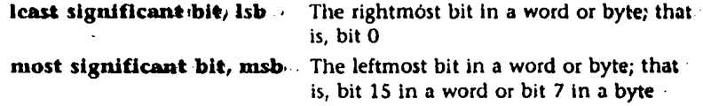

* The range of unsigned Integers that can be stored in a byte Is 0-255; in a 16-bit word, if is 0-65535.

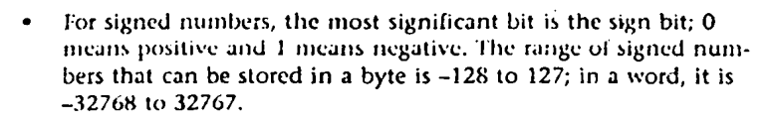

* The unsigned decimal interpretation of a word is outaim:<l by converting the binary value to decimal. If the sign bit is 0, this is also the signed decimal interpretation. If the sign bit Is l, the signed decimal interpretation may be obtained by subtracting 65536 from the unsigned decimal Interpretation.

#Conversions :

Converting Binary and Hex to Decimal

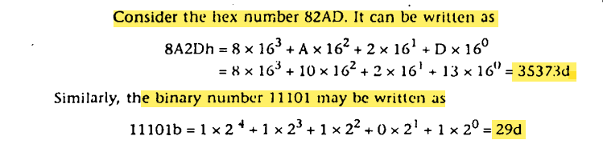

Converting Decimal to Binary and Hex

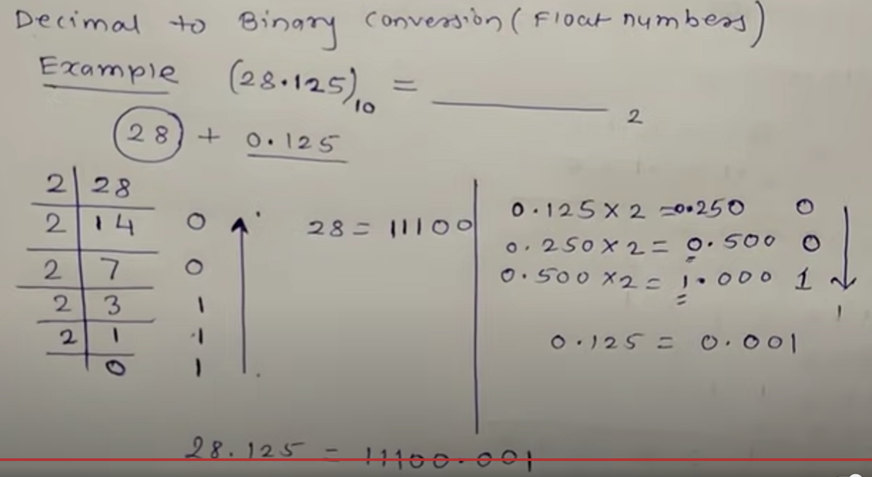

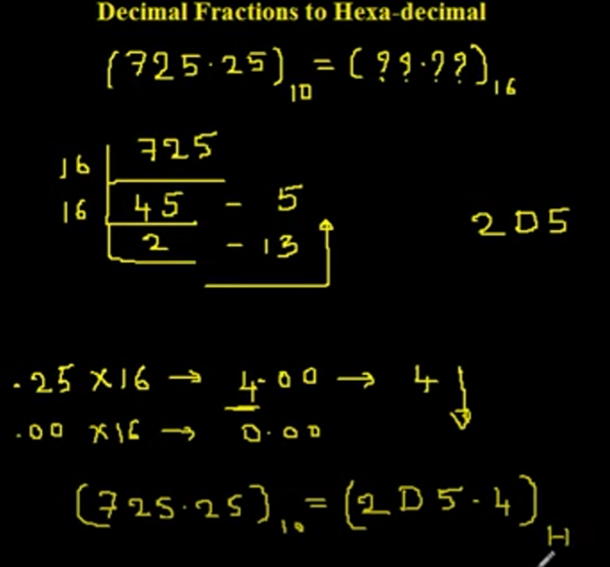

Conversion between Hex and Binary

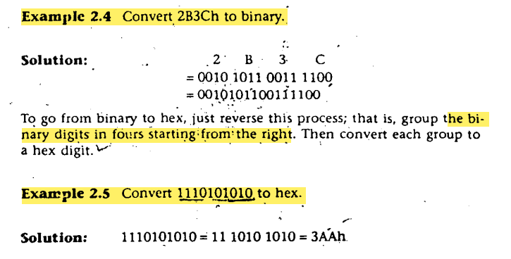

#Complement

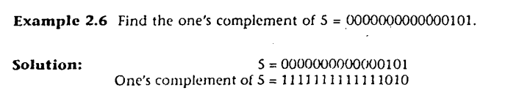

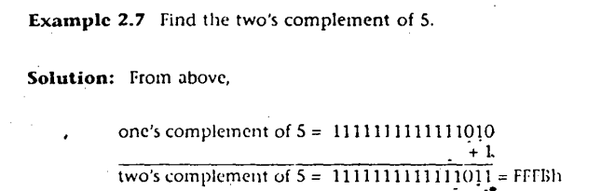

Subtraction in Two'.s Complement Addition

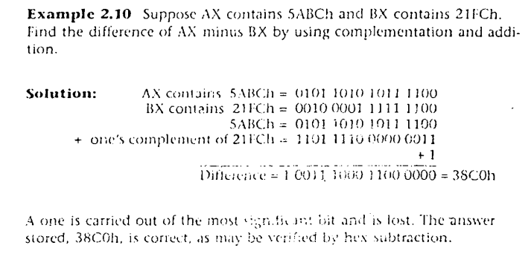

#Exercise :

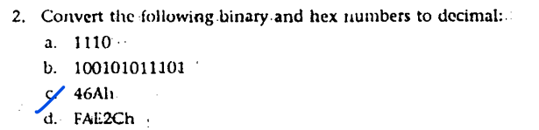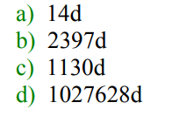

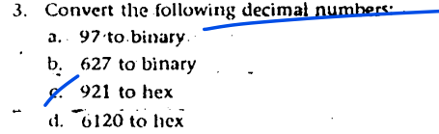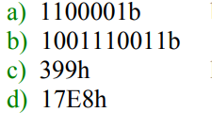

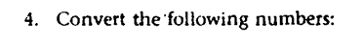

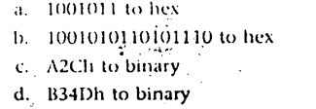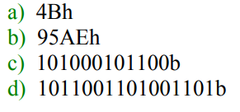

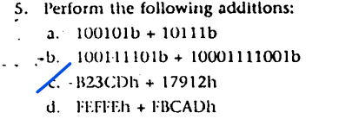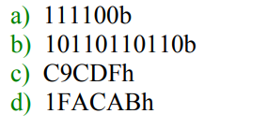

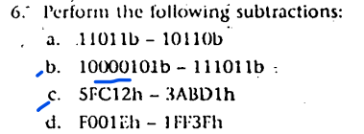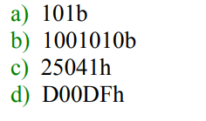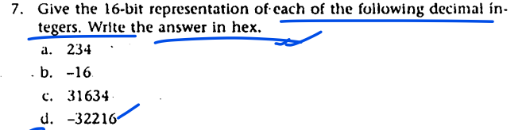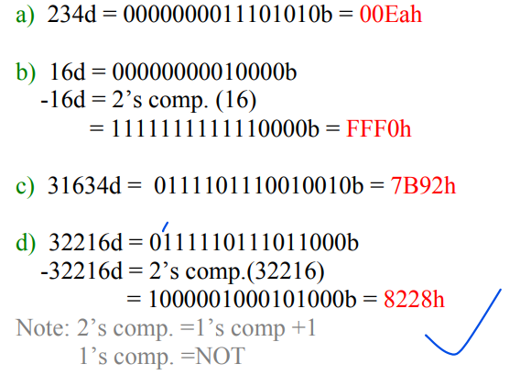

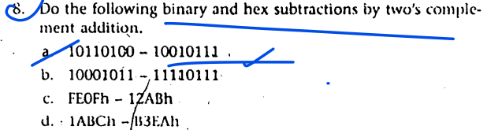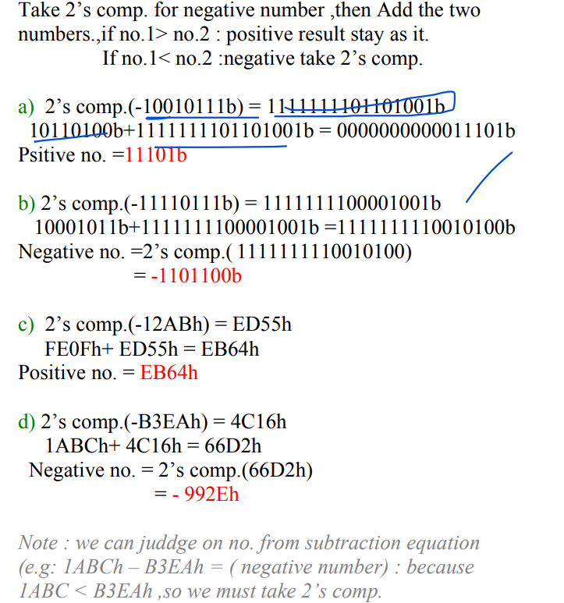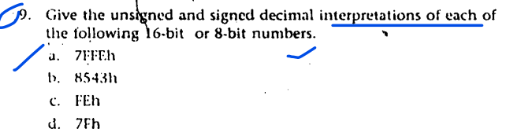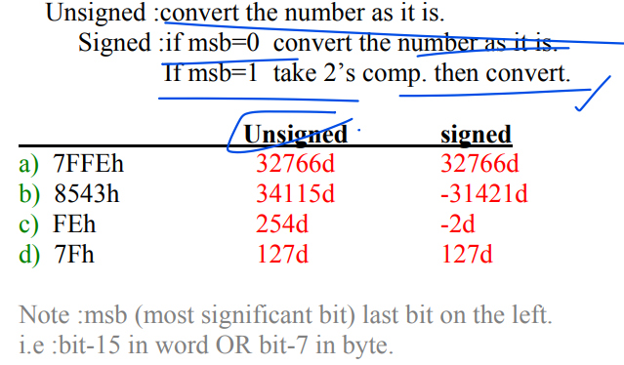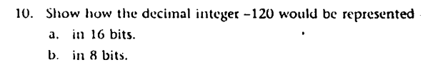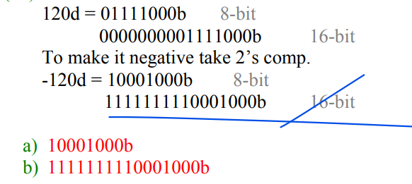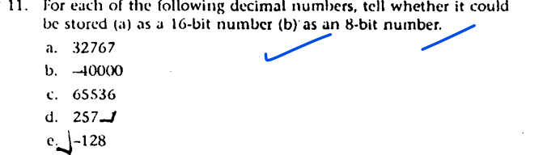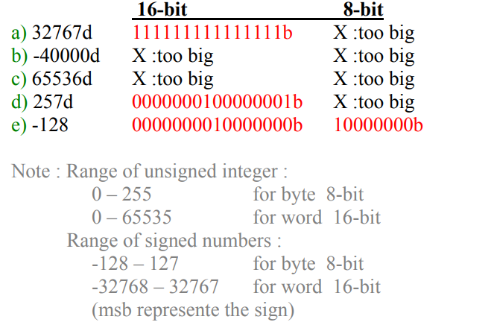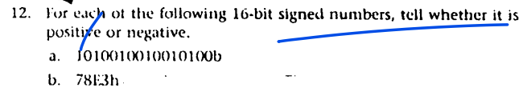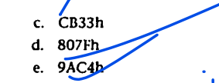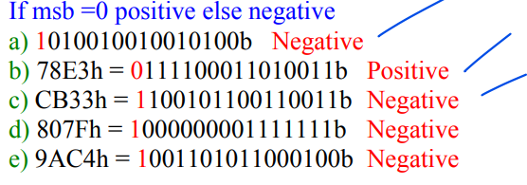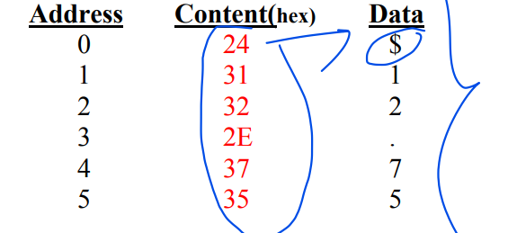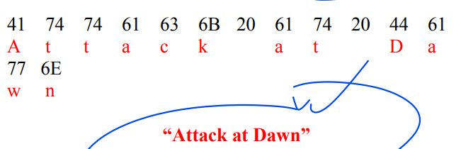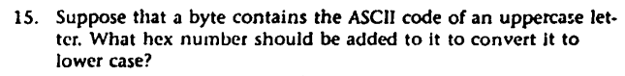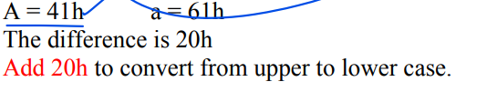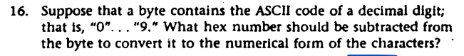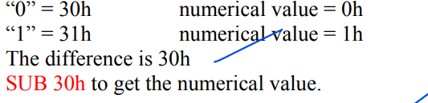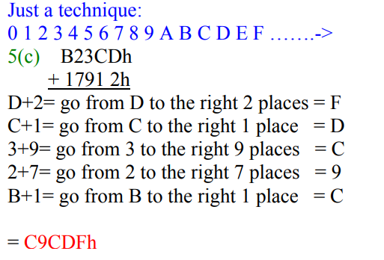

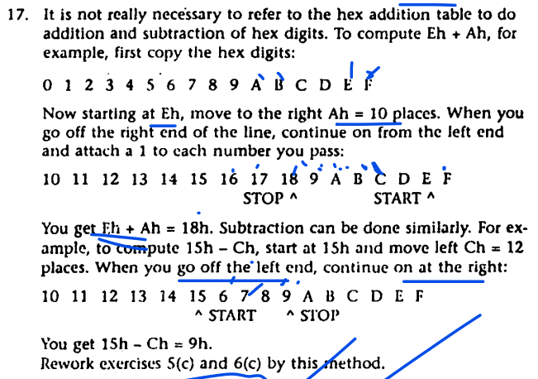

**Table of Contents**

**The Processor Status and the FLAGS Register 1**

**Status Flag 2**

Overflow Flag and Carry Flag 2

Decimal Range 3

Unsigned Overflow CF 3

Signed Overflow OF 3

Types of Overflow 3

Examples of Overflow 3

**Some “How” Q/As 4**

**Examples 5**

**Important Questions (Quiz, Exams, Assignments) 8**

**Exercises From Books ( Marut) 9**

# 

# **The Processor Status and the FLAGS Register**

For the 8086 processor, the processor state is implemented as nine individual bits called flags. The flags are placed in the FLAGS register and they arc classified as either status flags or control flags

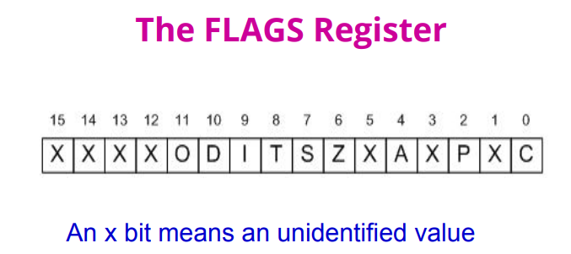

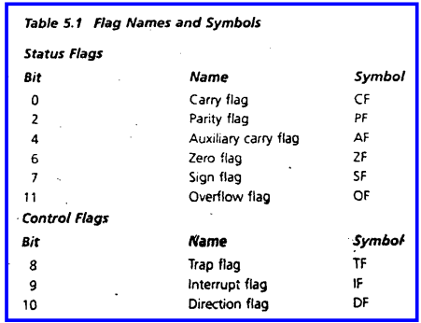

# 

# 

# 

# **Status Flag**

As stated earlier, the processor uses the status flags to reflect the result of an operation. For example, If SUB AX,AX is executed, the zero flag becomes l, thereby Indicating that a zero result was produced. Now let's get to know the status flags.

**The Carry Flag (C): This flag is set when the result of an unsigned arithmetic operation is too large to fit in the destination register.** CF=1 if a carry from most significant bit (msb) on addition, or a borrow into msb on subtraction; otherwise CF=0.

**The Overflow Flag (O): This flag is set when the result of a signed arithmetic operation is too large to fit in the destination register (i.e. when an overflow occurs).** Overflow can occur when adding two numbers with the same sign (i.e. both positive or both negative). A value of 1 = overflow and 0 = no overflow.

**The Sign Flag (S): This flag is set when the result of an arithmetic or logic operation is negative.** This flag is a copy of the MSB of the result (i.e. the sign bit). A value of 1 means negative and 0 = positive.

**The Zero Flag (Z): This flag is set when the result of an arithmetic or logic operation is equal to zero.** A value of 1 means the result is zero and a value of 0 means the result is not zero.

**The Auxiliary Carry Flag (A): This flag is set when an operation causes a carry from bit 3 to bit 4 (or a borrow from bit 4 to bit 3) of an operand.** A value of 1 = carry and 0 = no carry.

**The Parity Flag (P): This flags reflects the number of 1s in the low byte of a result of an operation.** If the number of 1s is even its value = 1 and if the number of 1s is odd then its value = 0.

## 

## **Overflow Flag and Carry Flag**

* Both are indicators of out-of-range condition.
* Overflow flag is used to evaluate an out-of-range condition of signed number operations .
* Carry flag is used in unsigned number operations.
* Since a binary number can represent an unsigned number or signed number, the processor computes both flags and the user checks the appropriate flag to check if the result is out of range or not.

The (decimal) range of signed numbers that can be represented by a 16 bit word is -32768 to 32767; for an 8 bit byte the range is -128 to 127. For unsigned numbers, the range for a word is 0 to 65535; for a byte, it is 0 to 255. If the result of an operation falls outside these ranges, overflow occurs and the truncated result that is saved will be incorrect.

## 

## **Decimal Range**

UNSIGN SIGN

BYTE [0, 255] [-128, 127]

WORD [0, 65535] [-32768, 32767]

## 

## **Unsigned Overflow CF**

Carry Flag CF is set to 1 if there is an end carry in an addition operation or there an end borrow in a subtraction operation. A value of 1 = carry and 0 = no carry.

## **Signed Overflow OF**

* Overflow Flag is set to 1 when adding two numbers the same sign and the result has a different sign. Otherwise, OF is reset to 0.
* Subtraction operation A - B can be performed as operation A + (-B). OF=1 if the result has a different sign than expected
* OF=1 if the carries into and out of the msb don’t match

## **Types of Overflow**

Signed and unsigned overflows are independent phenomena. When we perform an arithmetic operation such as addition, there are four possible outcomes:

1. no overflow,
2. signed overflow only,
3. unsigned overflow only, and
4. both signed and unsigned overflows.

## 

## **Examples of Overflow**

**As an example of unsigned overflow but not signed overflow**, suppose AX contains FFFFh, BX contains 0001h, and ADD AX,BX is executed. The binary result is-

1111 1111 1111 1111

+ 0000 0000 0000 0001

__________________________

1 0000 0000 0000 0000

If we are giving an unsigned interpretation, the correct ans is 10000h = 65536, but this is out of range for a word operation. A 1 is carried out of the msb and the answer stored in AX, 0000h, is wrong, so unsigned overflow occurred. But the stored answer is correct as a signed number, for FFFFh = -1, 0001h = 1, and FFFFh + 0001h = -1 + 1 = 0, so signed overflow did not occur.

**As an example of signed but not unsigned overflow**, suppose AX and BX both contain 7FFFh, and we execute ADD AX,BX. The binary result is

0111 1111 1111 1111

+ 0111 1111 1111 1111

________________________

1111 1111 1111 1110 = FFFEh

The signed and unsigned decimal interpretation of 7HFh IS 32767. Thus for both signed and unsigned addition, 7FFFh + 7FFFh = 32767 + 32767 = 65534. This is out of range for signed numbers; the signed interpretation of the stored answer FFFEh is -2. so signed overflow occurred. However, the unsigned interpretation of FFFEh is 65534, which is the right answer, so there is no unsigned overflow.

# **Some “How” Q/As**

**How the Processor Indicates Overflow ?**

The processor sets OF= 1 for signed overflow and CF= 1 for unsigned overflow. It is then up to the program to take appropriate action, and If nothing is done immediately the result of a subsequent instruction may cause the overflow flag to be turned off. ·

How the Processor Determines that Overflow Occurred ?

Many instructions can cause overflow; for simplicity, we'll limit the discussion to addition and subtraction.

How the Processor Determines that Unsigned Overflow Occurred?

* CF = 1
* Addition

▪ There is a carry out of the msb.

▪ The correct answer is larger than the biggest unsigned number (FFFFh and FFh).

* Subtraction

▪ There is a borrow into the msb.

▪ The correct answer is smaller than 0.

**How the Processor Determines that Signed Overflow Occurred?**

• OF = 1

▪ There is a carry into the msb but no carry out.

▪ There is a carry out but no carry in.

• Addition

▪ The sum has a different sign.

• Subtraction

▪ The result has a different sign than expected.

▪ A – (–B) = A + B

▪ –A – (+B) = –A + –B

• Addition of Numbers with Different Signs

▪ Overflow is impossible.

▪ A + (– B) = A – B

**How Instructions Affect the Flags ?**

Instruction Affects Flags

MOV/XCHG none

ADD/SUB all

INC/DEC all except CF

NEG all (CF = 1 unless result is 0,OF = 1 if word operand is 8000h, or byte operand is 80h)

# **Examples**

**NEG**

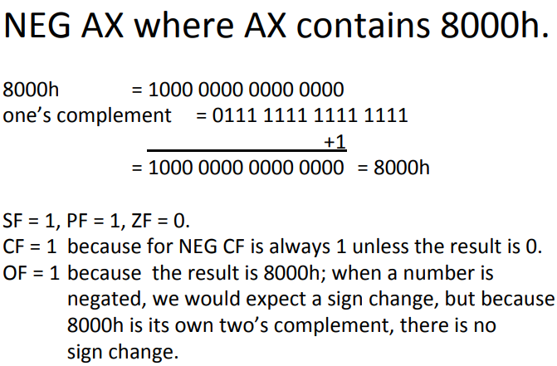

**MOV**

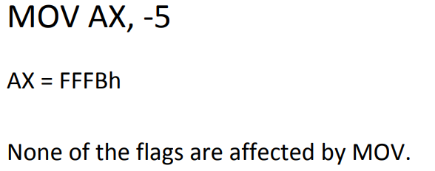

**INC**

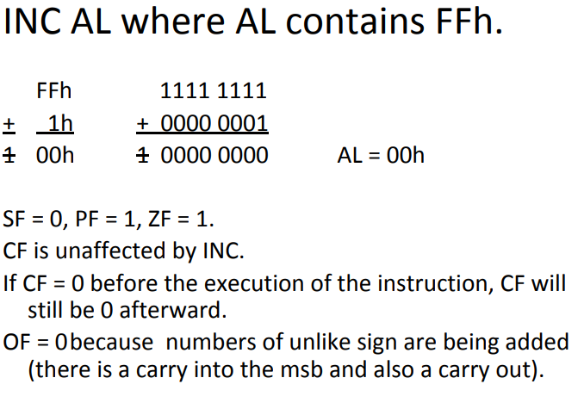

**ADD**

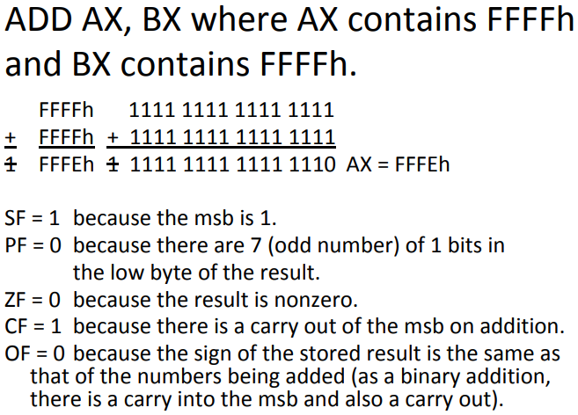

**SUB**

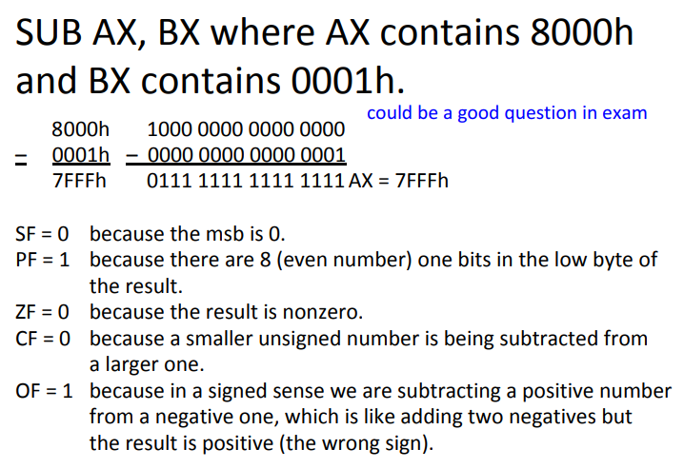

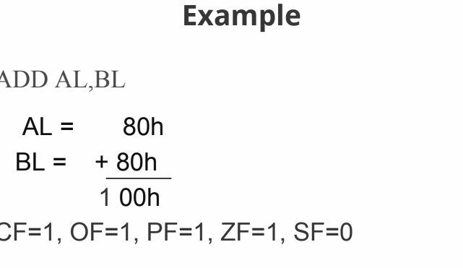

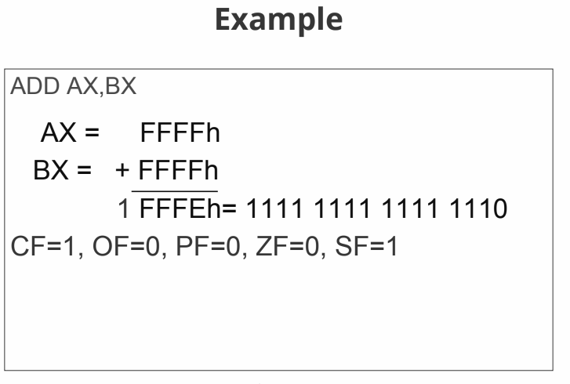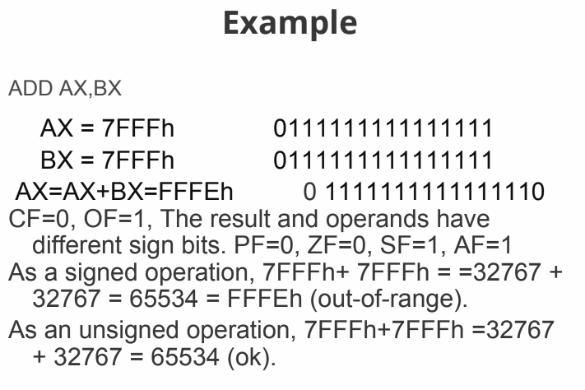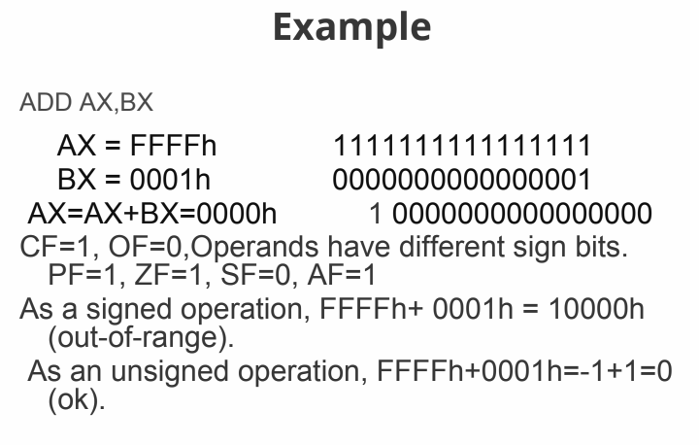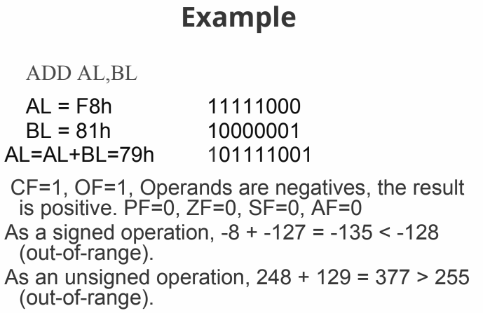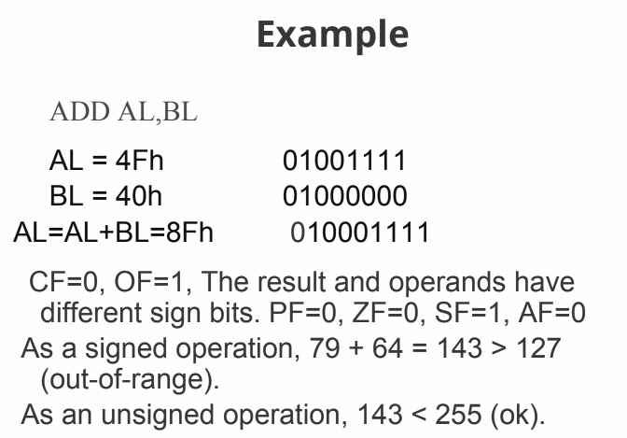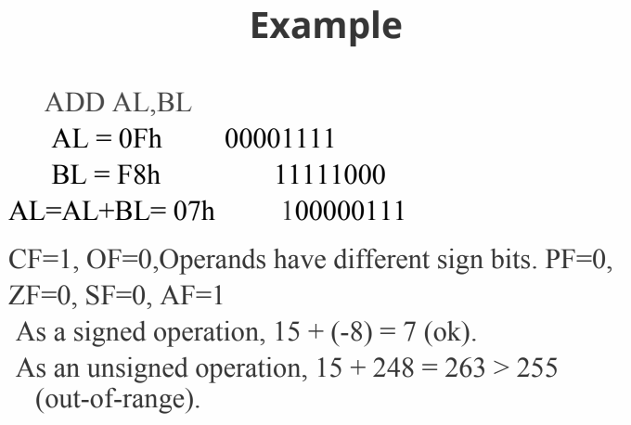

# **Important Questions (Quiz, Exams, Assignments)**

1.Perform the indicated operation on the following number

Ans:

0111 1001 BCD

+ 1001 0101 BCD

_________________________

0001 0110 0001 0100 BCD

2.How do we detect when a signed overflow does occur? Discuss three effective methods in brief.

Ans:

* OF = 1

▪ There is a carry into the msb but no carry out.

▪ There is a carry out but no carry in.

* Addition

▪ The sum has a different sign.

* Subtraction

▪ The result has a different sign than expected.

▪ A – (–B) = A + B

▪ –A – (+B) = –A + –B

* Addition of Numbers with Different Signs

▪ Overflow is impossible.

▪ A + (– B) = A – B

3.Suppose ADD AX, BX is executed. In each of the following parts, the first number being added is the contents of AX, and the second number is the contents of BX. Give the resulting value of the AX and tell whether signed or unsigned overflow occurred.

a) 512Ch + 4185h

b) 7132h + 7000h

Ans: a)

512Ch

+ 4185h

-----------

92B1h

The resulting value of AX is 92B1h.

To determine whether signed or unsigned overflow occurred, we need to look at the most significant bit (MSB) of the result (bit 15 in this case). Since the MSB is 1, we can tell that unsigned overflow occurred.

b) 7132h

+ 7000h

------------

E132h

The resulting value of AX is E132h.

To determine whether signed or unsigned overflow occurred, we need to look at the MSB of the result (bit 15 in this case). Since the MSB is 1, we can tell that signed overflow occurred.

# **Exercises From Books ( Marut)**

1. For each of the following instructions, give the new destination contents and the new settings of CF, SF, TF, PF, and OF. Suppose that the flags are initially 0 in each part of this question.

**Ans:**

a. ADD AX, BX where AX contains 7FFFh and BX contains 1000h

Ans: New destination contents: AX = 8FFFh

New settings of CF, SF, TF, PF, and OF: CF = 0, SF = 1, TF = 0, PF = 0, OF = 0

b. SUB AL, BL where AL contains 01h and BL contains FFh

Ans: New destination contents: AL = 02h

New settings of CF, SF, TF, PF, and OF: CF = 0, SF = 0, TF = 0, PF= 0, OF = 0

c. DEC AL where AL contains 00h

Ans: New destination contents: AL = FFh

New settings of CF, SF, TF, PF, and OF: CF = 1, SF = 1, TF = 0, PF = 1, OF = 0

d. NEG AL where AL contains 7Fh

Ans: New destination contents: AL = 81h

New settings of CF, SF, TF, PF, and OF: CF = 1, SF = 1, TF = 0, PF = 0, OF = 1

e. XCHG AX, BX where AX contains 1ABCh and BX contains 712Ah

Ans: New destination contents: AX = 712Ah, BX = 1ABCh

New settings of CF, SF, TF, PF, and OF: CF = 0, SF = 0, TF = 0, PF = 0, OF = 0

f. ADD AL, BL where AL contains 80h and BL contains FFh

Ans: New destination contents: AL = 7Fh

New settings of CF, SF, TF, PF, and OF: CF = 1, SF = 1, TF = 0, PF = 0, OF = 0

g. SUB AX, BX where AX contains 0000h and BX contains 8000h

Ans: New destination contents: AX = 8000h

New settings of CF, SF, TF, PF, and OF: CF = 1, SF = 1, TF = 0, PF = 1, OF = 0

h. NEG AX where AX contains 0001h

Ans: New destination contents: AX = FFFFh

New settings of CF, SF, TF, PF, and OF: CF = 1, SF = 1, TF = 0, PF = 1, OF = 1

Or

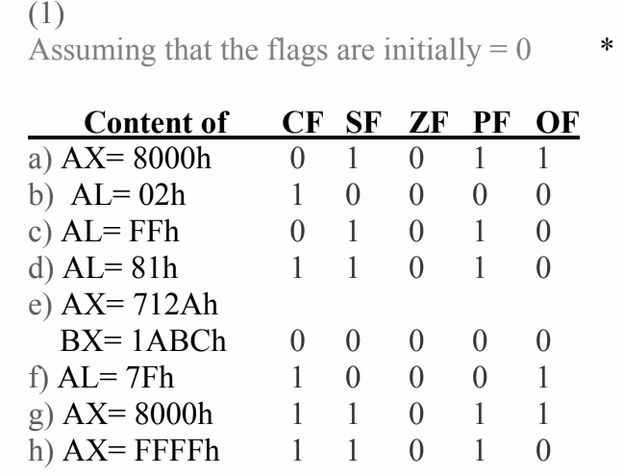

2. a. Suppose that AX and BX both contain positive numbers and

ADD AX,BX is executed. Show that there is a carry into the

msb but no carry out of the msb if, and only if, signed overflow occurs.

b. Suppose AX and BX both contain negative numbers, and

ADD AX,BX is executed. Show that there is a carry out of the msb but no carry into the msb if, and only if, signed overflow occurs.

**Ans:**

a. If AX and BX both contain positive numbers, then the msb of both AX and BX is 0 (since both numbers are positive). When these numbers are added, a carry into the msb occurs if and only if the sum of the msbs of AX and BX is 1. This is because the addition of two bits results in a carry if and only if both bits are 1.

If there is a carry into the msb, then the resulting msb of the sum will be 0 (since the sum of two 1s and a carry is 0 with a carry out). If there is no carry into the msb, then the resulting msb of the sum will be 1 (since the sum of two 0s and a carry is 1 with no carry out).

Therefore, signed overflow occurs if and only if there is a carry into the msb but no carry out of the msb. This is because a carry into the msb indicates that the result is too large to be represented as a signed number (i.e., it is positive, but the msb is 1), while the lack of a carry out of the msb indicates that the result is too small to be represented as a signed number (i.e., it is negative, but the msb is 0).

b. If AX and BX both contain negative numbers, then the msb of both AX and BX is 1 (since both numbers are negative). When these numbers are added, a carry out of the msb occurs if and only if the sum of the msbs of AX and BX is 0.

If there is a carry out of the msb, then the resulting msb of the sum will be 0 (since the sum of two 0s and a carry is 0 with a carry out). If there is no carry out of the msb, then the resulting msb of the sum will be 1 (since the sum of two 1s and a carry is 1 with no carry out).

Therefore, signed overflow occurs if and only if there is a carry out of the msb but no carry into the msb. This is because a carry out of the msb indicates that the result is too large to be represented as a negative signed number (i.e., it is positive, but the msb is 0), while the lack of a carry into the msb indicates that the result is too small to be represented as a negative signed number (i.e., it is negative, but the msb is 1).

Or

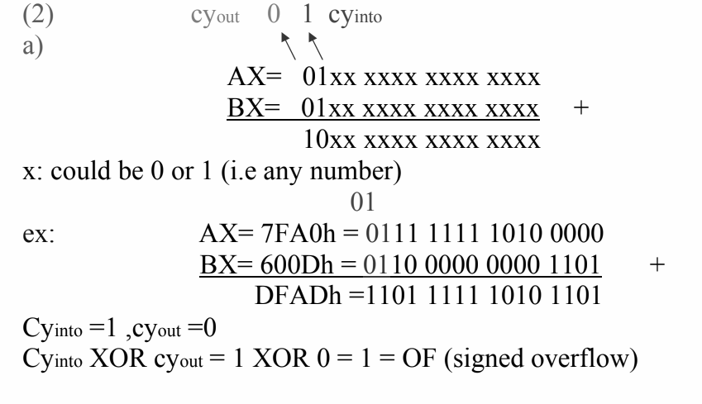

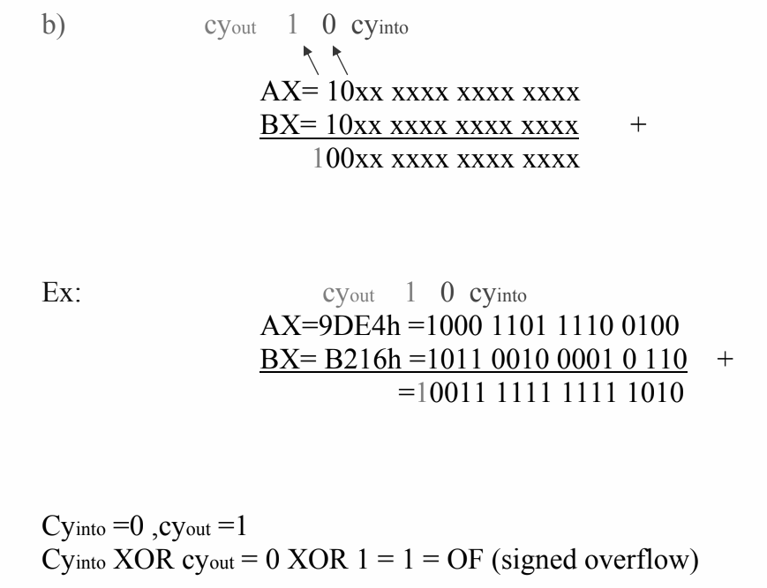

3. Suppose ADD AX,BX is executed. In each of the following parts, the first number being added is the contents of AX, and the second number is the contents of BX. Give the resulting value of AX and tell whether signed or unsigned overflow occurred.

a. 512Ch + 4185h

b. FE12h + lACBh

c. EIE.4h + DAB3h

d. 7132h + 7000h

e. 6389h + l l 76h

**Ans:**

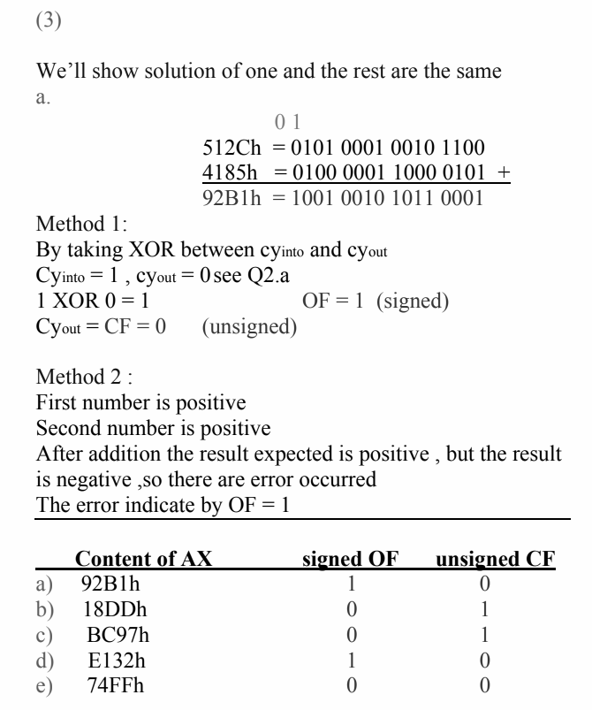

4. Suppose SUB AX, BX is executed. In each of the following parts, the first number is the initial contents of AX and the second number is the contents of BX. Give the resulting value of AX and tell whether signed or unsigned overflow occurred.

a. 2143h - J986h

b. 8JFEh - 1986h

c. 19BCh - 81fEh

d. 0002h - FEOFh

e. 8BCDh - 71ABh

**Ans:**

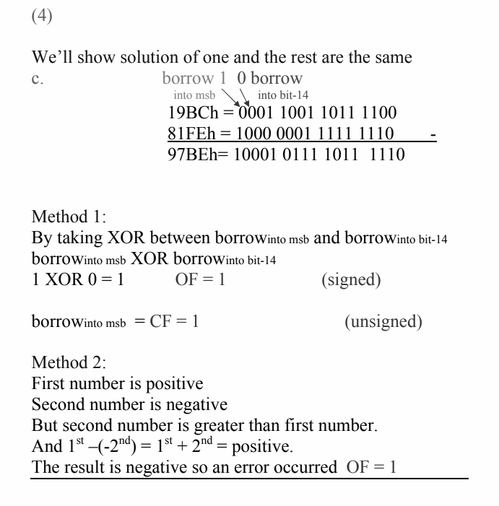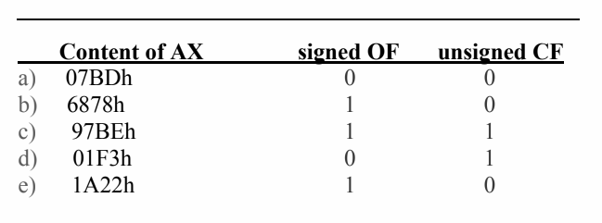

## **Flow control Instruction**

Table of Contents

**Flow control Instruction 1**

[**Overview 1**](https://docs.google.com/document/d/1ukhTnEMUg3BWjTzYToSAhBtJ0liXAThCPccBj97ec08/edit#heading=h.npd24rb41a2o)

[Range of the conditional jump: 1](https://docs.google.com/document/d/1ukhTnEMUg3BWjTzYToSAhBtJ0liXAThCPccBj97ec08/edit#heading=h.dkec2t3tkafu)

[How the CPU implements the conditional Jump: 1](https://docs.google.com/document/d/1ukhTnEMUg3BWjTzYToSAhBtJ0liXAThCPccBj97ec08/edit#heading=h.vau8caz8u25y)

[How CMP works: 1](https://docs.google.com/document/d/1ukhTnEMUg3BWjTzYToSAhBtJ0liXAThCPccBj97ec08/edit#heading=h.zcklnf9xydum)

[Signed Jump vs Unsigned Jump: 3](https://docs.google.com/document/d/1ukhTnEMUg3BWjTzYToSAhBtJ0liXAThCPccBj97ec08/edit#heading=h.jxyxfrjy16xo)

[Working with Characters: 3](https://docs.google.com/document/d/1ukhTnEMUg3BWjTzYToSAhBtJ0liXAThCPccBj97ec08/edit#heading=h.h9dal47tns3z)

[PROBLEM 1 3](https://docs.google.com/document/d/1ukhTnEMUg3BWjTzYToSAhBtJ0liXAThCPccBj97ec08/edit#heading=h.6pekhsh28ya4)

[JMP instruction: 3](https://docs.google.com/document/d/1ukhTnEMUg3BWjTzYToSAhBtJ0liXAThCPccBj97ec08/edit#heading=h.mkoy232ineb)

[Case: 4](https://docs.google.com/document/d/1ukhTnEMUg3BWjTzYToSAhBtJ0liXAThCPccBj97ec08/edit#heading=h.1g51bnd4amga)

[And using Jump: 5](https://docs.google.com/document/d/1ukhTnEMUg3BWjTzYToSAhBtJ0liXAThCPccBj97ec08/edit#heading=h.cf2rdyxpi1jl)

[OR using Jump: 5](https://docs.google.com/document/d/1ukhTnEMUg3BWjTzYToSAhBtJ0liXAThCPccBj97ec08/edit#heading=h.6s78j1qekucd)

[LOOP: 6](https://docs.google.com/document/d/1ukhTnEMUg3BWjTzYToSAhBtJ0liXAThCPccBj97ec08/edit#heading=h.4ao3noc8900)

[While LOOP ➰ 6](https://docs.google.com/document/d/1ukhTnEMUg3BWjTzYToSAhBtJ0liXAThCPccBj97ec08/edit#heading=h.uybt7mulahru)

#### **Overview**

1. **Why do we need flow control?**

There must be a way to make decisions and repeat sections of code to do useful tasks. In order to do that we need to control the flow of the program.

* Jump and loop are used to control the flow of the program
* There are 256 characters in the IBM character set
* 32 -127 are standard ASCII characters
* 0 - 31 and 128 - 255 are the graphics characters.

#### **Range of the conditional jump:**

The destination label must precede the jump instruction by no more than 126 bytes and follow no more than 127 bytes.

#### **How the CPU implements the conditional Jump:**

To implement a conditional jump, the CPU looks at the FLAGS register. You already know It reflects the result of the last thing the processor did. If the condition for the jump is true then the CPU adjusts the IP to point to the destination label. so that the instruction on this label will be done next. If the jump condition is false, then IP is not altered; this means that the next instruction in line will be done.

**Categories of the conditional Jumps:**

1. Signed Jump
2. Unsigned Jump
3. Single flag jump

#### **How CMP works:**

Syntax: CMP destination, source;

This compares the destination and the source by substituting the contents of the source with the contents of the destination. The result of this computation is not stored but it affects the flags. The CMP is just like the SUB only it does not change the contents of the destination. The destination can be a memory location or a constant.

**The conditional Jumps:**

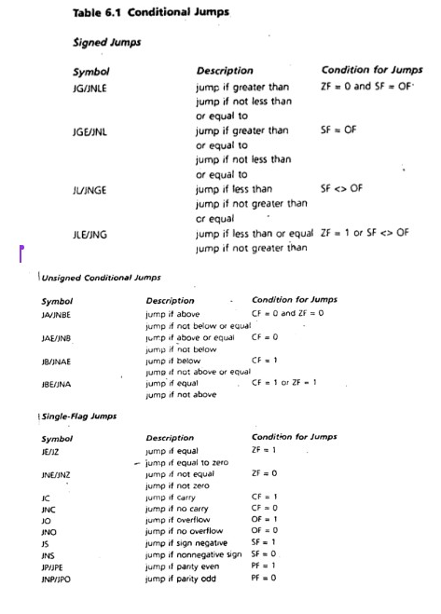

* Generally, all these jumps are used with the CMP

CMP AX, BX

JA There

* But it is not compulsory to use the CMP it can be used with

#### **Signed Jump vs Unsigned Jump:**

For every signed jump there is an analogous unsigned jump. JG has JA, JL has JB.

Flags used by Signed flags: ZF , SF, OF

Flags used by unsigned flags: CF , ZF

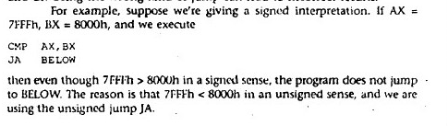

#### **Working with Characters:**

In working with the standard ASCII character set. either signed or unsigned jumps may be used because the sign bit of a byte containing a character code is always zero. However, unsigned jumps should be used when comparing EXTENDED ASCII char. (code 80 TO FFh)

##### **PROBLEM 1**

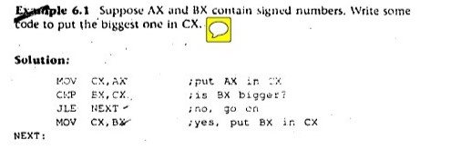

#### **JMP instruction:**

The jMP (jump) instruction causes an unconditional transfer of control (unconditional jump): The syntax is. JMP Destination;

The destination is usually a label in the same segment. JMP can be used to get around the range restriction.

**If then using Jump:**

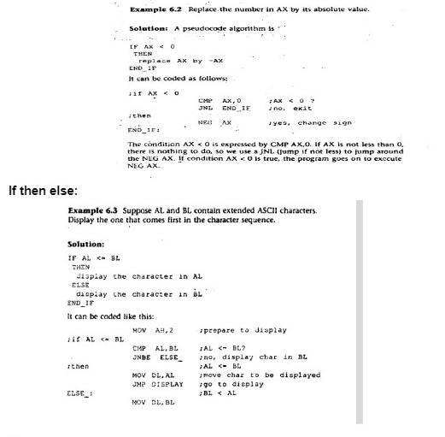

#### Case:

Example 6.4: If AX contains a negative number, put -1 In BX; if AX

contains 0, put O In BX; if AX contains a positive number, put 1 In BX.·

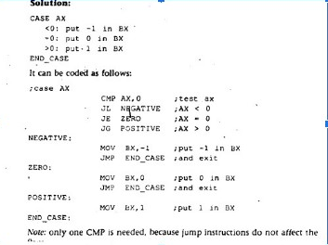

#### **And using Jump:**

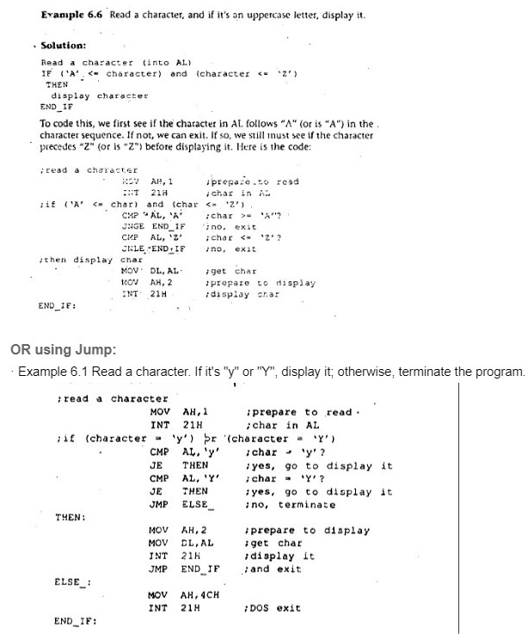

#### **LOOP:**

The counter for the loop is the register CX which is initialized to loop_Count. Execution of the LOOP Instruction causes CX to be decremented automatically. and if CX Is not 0, the control transfers to destination_label. If CX "'0, the next instruction after LOOP is done. Destinatlon_label must precede the LOOP instruction by no more than 126 bytes.

**The critical case for loop:** Typical for loop that is implemented using loop instruction will be executed at least once. So before entering the loop if CX holds 0 so the loop instruction will decrement the CX to FFFFh and the loop will be executed 65535 times so JCXZ is used before the loop starts to check this corner case.

#### While LOOP ➰

Example 6.9 Write some code to count the number of characters In the input line.

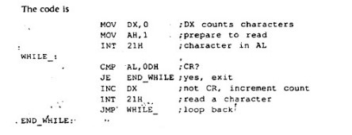

**While vs Repeat:**

In many situations where a conditional loop Is needed, the use of a WHILE loop or a REPEAT loop Is a matter of personal preference. The advantage of a WHILE is that the loop can be bypassed if the terminating, condition is initially false, whereas the statements in a REPEAT must be done at least once. However, the code for a REPEAT loop Is likely to be a little

shorter because there is only a conditional jump at the end, but a WHILE loop has two jumps: a conditional jump at the top and a JMP at the bottom

**Problem:**

Prompt the user to enter a line of text. On the next line, display the capital Jetter entered that comes first alphabetically and the one that comes last. If no capital letters are entered, display "No capital letters". The execution should look like this:

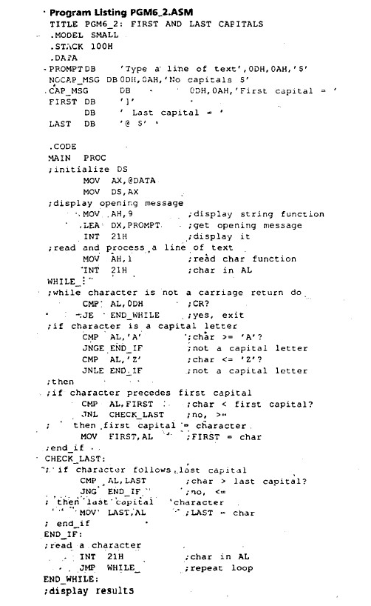

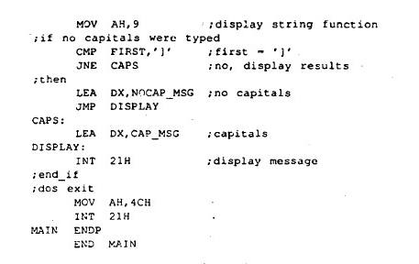

#### **Book Exercises:**

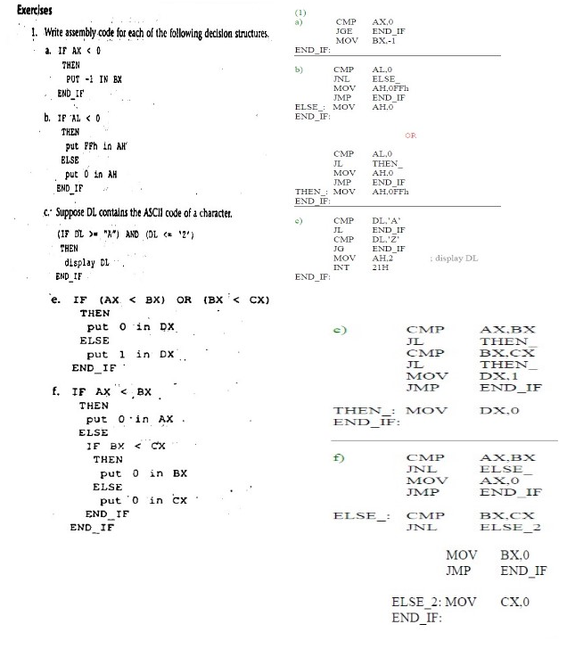

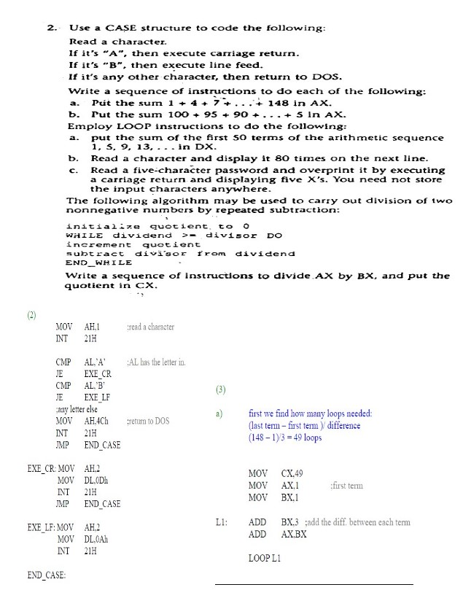

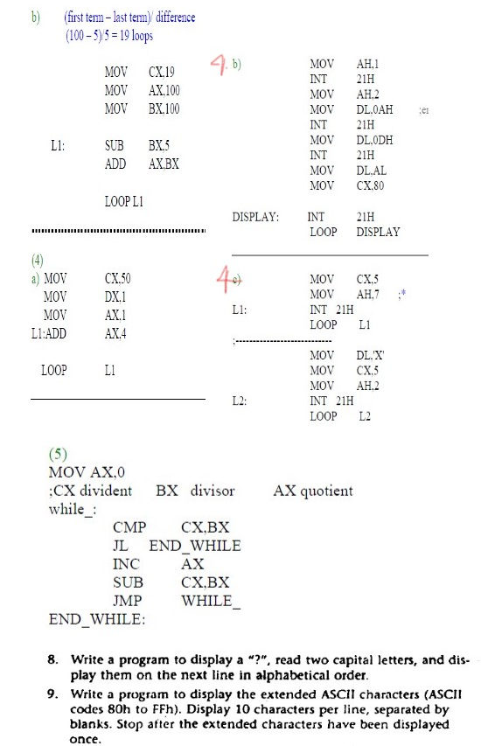

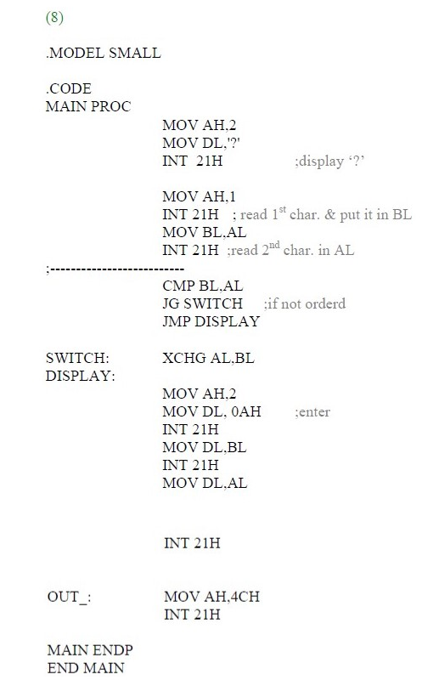

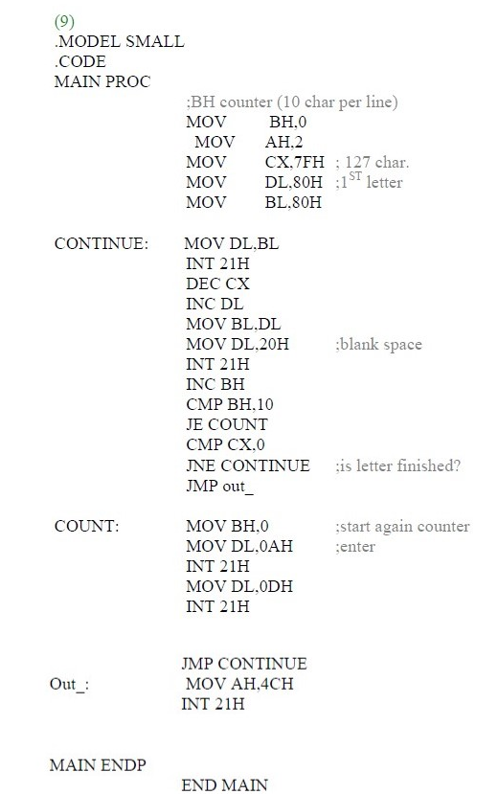

**Stack and Introduction to Procedures**

**The Stack**

* Stack is considered as the **temporary storage** of data and addresses
* **One dimensional** data structure
* **LIFO** (Last In First Out) technique is used
* The **most recent addition** to the stack is called the **top of the stack**
* The statement **.STACK 100H** in your program sets aside a block of **256 bytes** of memory to hold the stack (Here 100h is equivalent to 256 in decimal)
* The **SS** (Stack Segment Register) contains the segment number of the stack segment
* The complete segment:offset address to access the stack is **SS:SP**
* Initially before any data or addresses have been placed on the stack, the SP contains the offset address of the memory location immediately following the stack segment

**Push:**

Push command is mainly used to insert a new **word** into the stack. Here the **word** takes up to 2 bytes. As a result-

1. When a word is entered into the stack the SP (stack Pointer) is **decreased by 2**.
2. A **copy** of the source is moved to the stack to the address specified by the stack SS:SP

It is to be noted that-

1. Any data cannot be directly pushed into the stack
2. Any command like PUSH DL i.e. a 8-bit register cannot be pushed into the stack.

Command for PUSH -

**PUSH source**

Here source is the 16-bit register. For example -

PUSH DX

**Illegal -**

**PUSH DL**

**PUSHF:**

The instruction PUSHF, which has no operands, pushes the contents of the FLAGS register onto the stack.

PUSH and PUSHF don’t affect the flag registers.

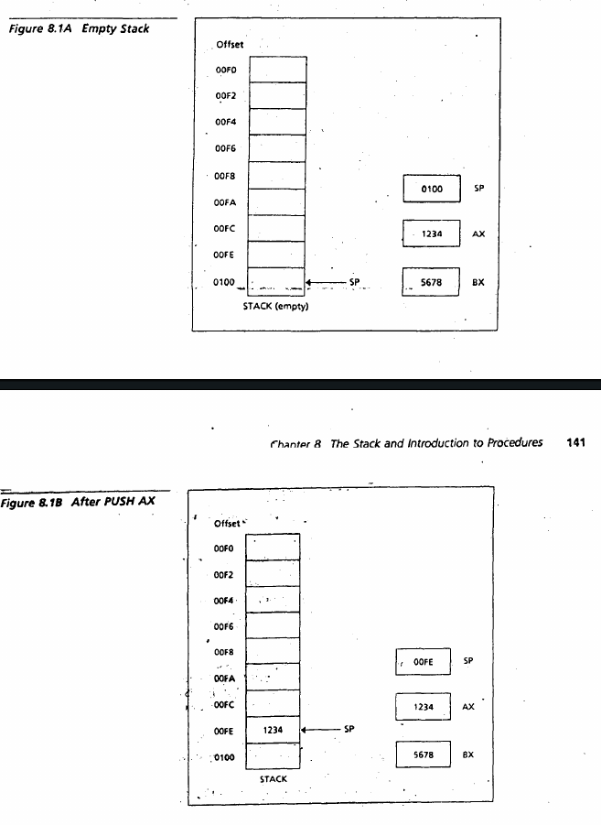



**POP:**

To remove the top item from the stack, we POP it. The syntax Is

**POP destination**

Here source is the 16-bit register.For example -

POP DX

**Illegal -**

**POP DL**

1. The opposite of push occurs here.
2. The SP is increased by 2.
3. The content of the top of the stack is moved to the source register.
4. It does not affect any flag register.

**POPF:**

The Instruction POPF pops the top of the stack into the FLAGS register.

POPF could theoretically change all the flags because it resets the FLAGS REGISTER to some original value that you have previously saved with the PUSHF instruction.

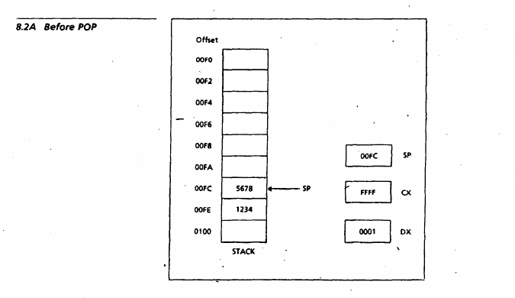

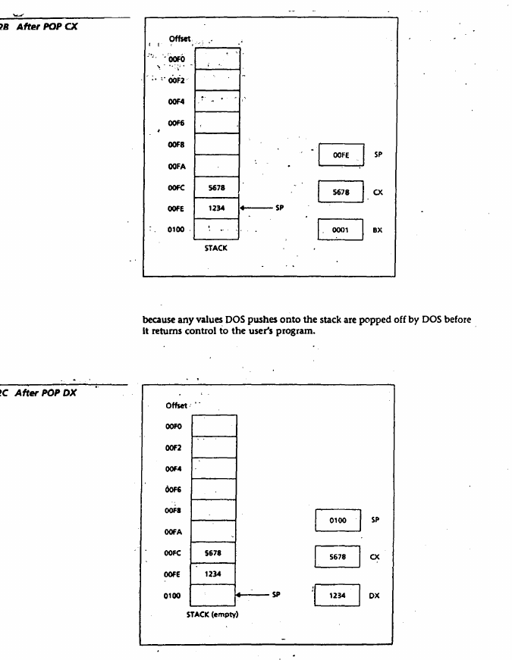

**If the Stack is empty then the value of the SP is 100h otherwise it has a value between 0000h-00FEh.**

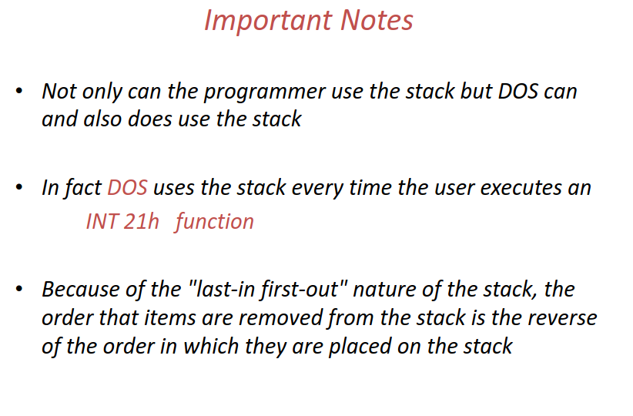

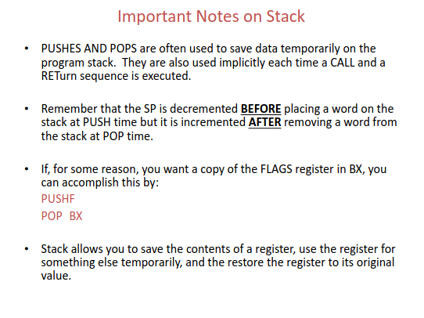

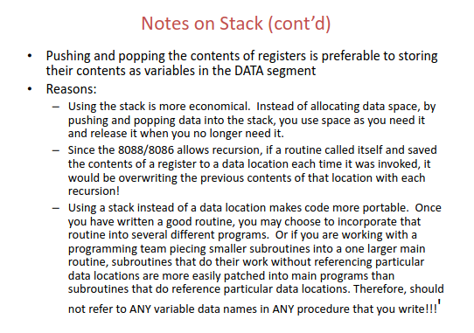

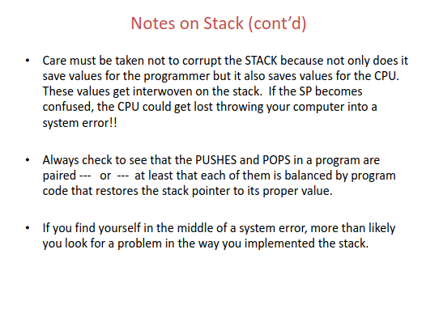

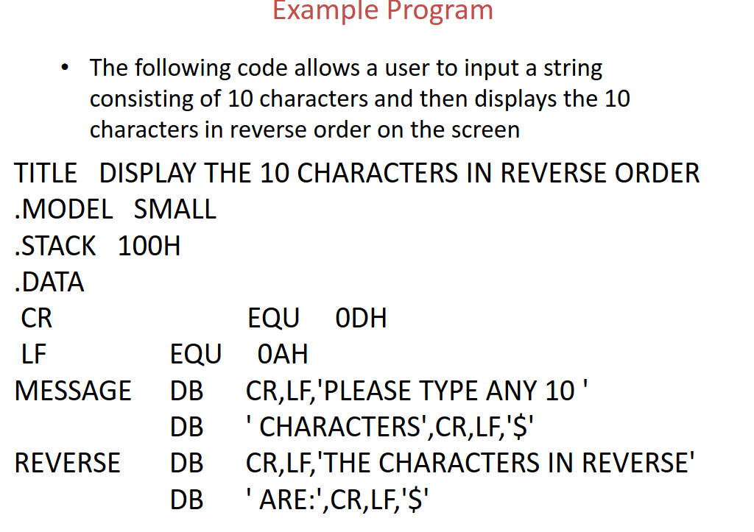

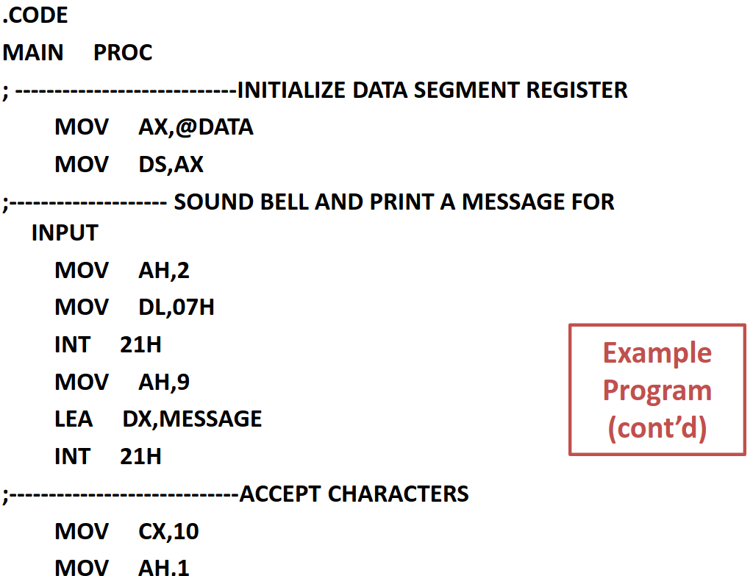

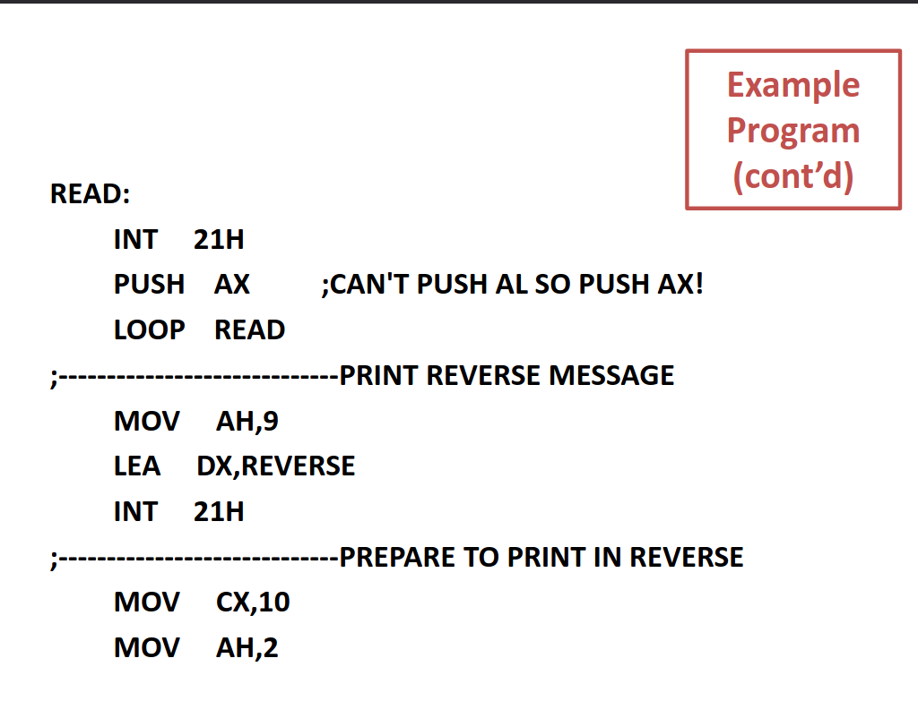



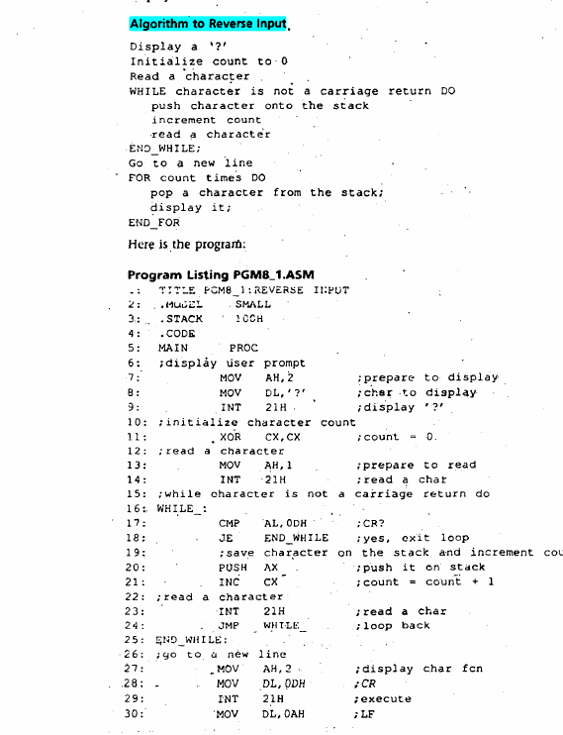

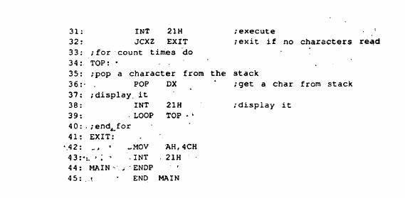

**The Procedure**

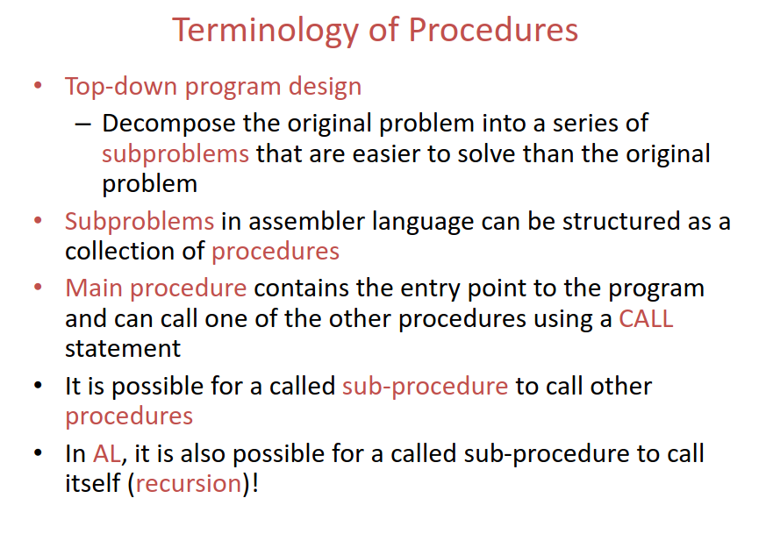

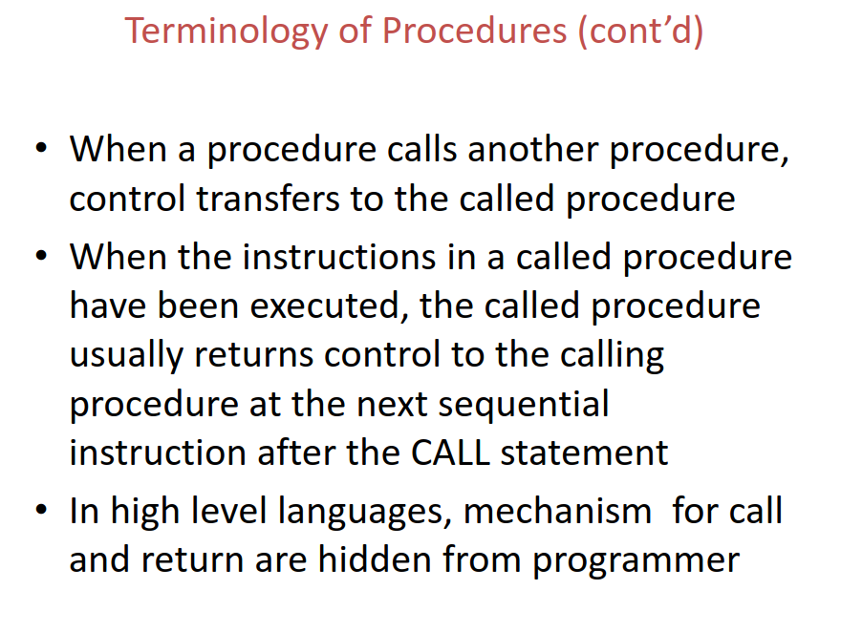

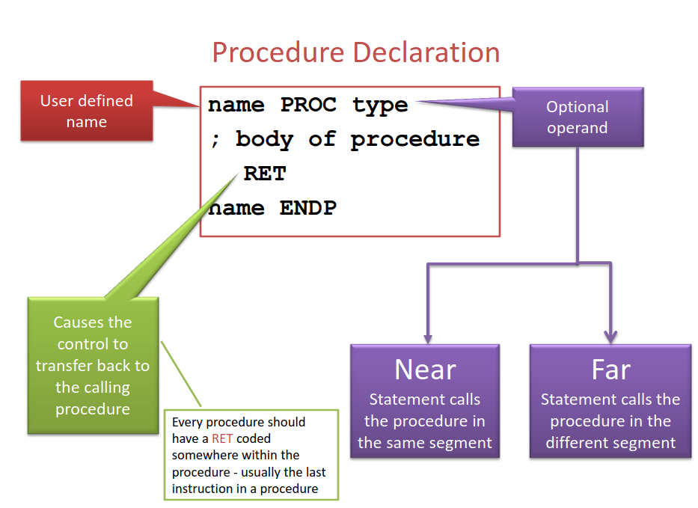

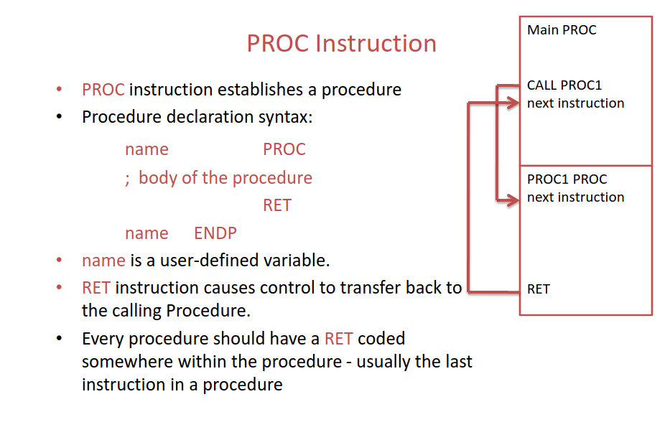

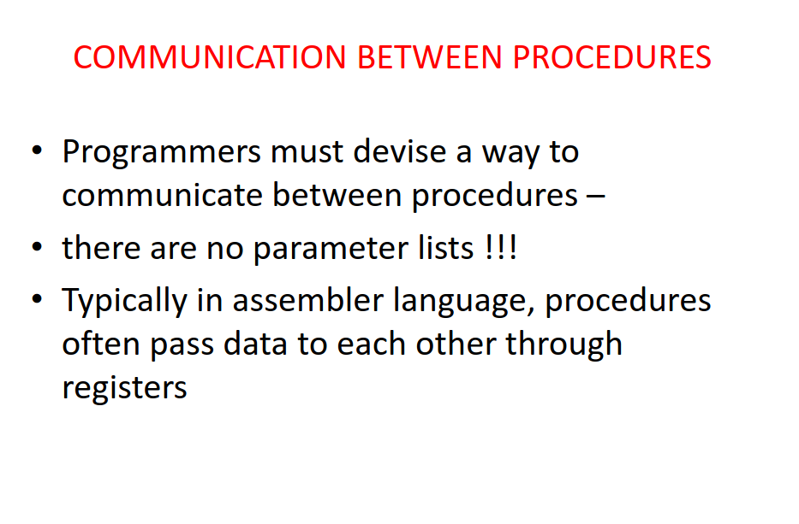

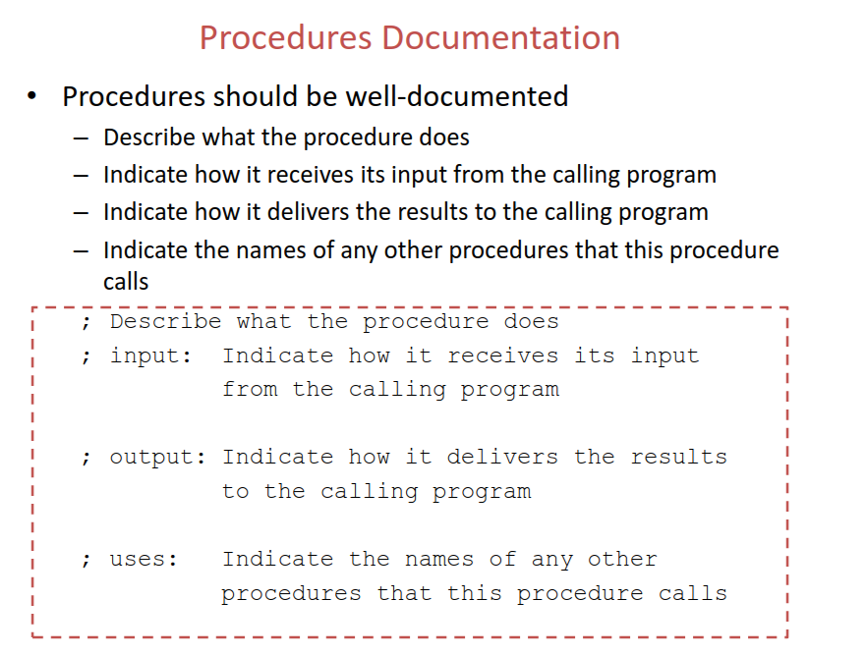

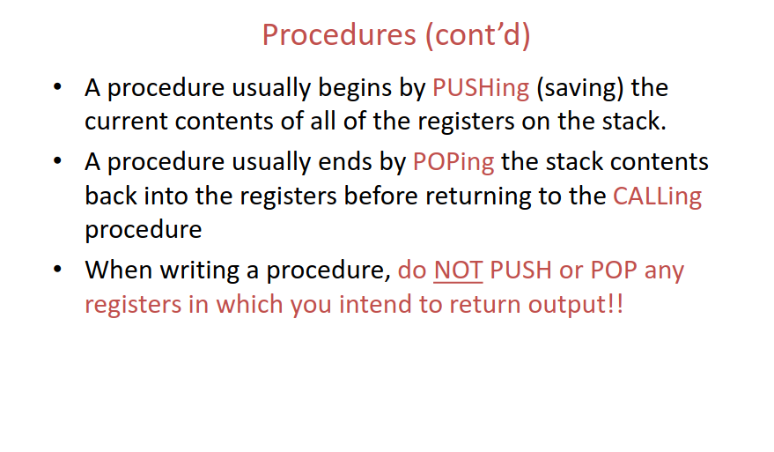

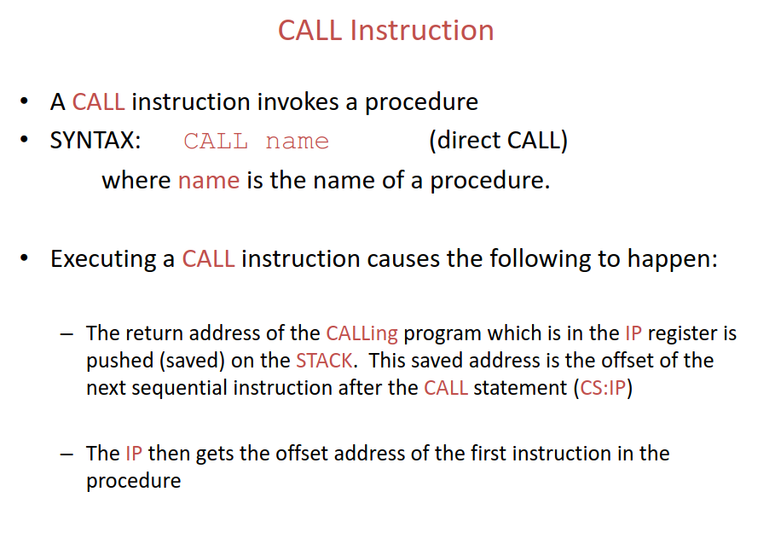

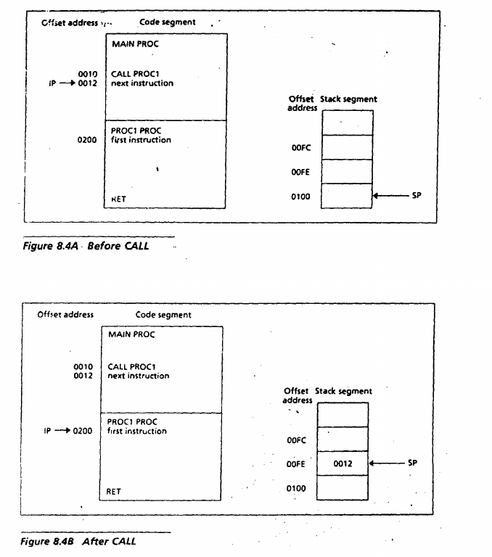

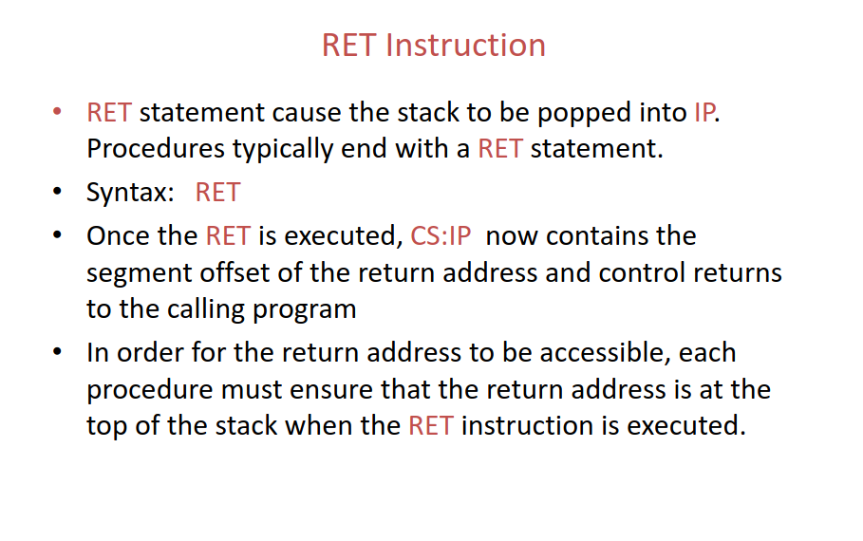

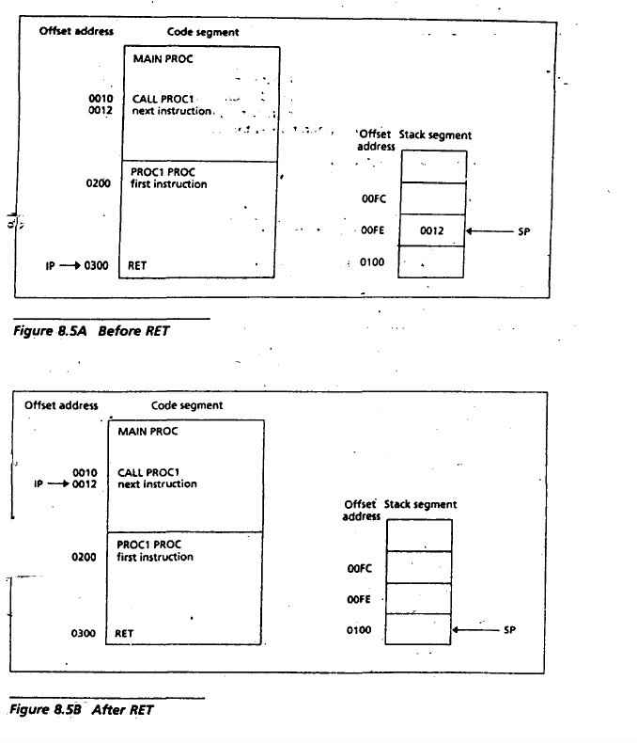

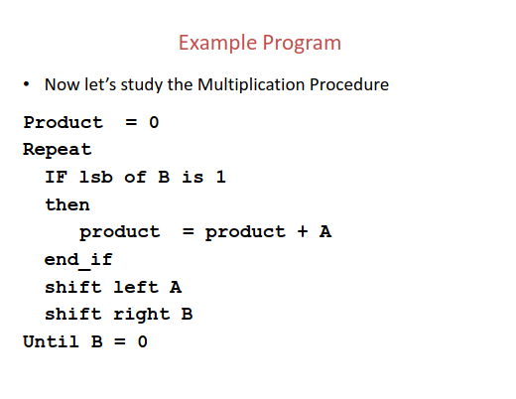

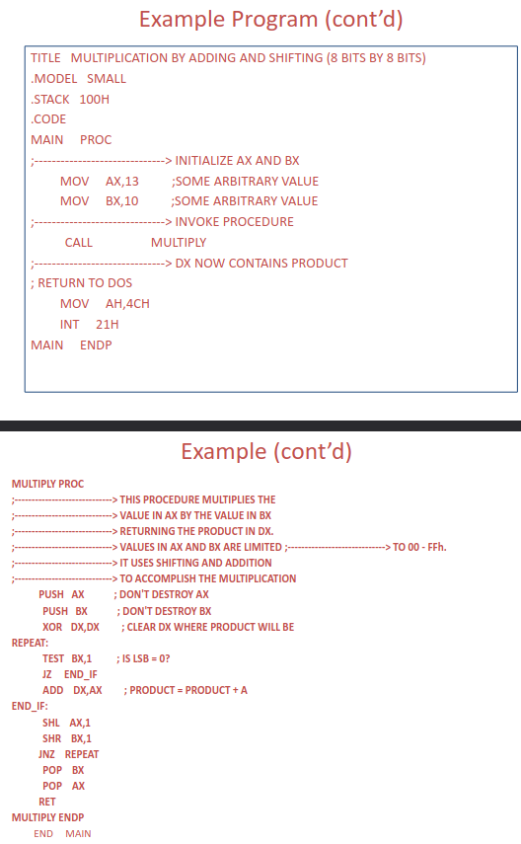

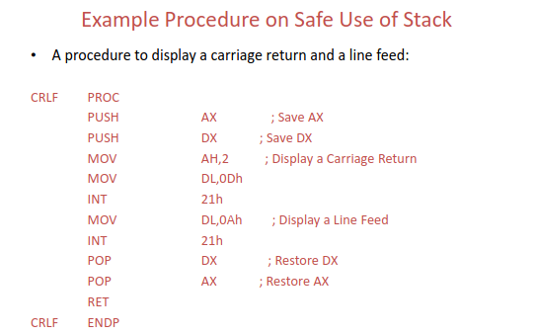

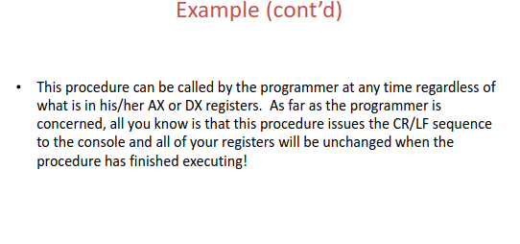

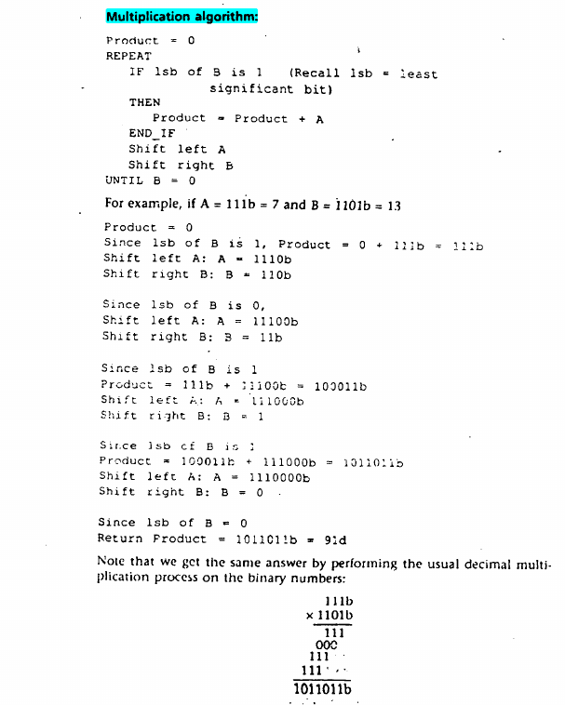

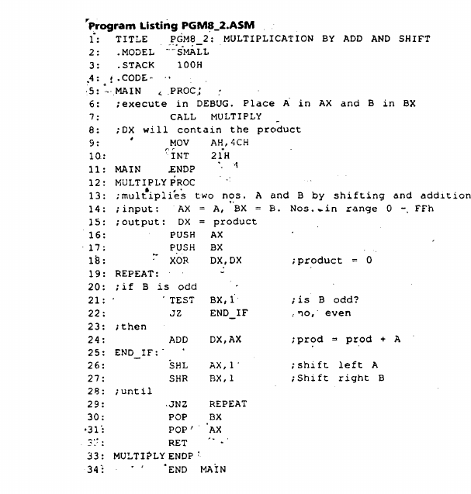

**EXERCISE**

***(MARUTT) —----->***

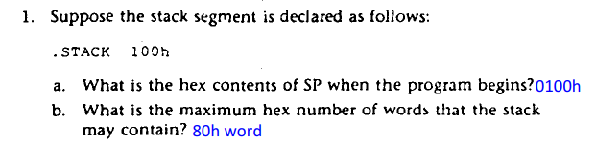

a) SP = 0100h

b) 100h byte for stack mean 100h/2 word = 80h word

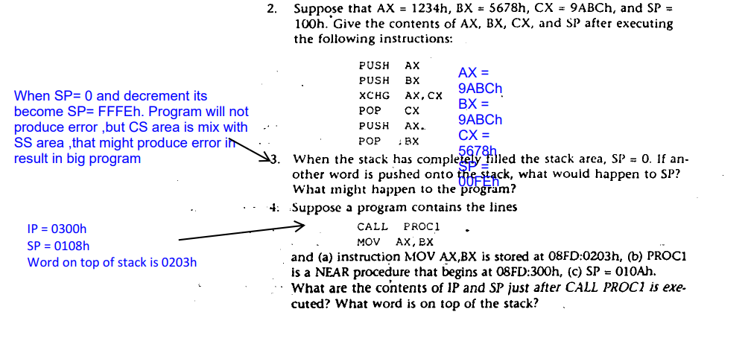

2) AX = 9ABCh

BX = 9ABCh

CX = 5678h

SP = 00FEh

3) When SP= 0 and decrement it becomes SP= FFFEh. Program will not produce error ,but CS area is mixed with SS area ,that might produce error in result in big program.

4) IP = 0300h

SP = 0108h

Word on top of stack is 0203h

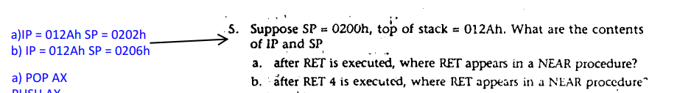

5) a) IP = 012Ah SP = 0202h

b) IP = 012Ah SP = 0206h

Explanation : RET POP_VALUE Mean the stack get more size Original value of SP =202h + POP_VALUE(4) = 206h

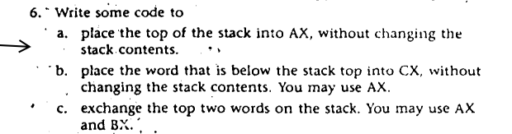

a) POP AX

PUSH AX

b) POP AX

POP CX

PUSH CX

PUSH AX

c) POP AX

POP BX

PUSH AX

PUSH BX

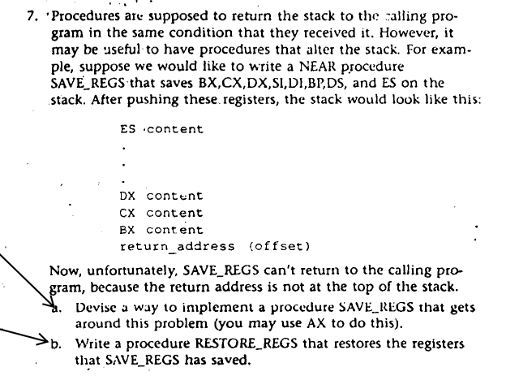

a) SAVE_REGS PROC

POP AX ;save return address

PUSH BX ;save regs in the stack

PUSH CX

PUSH DX

PUSH SI

PUSH DI

PUSH BP

PUSH DS

PUSH AX ;top of stack is return address

RET

SAVE_REGS ENDP

b) RESTORE_REGS PROC

POP AX ; save return address

POP DS ; restore regs from the stack

POP BP

POP DI

POP SI

POP DX

POP CX

POP BX

PUSH AX ; top of stack is return address

RET

RESTORE_REGS ENDP

8. Write; a program that lets the user type some text, consisting of words separated by blanks, ending with a carriage return, and displays the text in the same word order as entered, but with the let- __, ters ·in each word reversed. For example, "this is a test" becomes "siht si a tset". Hint: modify program PGM8_2.ASM in section 8.3.

9.; A problem in elementary algebra is to decide if an expression containing several kinds of brackets, such as, [,],{,),(,), is correctly bracketed. This is the case if (a) there are the same number of left and right brackets of each kind, and (b) when a right bracket appears, the most recent preceding unmatched left bracket should be of the same type.

For example,· ·(a~. I?- fc x (d - ~ ) I J + f} is correctly brackett!d, but (a+ (b -.lex (d - e)) I + f J is not Correct bracketing can be decided by using a stack. The expres- '· The slon is scanned left to right. When a left bracket is encountered, it is pushed onto -the stack. When a right bracket is encountered, the stack is popped (if the stack is empty, there are too many right brackets) and the brackets are compared. If they are of the same type, the scanning continues. If there is a mismatch, the ex·pression is incorrectly bracketed. At the end of the expression, if the stack is empty the expression is correctly bracketed. If the

stack Is not empty, there are too many left brackets.

Write a program that lets the user type in an algebraic expression, ending with a carriage return, that contains round (parentheses), square, and curly brackets. As the expression is being typed in, the program evaluates each character. If at any point the expression is incorrectly bracketed (too many right brackets or a mismatch between left and right brackets), the program tells the user

to start over. After the· carriage return is typed,

If the expression is correct, the program displays "expression Is correct." If not, the program displays "too many left brackets". In both cases, the program asks the user if he or she wants to continue. If the user types 'Y', the program runs again. Your program docs not need to store the input string, only check

it for correctness.

Sample execution:

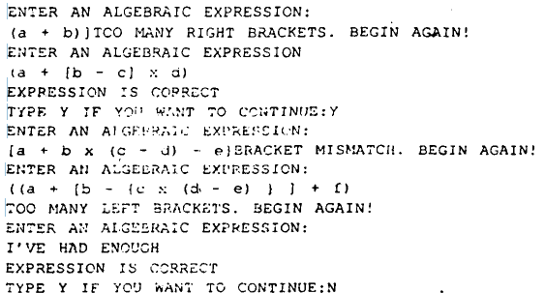

This is the case if

(a) There are the same number of left and right brackets of each kinds,and

(b) When a right bracket appears,the most recent preceding unmatched left bracket should be of the same type.

This can be decided by using stack. The expression is scanned left to right. When a left bracket is encountered,it is pushed onto the stack. When a right bracket is encountered, the stack is poped (if the stack is empty ,there are too many right brackets) and the brackets are compared. If they are of the same type,the scanning continues.If there is a mismatch,the expression is incorrectly bracketed. At the end of the expression ,if the stack is empty ,the expression is correctly bracketed otherwise there are too many left brackets.

Code :

**.model small**

**.stack 100h**

**.data**

**cr equ 0DH ; cr represents carriage return**

**lf equ 0AH ; lf represents line feed**

**msg DB cr,lf,'ENTER AN ALGEBRAIC EXPRESSION: ',cr,lf,'$'**

**msg_correct DB cr,lf,'EXPRESSION IS CORRECT.$'**

**msg_left_bracket DB cr,lf,'TOO MANY LEFT BRACKETS. BEGIN AGAIN!',cr,lf,'$'**

**msg_right_bracket DB cr,lf,'TOO MANY RIGHT BRACKETS. BEGIN AGAIN!',cr,lf,'$'**

**msg_mismatch DB cr,lf,'BRACKET MISMATCH. BEGIN AGAIN!',cr,lf,'$'**

**msg_continue DB cr,lf,'Type Y if you want to Continue: ',cr,lf,'$'**

**.code**

**main proc**

**mov ax, @data ;get data segment**

**mov ds, ax ;initialising**

**start:**

**lea dx, msg ;user prompt**

**mov ah, 9**

**int 21h**

**xor cx, cx ;initializing cx**

**mov ah, 1**

**input: ;this label for taking input**

**int 21h**

**cmp al, 0Dh ;checking if the enter is pressed or not**

**JE end_input**

**;if left bracket, then push on stack**

**cmp al, '['**

**JE push_data**

**cmp al, '{'**

**JE push_data**

**cmp al, '('**

**JE push_data**

**;if right bracket, then pop stack**

**cmp al, ')'**

**JE parentheses**

**cmp al, '}'**

**JE curly_braces**

**cmp al, ']'**

**JE line_bracket**

**jmp input**

**push_data:**

**push ax**

**inc cx**

**jmp input**

**parentheses:**

**dec cx**

**cmp cx, 0**

**JL many_right**

**pop dx**

**cmp dl, '('**

**JNE mismatch**

**JMP input**

**curly_braces:**

**dec cx**

**cmp cx, 0**

**JL many_right**

**pop dx**

**cmp dl, '{'**

**JNE mismatch**

**JMP input**

**line_bracket:**

**dec cx**

**cmp cx, 0**

**JL many_right**

**pop dx**

**cmp dl, '['**

**JNE mismatch**

**JMP input**

**end_input:**

**cmp cx, 0**

**JNE many_left**

**mov ah, 9**

**lea dx, msg_correct**

**int 21h**

**lea dx, msg_continue**

**int 21h**

**mov ah, 1**

**int 21h**

**cmp al, 'Y'**

**JNE exit**

**JMP start**

**mismatch:**

**lea dx, msg_mismatch**

**mov ah, 9**

**int 21h**

**JMP start**

**many_left:**

**lea dx, msg_left_bracket**

**mov ah, 9**

**int 21h**

**JMP start**

**many_right:**

**lea dx, msg_right_bracket**

**mov ah, 9**

**int 21h**

**JMP start**

**exit:**

**mov ah, 4ch**

**int 21h**

**main endp**

**end main**

10. The following method can be used to generate random numbers in the range 1 to 32767. Start with any number in this range. Shift left once. Replace bit 0 by the XOR of bits 14 and 15. Clear bit 15.

Write the following procedures:

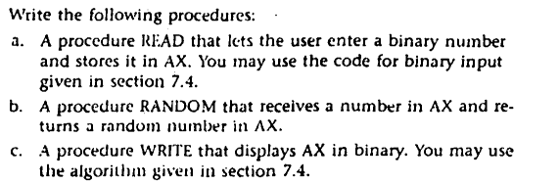

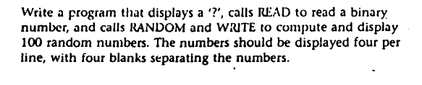

a) Explanation : to make the range between 1 to 32767 we just ignore msb (sign bit /bit-15) by enter 15 bit.

INBINARY PROC

XOR BX,BX

Mov CX,15

MOV AH,1

INT 21H

WHILE_: CMP AL,0DH

JE END_WHILE

AND AL,01H

SHL BX,1

OR BL,AL

INT 21H

LOOP WHILE_

END_WHILE:

RET

INBINARY ENDP

b)

by following the algorithm:

RANDOM PROC

;input in AX : start with any number in the range

;output in AX (Random number)

PUSH BX ;save regs

PUSH DX

SHL AX,1 ; shift left once

MOV DX,AX ;get copy

SHL DX,1 ;make bit-14 be bit-15

XOR AX,DX ;xor bit-14 with bit-15

TEST DX,8000h ;result of XOR bit-14 with bit-15

JZ NOT_ONE

OR AX,1 ;replace bit-0 with result (1)

JMP CL_B15 ;clear bit-15

NOT_ONE: AND AX,0FFFEH ;replace bit-0 with (0)

CL_B15: AND AX,7FFFH

POP DX ;restore regs

POP BX

RET

RANDOM ENDP

c)

OUTBIN PROC

;input AX

;output on screen

;we copy number in BX to make sure not changing the

;number because of output function that depend on AX

MOV BX,AX ;get copy

MOV CX,16

start: ROL BX,1

JC ONE

MOV AH,2

MOV DL,'0'

INT 21H

JMP L1

ONE: MOV AH,2

MOV DL,'1'

INT 21H

L1: LOOP start

;put the random number in AX to be new number to

generate another random number

MOV AX,BX

RET

OUTBIN ENDP

The full program looks like :

.MODEL SMALL

.stack 64

.DATA

Counter DB 100 ;number to be generated

Counter2 DB 4 ;4 number on same line

.CODE

Main PROC

MOV AX,@DATA

MOV DS,AX

;-------------------

CALL INBINARY

MOV AX,BX

Begin: MOV D,4

L10: POP AX

CALL RANDOM

CALL OUTBIN

PUSH AX

;-------------------

MOV AH,2

MOV DL,20H ;blank space

INT 21H

DEC counter2

CMP counter2,0 ;is there 4-number on line

JE NEW_LINE

DEC Counter

CMP Counter,0

JNE L10

JMP OUT_

NEW_LINE: MOV AH,2

MOV DL,0AH ;enter LF

INT 21H

JMP Begin

OUT_:

MOV AH,4CH

INT 21H

;-------------------------

Main ENDP

;see Appendix C for include pseudo-ops

;Test is folder’s name in c:\ contain procedures

INCLUDE C:\TEST\RANDOM.ASM

INCLUDE C:\TEST\INBINARY.ASM

INCLUDE C:\TEST\OUTBIN.ASM

END Main

**Arrays and Addressing**

# **Notes**

## **Overview:**

* Why do we need arrays?
* In order to treat a collection of values as a group.
* Advantages of arrays
* A single name can be given to the whole structure
* Any element can be accessed using indexing
* What is a two-dimensional Array?
* A two-dimensional array is a one-dimensional array whose elements are also one-dimensional arrays.
* Most easily manipulated by the based index addressing mode.
* XLAT instruction -> This instruction is useful when we want to do data conversion and we use it for encoding and decoding a secret message

## **One Dimensional Array**

**Definition:** A one-dimensional array is an ordered list of elements of the same type. Ordered does not mean sorted it means there is a first, second element, and so on.

* The Pseudo ops used to declare Arrays are DB for byte, DW for word arrays.

**MSG DB ‘abcde’**

**W DW 10,20,30,40,50,60**

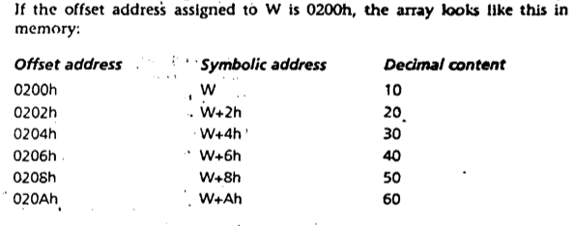

* **What is the base address of an array?**
* The address of the array variable is known as the **base address** of the array.

**DUP operator:** It is used for initialing duplicate values.

**Syntax: repeat_count DUP( value )**

**W DW 100 DUP(0)** → this will initiate the W array with 100 elements all will have the value 0. Instead of DUP(0) if we write **DUP(?)** it will create an array of 100 uninitialized words.

**Nested DUP : Line DB 5,4, 3 DUP(2 , 3 DUP(0) , 1)**

**=> 5, 4, 2, 0, 0, 0,1,2, 0,0, 0, 1, 2, 0, 0, 0, 1**

**Location of Array Elements:**

* **How to access an element in the array?**
* The address of an array element may be specified by adding a constant to the base address.

**Formula to access an element:** address of Nth element  **= A + (N - 1) ✖️ S** [ A = base address of the array , N = number of the element , S = 1 or 2 ( 1 = byte and 2 = word) ]

Example : W[10] = W + ( 10 - 1 ) * 2 => W + 9 * 2 => W + 18

**Addressing Modes:**

**Definition:** The way an operant is specified is known as its addressing mode.

**Address modes:**

* Register mode: Operand is a register
* Immediate mode: Operand is a constant;
* Direct Mode: operand is a variable

**Register addressing mode:**

With the Register Addressing mode, the operand to be accessed is specified as residing in an internal register of the 8086.

Example: MOV AX, BX

This code moves the contents of BX (the source operand) to AX (the destination operand).Both the source and the destination operands have been specified as the contents of internal registers of the 8086.

**Immediate Addressing**

The 8-bit or 16-bit data is provided as a part of the instruction in the immediate addressing mode. The data occupies the immediate next byte to the instruction code in memory.

Example: MOV AL , 055H

In this instruction the operand 055H is an example of a byte-wide immediate source operand. The destination operand, which consists of the contents of AL, uses register addressing. Thus this instruction employs both immediate and register addressing modes.

**Direct Addressing ( according to prev chapters)**

The 16-bit offset address of a memory location is directly provided as a part of the instruction in direct memory addressing mode. Direct address references are usually relative to DS.

Example: MOV CX, [1234H]

This addressing moves the contents of the memory location, which is offset by 1234H from the current value in DS (DS:1234H) into internal register CX. If DS contains 2000H, and the memory location 2000H:1234H and 2000H:1235H contains CDH and AB respectively the execution will load ABCDH into CX. This is because the destination set is 16-bit, so the source has to be 16 bit and so the 2 bytes are combined to form the 16-bit data. The location larger is the higher byte and the smaller location is the lower byte of the 16-bit data.

To change the reference register to any other use a segment override:

mov ch, [es:OverByte]

mov dh, [cs:CodeByte]

mov dh, [ss:StackByte]

mov dh, [ds:DataByte]

An override occupies a byte of machine code which is inserted just before the affected instruction

**Four additional Addressing modes in the 8086:**

* **Register Indirect**
* In this mode, the offset address of the operand is contained in a register.
* The register acts as a pointer to the memory location. Format : [register]
* MOV AX , [SI] → the address stores in the SI is used as offset with the DS register . so the address will be DS:0100h [ suppose SI has the 0100h ]
* MOV AX,SI moves 0100h in AX but AX,[SI] moves the value in the DS:0100h value in the AX.
* Source register can be **BX,SI or DI** for register indirect addressing ( is DS) . BP can be used for SS.

**Example 10.3** Write some code to sum in AX the elements of the 10-element array W defined by “W DW 10, 20, 30, 40, 50, 60, 70, 80, 90, 100”

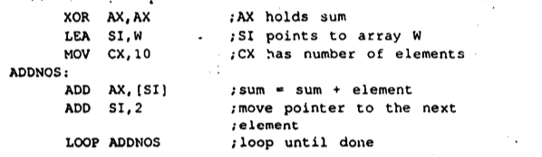

**Example 10.4** Reverse an array

Solution : The idea ts to exchange the 1st and Nth words, the 2nd and (N-l)st words, and so on. The number of exchanges will be N/2 (rounded down to the nearest Integer If N Is odd). Recall the Nth element ln a word array A has address A+ 2 x (N - 1).

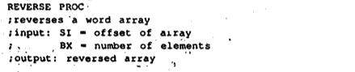

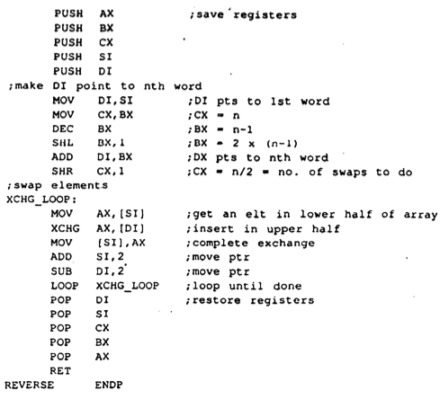

* **Based and 3. Indexed**

**Definition:** In these modes, the operand's offset address Is obtained by adding a number called a displacement to the contents of a register.

Displacement can be :

* the offset address or a variable
* a constant (positive or negative)
* the offset address or a variable plus or minus a constant
* When it is called indexed and when it is called based?

=> The addressing mode is called based if BX (base register) or BP(base pointer) is used. The addressing mode is called indexed if SI (source index) or DI (destination index) is used

**Syntax:**

**[register + displacement]**

**[displacement + register]**

**[register] + displacement**

**displacement + [register]**

**displacement [register]**

**Example :**

Ex. Suppose W is a word array, and BX contains 4

MOV AX, W[BX]

• The displacement is the offset address of variable W.

• The instruction moves the element at address W + 4 to AX. (this is the third element in the array)

• The instuction could also have been written in any of these forms:

MOV AX, [W+BX]

MOV AX, [BX+W]

MOV AX, W+[BX]

MOV AX, [BX]+W

Array sum with base mode :

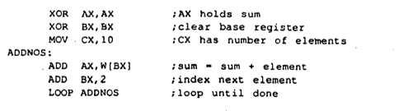

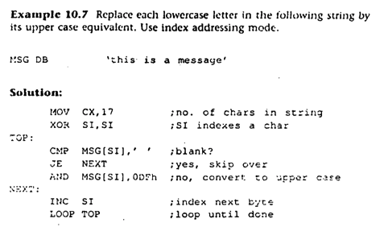

**Consider the following instructions:**

**mov [BX], 100**

**add [SI], 20**

**inc [DI]**

Where BX, SI, and DI contain memory addresses The size of the memory operand is not clear to the assembler BX, SI, and DI can be pointers to BYTE, WORD

**Solution:**

**use PTR operator to clarify the operand size**

**mov BYTE PTR [BX], 100 ; BYTE operand in memory**

**add WORD PTR [SI], 20 ; WORD operand in memory**

**Label Pseudo-op:**

**Money LABEL word**

**Dollars DB 1Ah**

**Cents DB 52h**

This declaration types Money as a word variable,and the components DOL· LARS and CENTS as byte variables, with MONEY and DOLLARS being assigned the same address by the assembler. The instruction

MOV AX,MONEY ;AL = dollars , AH = cents

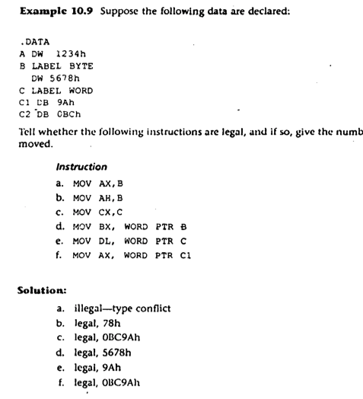

**Segment override :**

By default the DI , SI and BX specifies offset the the address of the DS. But we can explicitly specify the segment to override it.

**MOV AX,ES: [SI] → it will add the offset to the ES.**

**Sort Array:**

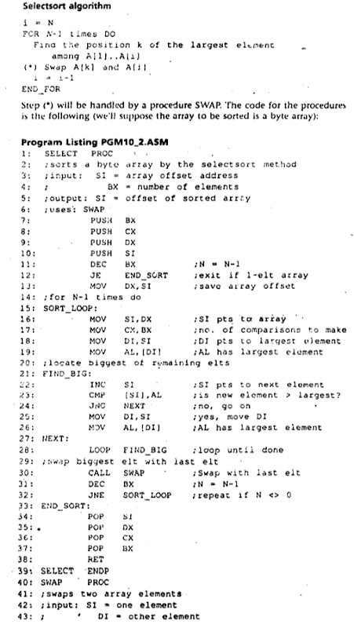

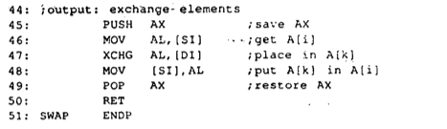

**Two-dimensional Array:**

**Row major order:** the row 1 elements are stored, followed by the row 2 elements, then the row 3 elements, and so on.

**Column major order:** column after column is stored.

**Locating an Element in a Two-Dimensional Array:**

**Row Major:**

To find the location of A[i, j],

1. Find where row i begins.

2. Find the location of the jth element in that row.

Step 1 : Row 1 begins at A, has N elements and each element has size S. so the 2nd row begins at A+ N*S And row 3 begins at A + 2 * N * S . So we can say that the i row begins at **A + (i - 1 ) * N * S.**

Step 2: Now the second step j th element is in (j - 1 ) * S position

So if we combine the both step 1 and step 2 we get = A + ((i-1)*N + (j -1)) * S

**Column major:**

**If A is an M x N array, with element size S, stored in column-major, then :**

**A[i,j] has address A + ((i - 1) + (j - 1) x M) x S**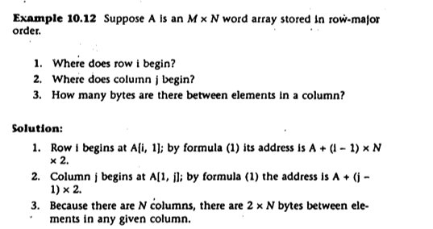

**Based-Indexed Addressing mode:**

This mode is used for 2-dimensional arrays.

In this mode, the offset address of the operand is the sum of

* the contents of a base register (BX or Bl')
* the contents of an index register (SI or DI)
* optionally, a variable's offset address
* optionally, a constant (positive or negative)

1. variable[base_register] [index_register]

2. [base_Resister + index_register + constant + variable]

3. Variable[base_register + index_register + constant]

4. Constant[base_register + index_register + variable]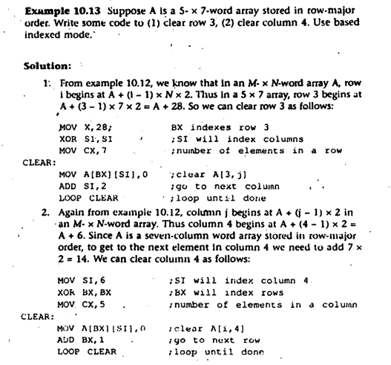

Example: Average subject score

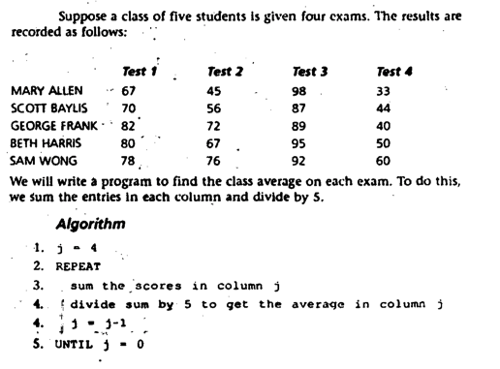

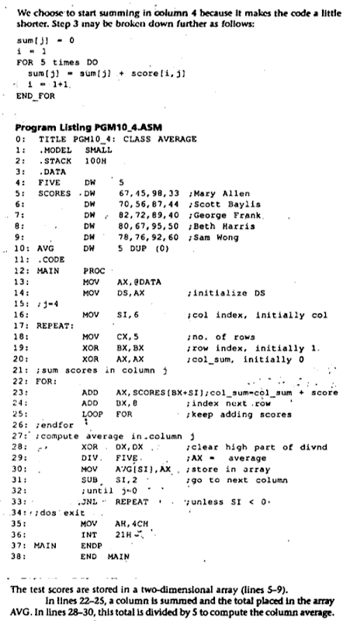

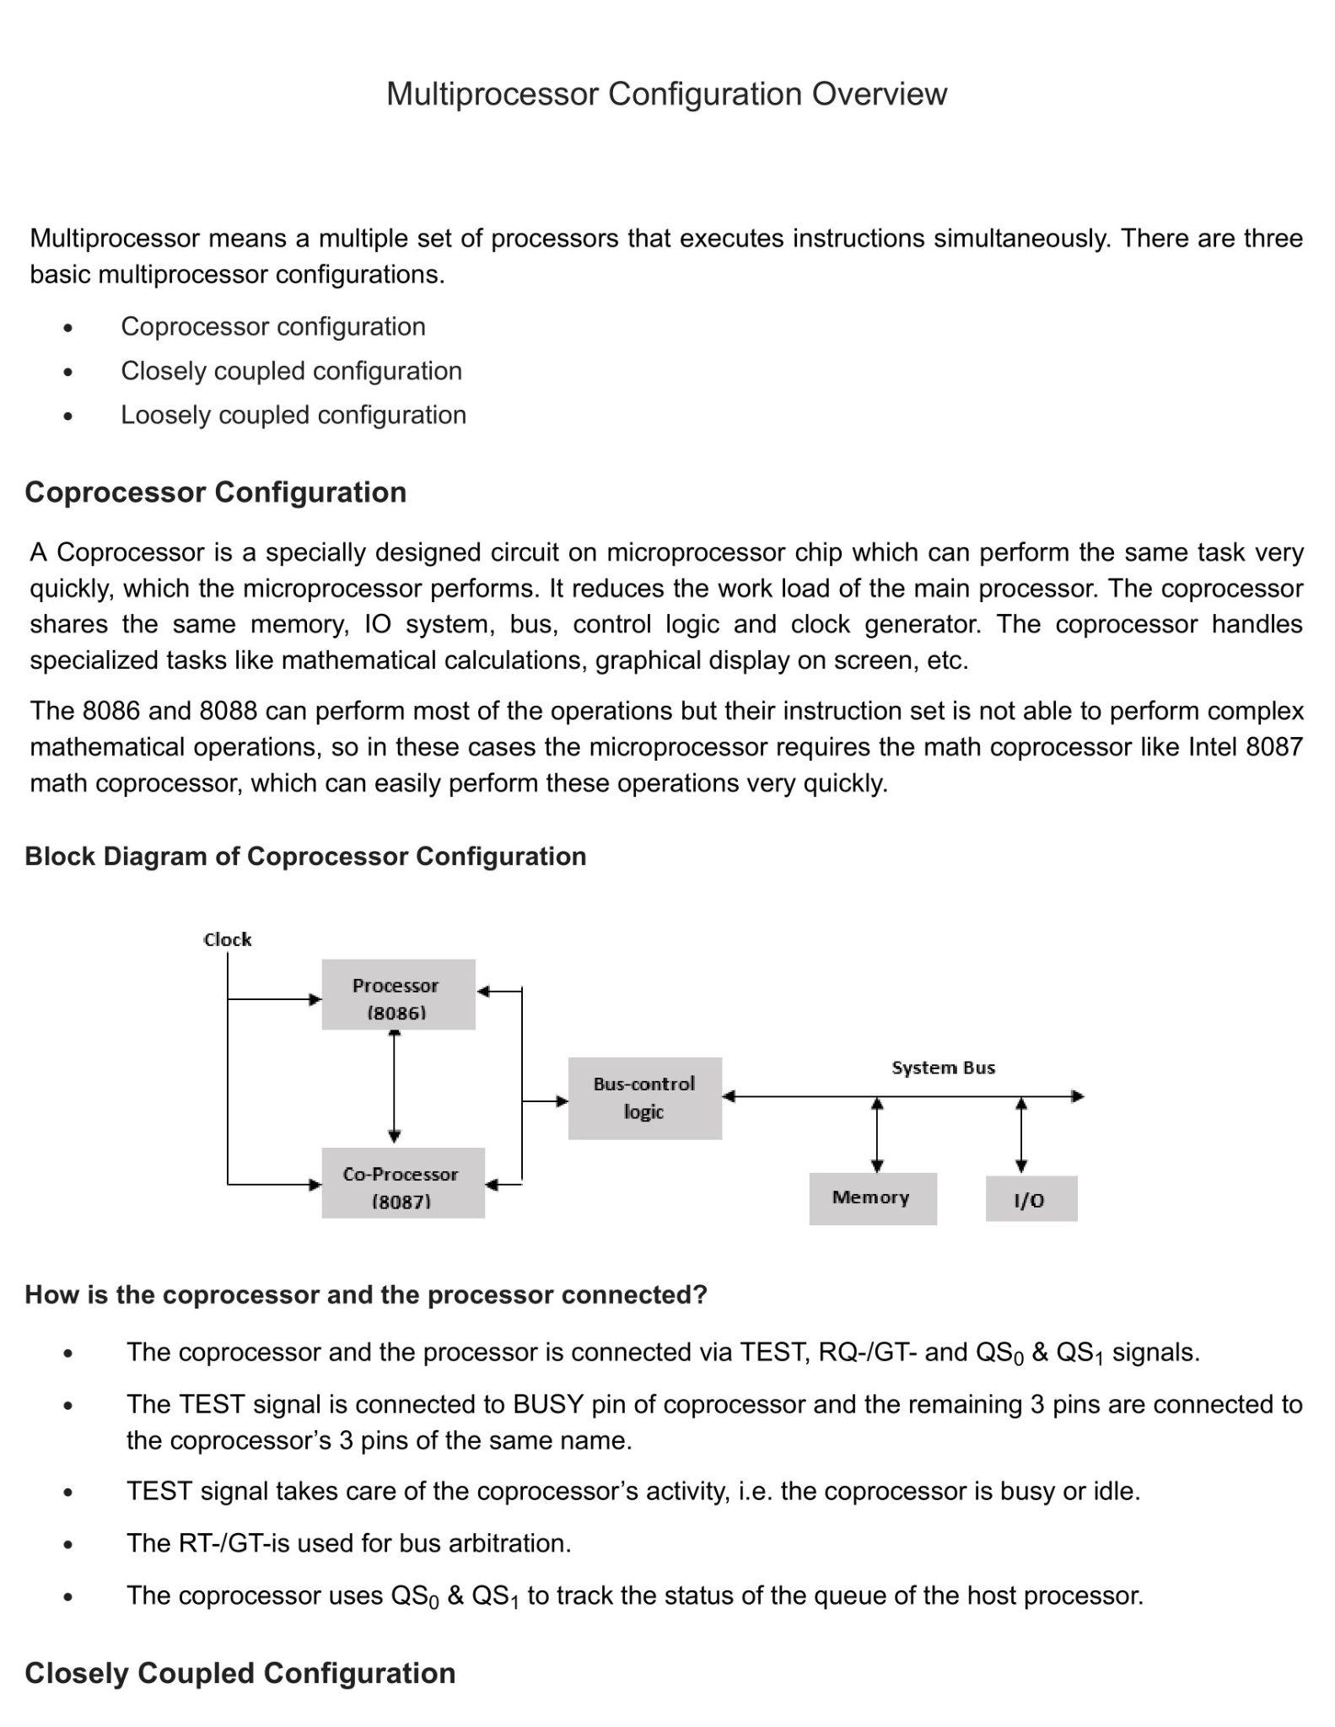

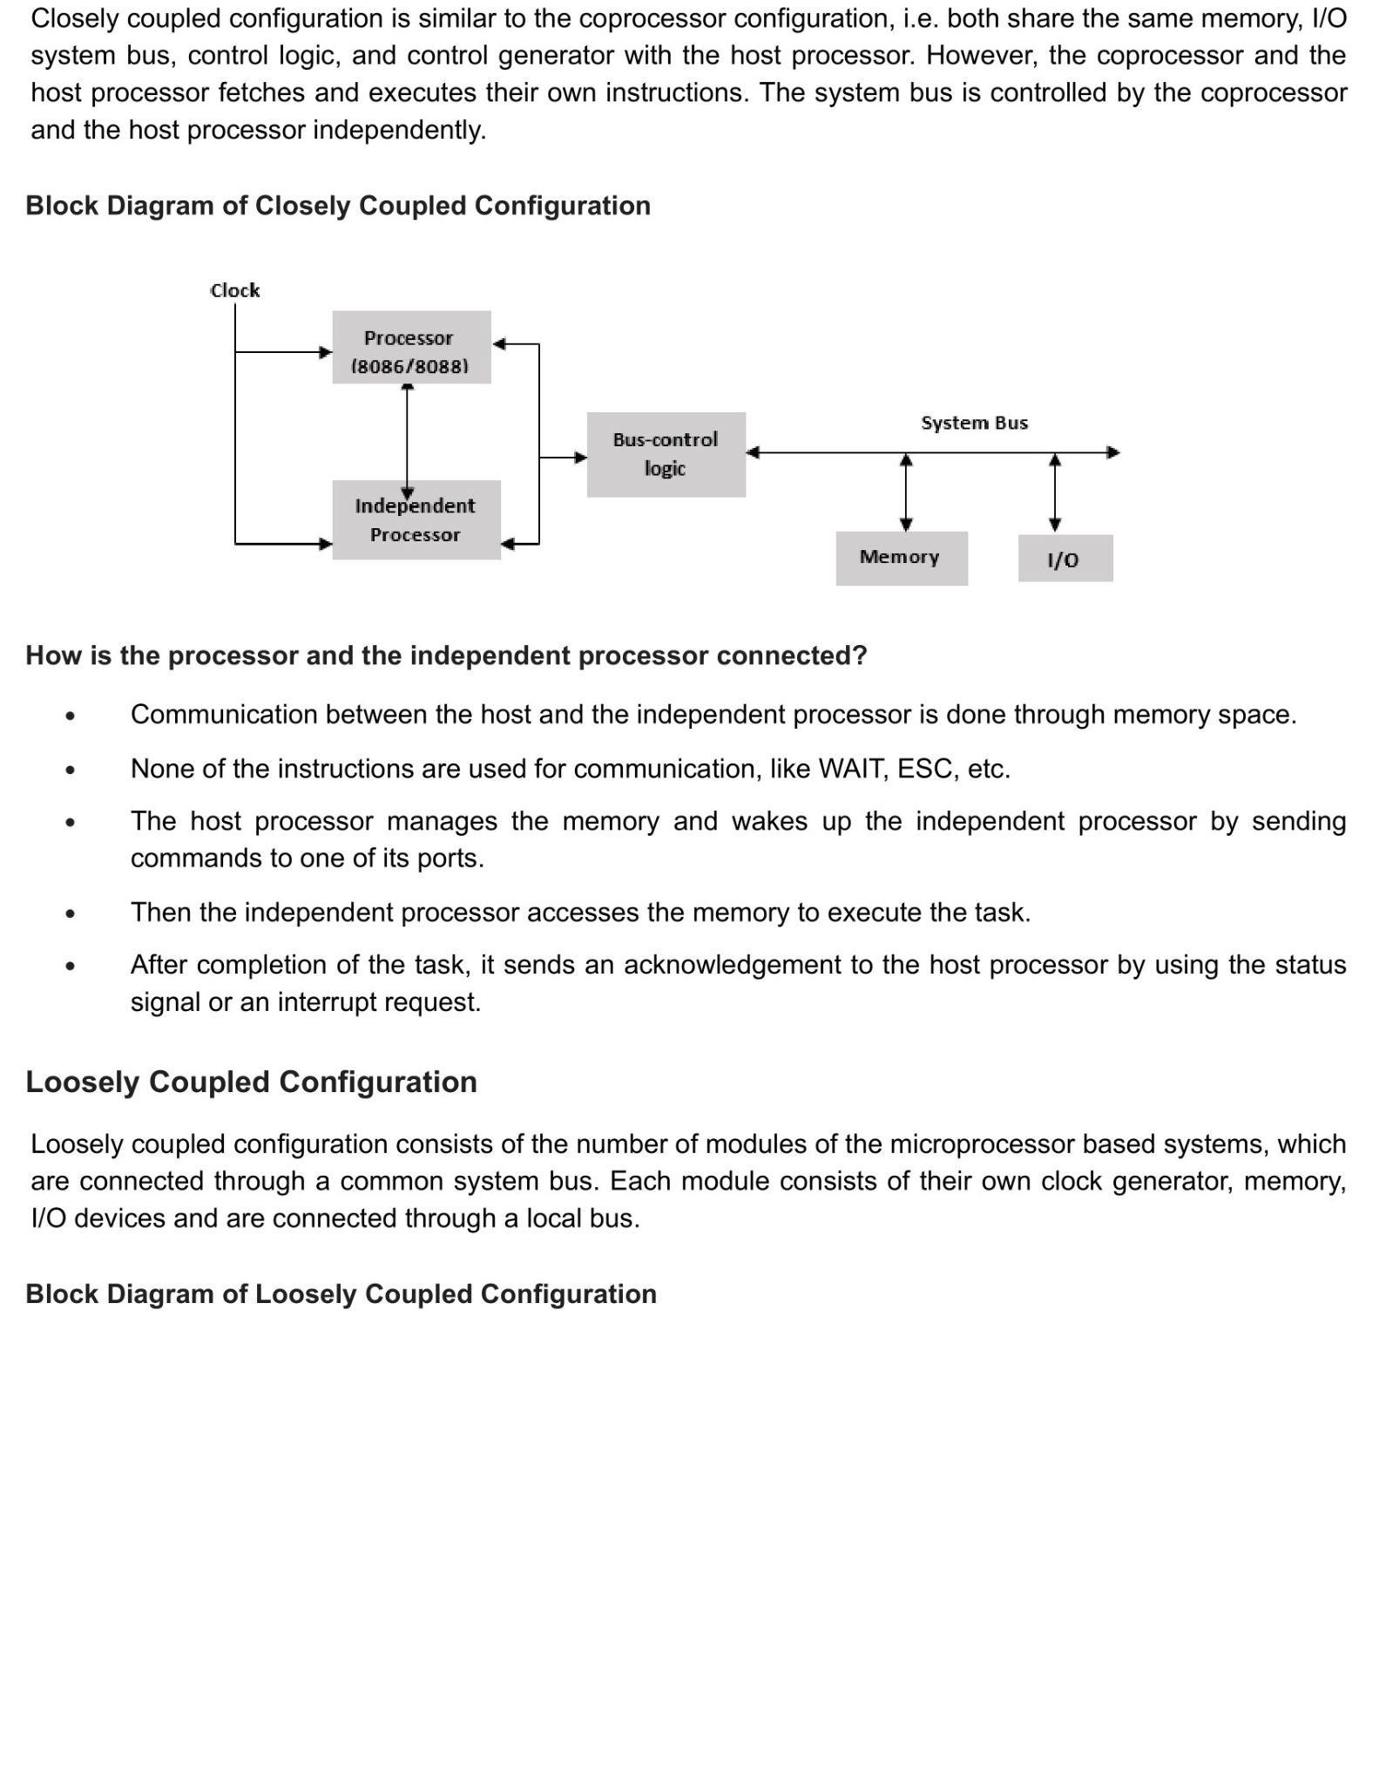

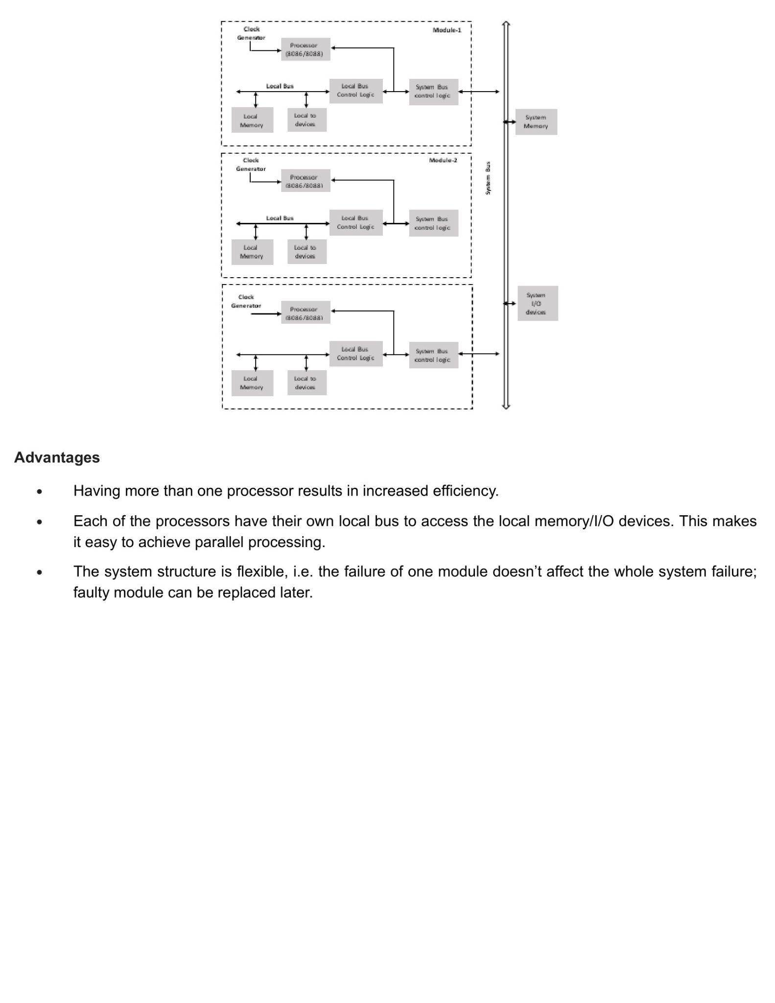

* **Configurations of each categories :**

1. Coprocessor Configuration: In this configuration, a specialized coprocessor is added to a main processor to offload specific tasks, such as mathematical calculations or graphics rendering. The coprocessor works in tandem with the main processor, with each processor handling different types of tasks. This configuration can result in significant performance gains for certain applications, but can also add complexity and cost to the system.
2. Closely Coupled Configuration: In this configuration, multiple processors are closely integrated and share resources such as memory and I/O. The processors work in close collaboration with each other and communicate with low latency, resulting in high performance. This configuration is suitable for systems with high performance and low latency requirements, but can be complex and difficult to manage.
3. Loosely Coupled Configuration: In this configuration, multiple processors operate independently and communicate with each other through a shared memory or a communication network. Each processor works on different tasks, and the system can be easily scaled by adding or removing processors. This configuration is suitable for systems that need to be easily scalable and flexible, but may have higher communication overhead and lower performance compared to closely coupled configurations.

* Advantages and disadvantages of these categories ?

Advantages of Coprocessor Configuration:

1. Improved performance: Coprocessors can offload specific tasks from the main processor, which can result in significant performance gains for certain applications.
2. Specialized functionality: Coprocessors are designed to handle specific types of tasks, such as mathematical calculations or graphics rendering, which can improve performance in those areas.
3. Scalability: Coprocessors can be added or removed from a system as needed, allowing for scalability and flexibility in the system's capabilities.

Disadvantages of Coprocessor Configuration:

1. Complexity: Coprocessors can add complexity to a system, requiring additional configuration and management.
2. Cost: Coprocessors can be expensive, especially for high-end models with specialized functionality.

Advantages of Closely Coupled Configuration:

1. High performance: Closely coupled configurations allow for close integration between the processors, resulting in high performance and low latency.
2. Efficient use of resources: Closely coupled configurations can efficiently use shared resources such as memory and I/O.
3. Low communication overhead: With closely coupled configurations, communication between processors is fast and efficient, with low overhead.

Disadvantages of Closely Coupled Configuration:

1. Complexity: Closely coupled configurations can be complex and difficult to manage, requiring specialized knowledge and skills.
2. Limited scalability: Closely coupled configurations can be difficult to scale beyond a certain number of processors, due to issues with communication and resource sharing.

Advantages of Loosely Coupled Configuration:

1. Scalability: Loosely coupled configurations can be easily scaled to support large numbers of processors, as each processor operates independently.
2. Flexibility: Loosely coupled configurations allow for different types of processors with varying capabilities to be used together.

Disadvantages of Loosely Coupled Configuration:

1. Lower performance: Loosely coupled configurations can have higher communication overhead, resulting in lower performance and increased latency.
2. Resource contention: With loosely coupled configurations, processors may compete for resources such as memory and I/O, which can lead to contention and reduced performance.

* Which one is better ?

The choice of which configuration is better depends on the specific use case and requirements of the system. Each configuration has its own advantages and disadvantages, and the optimal choice will depend on factors such as performance requirements, scalability needs, and budget constraints.

For example, Coprocessor Configuration may be beneficial for applications that require specialized functionality, such as mathematical calculations or graphics rendering, and where performance gains are important. On the other hand, Closely Coupled Configuration may be more suitable for systems that require high performance and low latency, but are limited in scalability. Loosely Coupled Configuration, on the other hand, may be a good choice for systems that need to be easily scalable and flexible, but do not require high performance or low latency.

In summary, the choice of configuration will depend on the specific needs and requirements of the system, and there is no one-size-fits-all answer to which configuration is better.

* Advantages and disadvantages of multiprocessors ?

Advantages:

1. Improved performance: Multiprocessor configurations can improve system performance by allowing multiple processors to work on different tasks simultaneously.
2. Increased scalability: Multiprocessor configurations can be easily scaled up to support larger workloads and higher performance requirements.
3. Redundancy and fault tolerance: Multiprocessor configurations can provide redundancy and fault tolerance, as a system can continue to operate even if one processor fails.
4. Cost savings: In some cases, a multiprocessor configuration can be more cost-effective than using a single high-performance processor, as it allows for more efficient use of resources and better scalability.
5. Better utilization of resources: A multiprocessor configuration allows for better utilization of system resources, as multiple processors can work on different tasks simultaneously.

Disadvantages:

1. Increased complexity: Multiprocessor configurations can be more complex and difficult to manage than single-processor systems, requiring specialized knowledge and skills.
2. Increased power consumption: Multiprocessor configurations can consume more power than single-processor systems, leading to higher energy costs.
3. Synchronization issues: In a multiprocessor configuration, synchronization issues can arise when multiple processors need to access shared resources, leading to potential performance issues and delays.
4. Communication overhead: Multiprocessor configurations can have higher communication overhead, as processors need to communicate with each other and synchronize their work, leading to increased latency and reduced performance.
5. Scalability limitations: Some multiprocessor configurations may have scalability limitations, as adding additional processors may not result in linear improvements in performance, due to communication and synchronization issues.

**Tri-State Logic**

THEORY :

How does the concept of Tri-state arise ?

* what happens when multiple devices have their outputs connected to it. For example two or more logic gates’ output is connected together. One of the devices might output a logic ‘1’ and simultaneously the other might output a ‘0’. Leading to short circuit currents and pulling the potential of the line to some indeterminate state.

What states does a tri-state have ?

* Tri-state, or three-state, is a type of digital logic circuit that allows a signal to be in one of three states: logic high (1), logic low (0), or high-impedance (or "floating"). The high-impedance state essentially means that the signal is disconnected from the circuit, allowing other signals to pass through without interference.

Explain one of the main factors of using Tri-State ?

* When there are two or more devices in a circuit and they are using shared channel of data transfer i.e. Data Bus, and one of the devices produces output - 0 and the other produces 1 , now producing two different results that causes short-circuit in that single shared channel. That's why we use Tri-state Logic for creating high impedance.

What is the result of using Tri-state ?

* All the devices will have tri-state drives at their output. Now when enabled, the outputs can either be ‘1’ or ‘0’ but when disabled they go into a third state •i.e. tri-state, They can neither source or sink. Such outputs can be connected in parallel and they will not affect the existing condition of the bus
* When we connect multiple memory devices together on the data bus then the only device which is being addressed will enable the output buffers out of tri-state in response to the read signal.
* The main advantage of using Tri-state is that it allows multiple devices to share a common data bus without causing conflicts. By using Tri-state drivers, a device can place its signal on the data bus when it needs to transmit data, and then release the bus by putting its driver in high-impedance state when it's not transmitting.

Mention some advantages and disadvantages of using Tri-state ?

* Advantages of using Tri-state:

1. Efficient use of shared buses: Tri-state logic is commonly used to share a bus between multiple devices, as it allows each device to place its signal on the bus when it needs to transmit data, and then release the bus when it's not transmitting.
2. Reduced power consumption: When a Tri-state output is in high-impedance state, it consumes very little power, which can help to reduce overall power consumption in a digital system.
3. Flexibility: The Tri-state output provides flexibility in connecting multiple devices to the same bus and allows multiple devices to share the same data line.

* Disadvantages of using Tri-state:

1. Complexity: Using Tri-state requires additional circuitry to enable the high-impedance state, which can add complexity and cost to a digital system.
2. Delay: When a Tri-state output is switched from high-impedance state to an active state, there may be a delay before the output signal stabilizes. This delay can cause issues with timing and can potentially result in errors.
3. Signal Integrity: If multiple devices connected to a shared bus are driving signals simultaneously, it can lead to signal integrity issues such as crosstalk, noise, and other signal distortions.

Mention some Pins in 8085 that have Tri-state Type ?

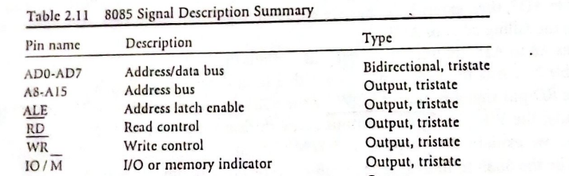

Mention some Pins in 8086 that have Tri-state Type ?

1. AD0-AD15 (Address/Data bus): These are the pins used for bi-directional communication between the microprocessor and memory or I/O devices.
2. DT/R (Data Transmit/Receive): This pin is used for transmitting or receiving data between the microprocessor and external devices.
3. DEN (Data Enable): This pin is used to enable or disable the Tri-state output of the DT/R pin.
4. HOLD (Hold Request): This pin is used for interrupting the microprocessor by external devices.
5. HLDA (Hold Acknowledge): This pin is used to acknowledge the HOLD request by external devices.

What does it mean that a pin in a microprocessor is a tri-state type ?

* When a pin in a microprocessor is a Tri-state type, it means that the pin can have three different states: logic high (1), logic low (0), or high-impedance (Z or floating).
* The pin can be placed in a high-impedance state, which means that it is effectively disconnected from the circuit and can float to any voltage level.
* It allows multiple devices to share a common bus without interfering with each other's signals.
* Tri-state type pins are commonly used in microprocessors to enable efficient communication between devices and to prevent conflicts between multiple signals that may try to drive the same output.

Suppose, there are multiple devices in a shared channel and produce output at the same time. Will there be any problem ?

* Yes

Suppose, there is a device in a shared channel and produces output and that received by multiple devices. Will there be any problem ?

* No

What's a Tri-state buffer ?

* A Tri-state buffer is a digital logic circuit that acts as a buffer between an input signal and an output signal. It allows the input signal to pass through to the output when the enable input is asserted (logic high), and it disconnects the output from the input when the enable input is de-asserted (logic low). In other words, the Tri-state buffer can drive the output signal onto a shared bus or other connected devices when it is enabled, and it can release the bus by entering high-impedance state when it is disabled.
* The Tri-state buffer is commonly used to enable or disable multiple devices connected to a shared bus without causing conflicts or interference. By using Tri-state buffers, each device can place its signal on the bus when it needs to transmit data and then release the bus when it's not transmitting, allowing other devices to take their turn. Tri-state buffers are also useful for preventing contention between multiple signals that may try to drive the same output.

What's Tri-state enable buffer/ Tri-state enable database ?

* When a diode/output pin has the ability to generate three state: 1,0 and Disconnected state, then we call it Tri-state enable buffer/ Tri-state enable Databus. When a pin is disconnected , it means the device is disconnected from circuit perspective.

What does tri state mean in an 8085 microprocessor?

* The 8085 microprocessor is a dual-state logic device, which means its output pins can be in one of two states: high or low. However, some pins of the 8085 microprocessor also have tri-state capabilities.

In the case of the 8085 microprocessor, the tristate means that the output pin of the device can be put in a third high-impedance state or "disconnected" state. In this state, the output pin is effectively disconnected from the bus and does not drive any sink or source currents into the data bus.

The tristate capability of the 8085 microprocessor is useful in situations where multiple devices share the same communication channel or bus. By using tri-state outputs, multiple devices can share the same bus without interference, allowing for efficient communication between the devices. The tristate feature is typically used in conjunction with external buffers to interface the microprocessor with other devices or systems.

DIAGRAM :

Show a circuit diagram where we can say there is a possibility of conflict among devices and that conflict can be solved using Tri-state Logic ?

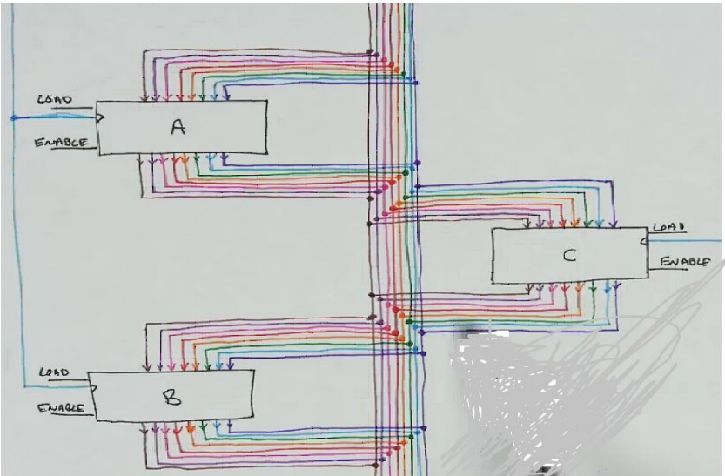

Explain using a circuit diagram the short-circuit and using dual state it is not possible to remove / prevent conflict ?

* In a shared channel or bus, such as a data bus, multiple devices can connect and share the same communication path. When one device transmits a signal (logic 1 or 0), it acts as a current source, and when another device receives the signal, it acts as a current sink.

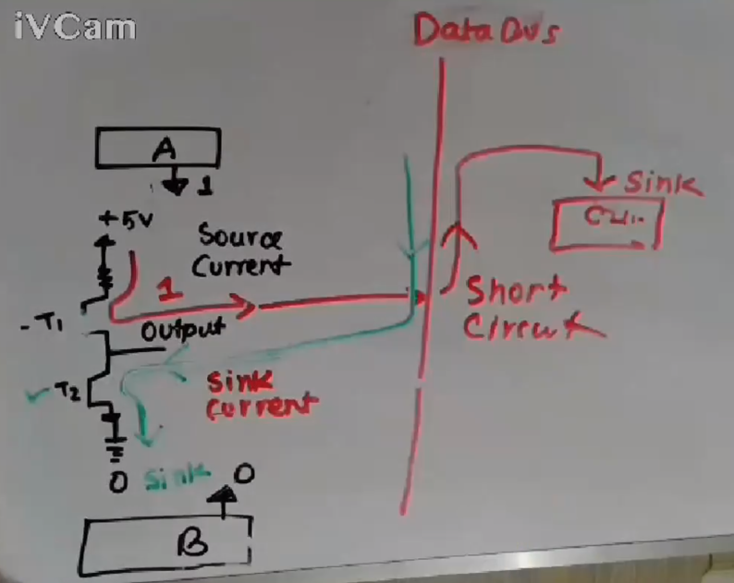

* In the scenario, device A is acting as a current source and device C is acting as a current sink. The output pins of the devices are typically connected to transistors. When a logical 1 is transmitted, the transistor is turned ON and allows current to flow from the device, acting as a current source.
* And when B is transmitting 0, some amount of voltage current enters the device B via the shared channel (data bus). So here we can see a short circuit is generated as in the shared channel because there is forward current as well as the reverse current.
* So regarding device B, it should be in a high-impedance state (Z-state) when it is not transmitting any signals. This means that the output pin of device B is effectively disconnected from the bus and does not drive any sink or source currents into the data bus.

In Tri-state logic, the third state is known as the high-impedance state or the "disconnected" state. When a device's output pin is in this state, it is effectively disconnected from the bus and does not drive any sink or source currents into the data bus. This allows multiple devices to share the same bus without interference and enables efficient communication between the devices.

Draw a circuit diagram or a diode or Tri-state buffer gate that can generate tri-state.And explain this Tri-state buffer how it works ?

* We have to keep a third input in the diode which is known as the control signal C
* Whatever the value is in the input and the value of the voltage +5V or 0V, if the enable = 0 , the circuit is open, and no current will be pass to outside
* It doesn’t enable the circuit and pass the output to the outside of the circuit

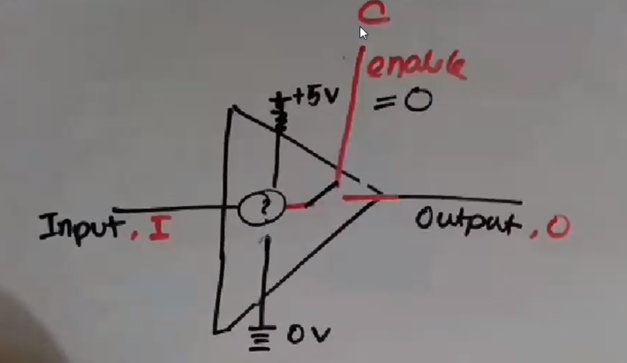

Fig : Tri-state buffer gate when enable = 0

* And in this case i.e. enable = 0 ; the output will be D (disconnected)

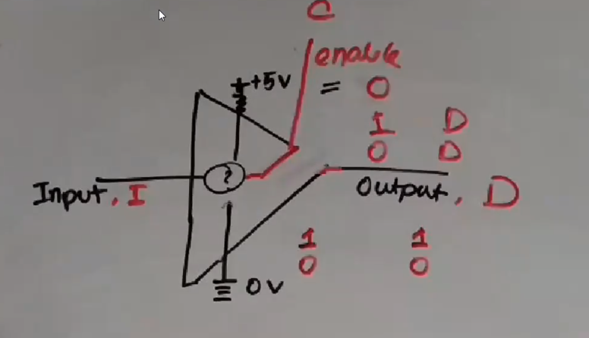

Fig : Tri-state buffer gate

* But when the enable = 1 , it means the circuit is closed and what the input is it will reflect to the output.
* If the input is I = 1, the output will be 1 and when its I = 0, the output will be 0

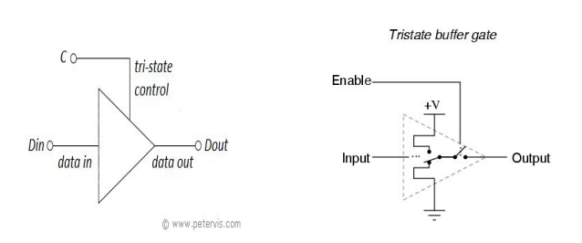

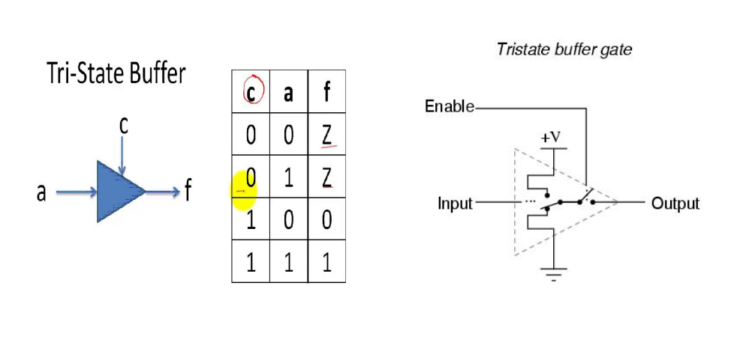

Fig : Tri-state buffer gate and truth table with the enable

* When a(input) = 1 and enable = 1, f (output) = 1 and a(input) = 0 and enable = 1, f (output) = 0
* When a(input) = 1 and enable = 0, f (output) = Z(high impedance) and a(input) = 0 and enable = 0, f (output) = Z(high impedance)

**Important Questions**

1. What is the purpose of a Tri State Buffer in microprocessor circuits? How does it work?

**Ans:** A Tri-State Buffer is a digital logic circuit that is commonly used in microprocessor circuits. Its purpose is to control the flow of data on a bus or a data line.

The term "tri-state" refers to the three possible output states that the buffer can have: high, low, or high impedance. When the buffer is in the high or low state, it behaves like a regular buffer, passing the input signal to the output. However, when it is in the high impedance state, the buffer effectively disconnects the output from the bus, allowing other devices to drive the bus without interference.

This feature is particularly useful in multi-master systems, where multiple devices share a common bus. In such systems, a device can place its output in high impedance mode when it is not actively driving the bus, allowing other devices to use the bus without interference. This can help avoid data collisions and improve system reliability.

In summary, the Tri-State Buffer is used to control the flow of data on a bus or data line in a microprocessor circuit. It can selectively allow data to pass through or isolate the output from the bus, depending on the state of its control input signal.

**DMA with Diagram**

THEORY :

WHAT IS DMA IN MICROPROCESSOR?

* Direct Memory Access (DMA) transfers the block of data between the memory and peripheral devices of the system, without the participation of the processor.
* The unit that controls the activity of accessing memory directly is called a DMA controller .The processor relinquishes the system bus for a few clock cycles. So, the DMA controller can accomplish the task of data transfer via the system bus.
* For example, a sound card may need to access data stored in the computer's RAM, but since it can process the data itself, it may use DMA to bypass the CPU. Video cards that support DMA can also access the system memory and process graphics without needing the CPU. Ultra DMA hard drives use DMA to transfer data faster than previous hard drives that required the data to first be run through the CPU. In order for devices to use direct memory access, they must be assigned to a DMA channel. Each type of port on a computer has a set of DMA channels that can be assigned to each connected device. For example, a PCI controller and a hard drive controller each have their own set of DMA channels.

What is DMA and Why is it used?

* Direct memory access (DMA) is a mode of data transfer between the memory and I/O devices. This happens without the involvement of the processor. We have two other methods of data transfer, programmed I/O and Interrupt driven I/O. Let’s revise each and get acknowledge with their drawbacks. In programmed I/O, the processor keeps on scanning whether any device is ready for data transfer. If an I/O device is ready, the processor fully dedicates itself in transferring the data between I/O and memory. It transfers data at a high rate, but it can’t get involved in any other activity during data transfer. This is the major drawback of programmed I/O. In Interrupt driven I/O, whenever the device is ready for data transfer, then it raises an interrupt to processor. Processor completes executing its ongoing instruction and saves its current state. It then switches to data transfer which causes a delay. Here, the processor doesn’t keep scanning for peripherals ready for data transfer. But, it is fully involved in the data transfer process. So, it is also not an effective way of data transfer. The above two modes of data transfer are not useful for transferring a large block of data. But, the DMA controller completes this task at a faster rate and is also effective for transfer of large data block.
* The DMA controller transfers the data in three modes:

1. Burst Mode: Here, once the DMA controller gains the charge of the system bus, then it releases the system bus only after completion of data transfer. Till then the CPU has to wait for the system buses.

2. Cycle Stealing Mode: In this mode, the DMA controller forces the CPU to stop its operation and relinquish control over the bus for a short term to the DMA controller. After the transfer of every byte, the DMA controller releases the bus and then again requests for the system bus. In this way, the DMA controller steals the clock cycle for transferring every byte.

3. Transparent Mode: Here, the DMA controller takes the charge of system bus only if the processor does not require the system bus

* Direct Memory Access Advantages and Disadvantages
  + Advantages:
    - 1. Transferring the data without the involvement of the processor will speed up the read-write task.
    - 2. DMA reduces the clock cycle required to read or write a block of data.
    - 3. Implementing DMA also reduces the overhead of the processor.
  + Disadvantages
    - 1. As it is a hardware unit, it would cost to implement a DMA controller in the system.
    - 2. Cache coherence problems can occur while using a DMA controller.
* Key Takeaways :
  + DMA is an abbreviation of direct memory access.
  + DMA is a method of data transfer between main memory and peripheral devices. The hardware unit that controls the DMA transfer is a DMA controller.
  + DMA controller transfers the data to and from memory without the participation of the processor.
  + The processor provides the start address and the word count of the data block which is transferred to or from memory to the DMA controller and frees the bus for DMA controller to transfer the block of data.DMA controller transfers the data block at the faster rate as data is directly accessed by I/O devices and is not required to pass through the processor which save the clock cycles.
  + The DMA controller transfers the block of data to and from memory in three modes: burst mode, cycle steal mode and transparent mode.
  + DMA can be configured in various ways; it can be a part of individual I/O devices, or all the peripherals attached to the system may share the same DMA controller.

Thus the DMA controller is a convenient mode of data transfer. It is preferred over the programmed I/O and Interrupt-driven I/O mode of data transfer.

**How does DMA work ?**

* The diagram of DMA controller that explains its working:

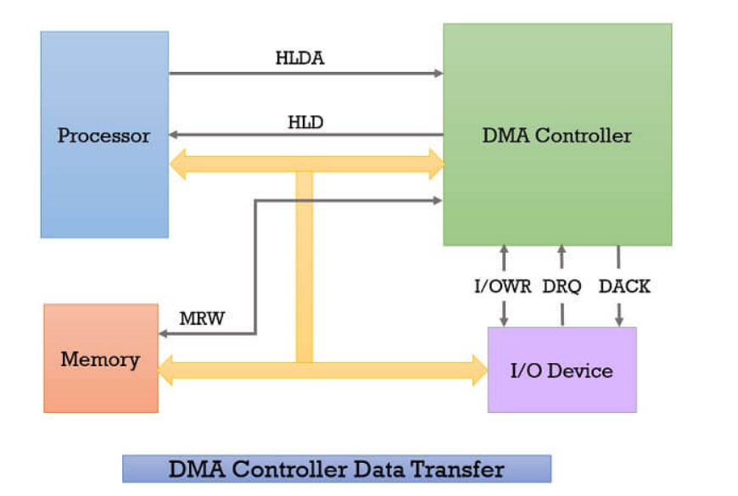

Whenever an I/O device wants to transfer the data to or from memory, it sends the DMA request (DRQ) to the DMA controller. The DMA controller accepts this DRQ and asks the CPU to hold for a few clock cycles by sending it the Hold request (HLD). 2. CPU receives the Hold request (HLD) from DMA controller and relinquishes the bus and sends the Hold acknowledgement (HLDA) to DMA controller. 3. After receiving the Hold acknowledgement (HLDA), DMA controller acknowledges I/O device (DACK) that the data transfer can be performed and DMA controller takes the charge of the system bus and transfers the data to or from memory. 4. When the data transfer is accomplished, the DMA raises an interrupt to let the processor know that the task of data transfer is finished and the processor can take control over the bus again and start processing where it has left. Now the DMA controller can be a separate unit that is shared by various I/O devices, or it can also be a part of the I/O device interface.

**Explain DMA block diagram ?**

* 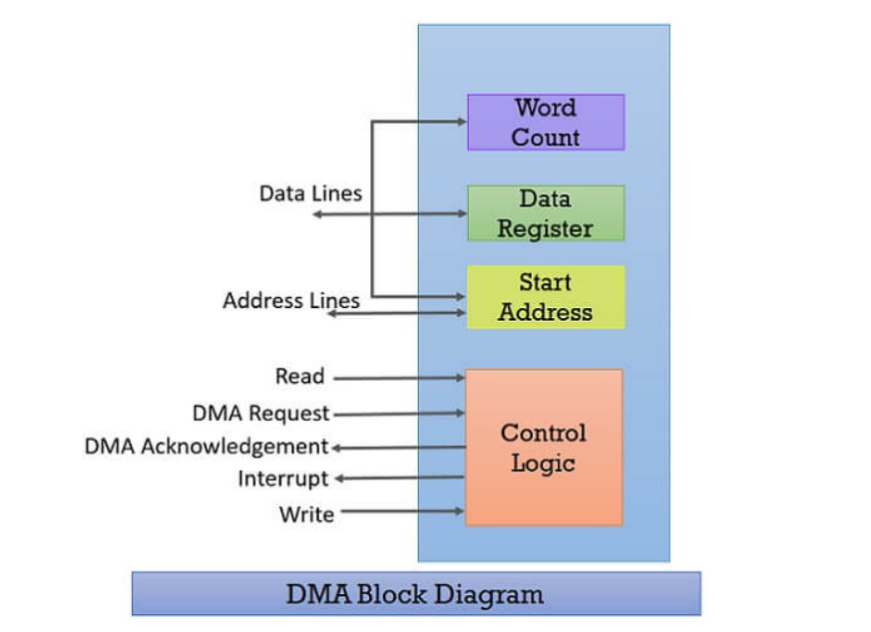

Whenever a processor is requested to read or write a block of data, i.e. transfer a block of data, it instructs the DMA controller by sending the following information.

1. The first information is whether the data has to be read from memory or the data has to be written to the memory. It passes this information via read or write control lines that is between the processor and DMA controllers control logic unit.

2. The processor also provides the starting address of/ for the data block in the memory, from where the data block in memory has to be read or where the data block has to be written in memory. DMA controller stores this in its address register. It is also called the starting address register.

3. The processor also sends the word count, i.e. how many words are to be read or written. It stores this information in the data count or the word count register. 4. The most important is the address of the I/O device that wants to read or write data. This information is stored in the data register.

WHAT'S DMA CONTROLLER AND ITS USE?

* A DMA controller is a specialized hardware device that manages data transfer between I/O devices and memory in a computer system. It contains several channels that can manage multiple DMA operations simultaneously, with each channel assigned to a specific I/O device. The DMA controller works by controlling the flow of data between the device and memory, freeing up the CPU to perform other tasks. It can handle interrupts and signal the CPU when a transfer is complete. DMA controllers are used in applications such as disk I/O, network communications, and multimedia processing to improve the performance of data transfer operations and achieve high data transfer rates.

WHATS USE OF DATA BUFFER IN DMAC?

* A data buffer is a temporary storage area used in a DMA controller (DMAC) to optimize data transfer between I/O devices and memory. The use of data buffers ensures efficient use of system resources, improves system performance, reduces the risk of data loss, and is compatible with different I/O devices. Data buffers allow the DMAC to transfer data in small blocks, which reduces the load on the system and ensures efficient data transfer. They also enable parallel data transfer operations, freeing up the CPU to perform other tasks. Overall, data buffers are essential for optimizing data transfer operations and improving system performance in modern computer systems.

DIAGRAM :

WITHOUT DMA -

* Without DMA it’s a issue that I/O device and memory speed in case of communication like - read, write operations are slow down
* But with the help of DMA the I/O device can communicate with memory in fast mode without microprocessor’s involvement

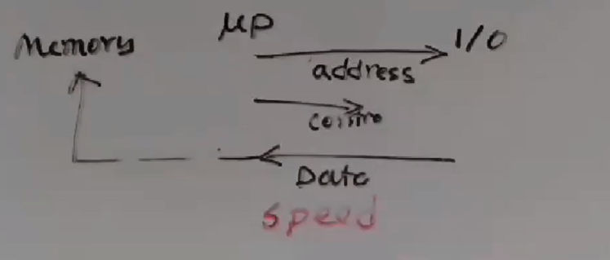

WITH DMAC (DMA CONTROLLER) :

* DMAC requests a microprocessor for the system bus(address, controller, data bus) so that it can make the communication of memory with the peripheral or I/O devices by transferring data via system bus.
* But it still remains slow in operation as the system bus may remain busy while serving the microprocessor, so DMAC has to wait for a long time for the available of the system bus.

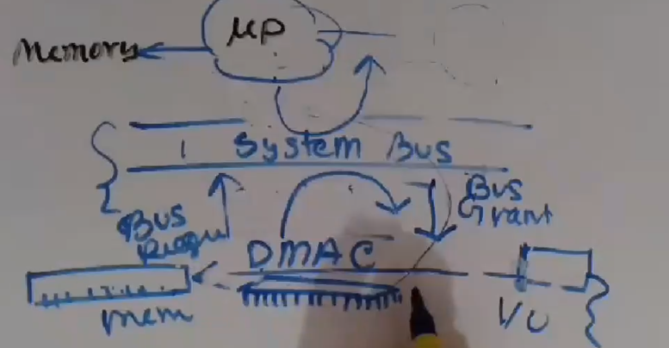

WITH DMAC AND DATA BUFFER

* DATA BUFFER solves the above problem, while it stores the data to be read from the I/O device in its buffer and sets a count.
* When the system bus becomes available, the data buffer releases its data and the system bus passes this data to memory. It continues its job until the count of data stored in DATA BUFFER becomes zero.
* After that, the system bus again became available for the microprocessor.

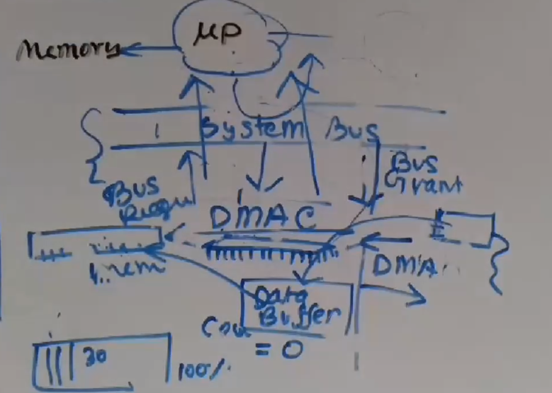

**Instruction Sets (NEXT PAGE)**

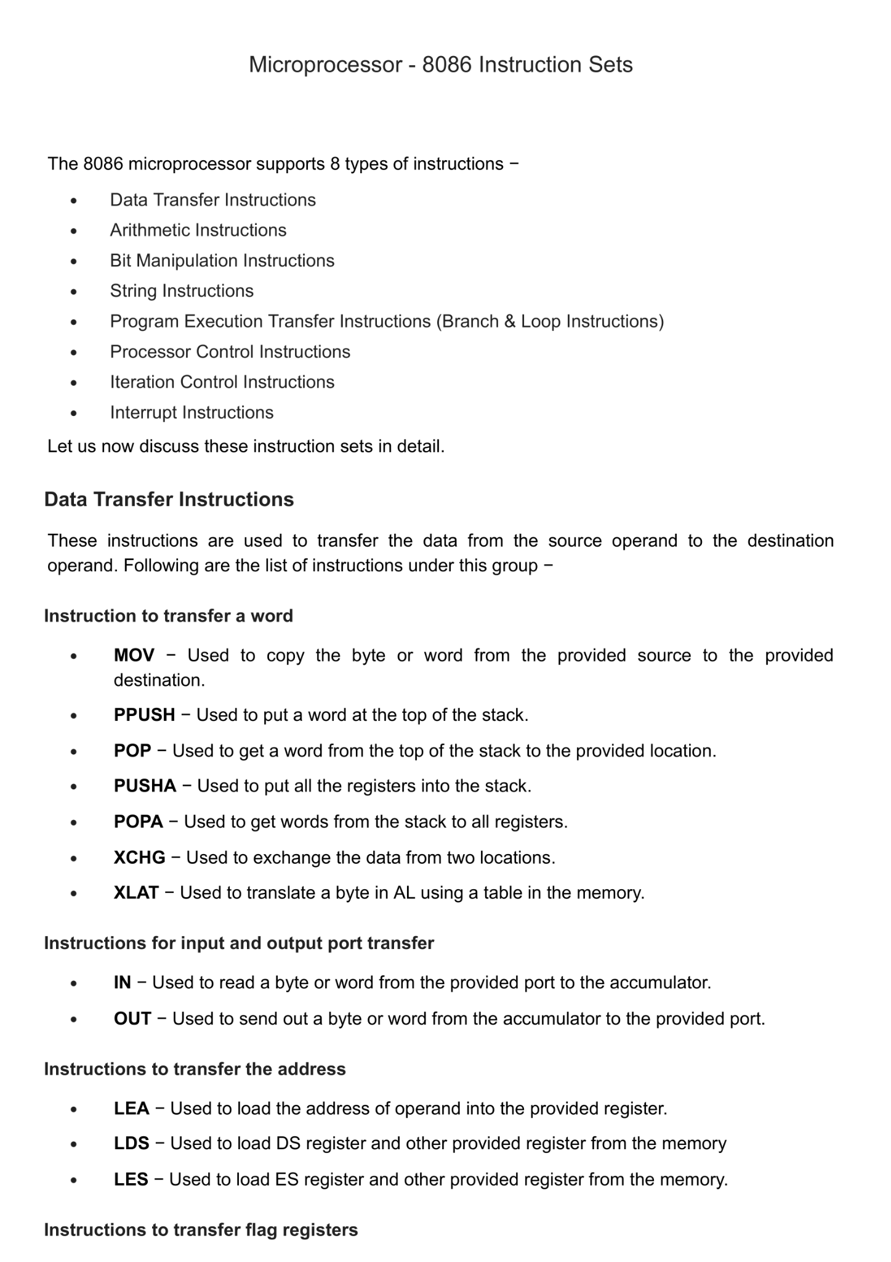

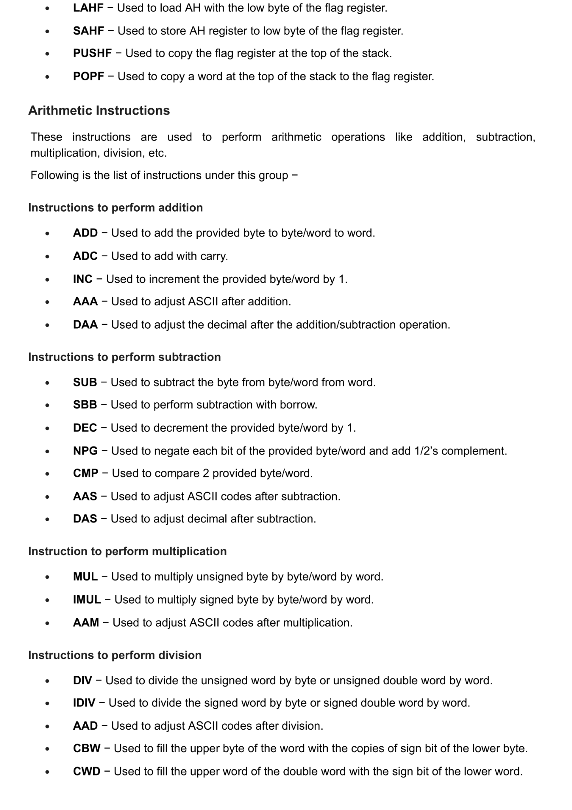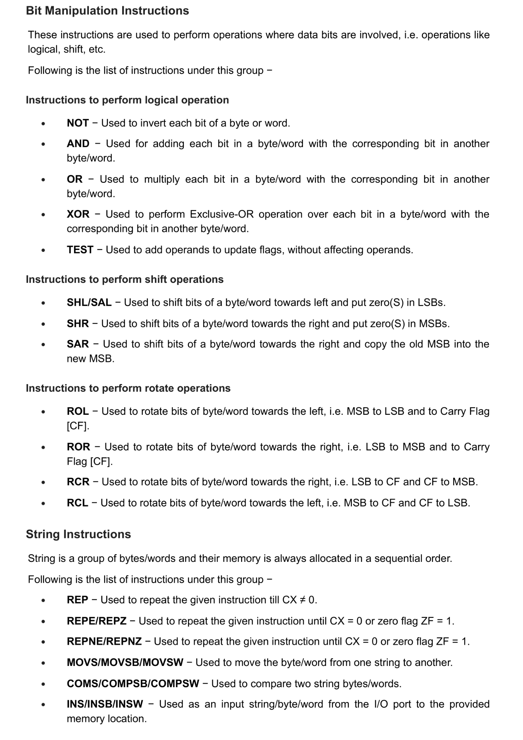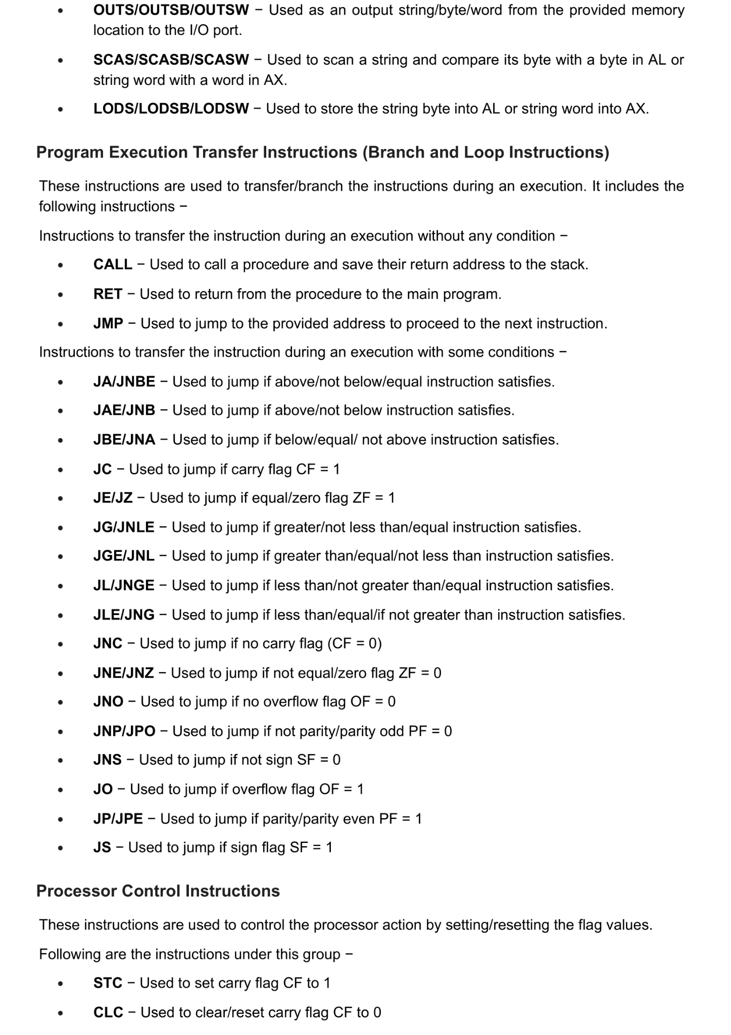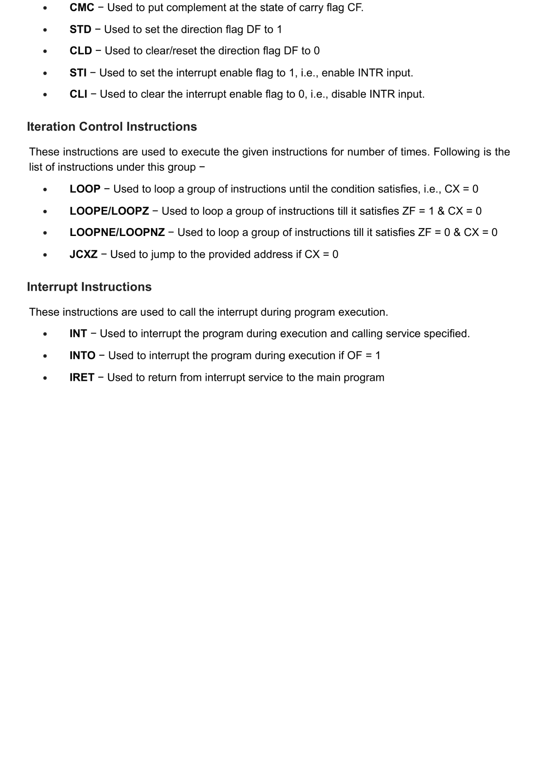

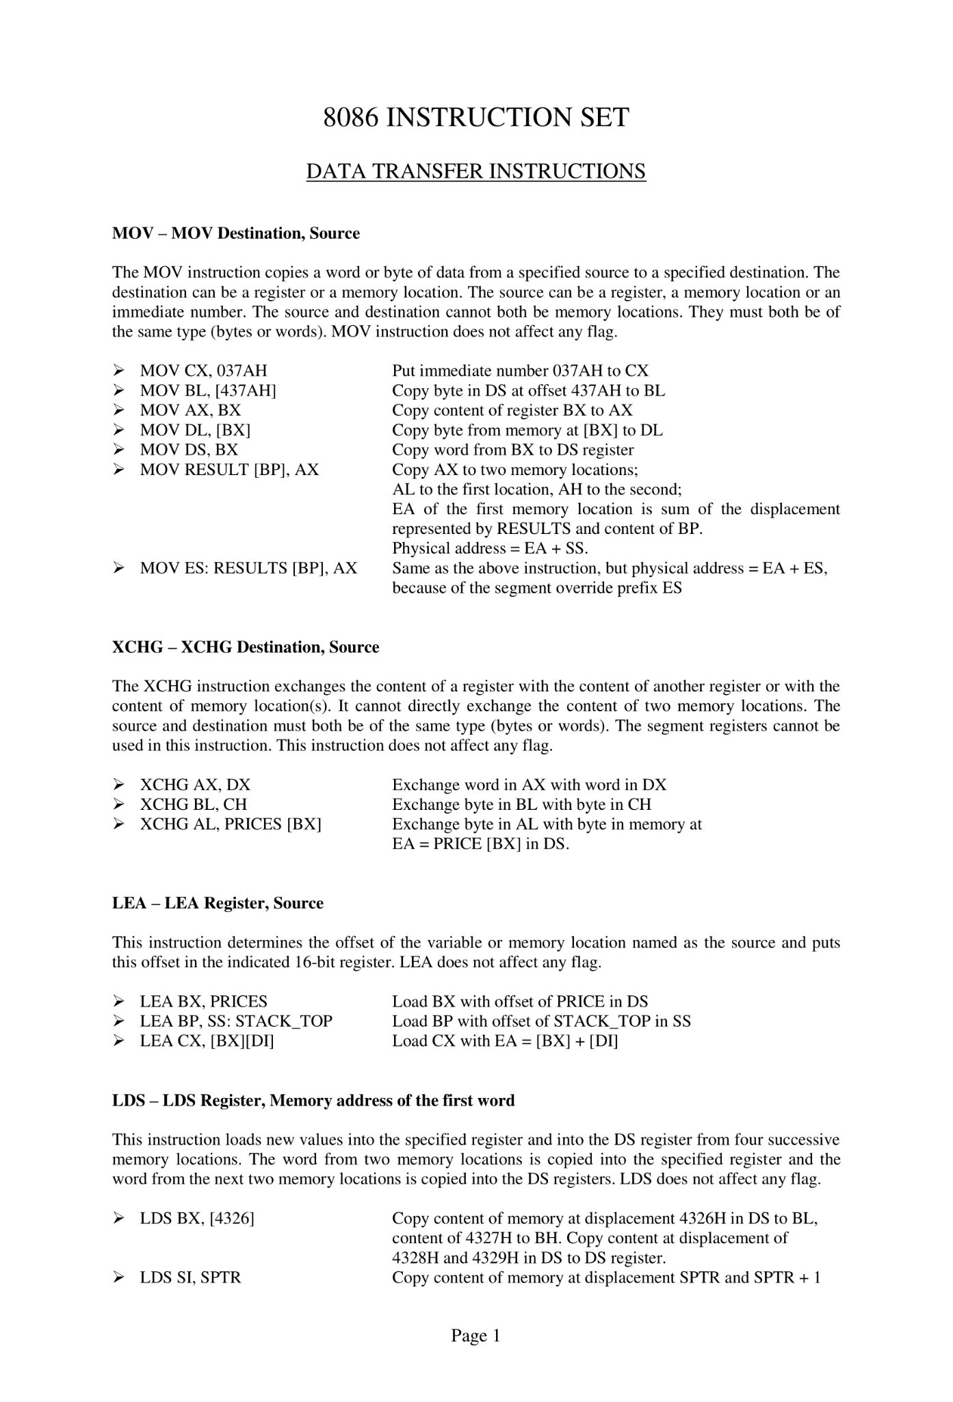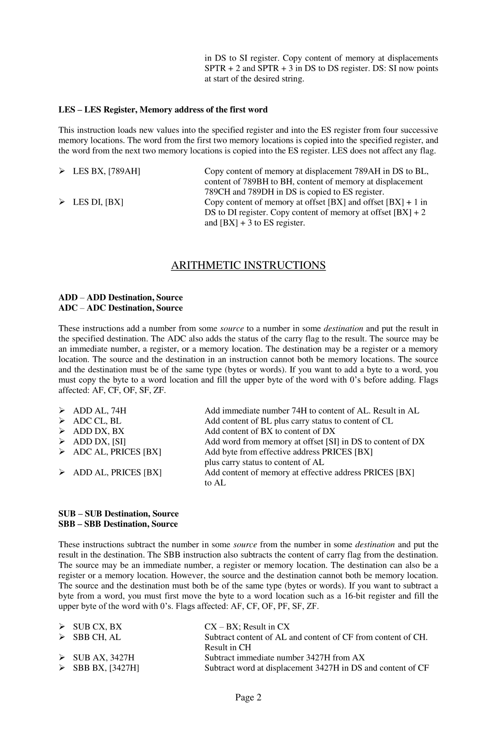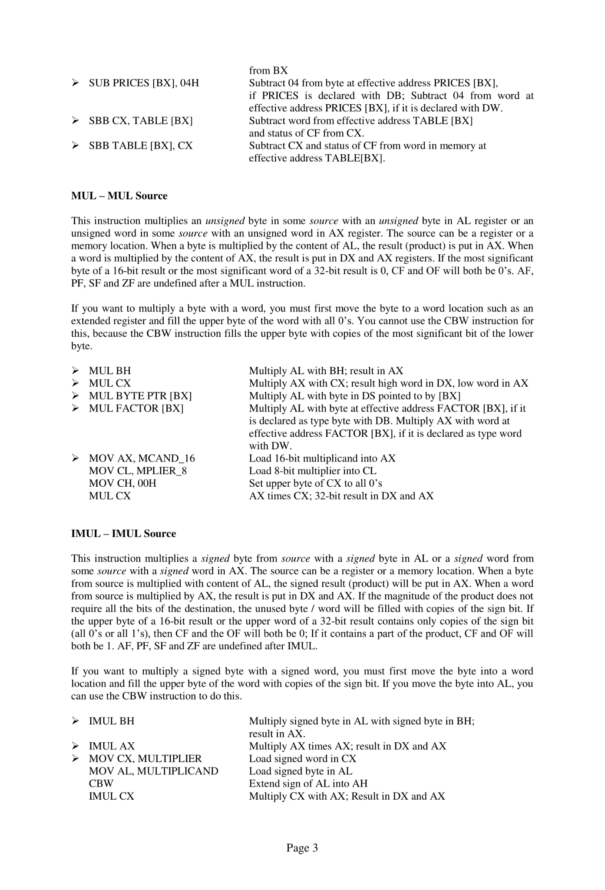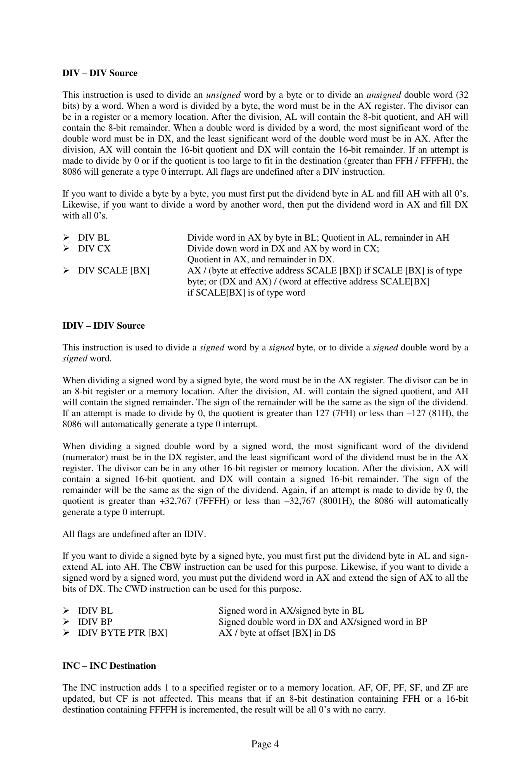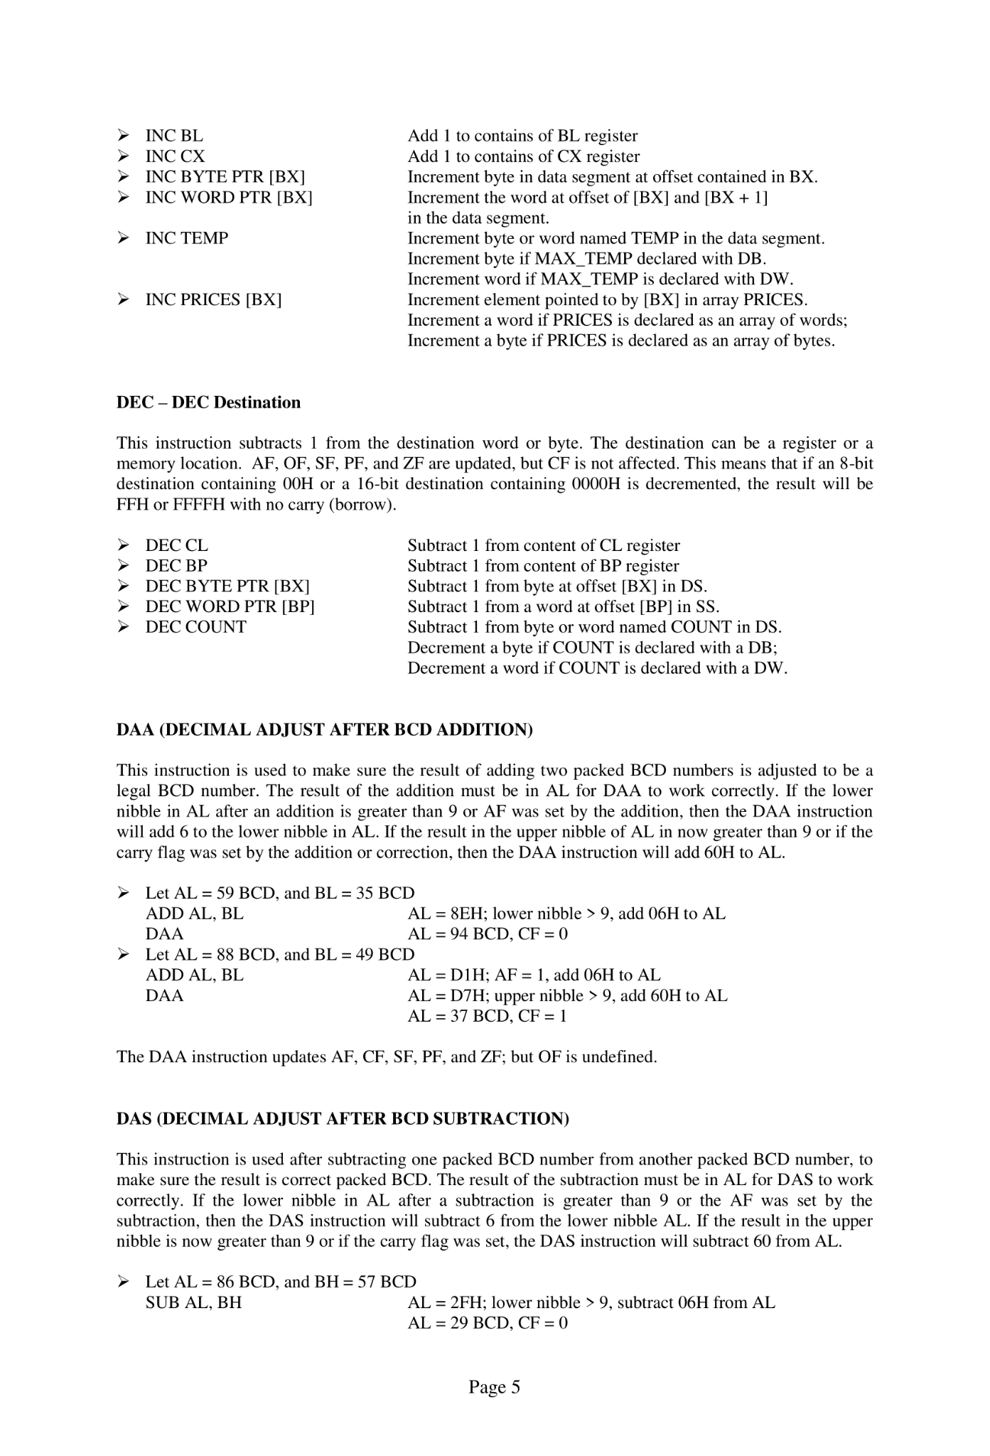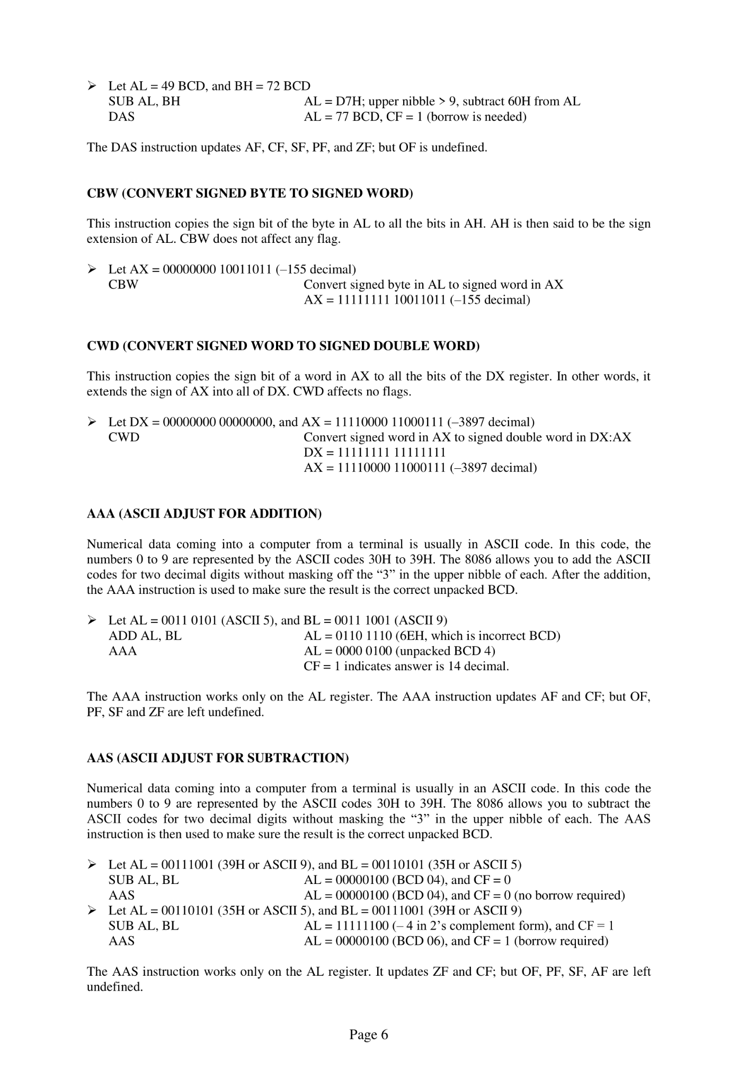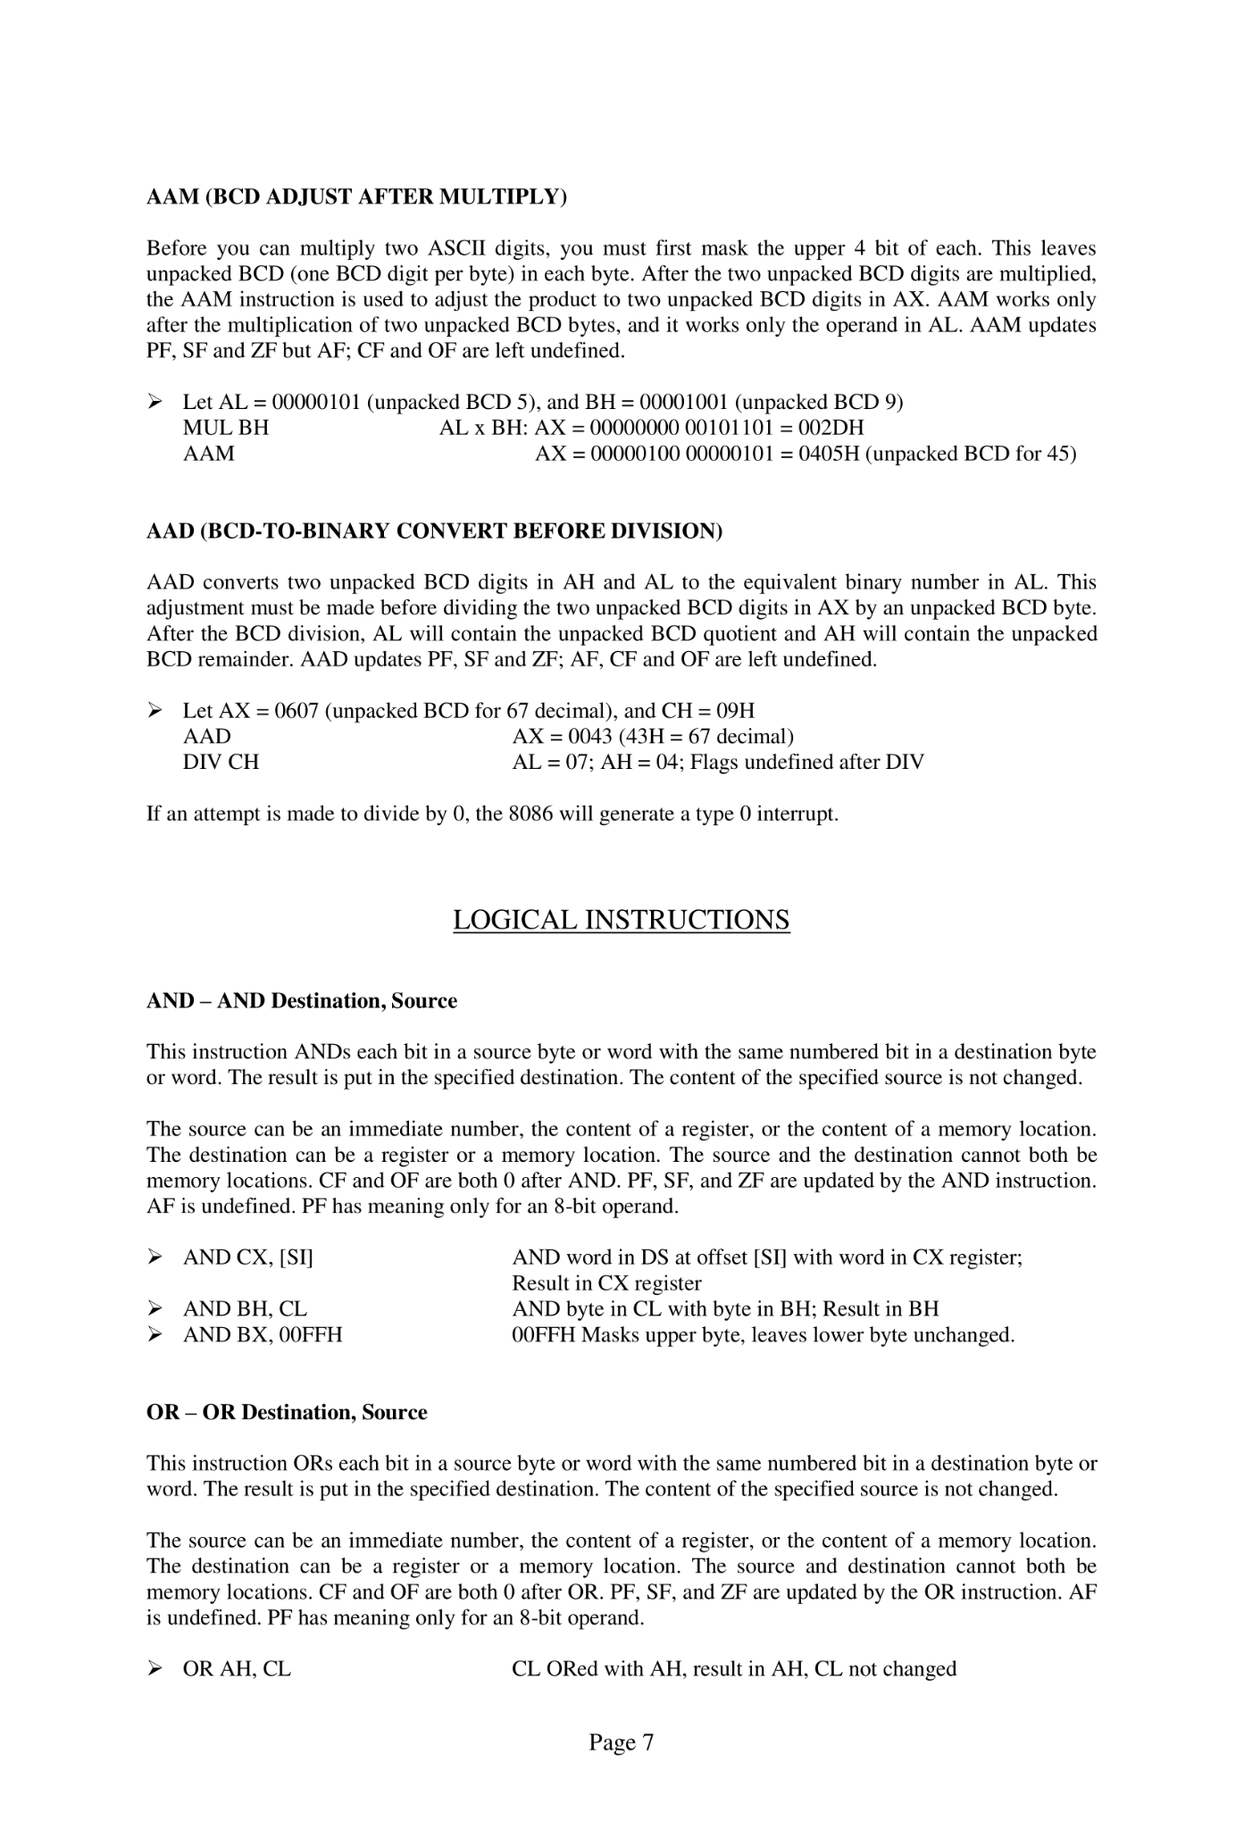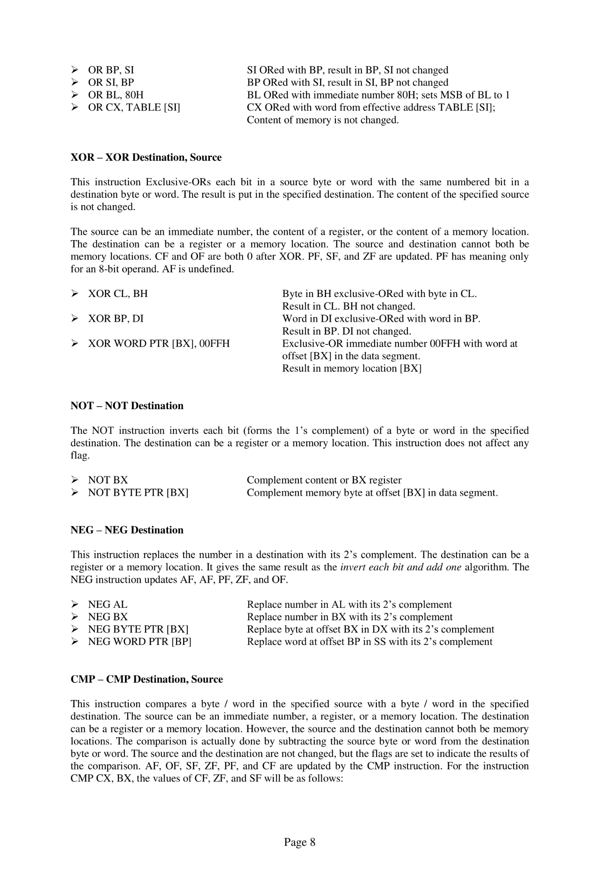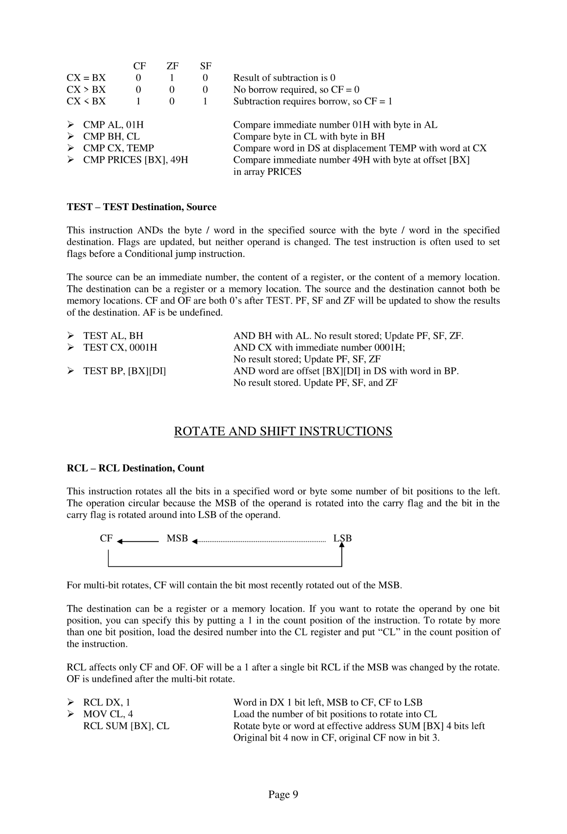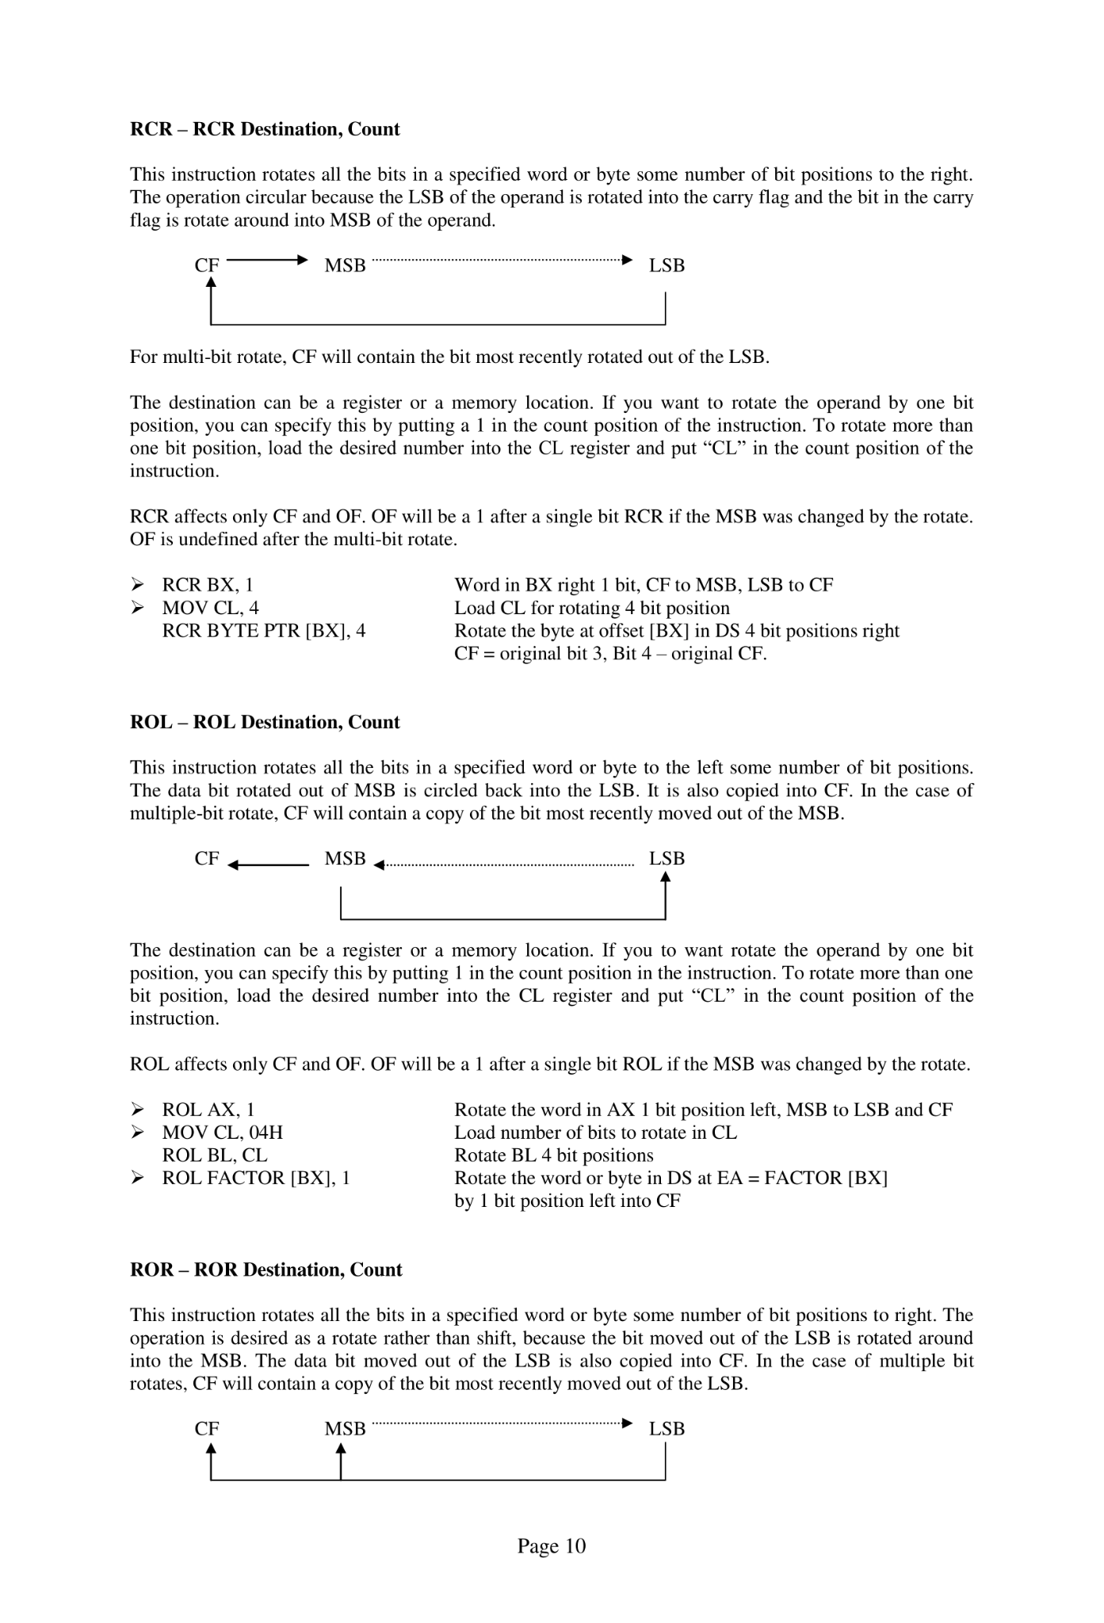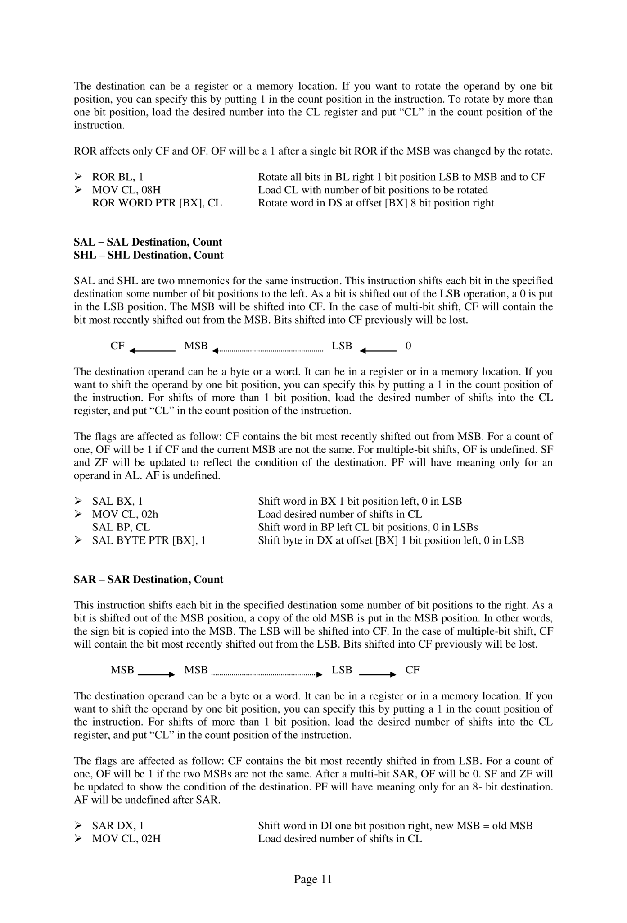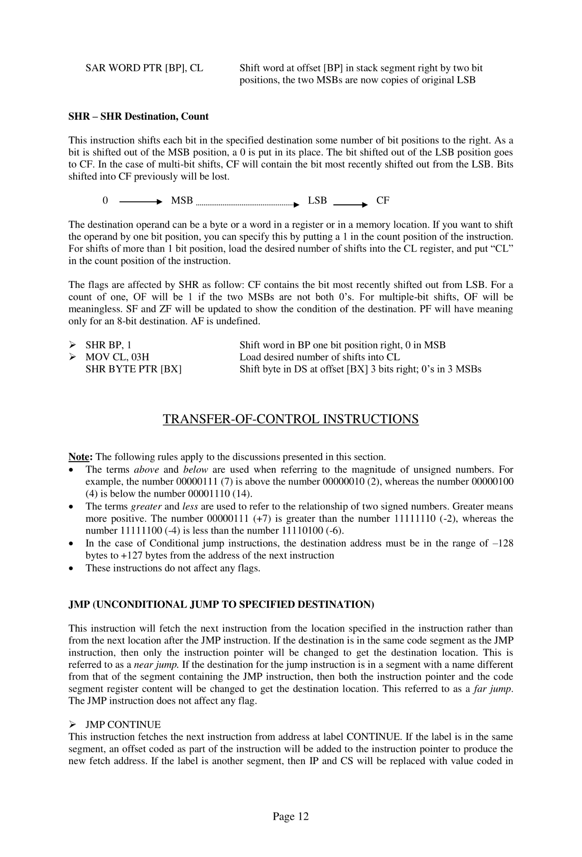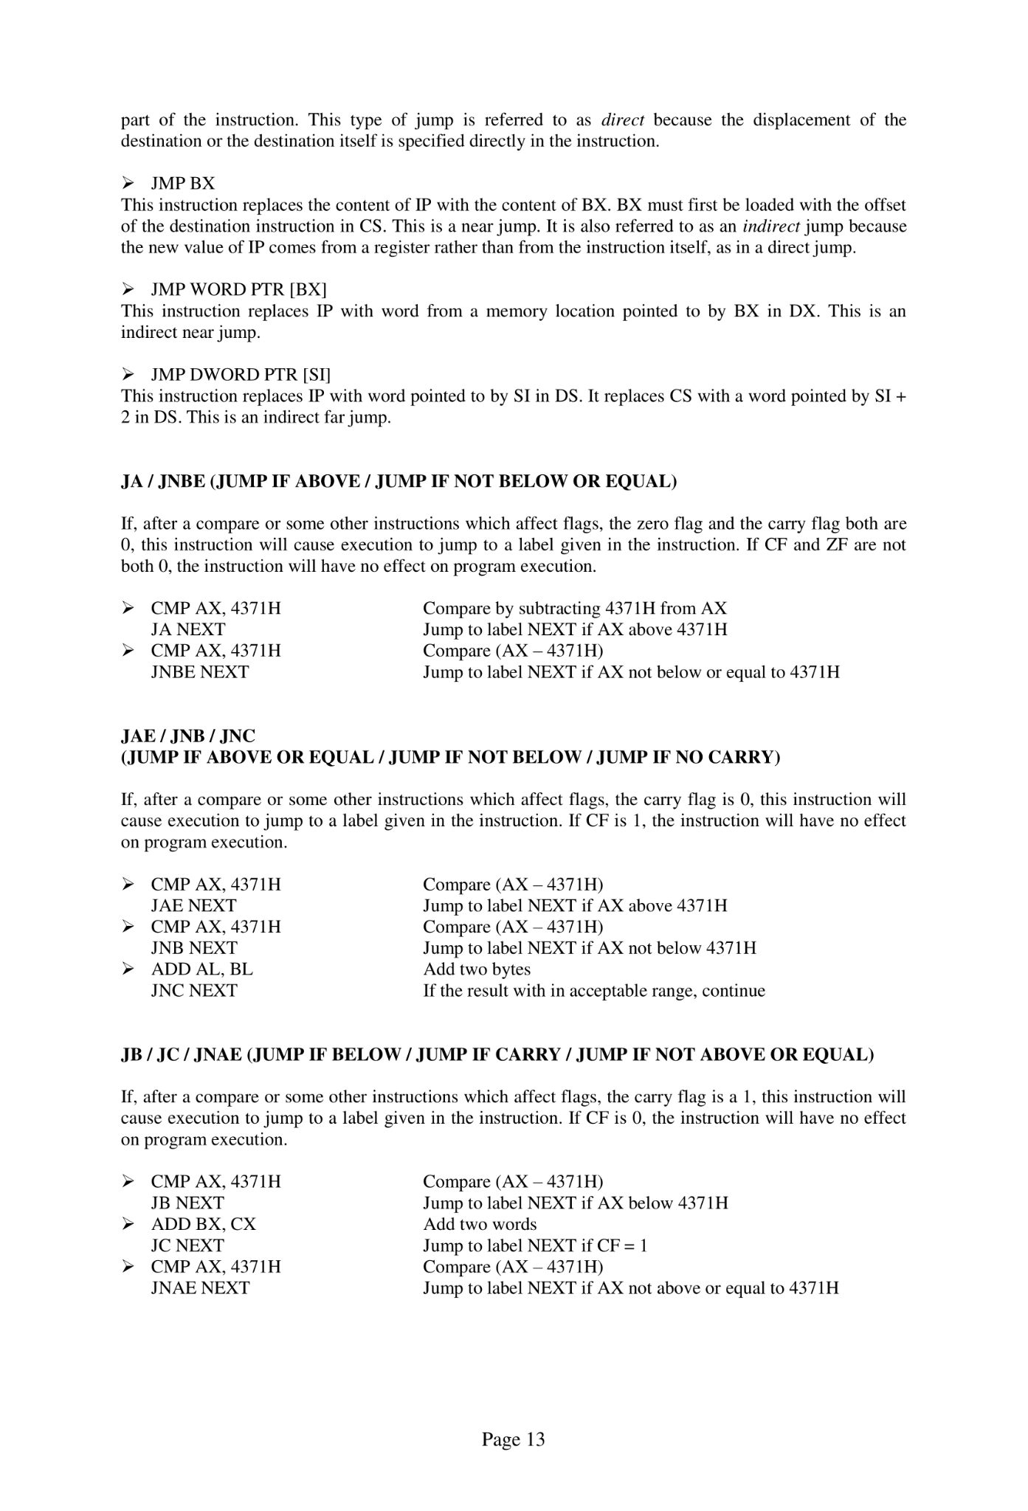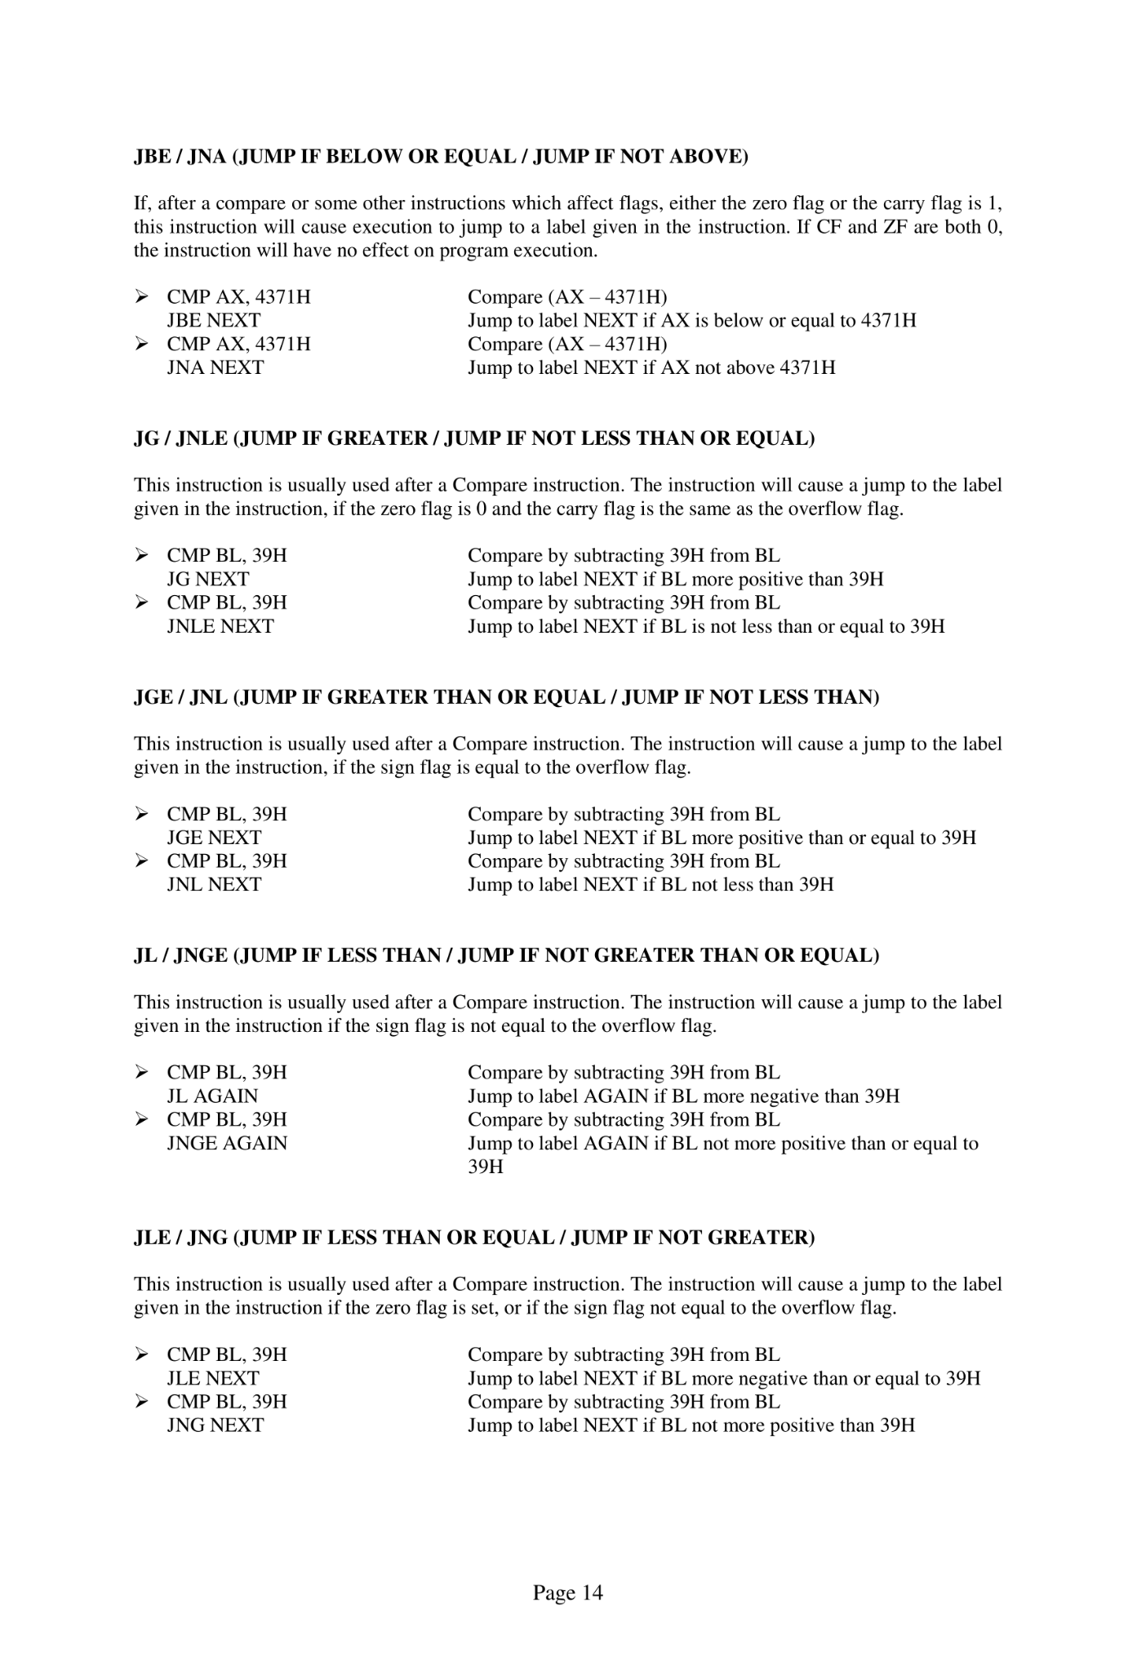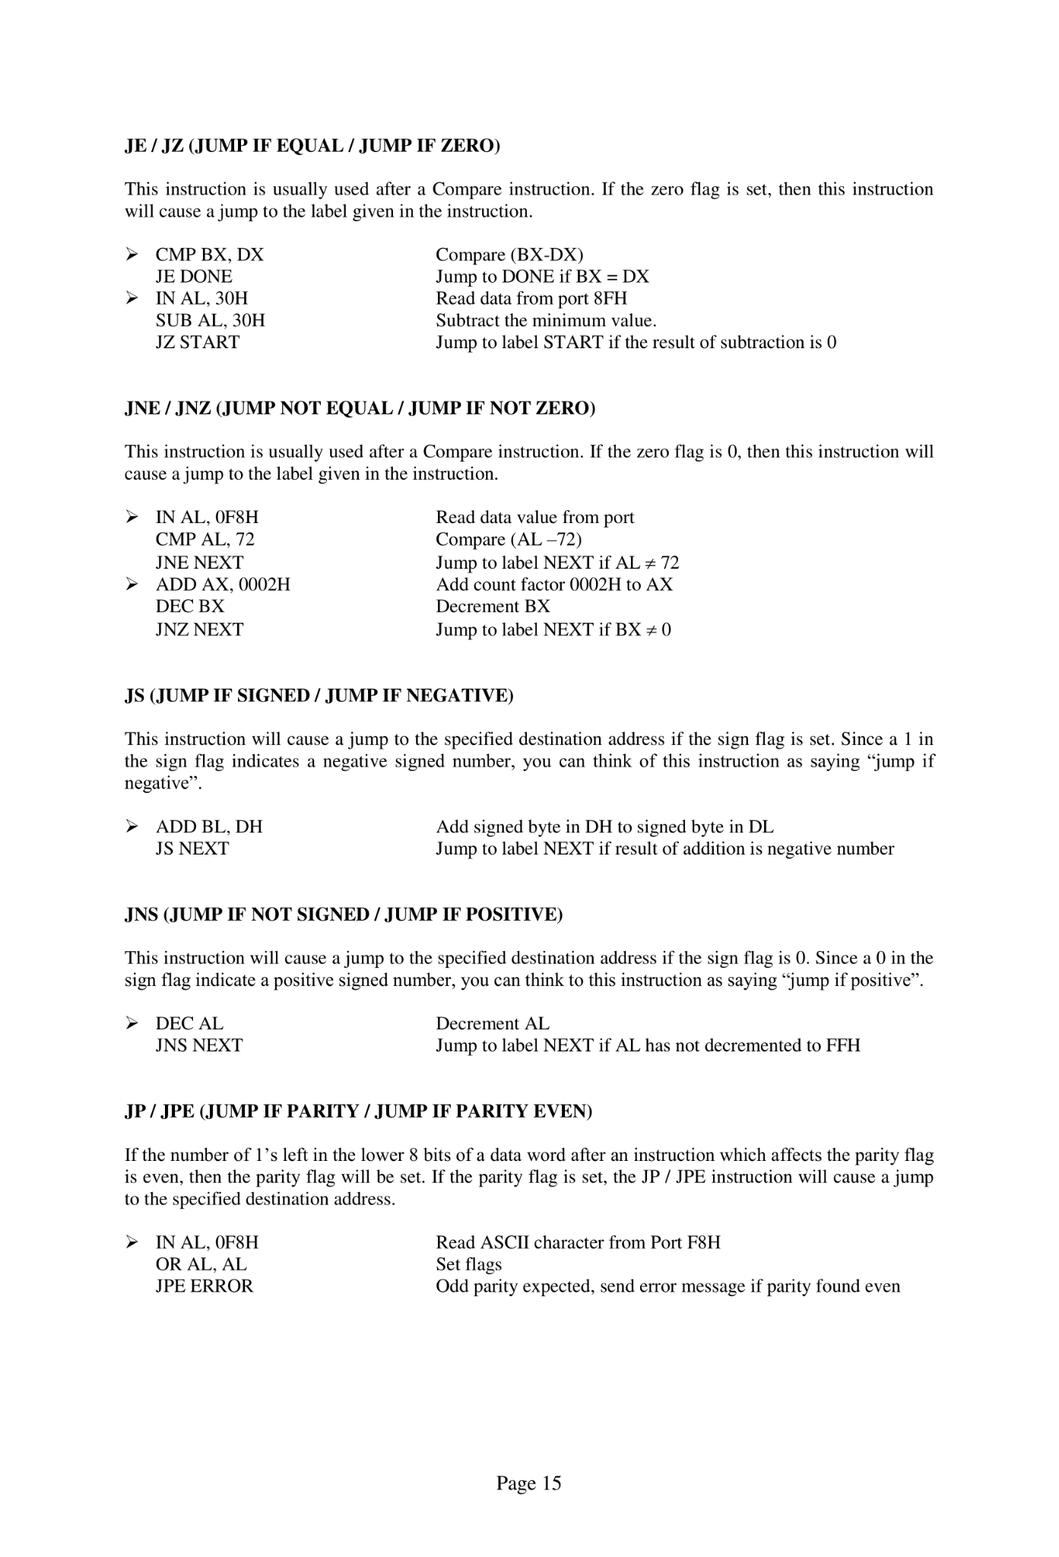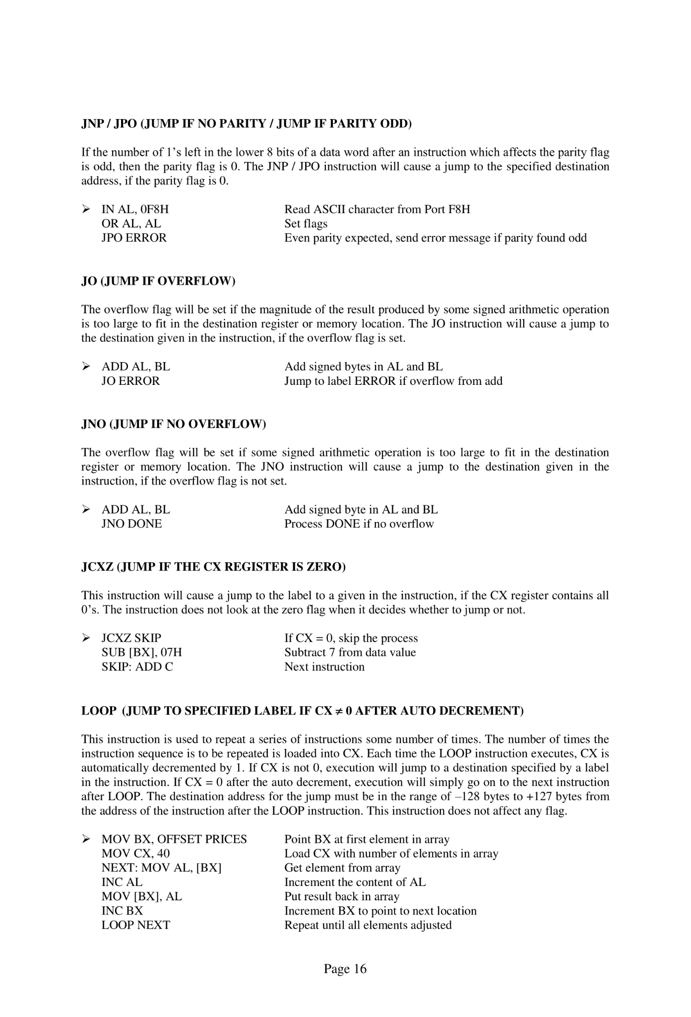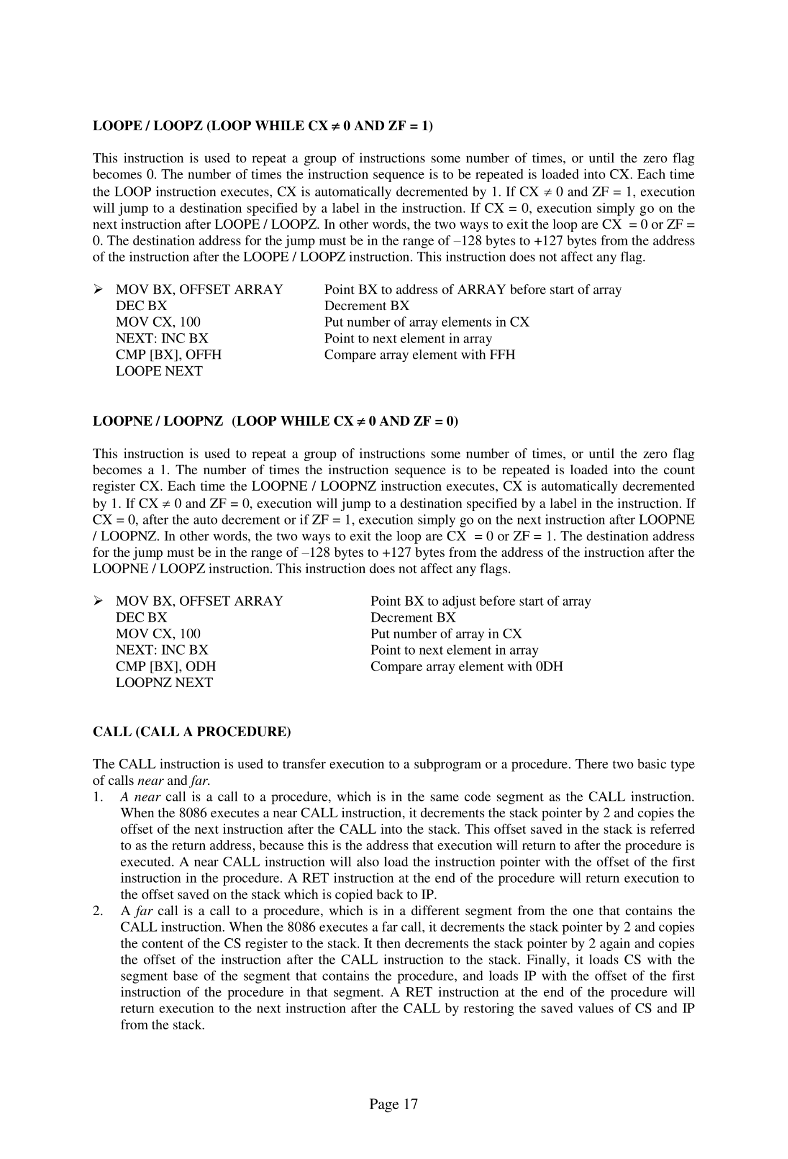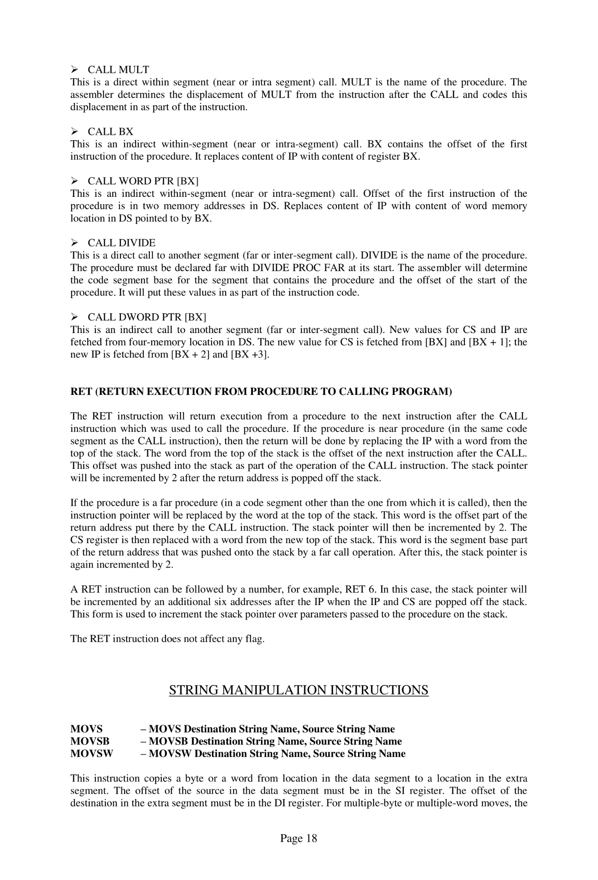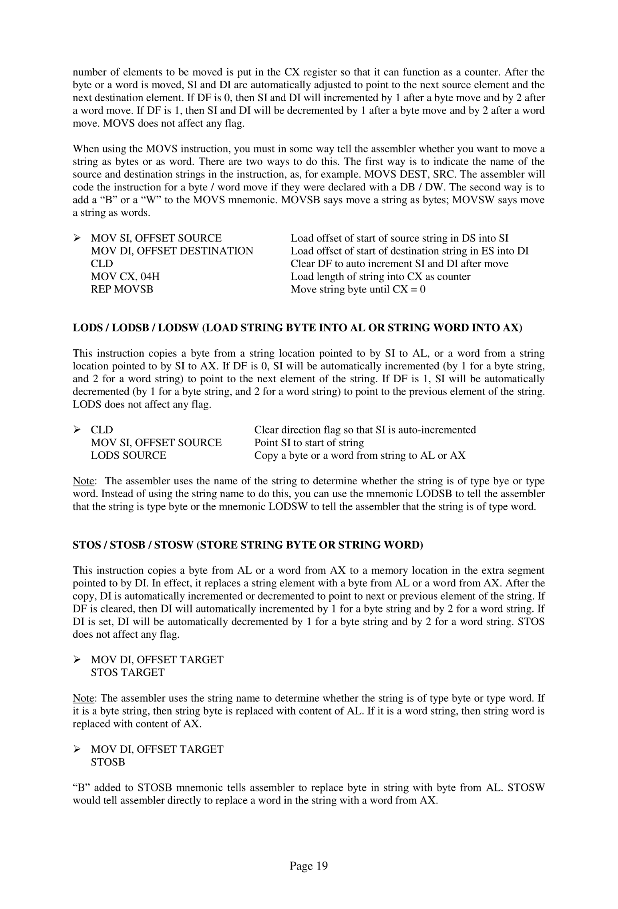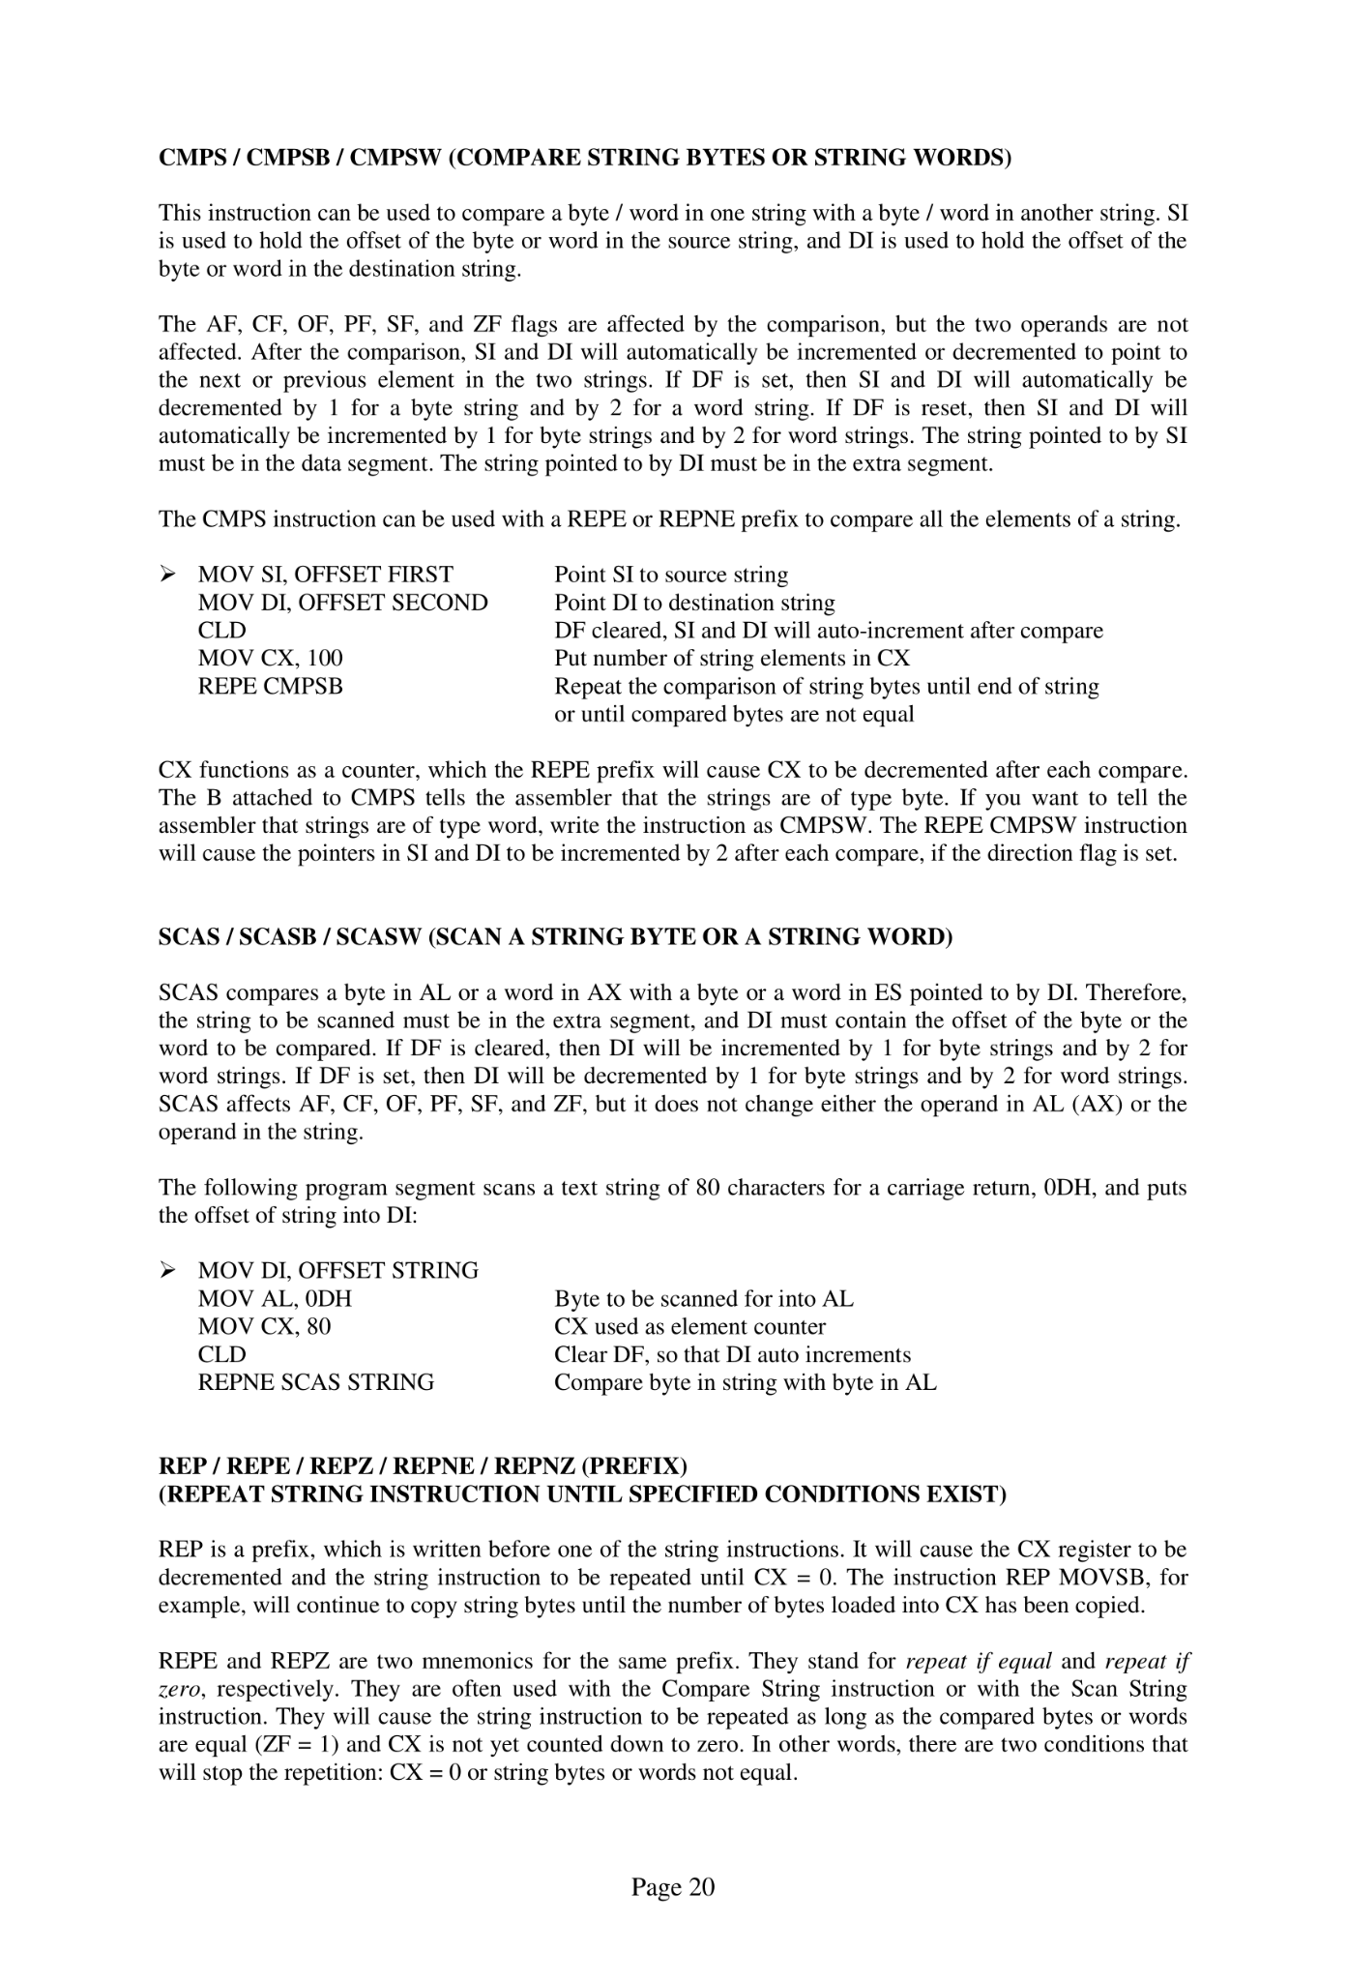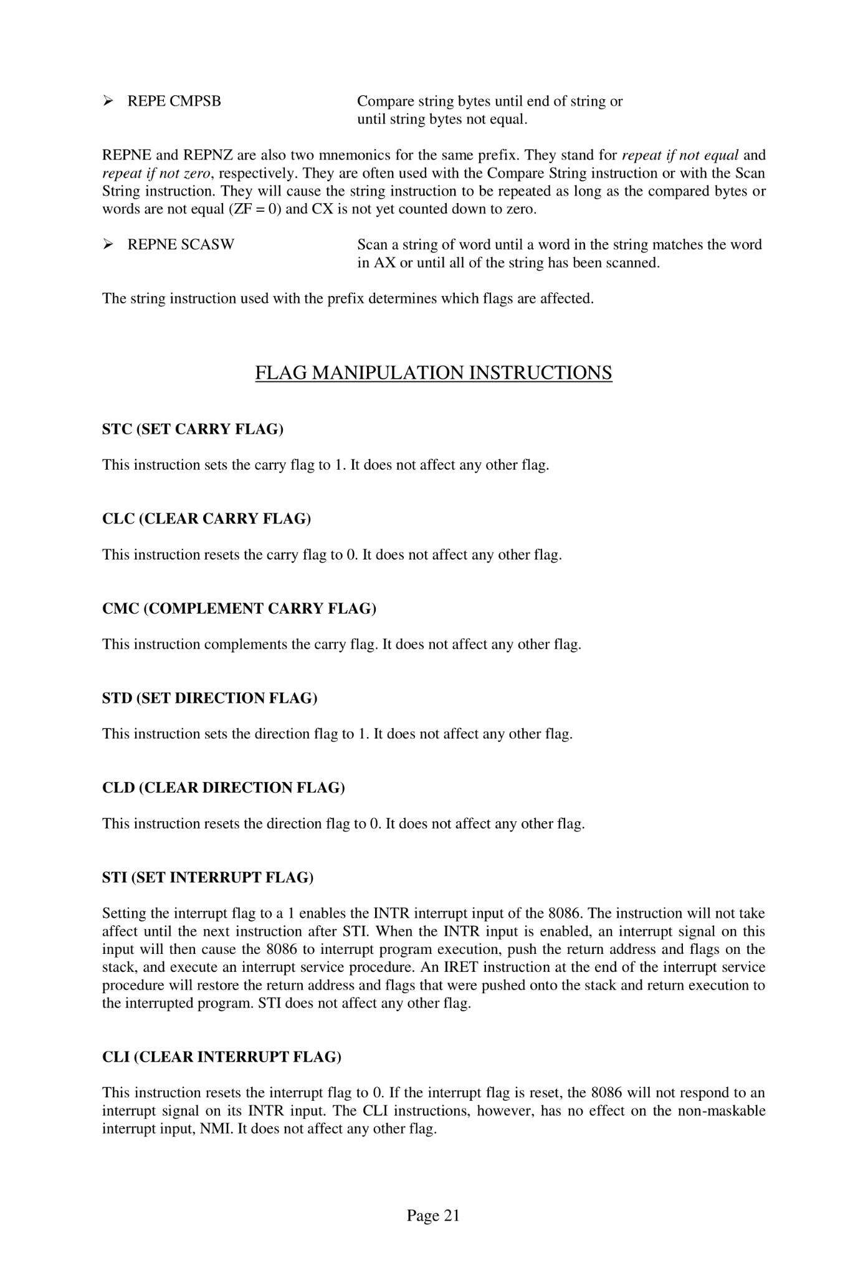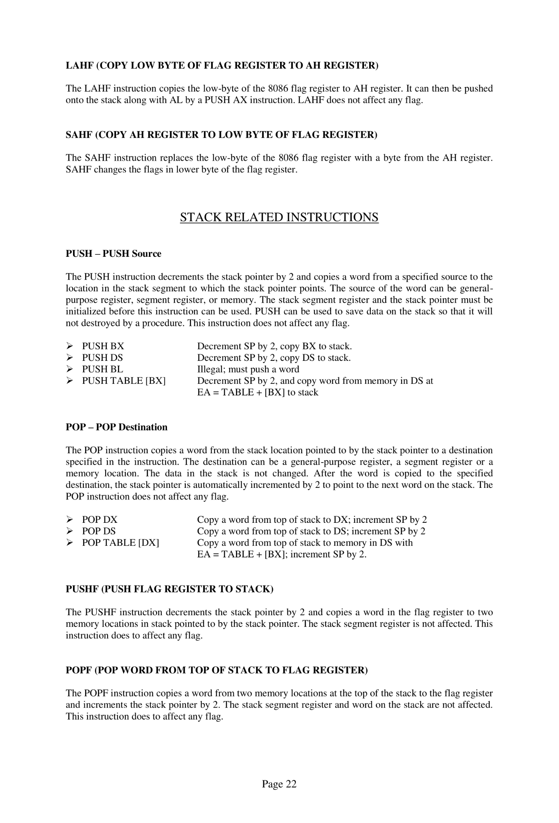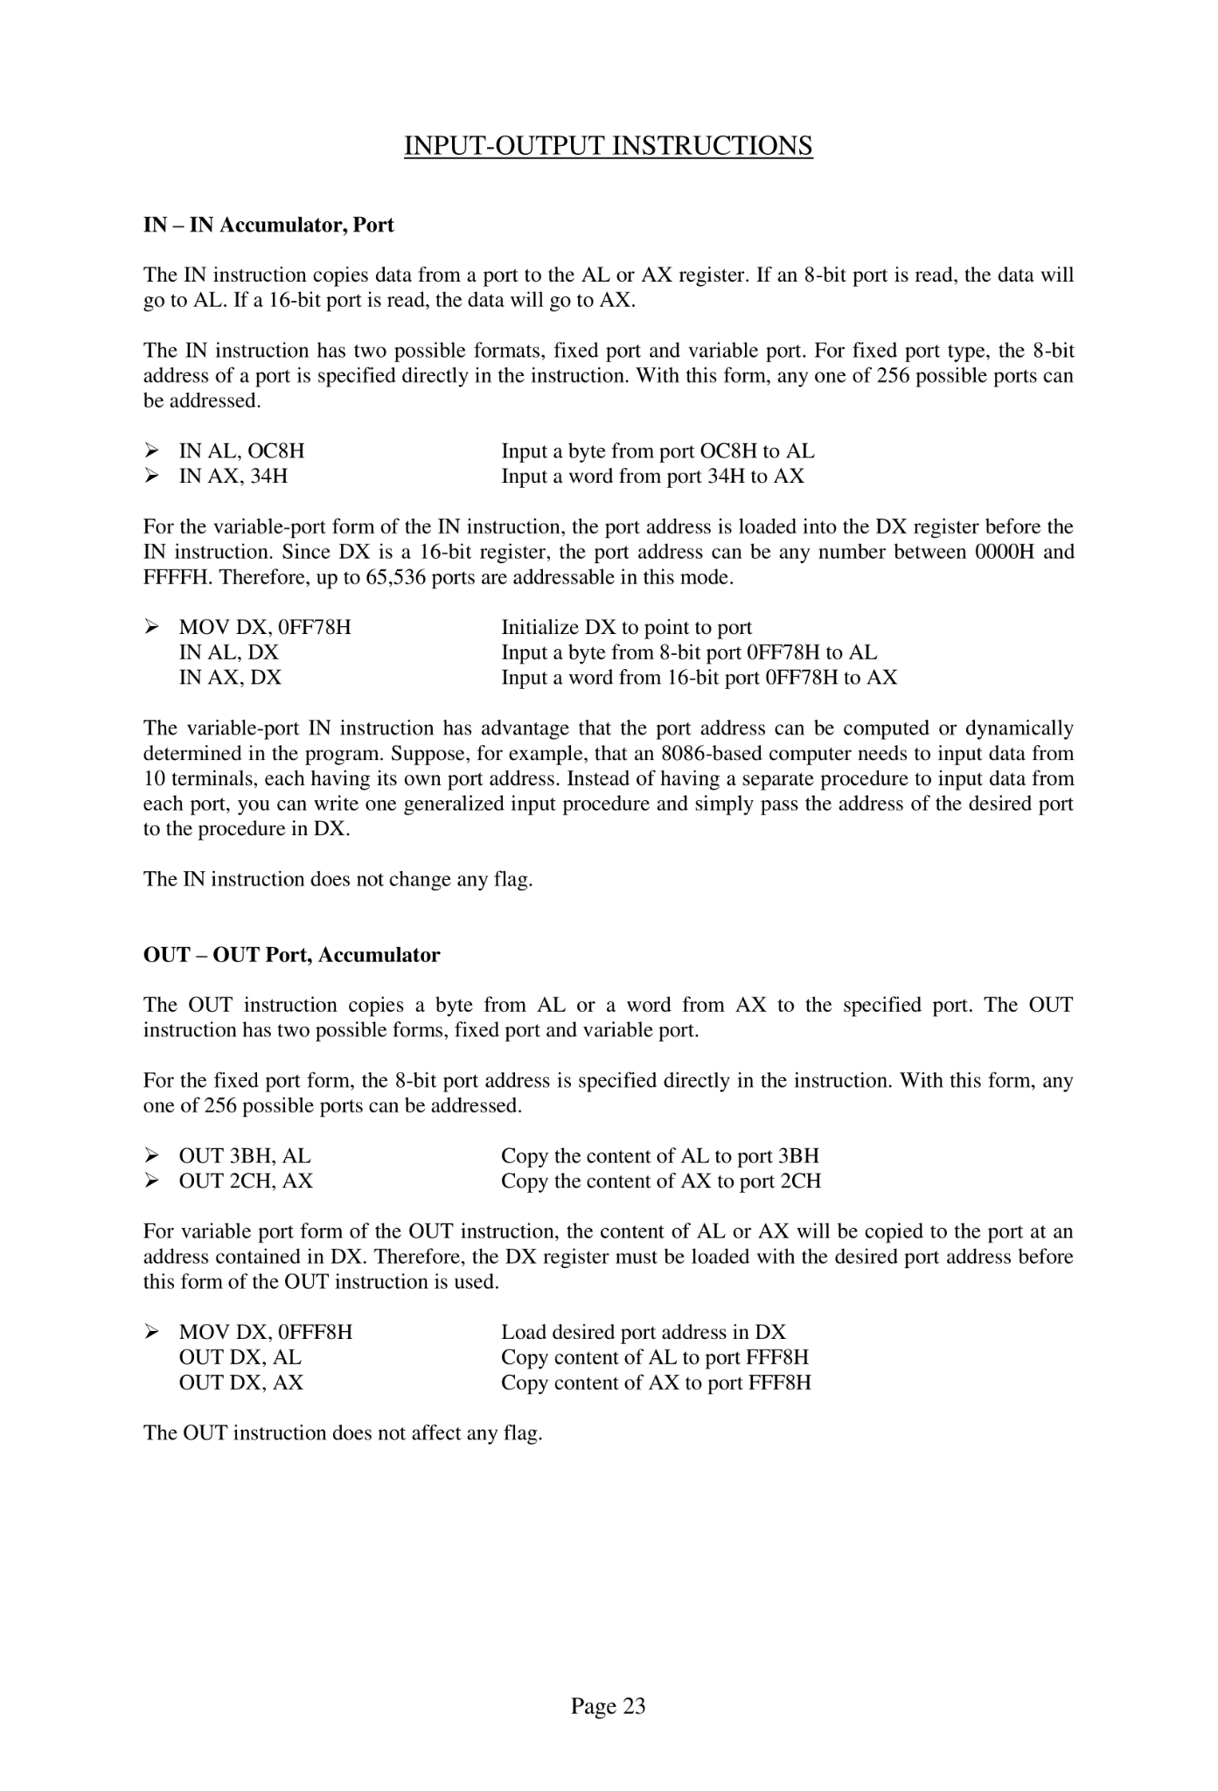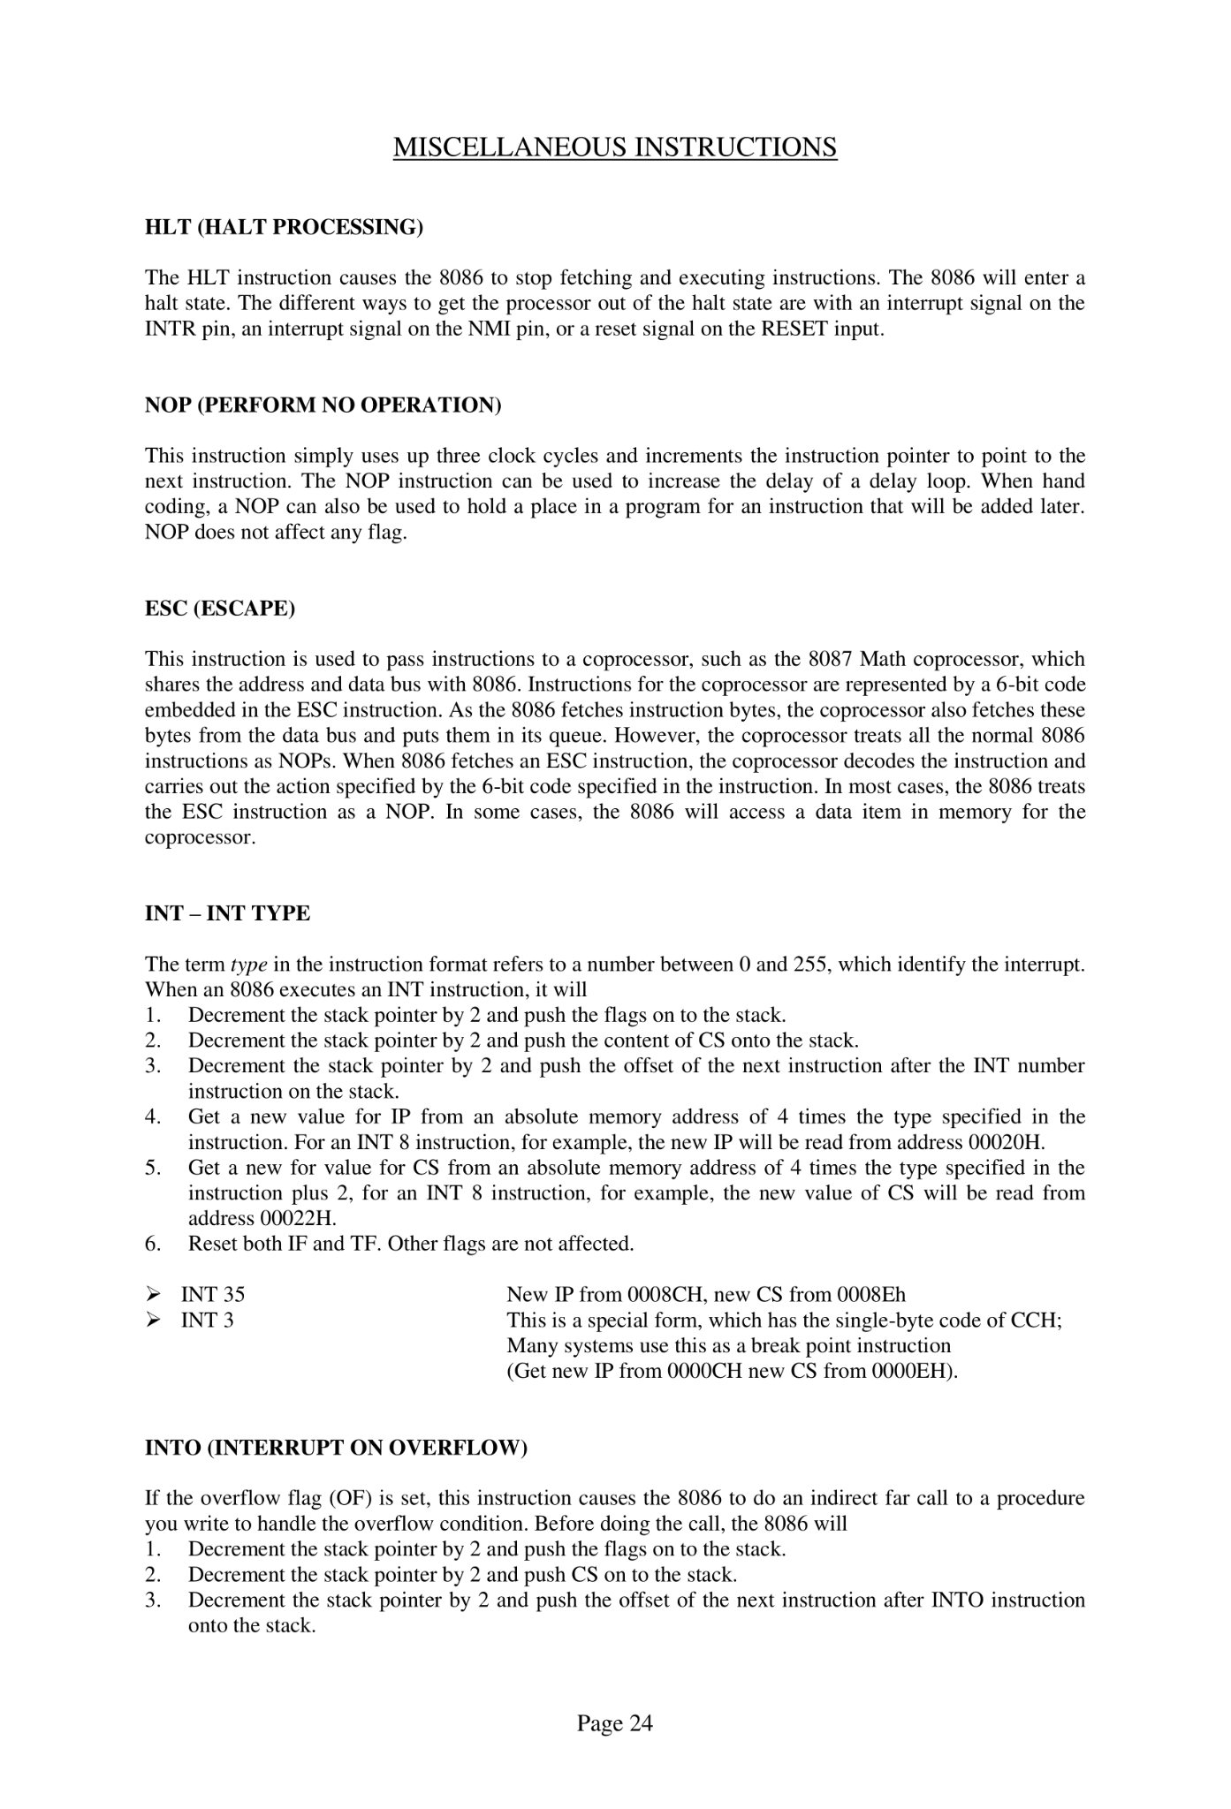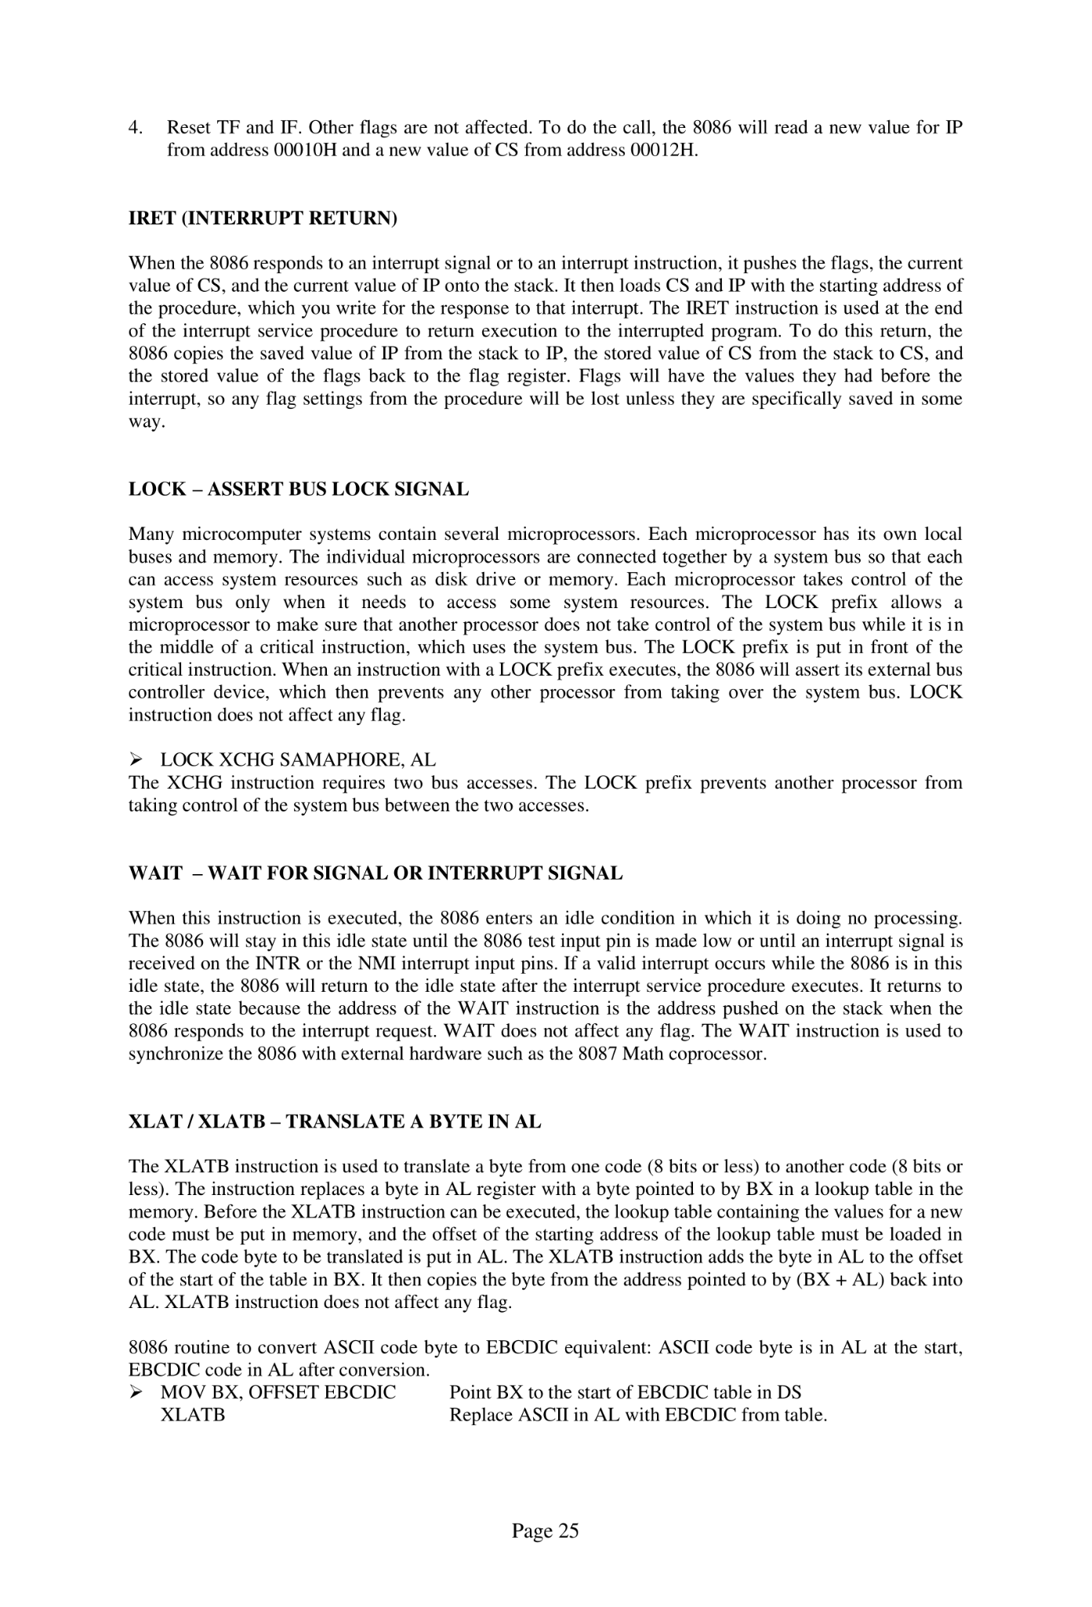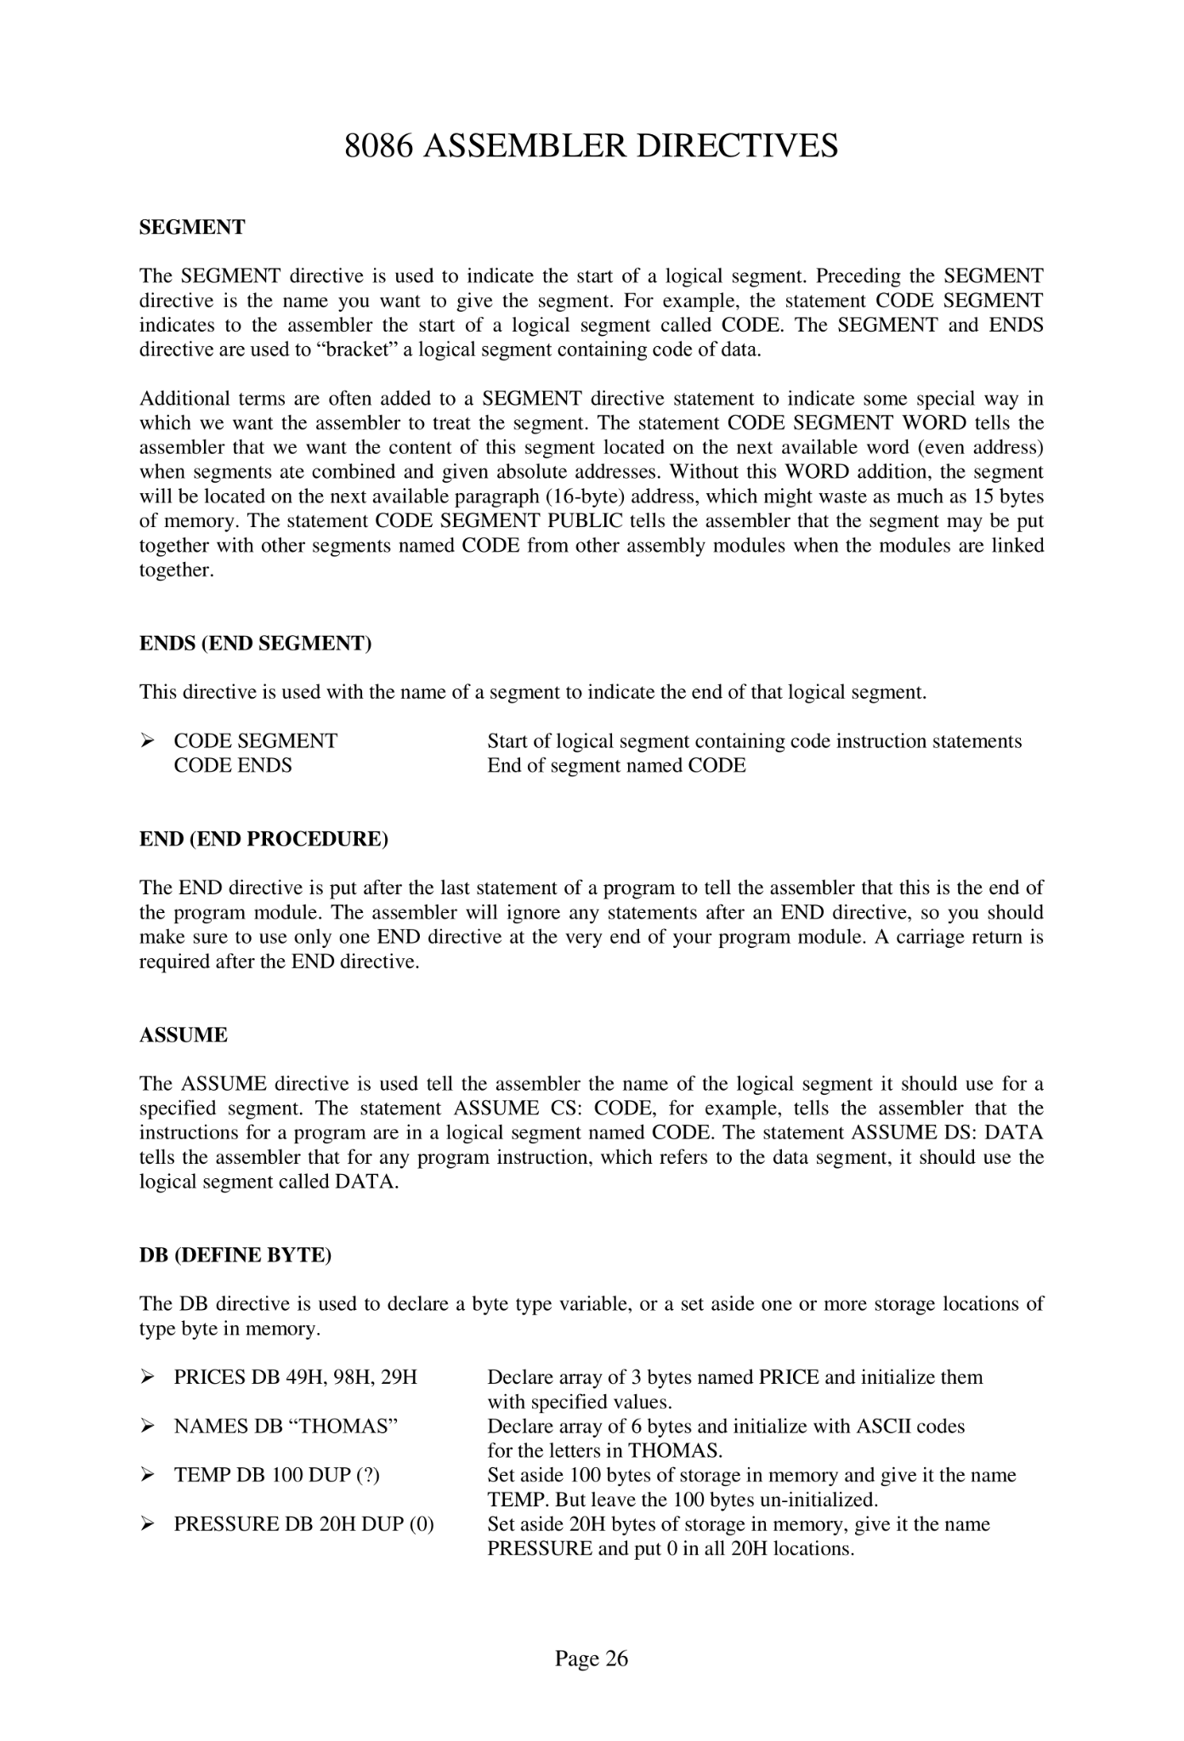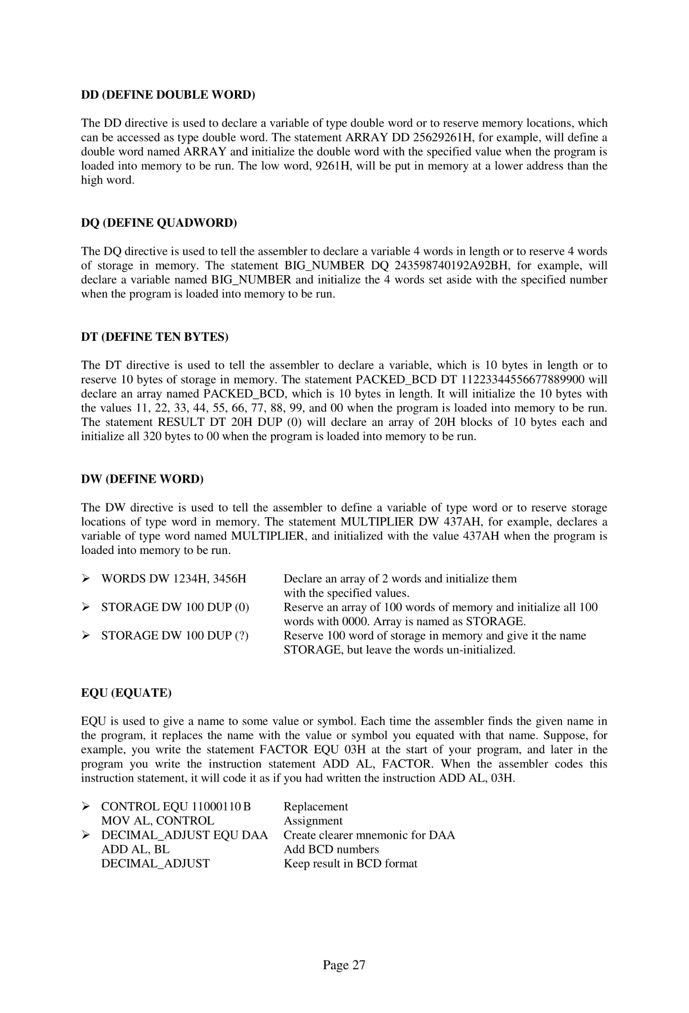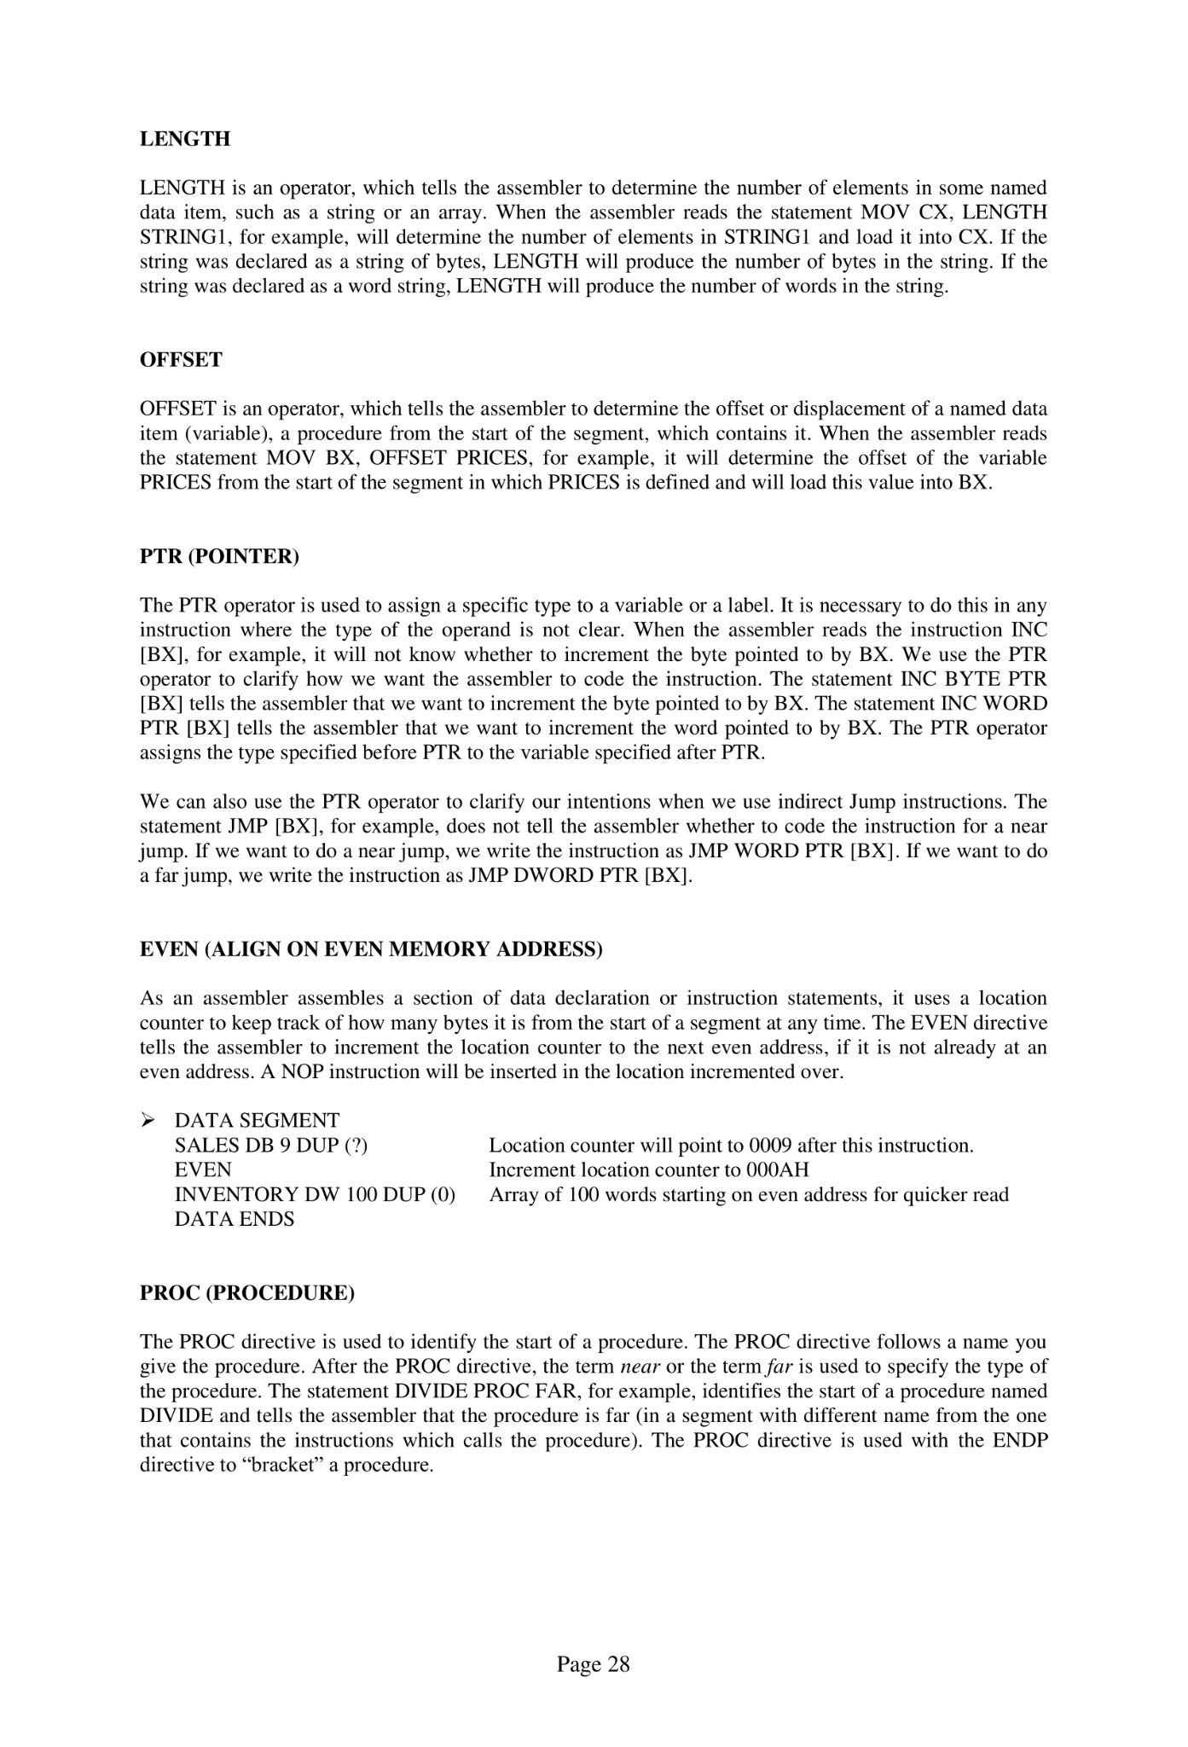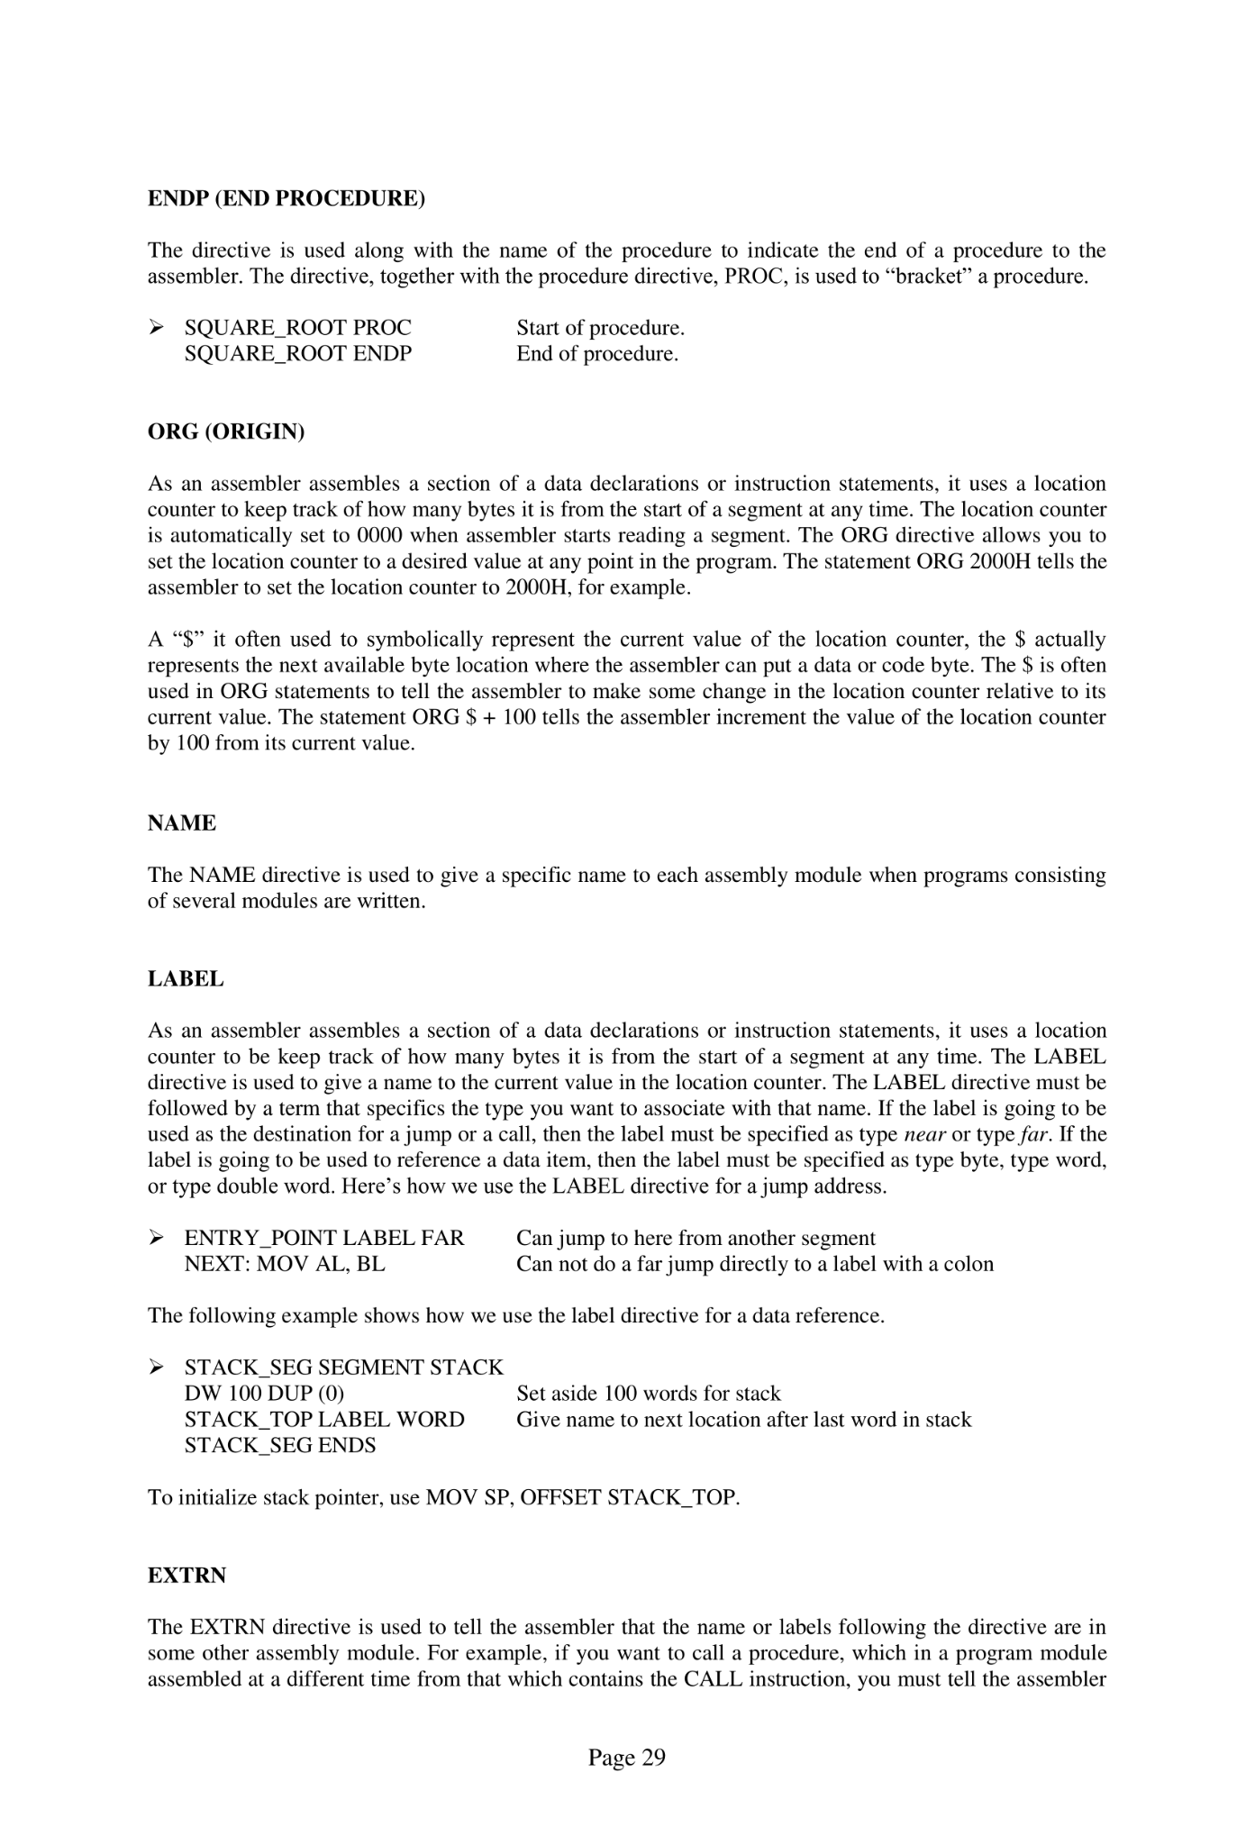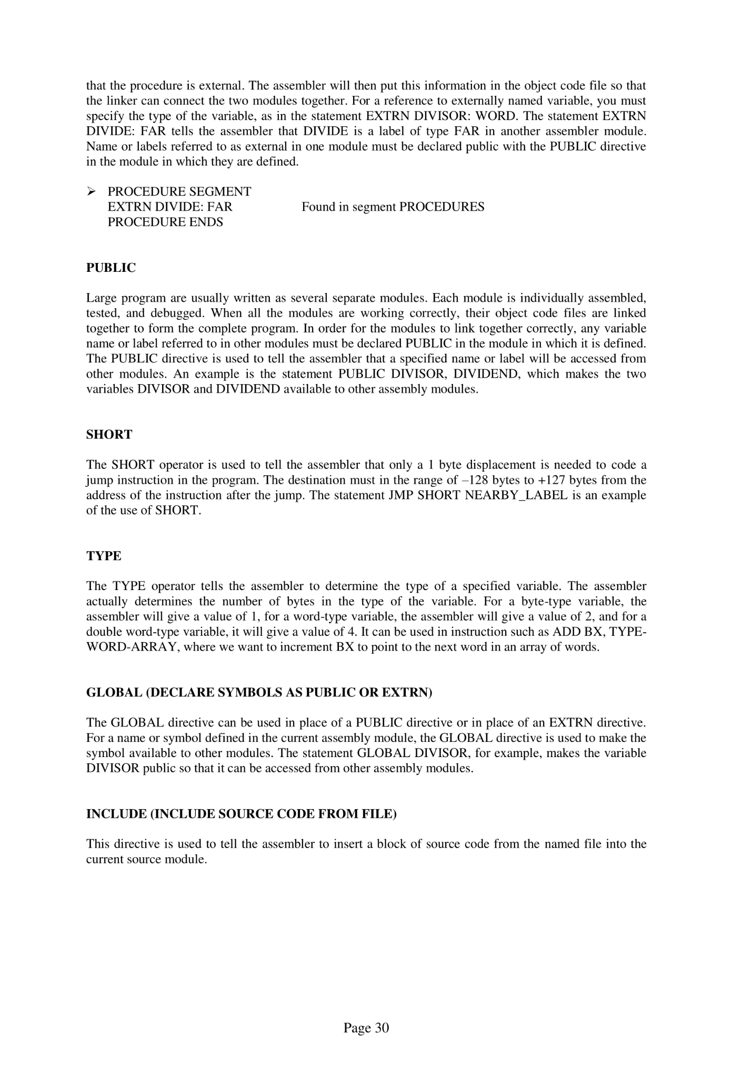

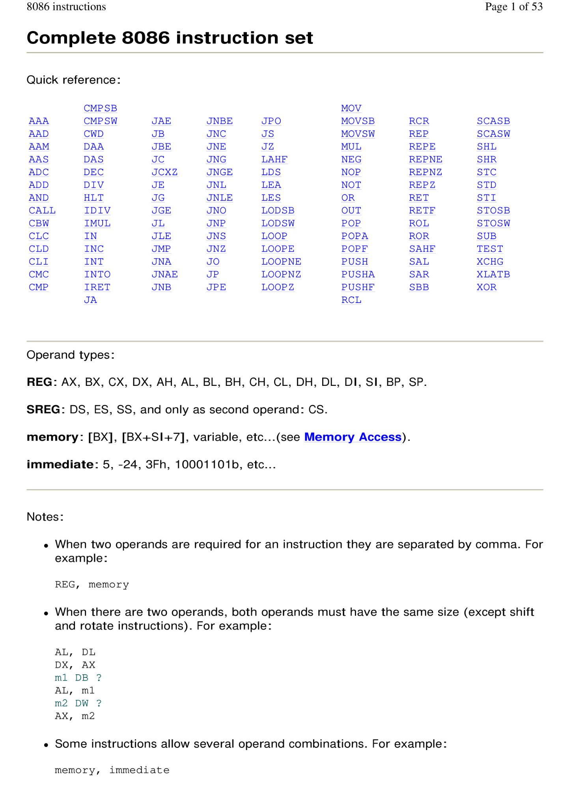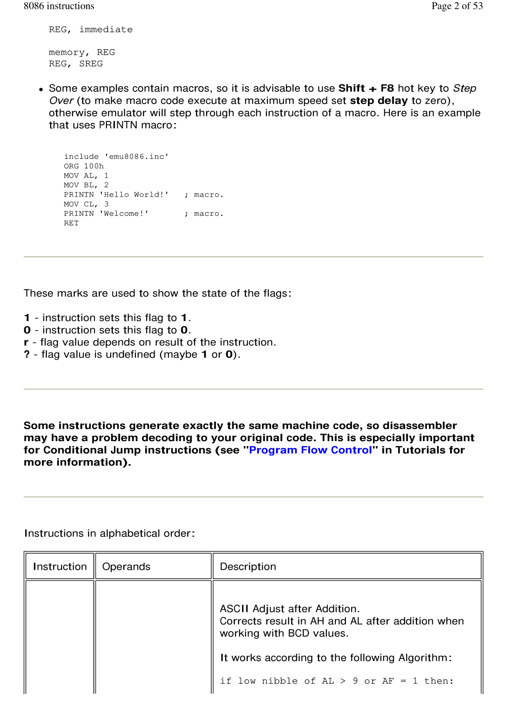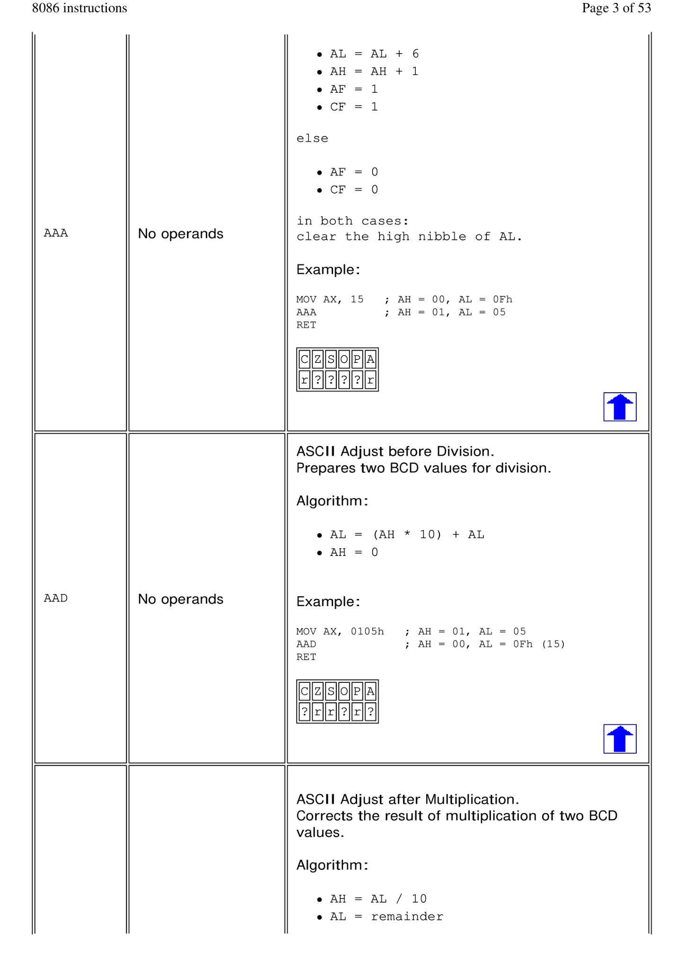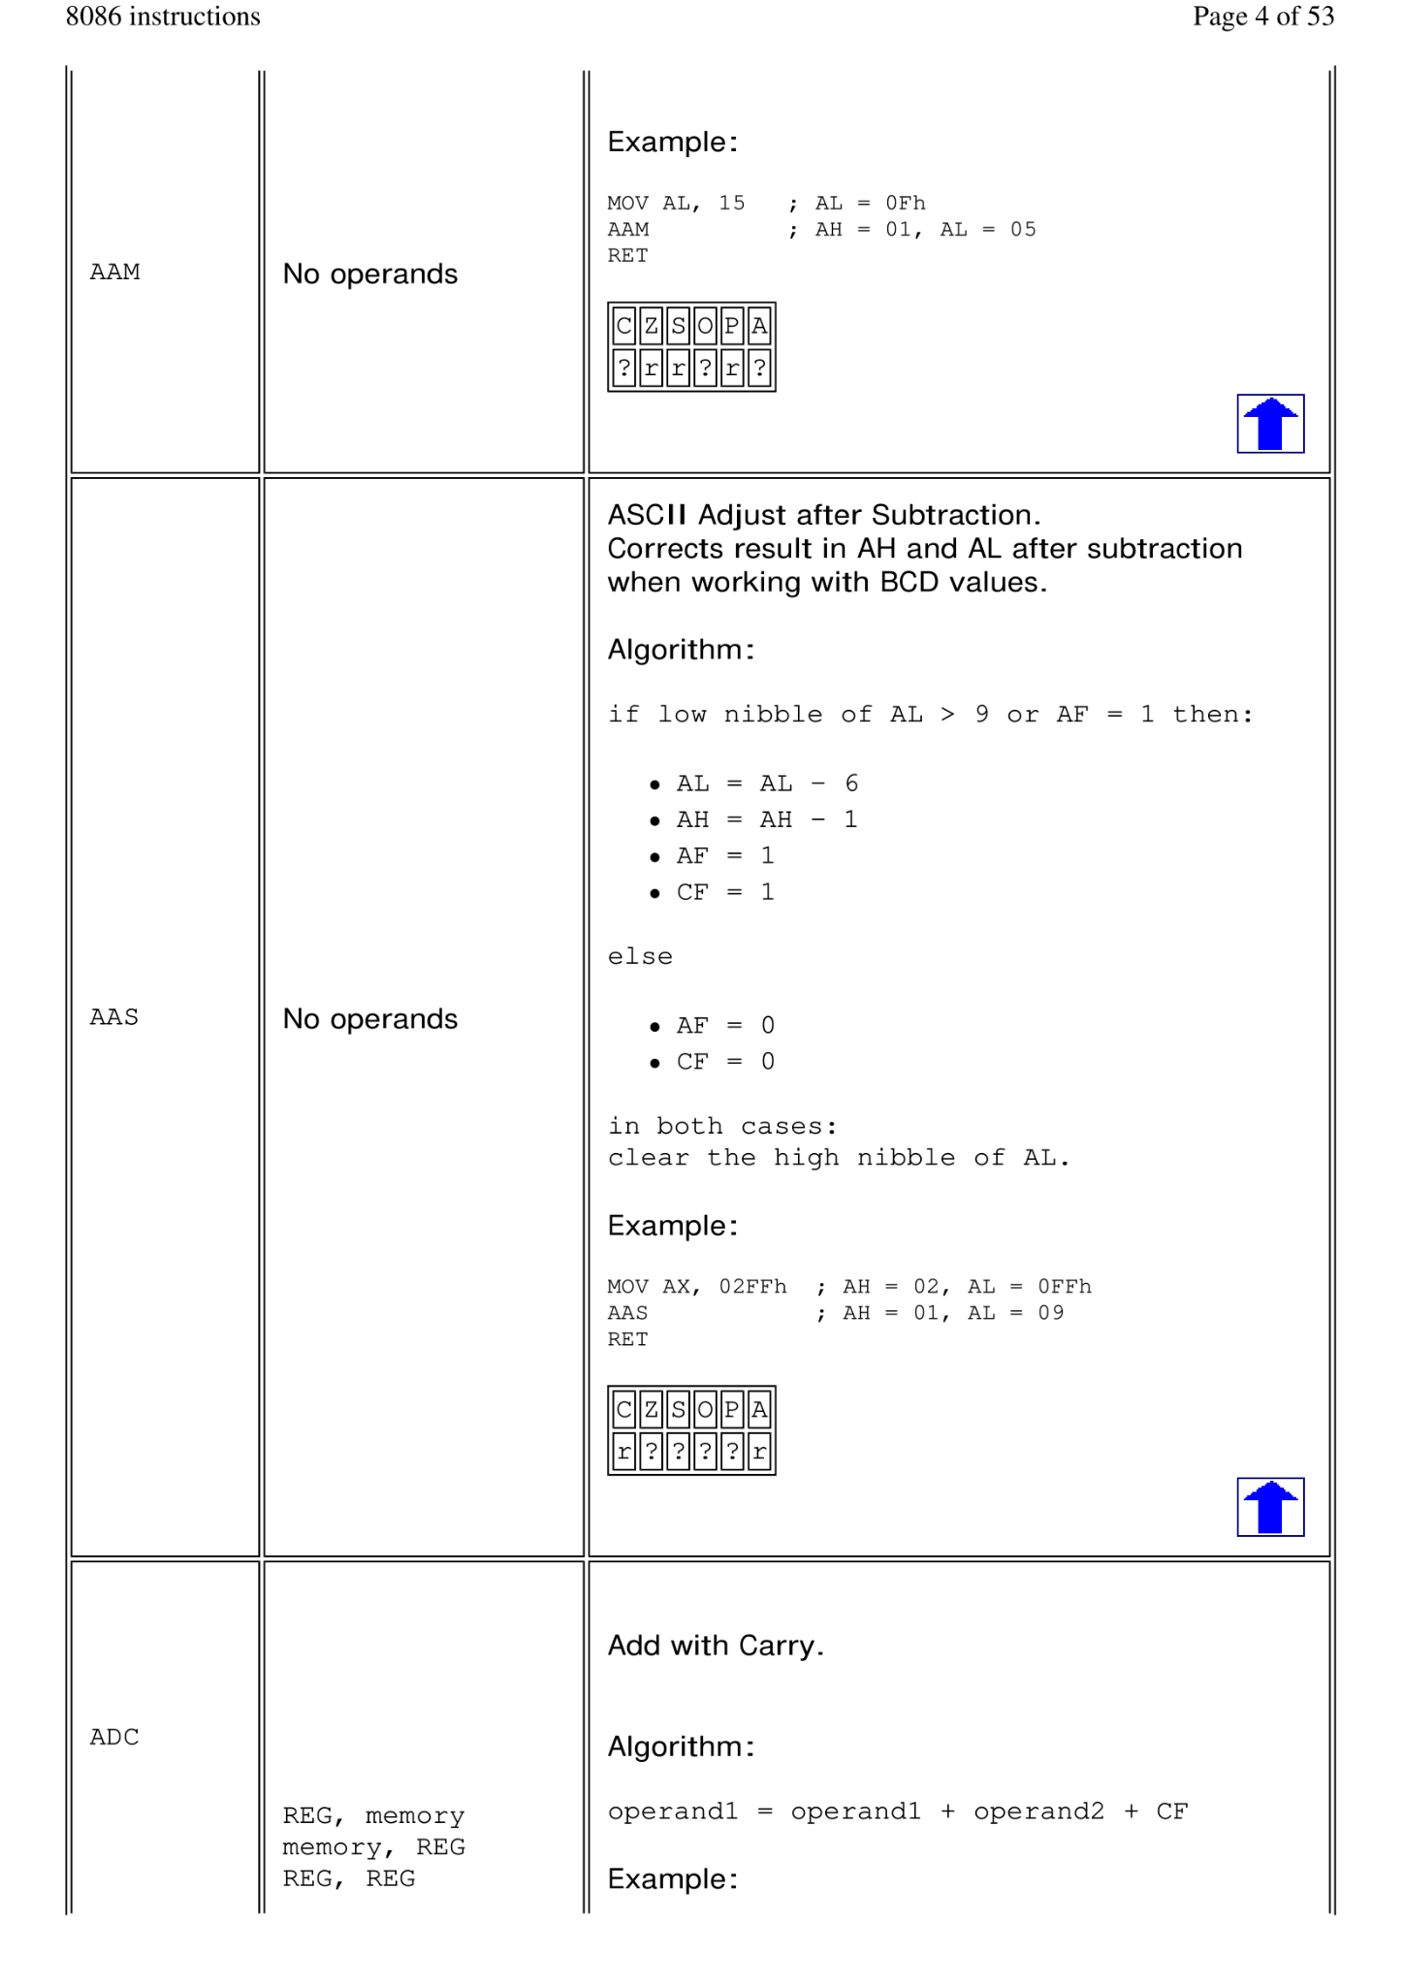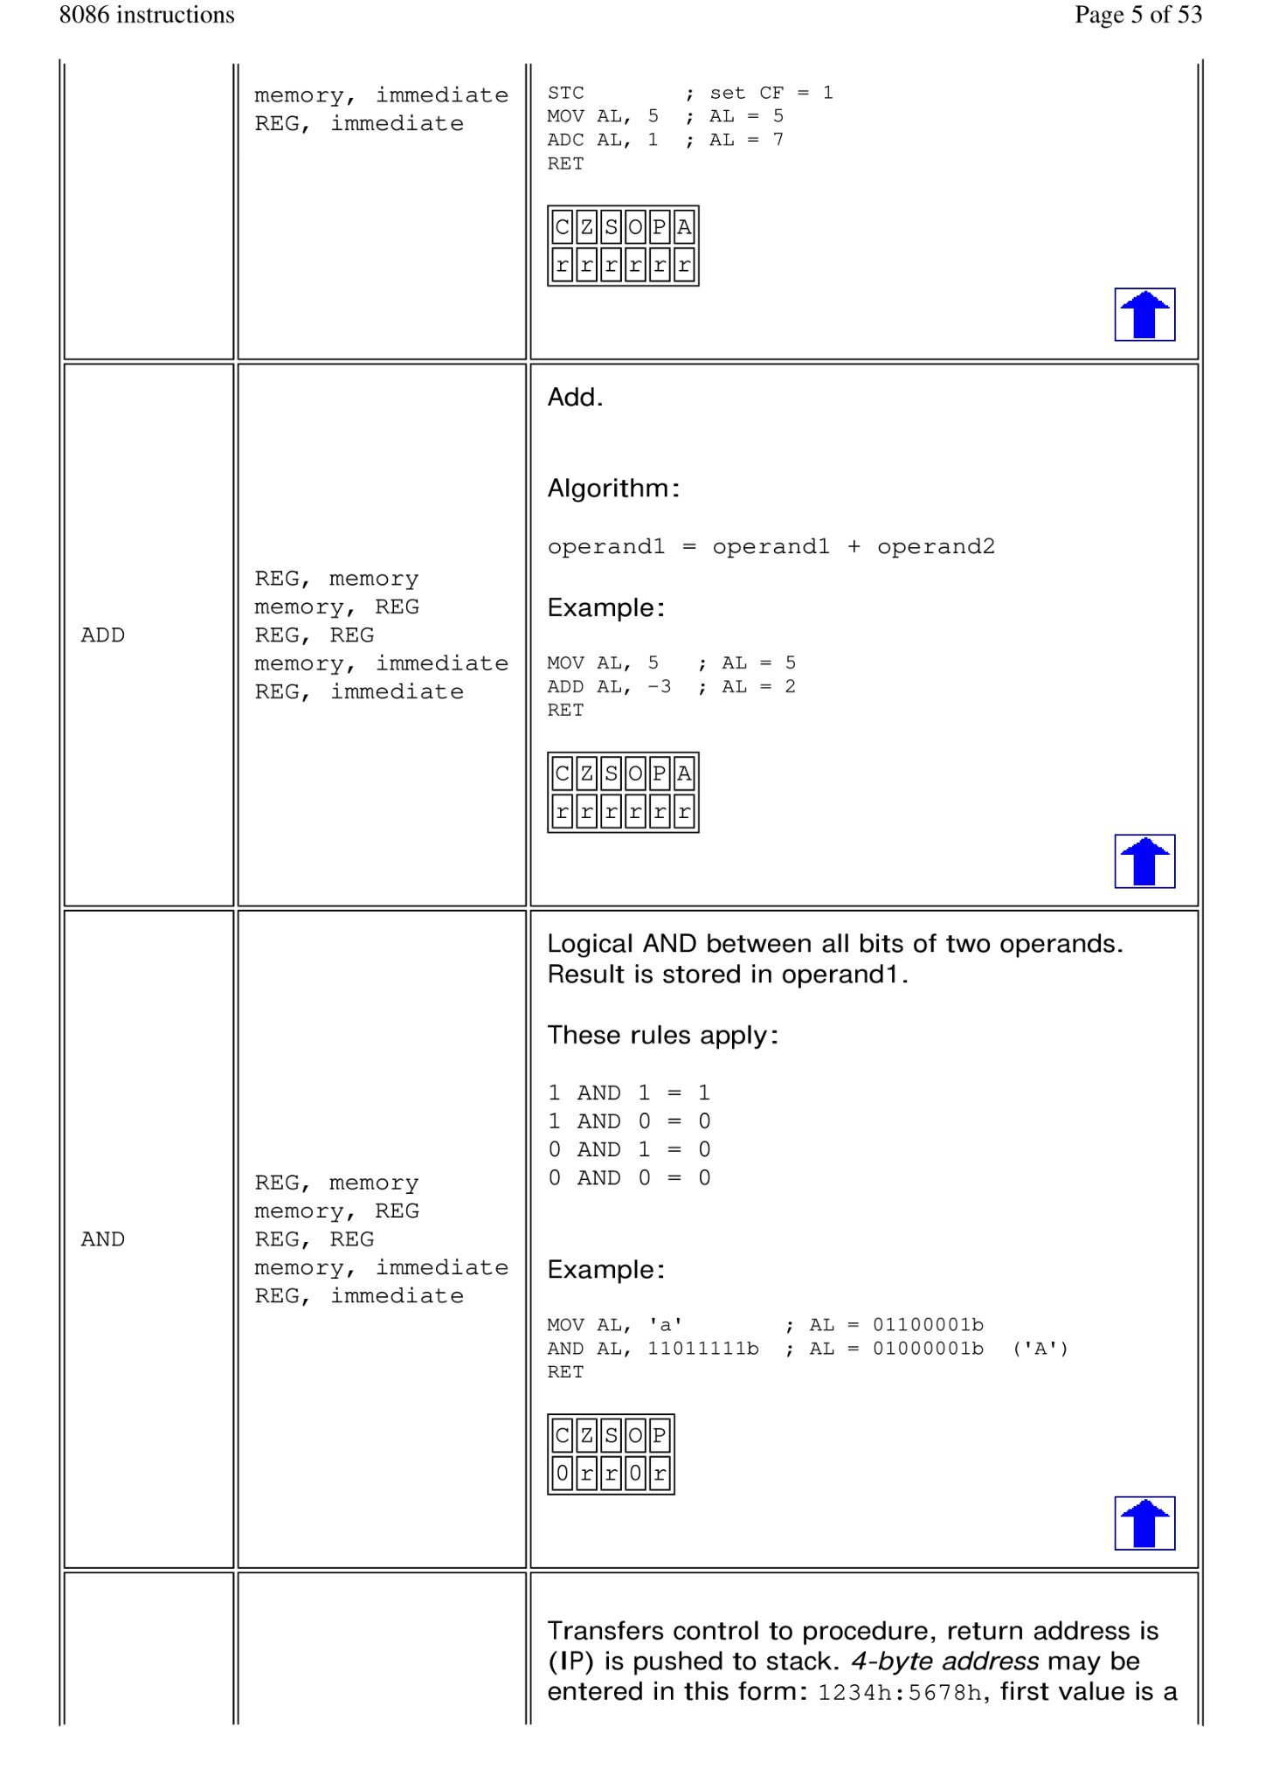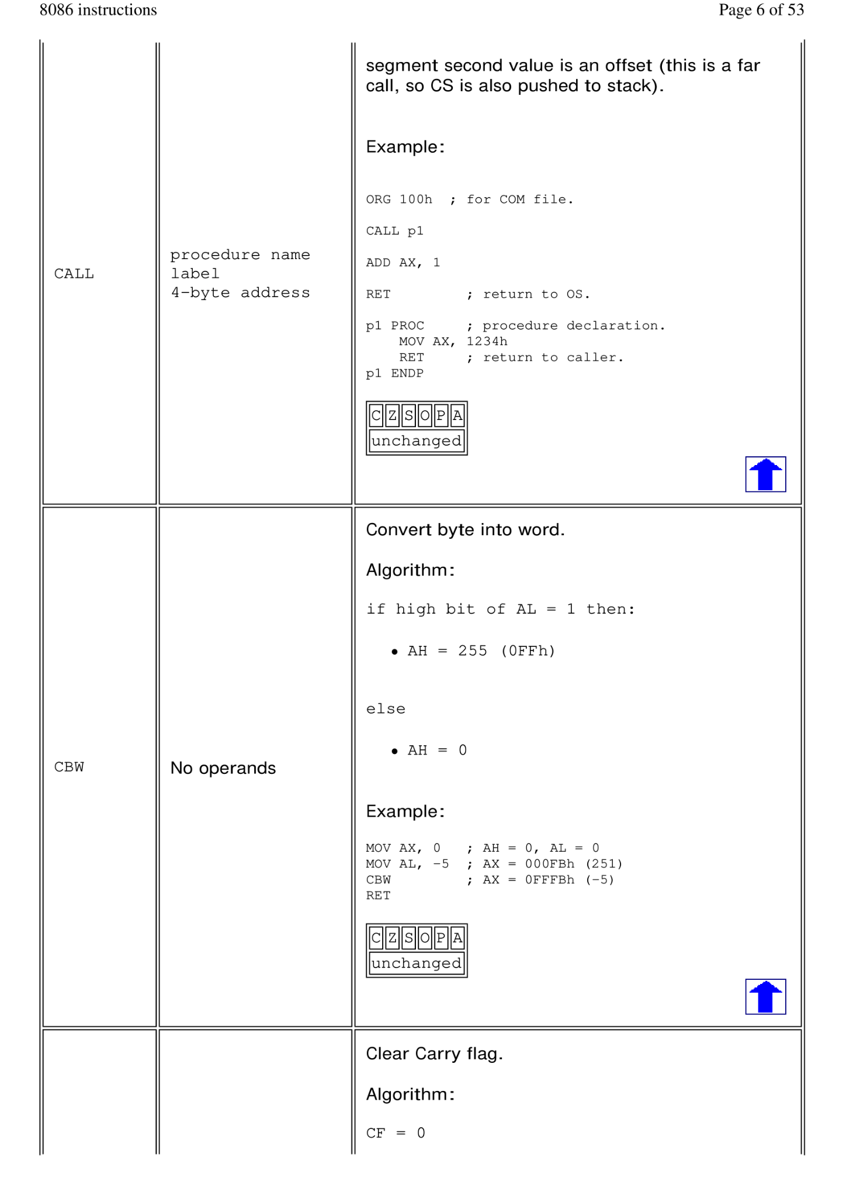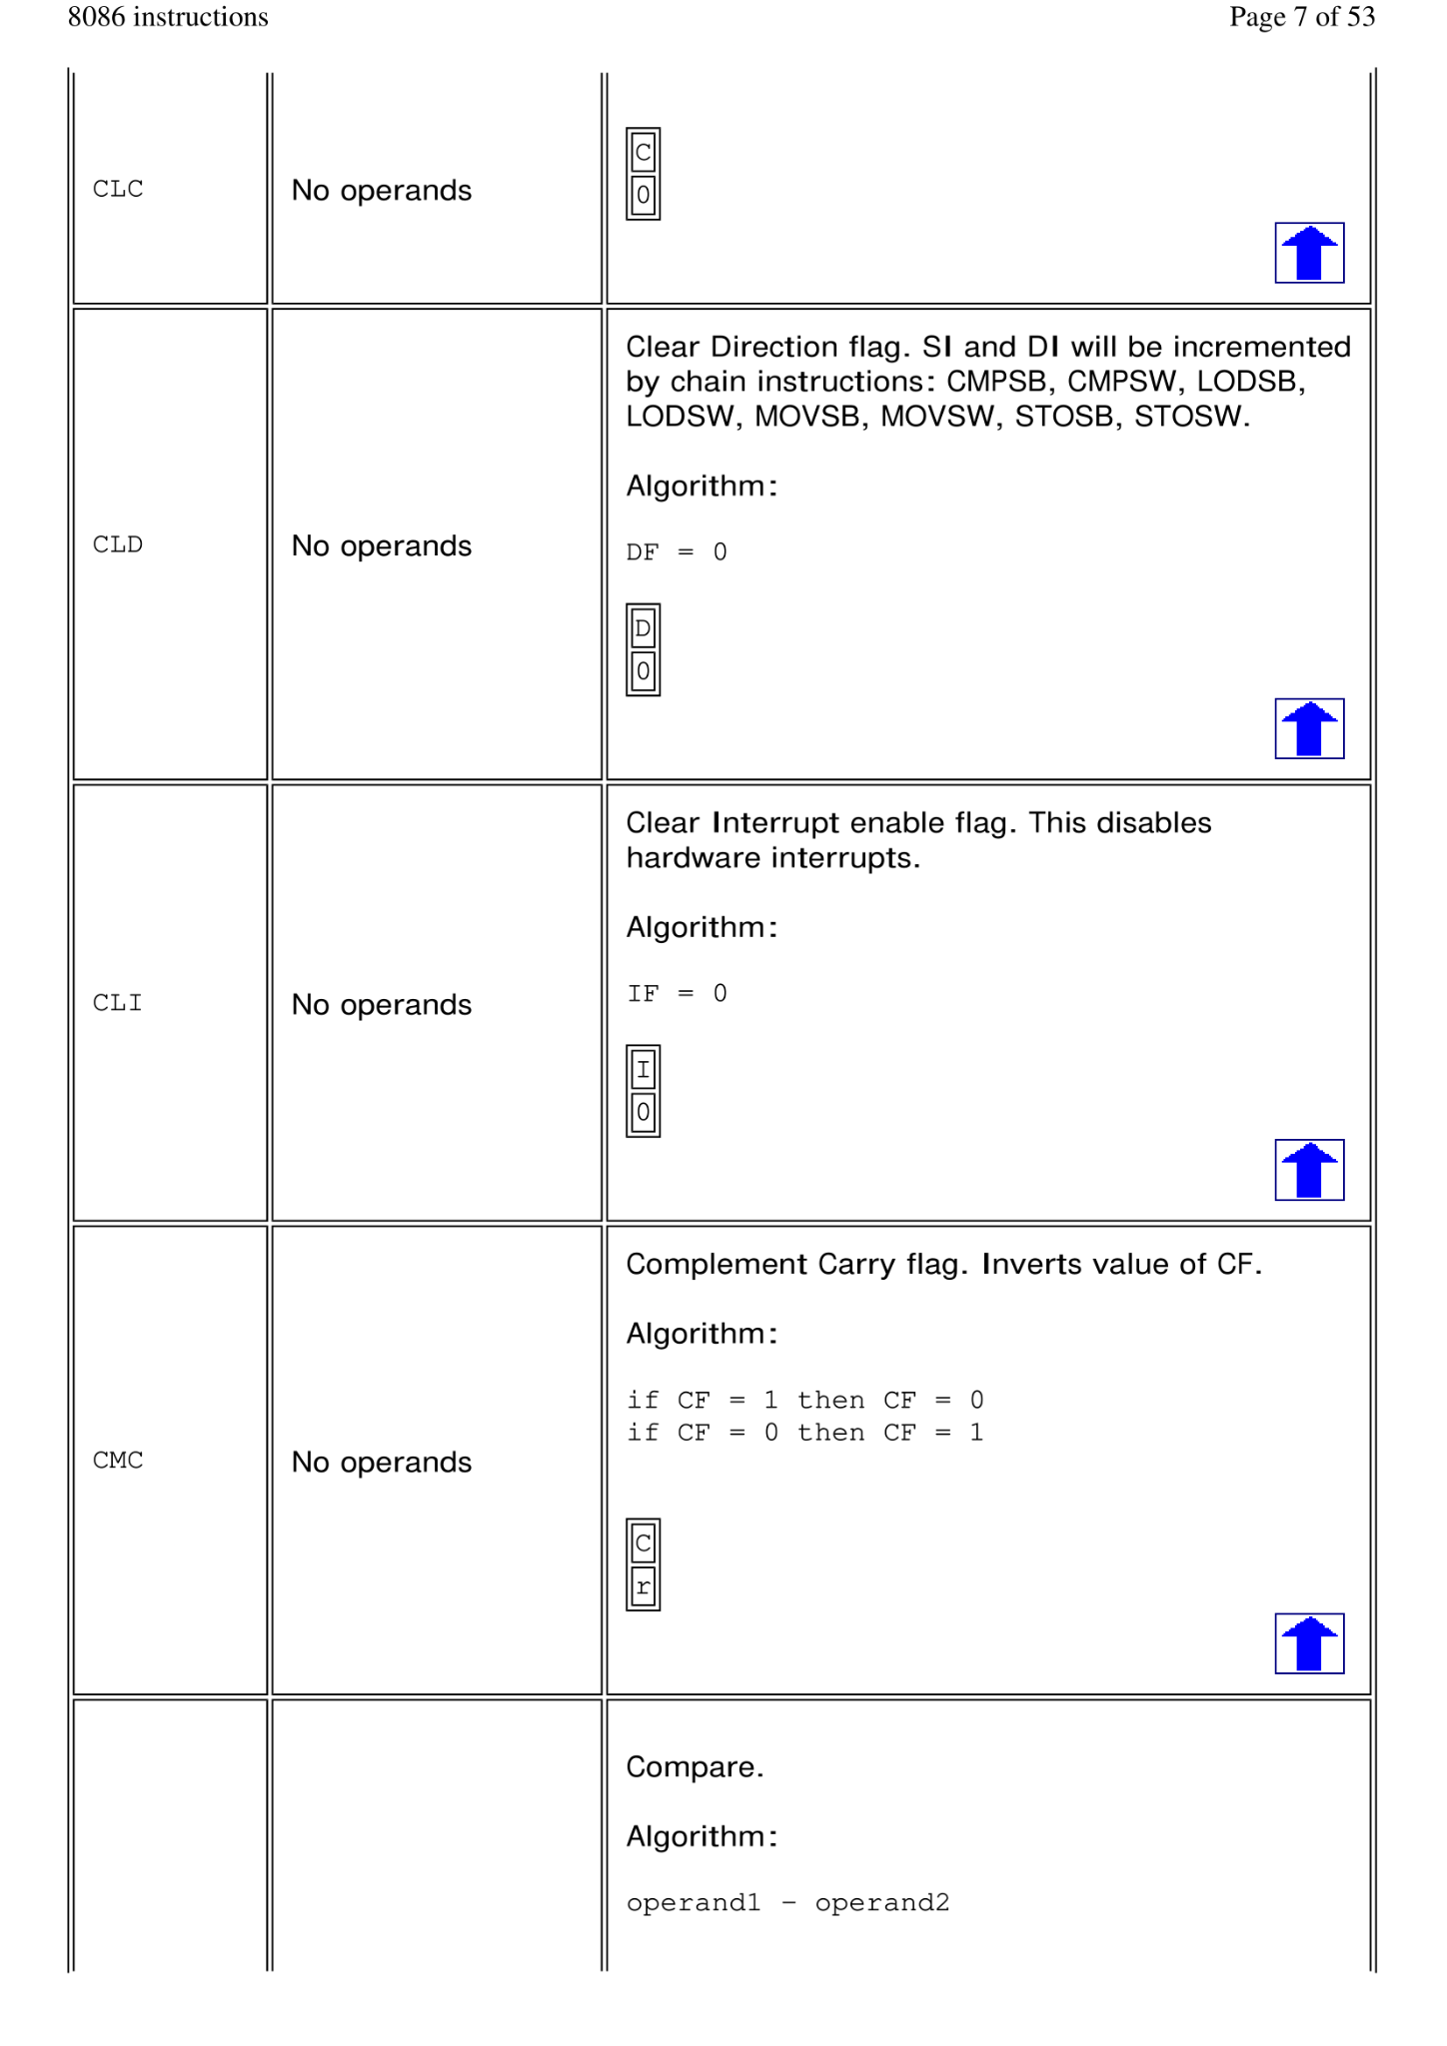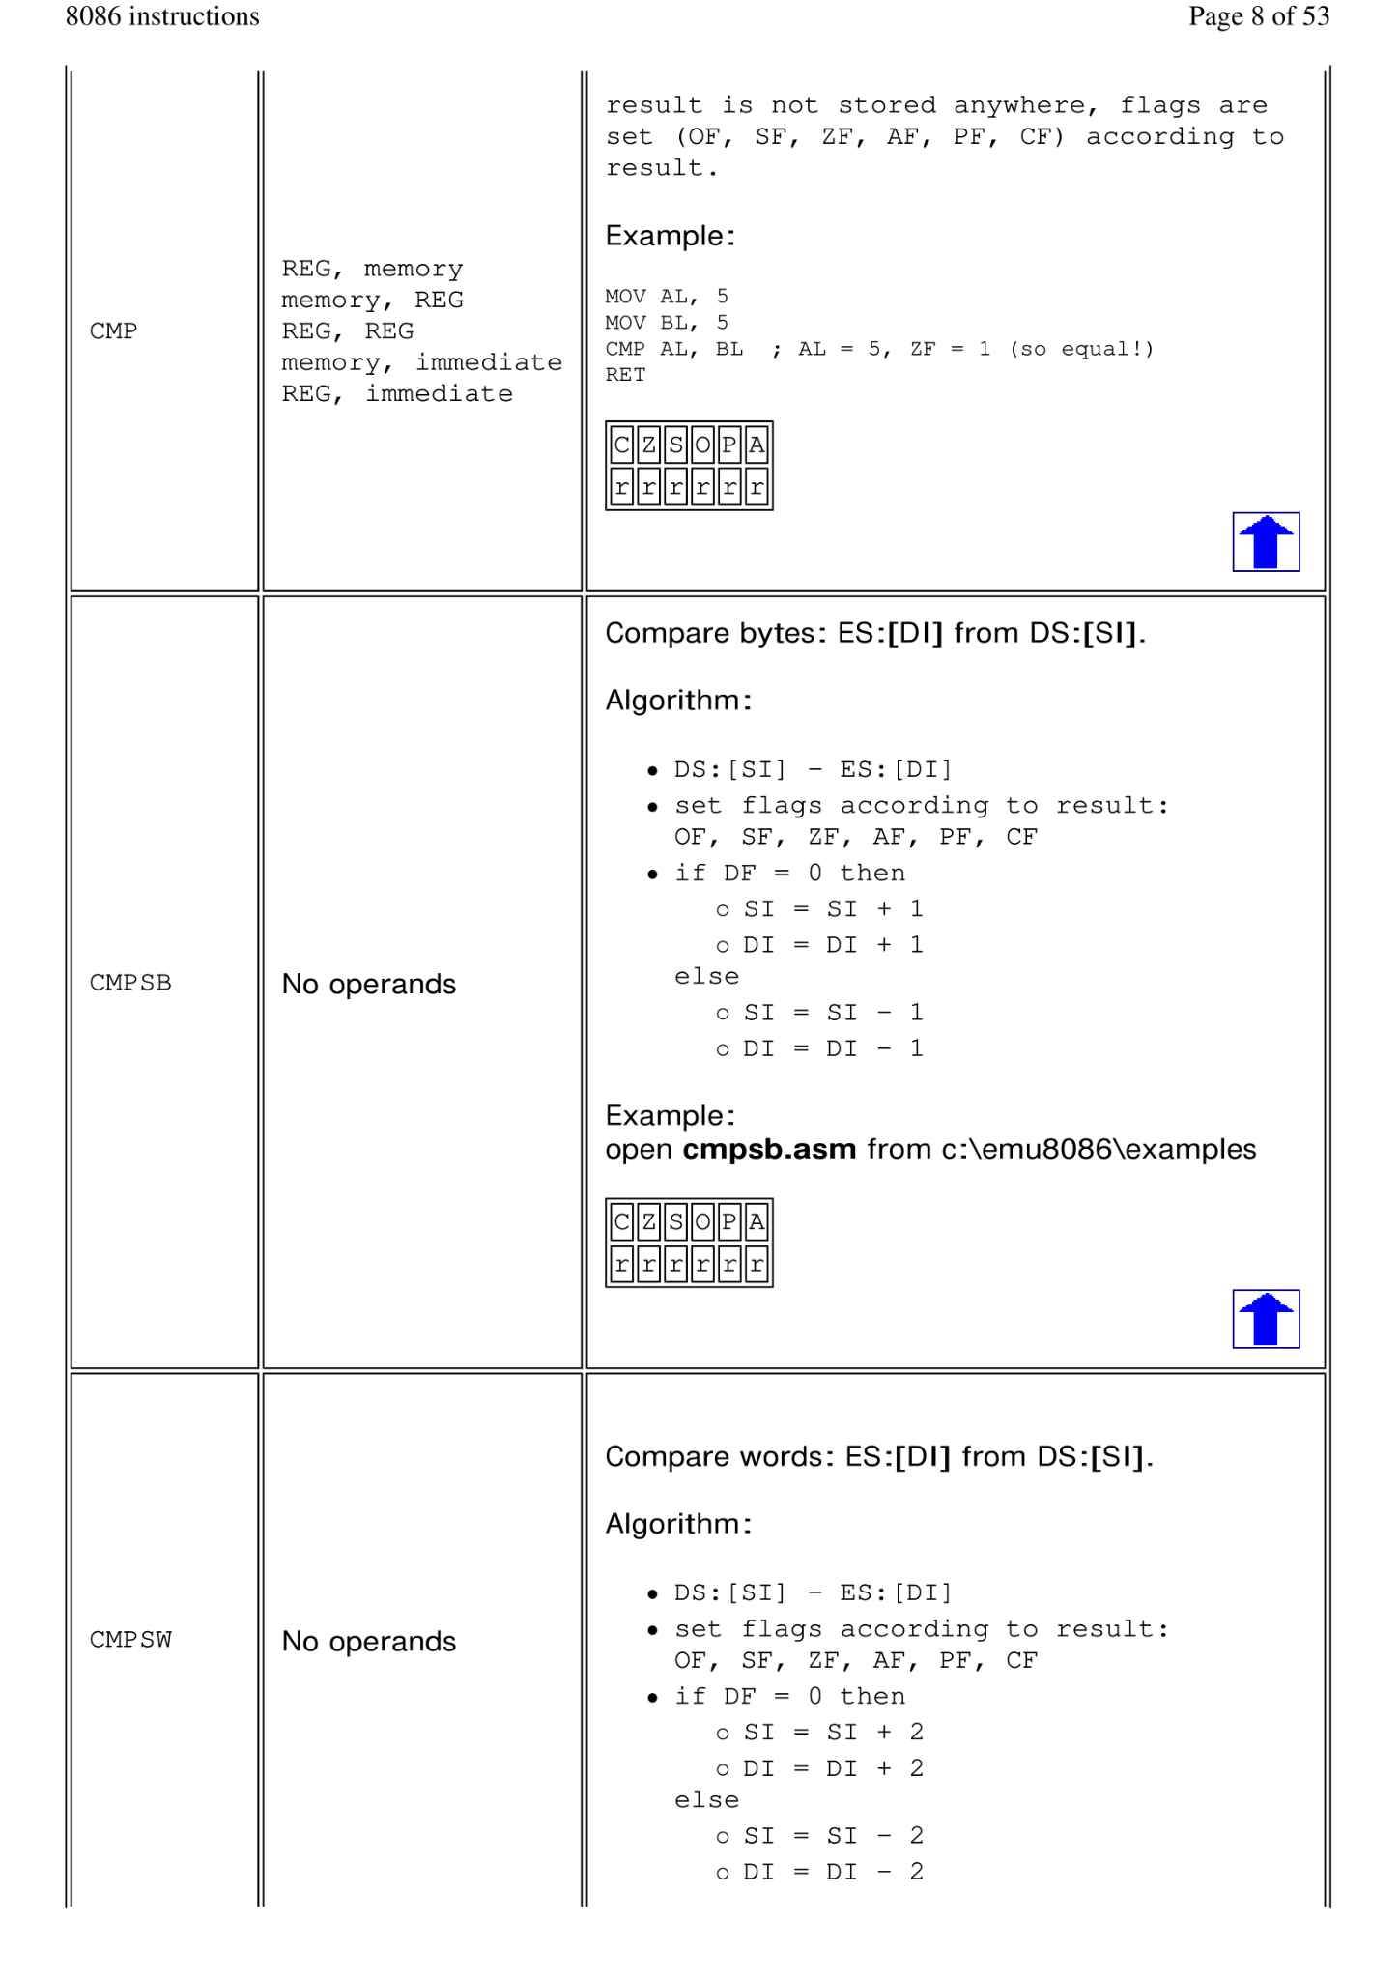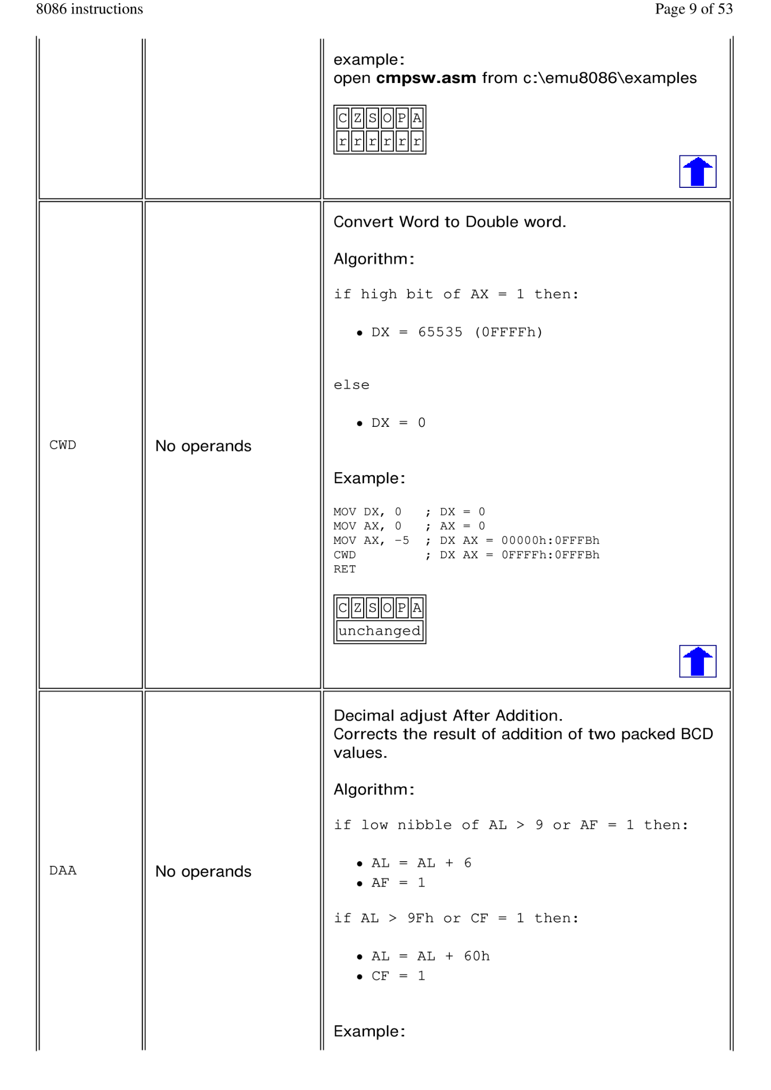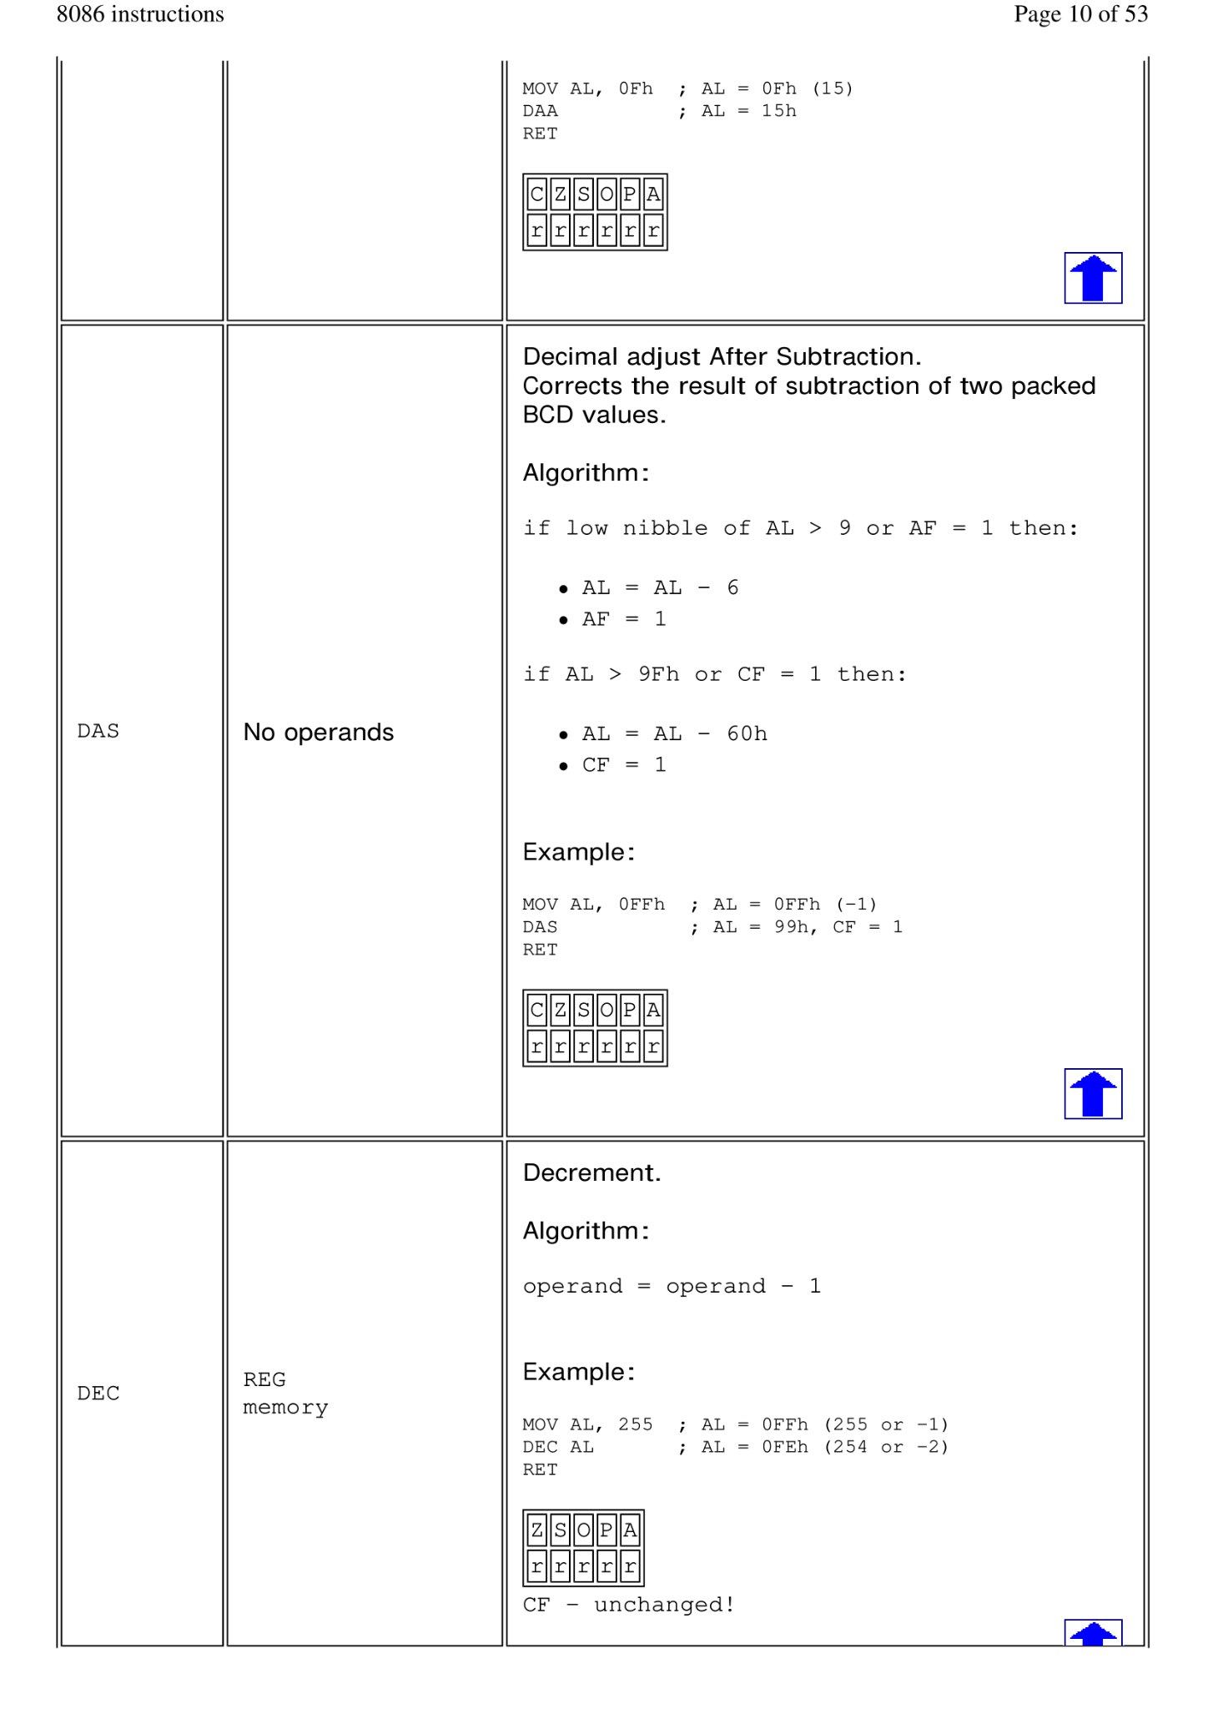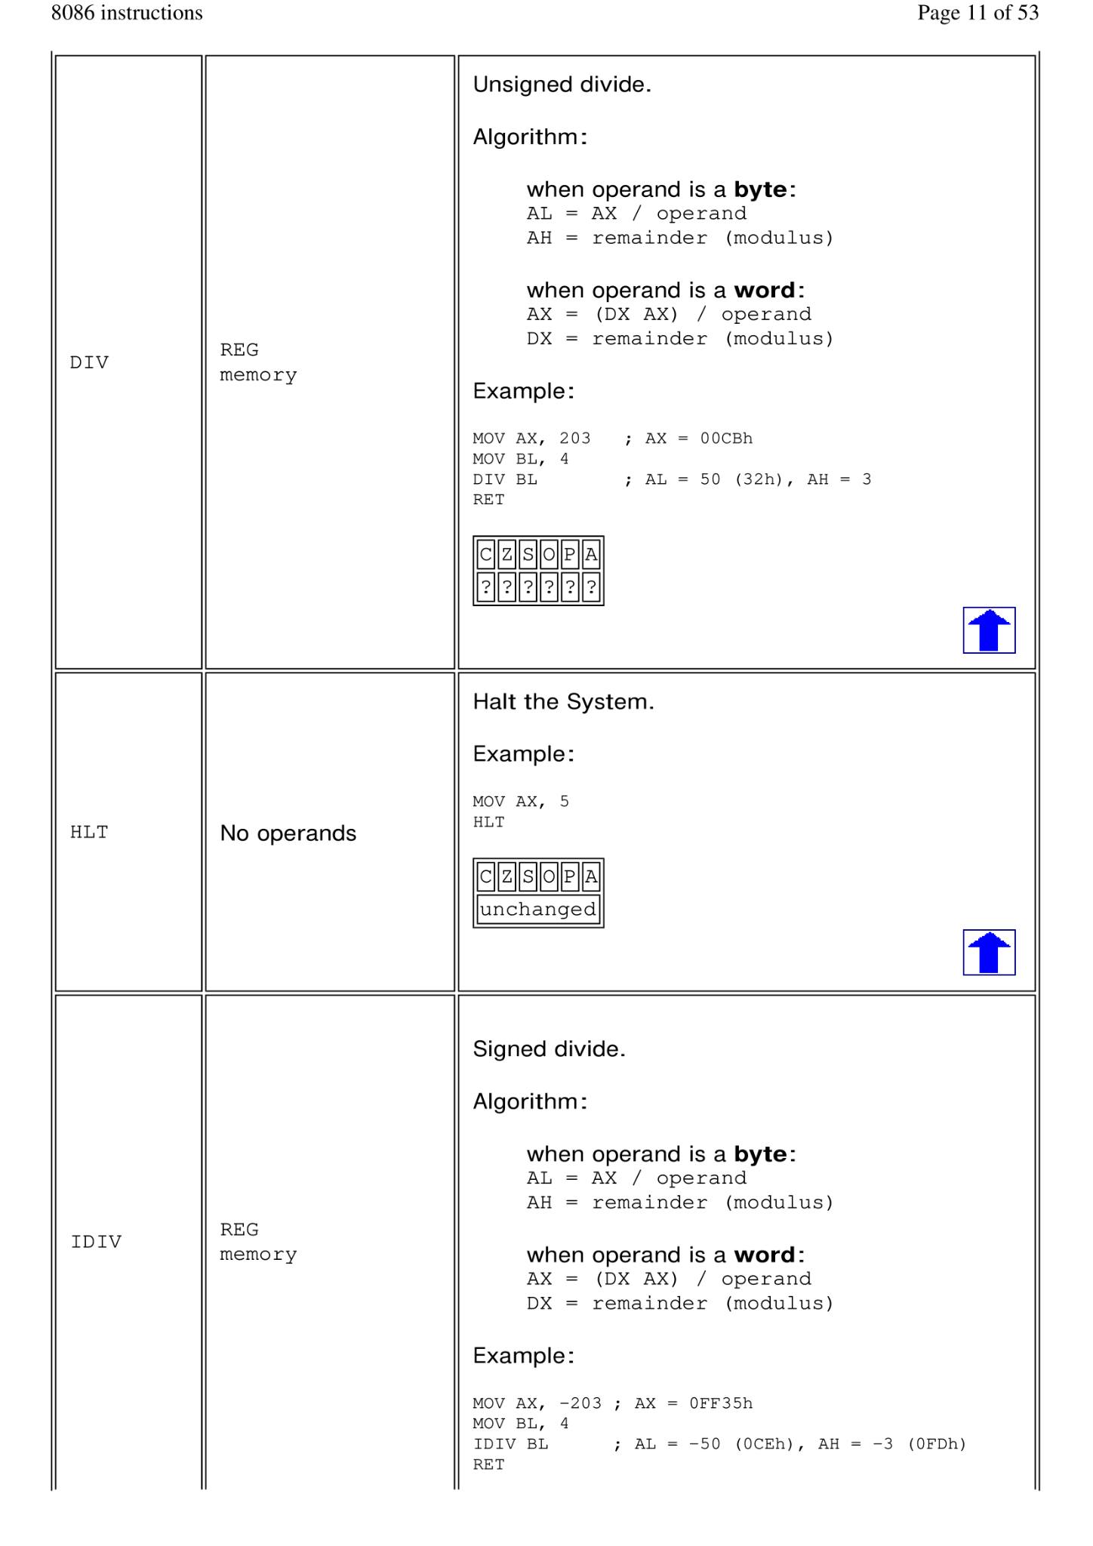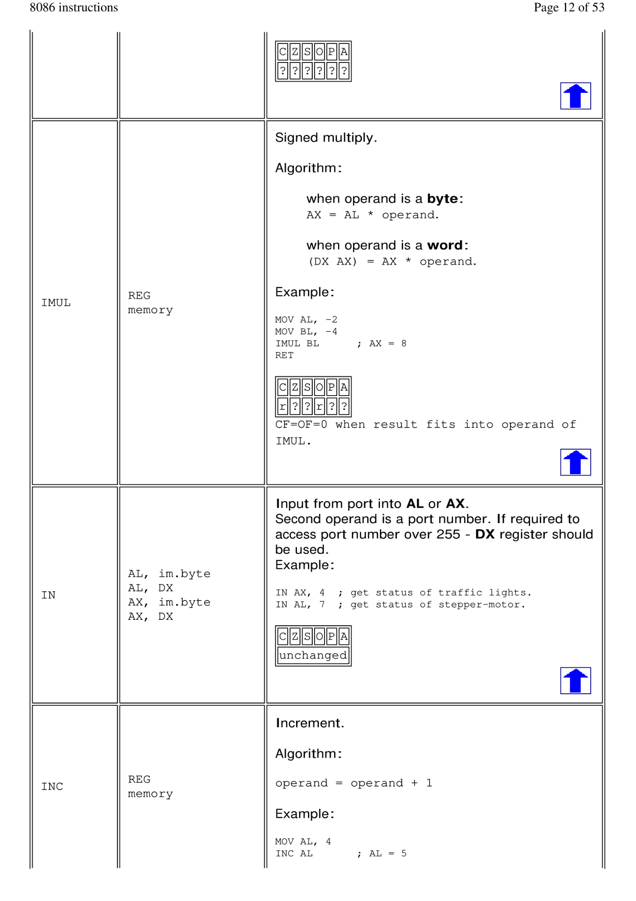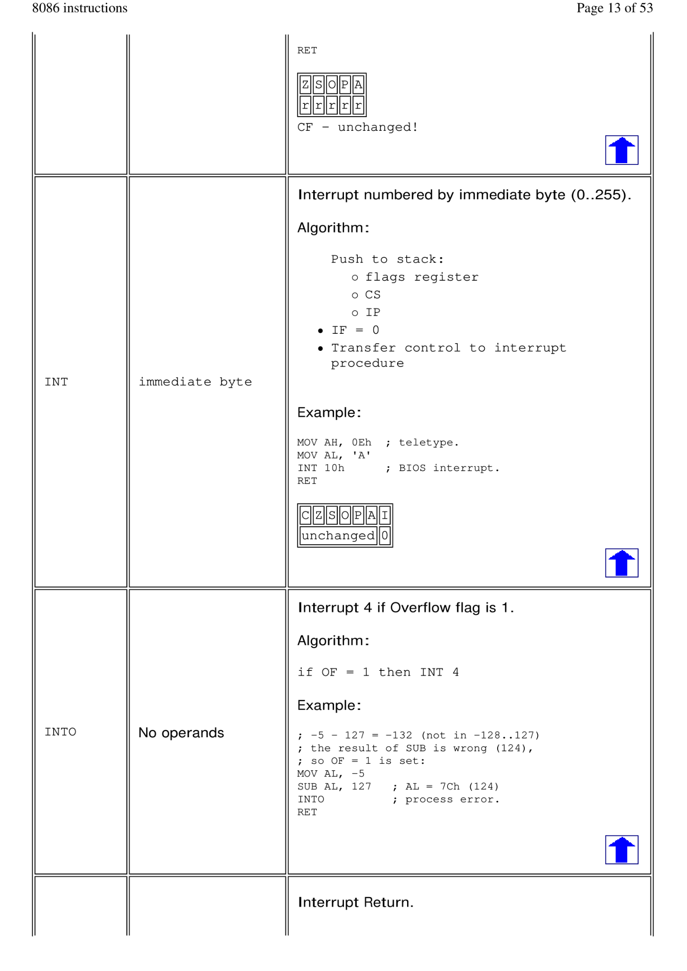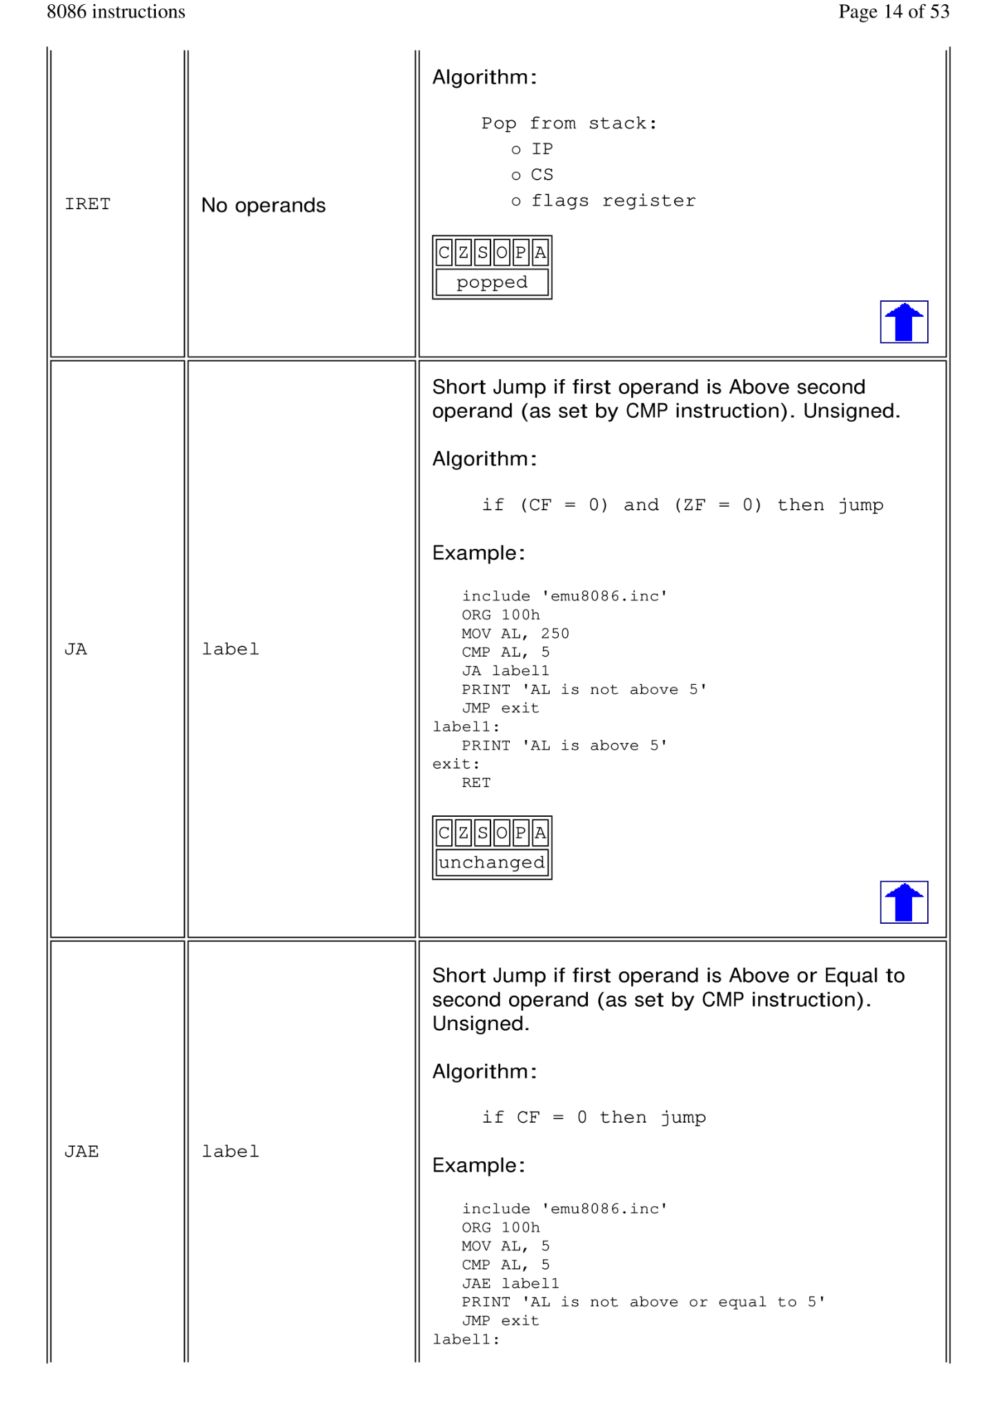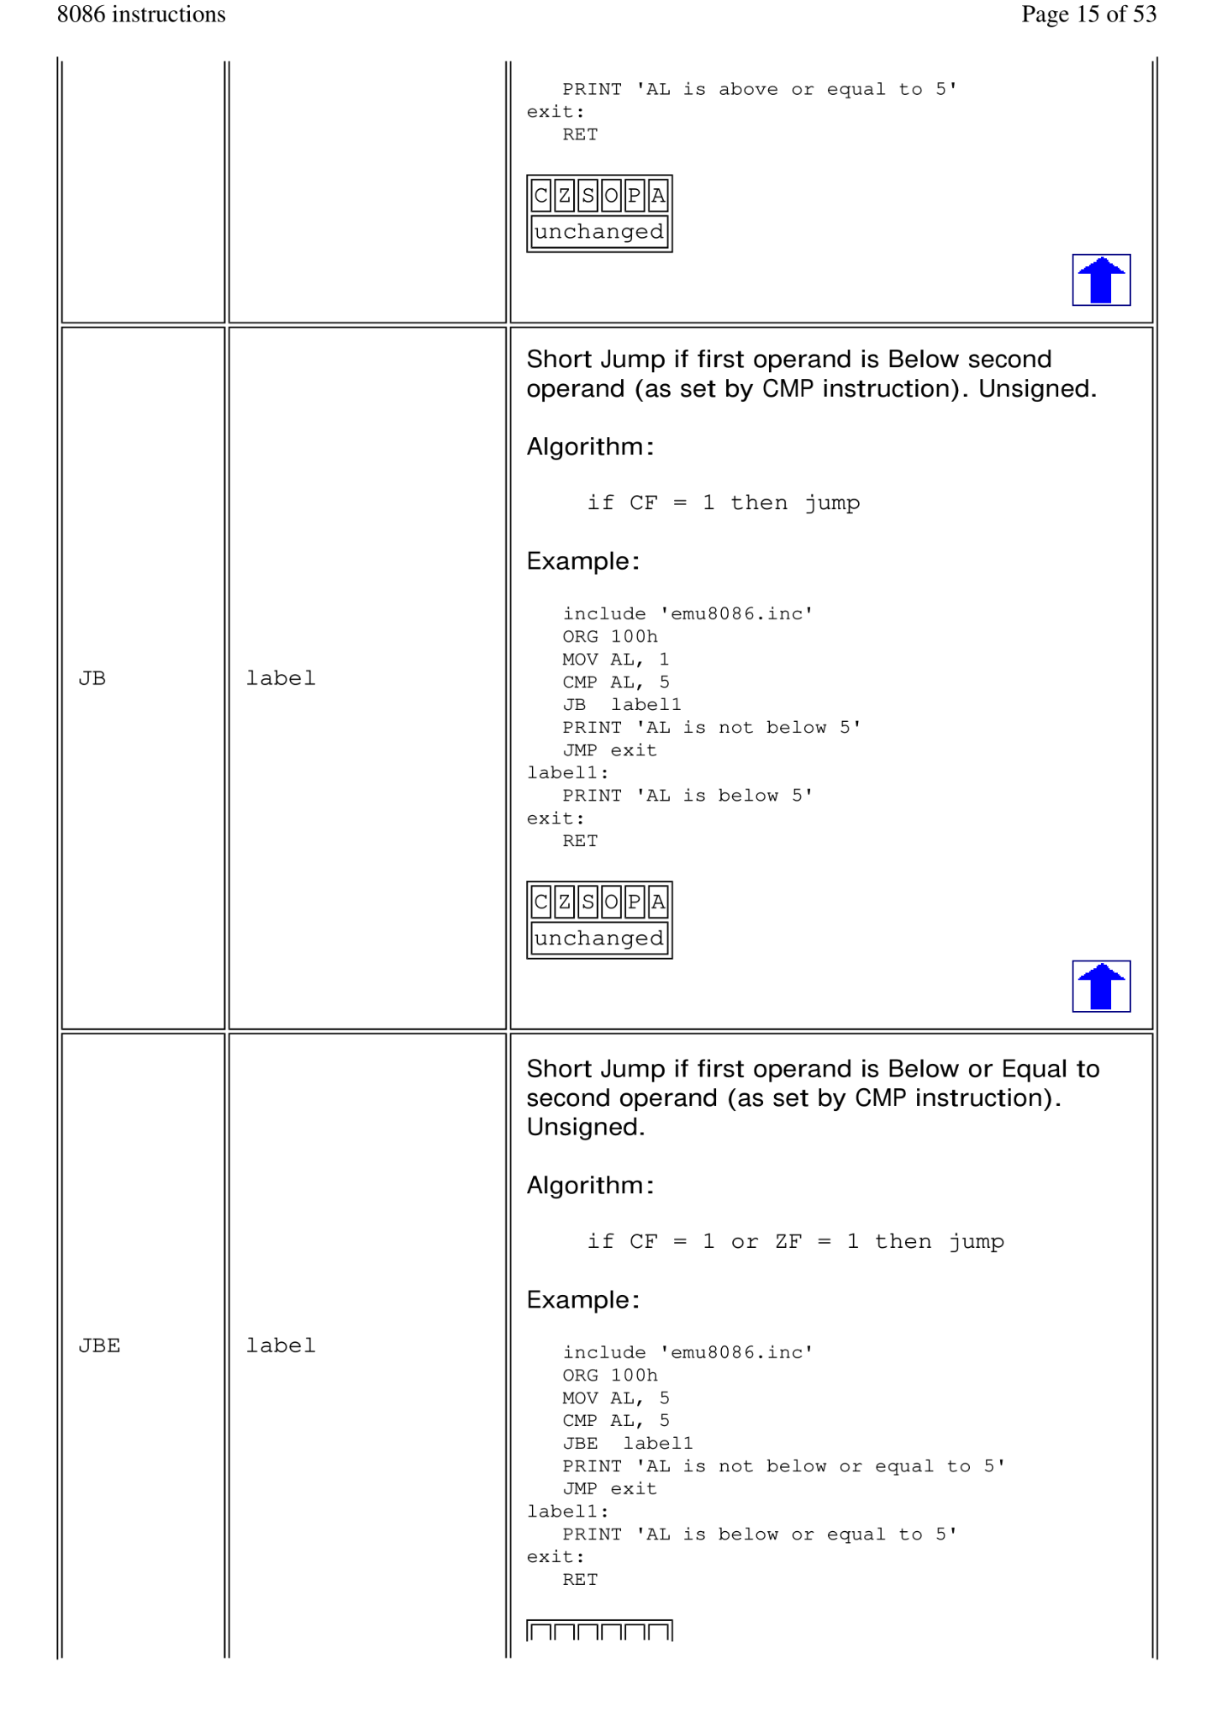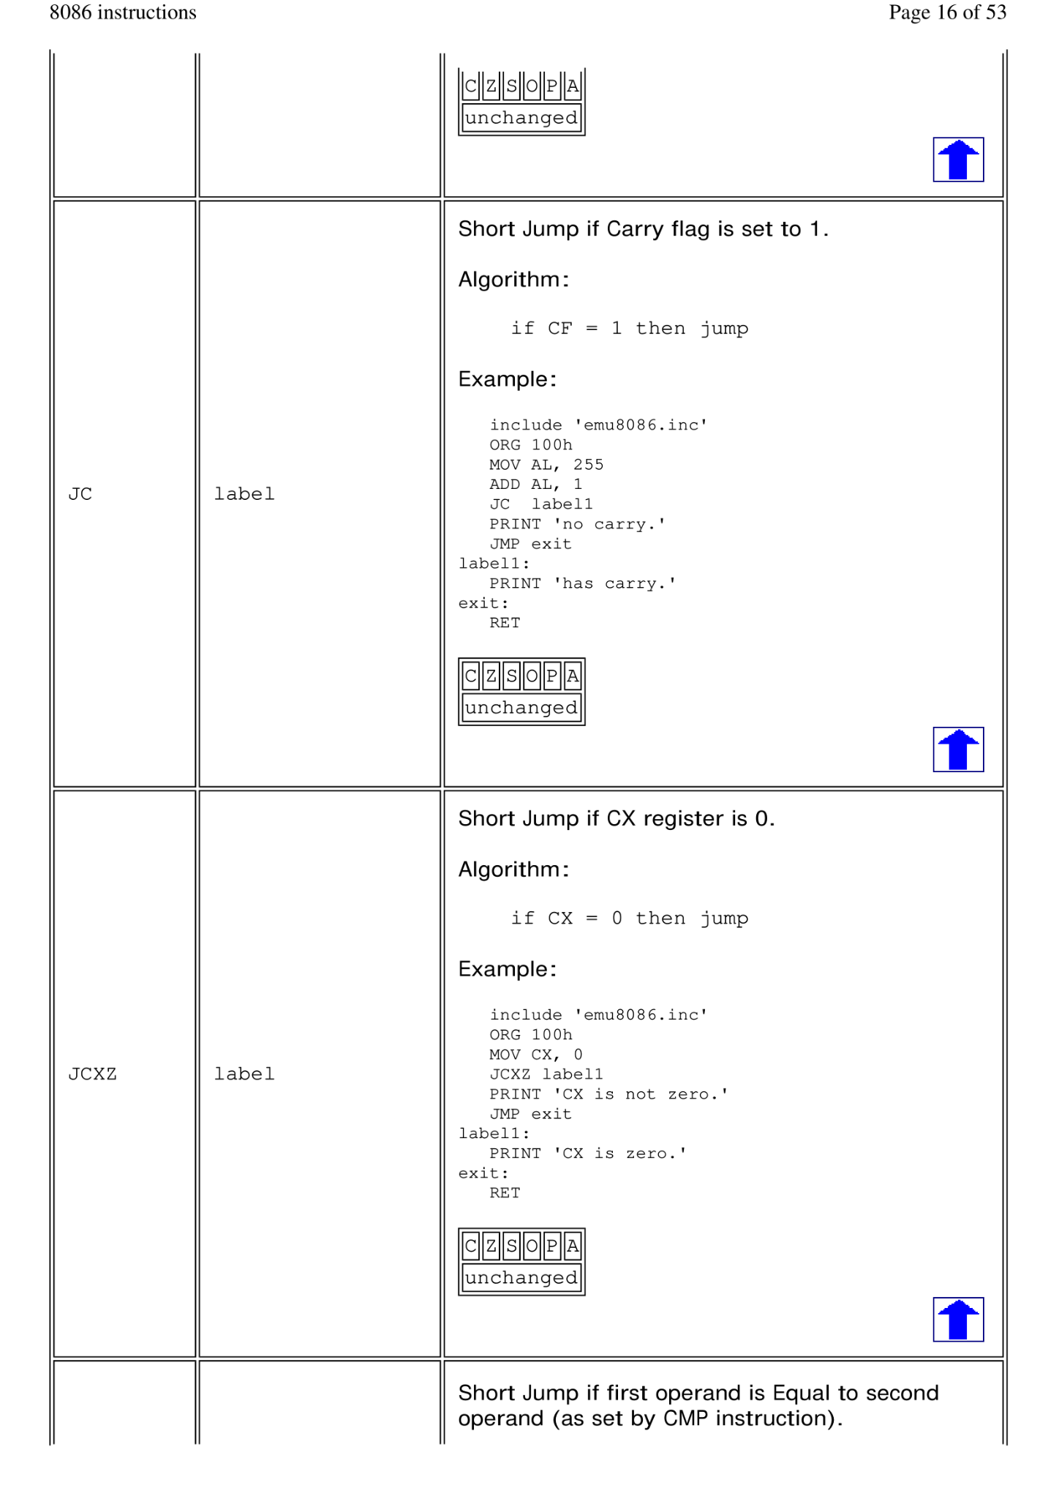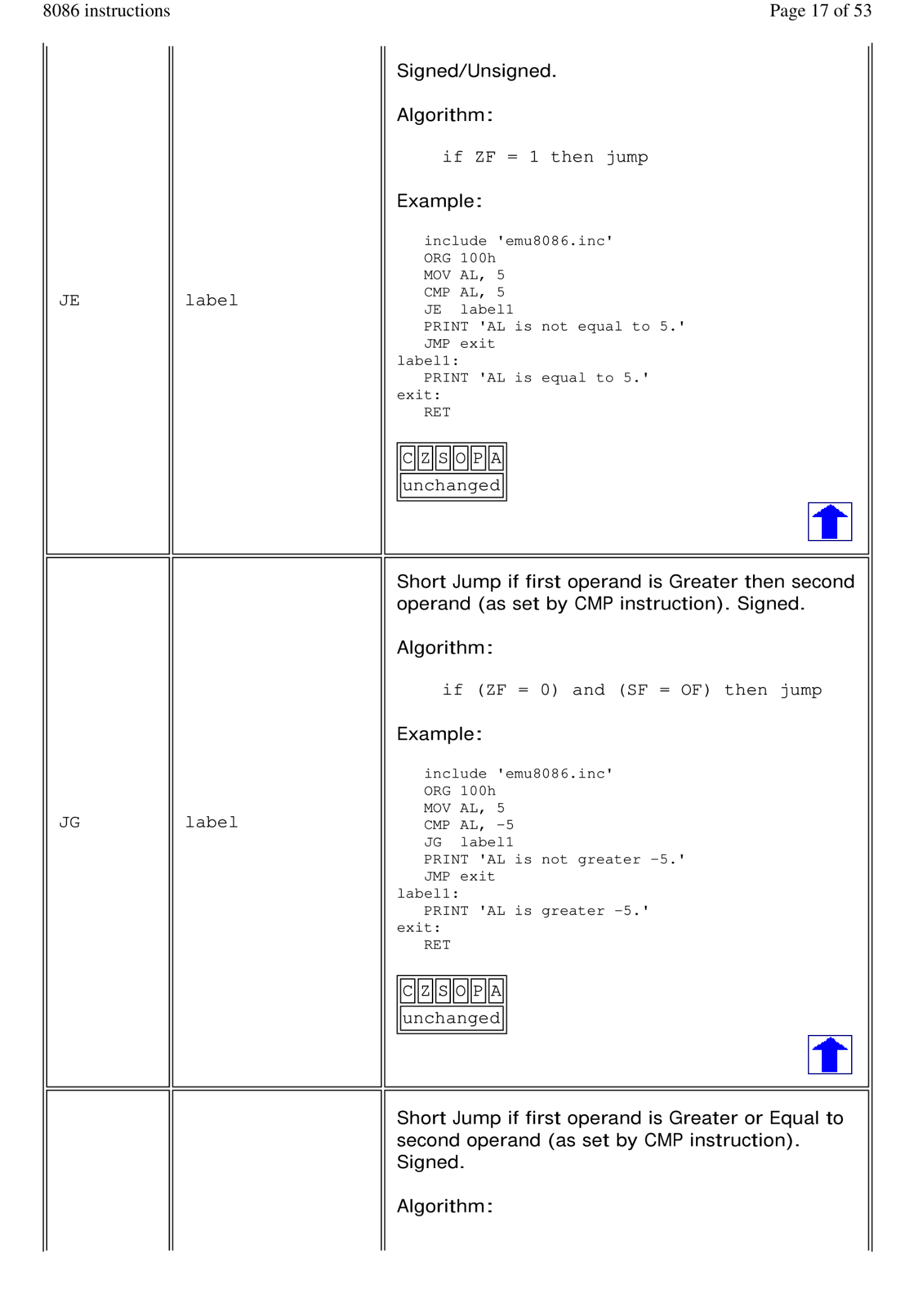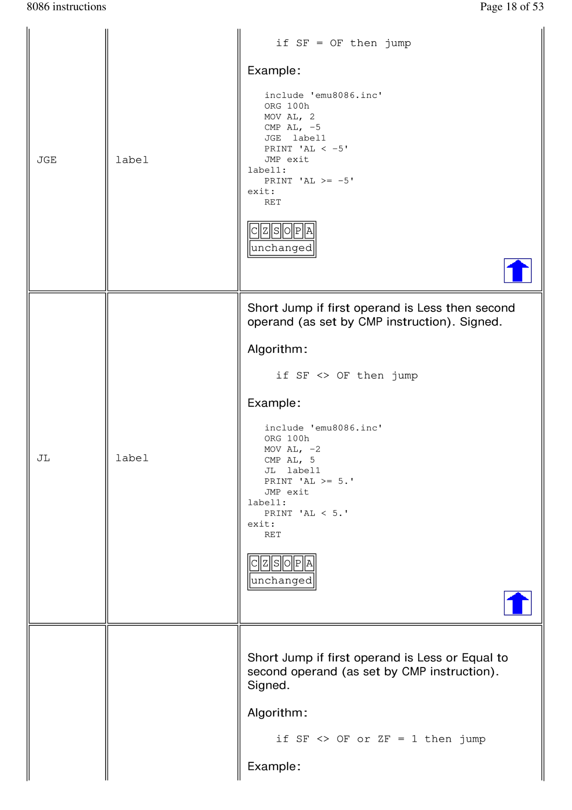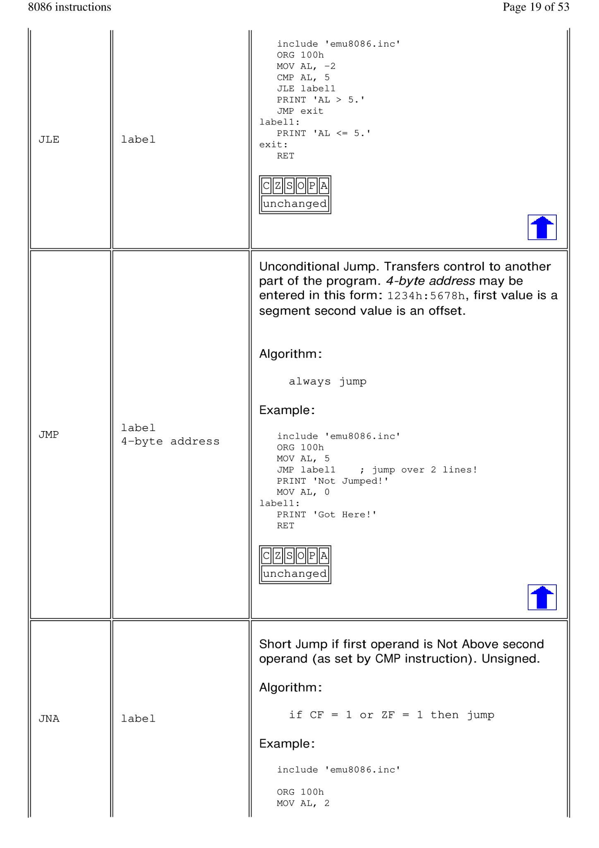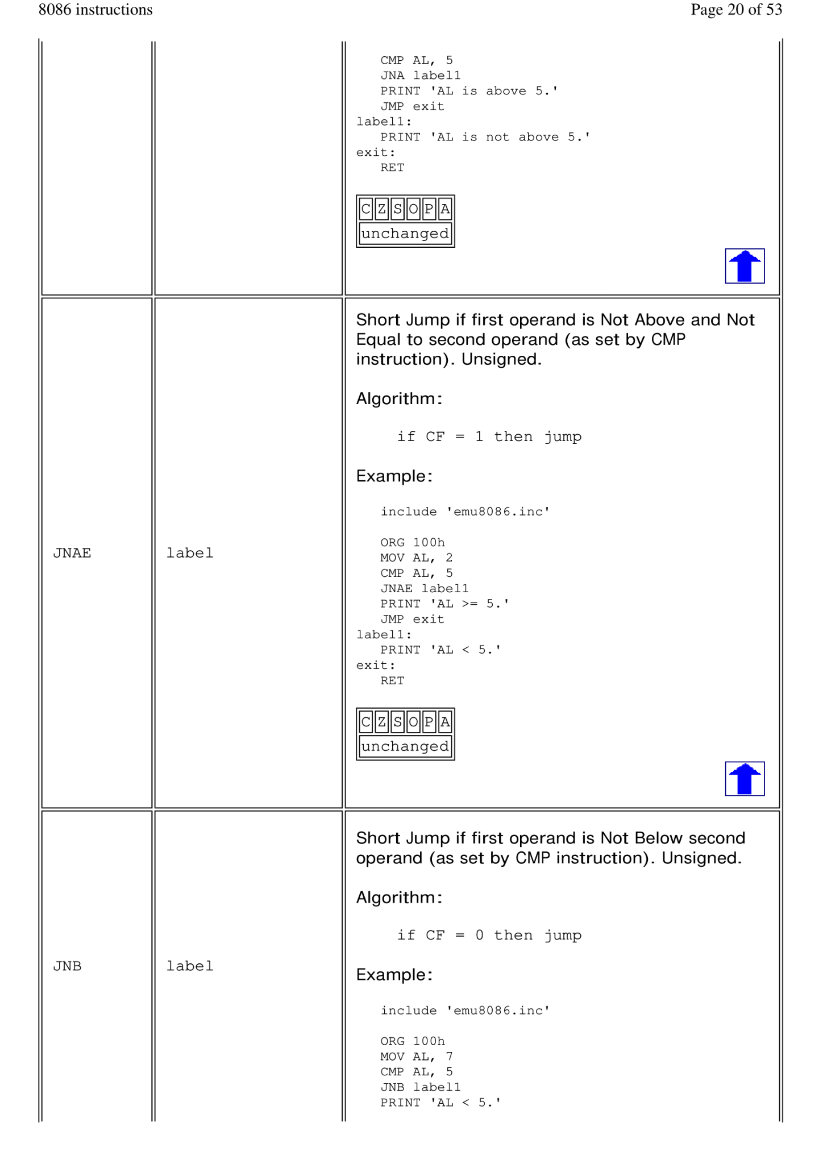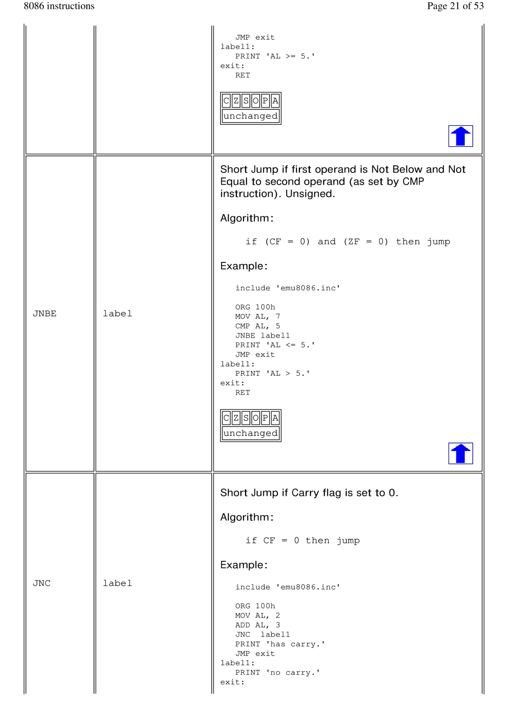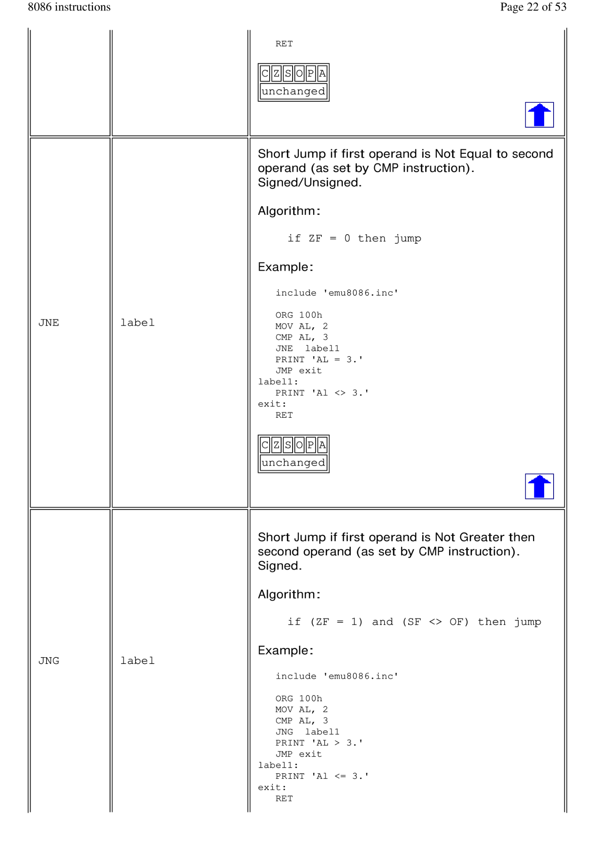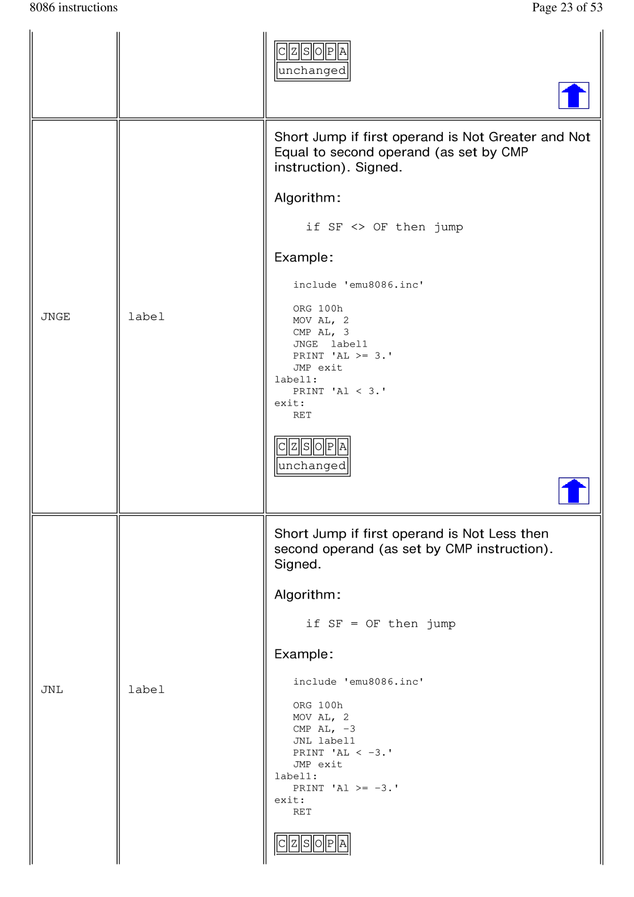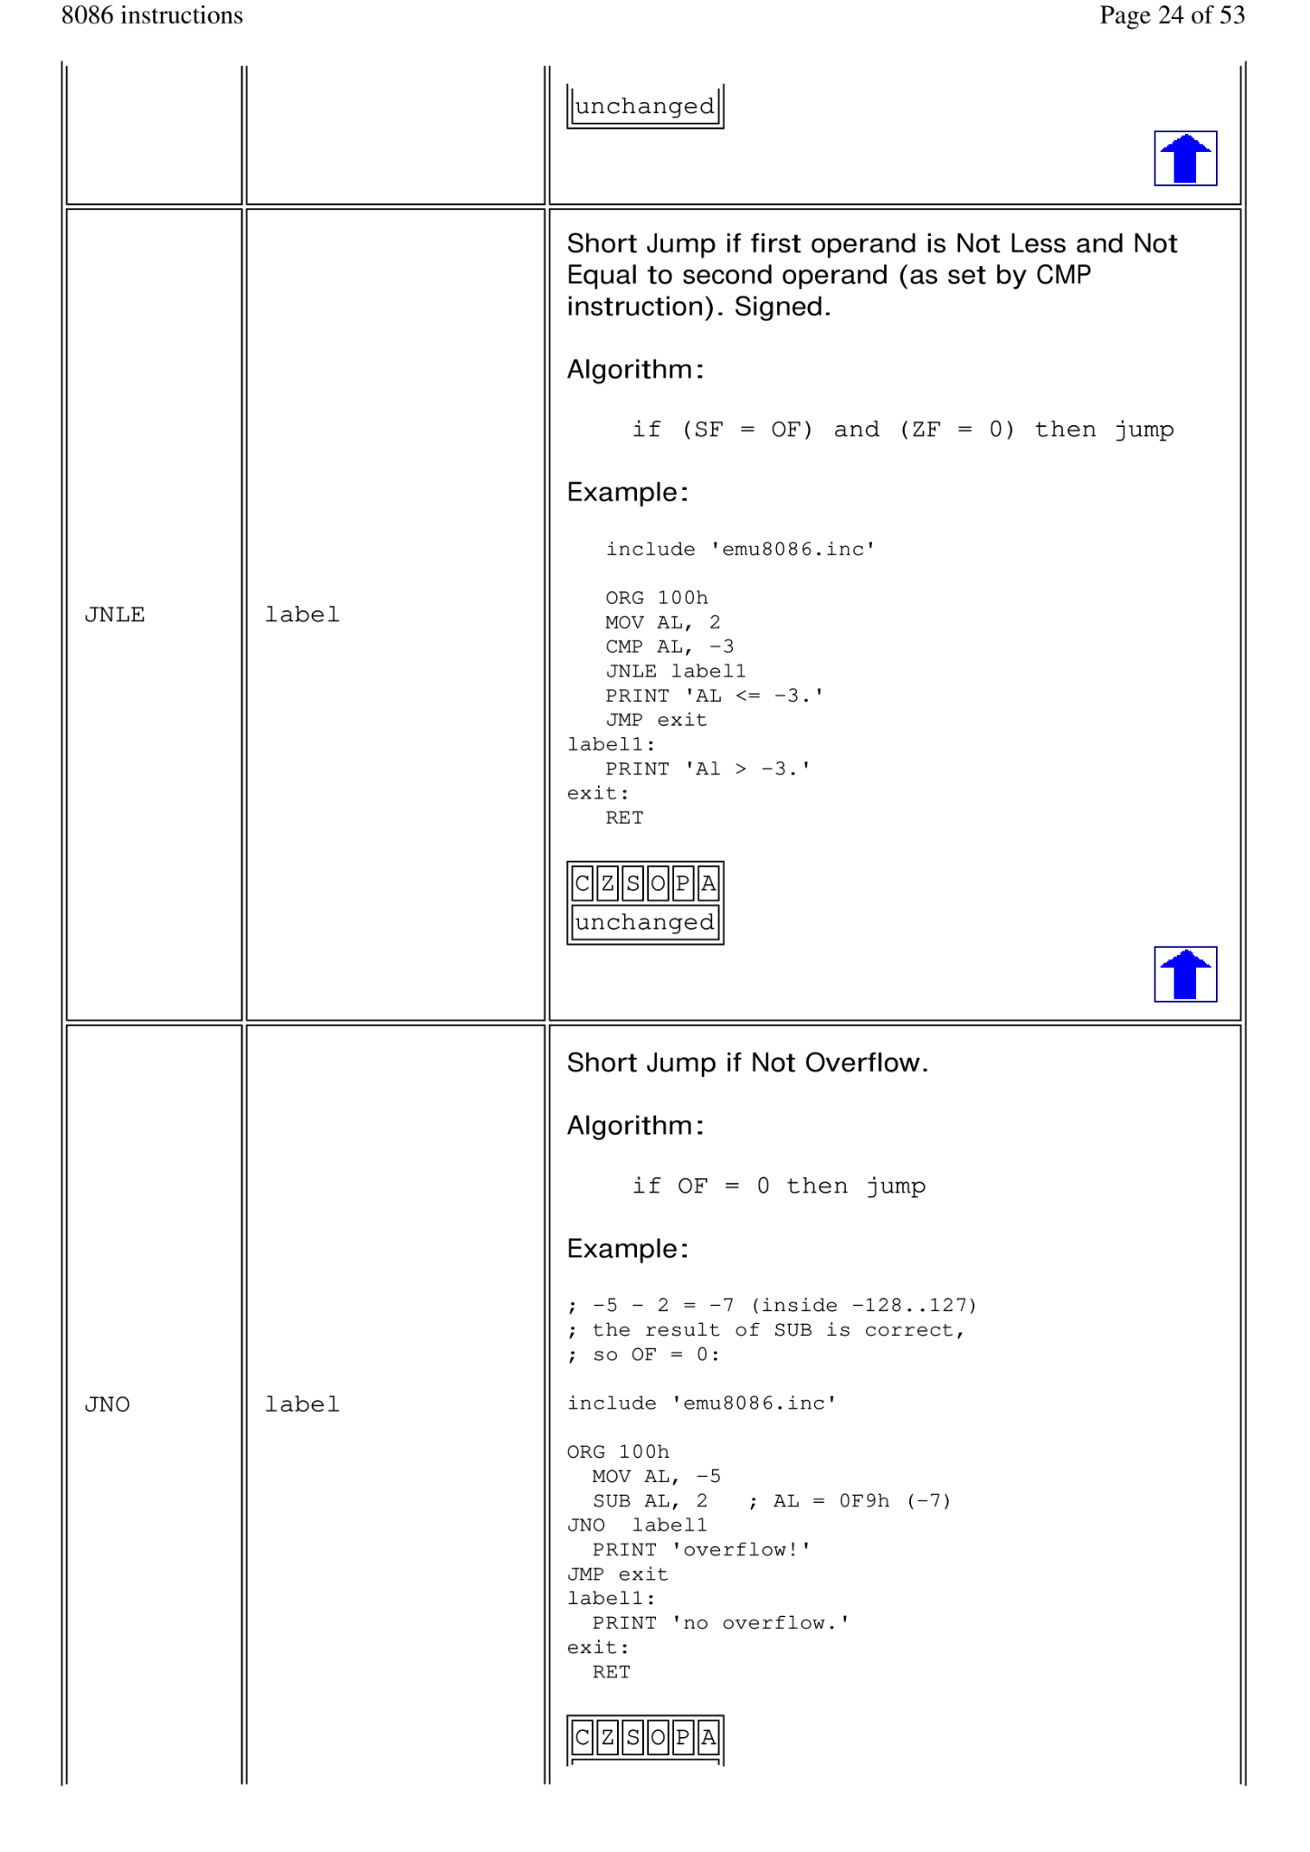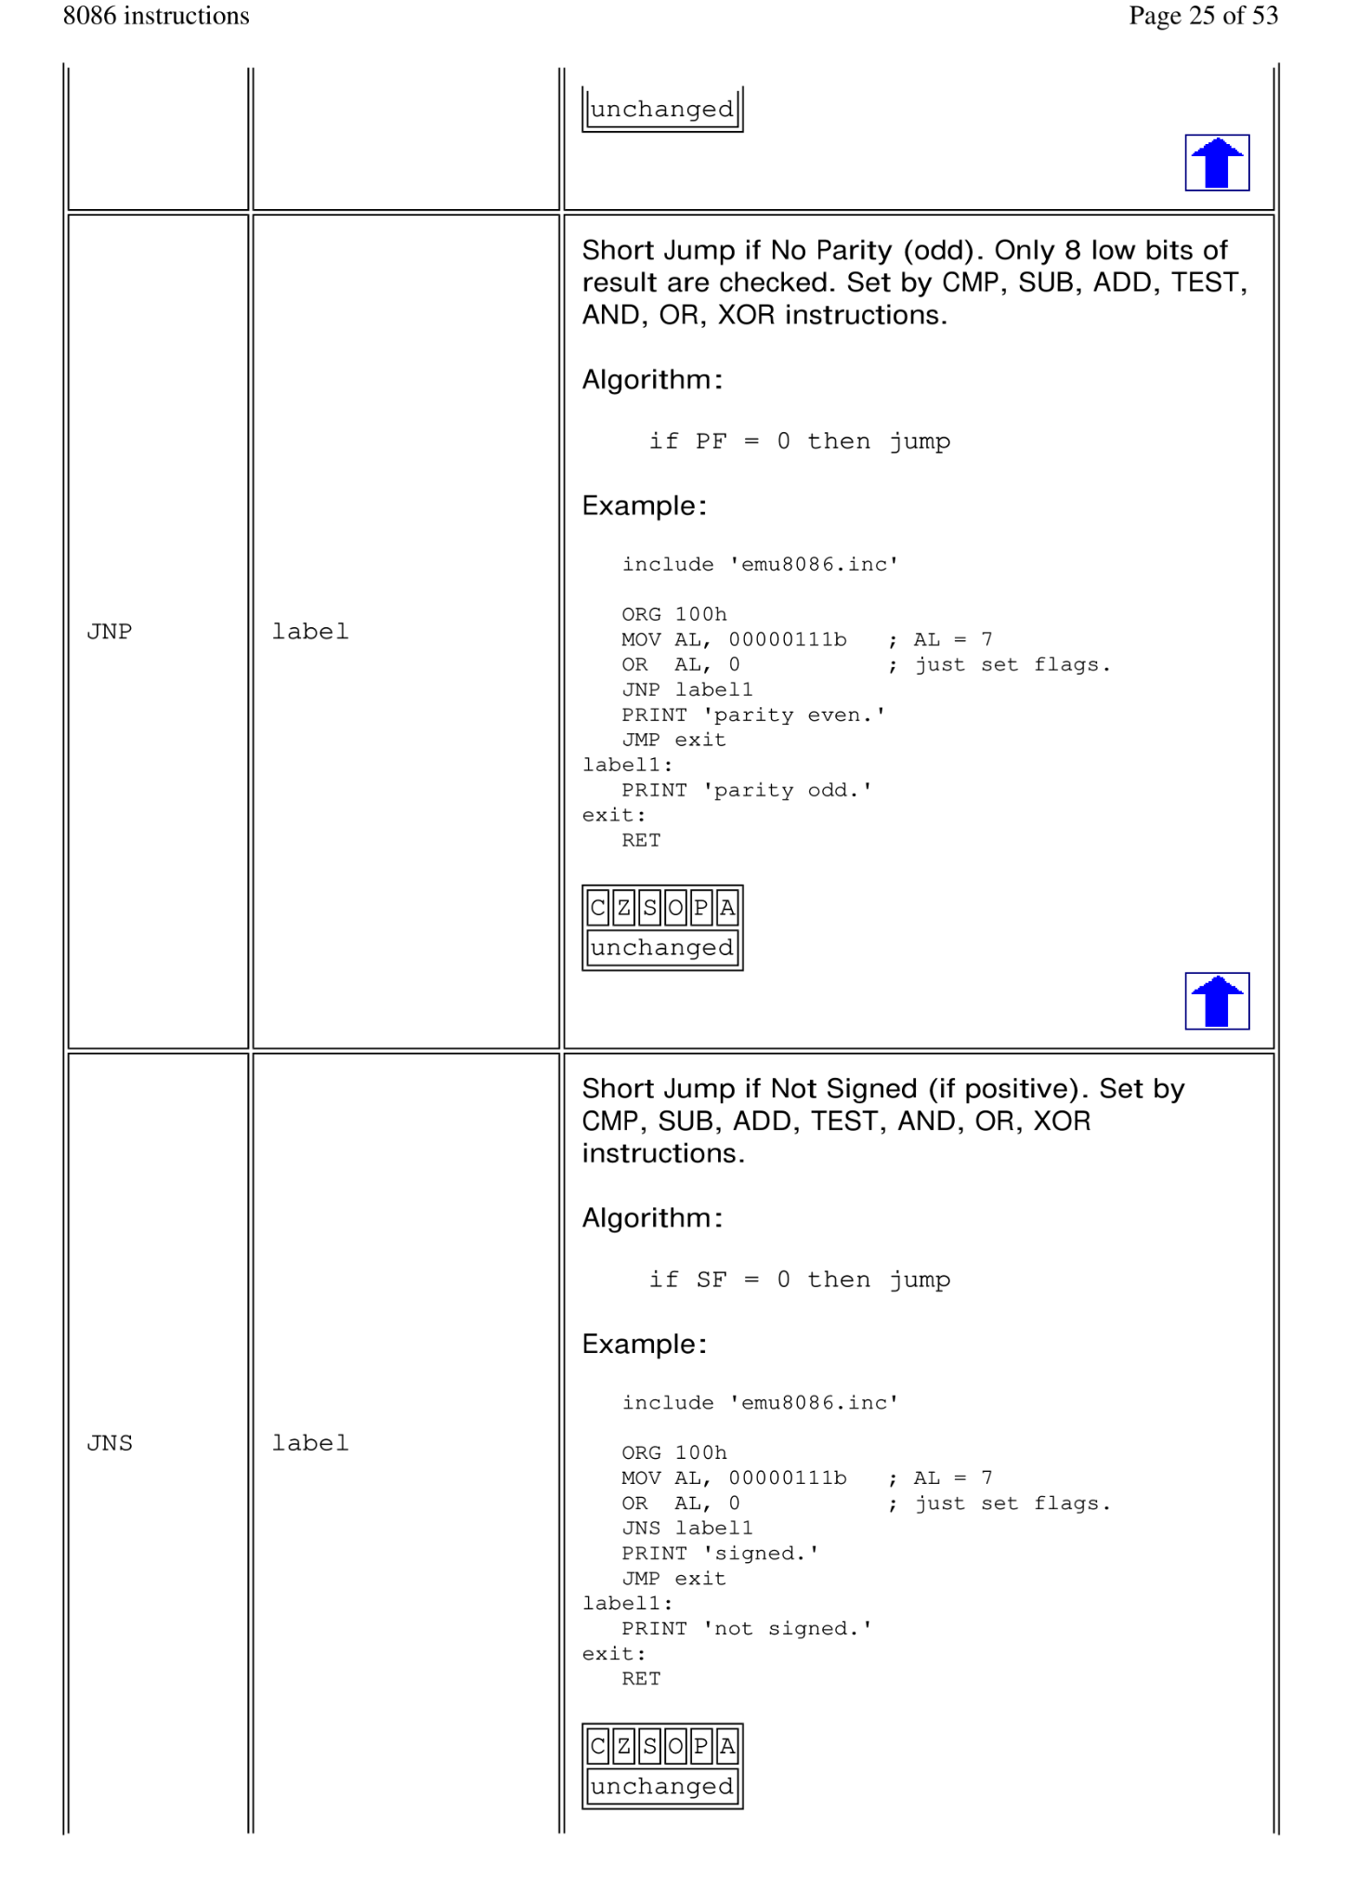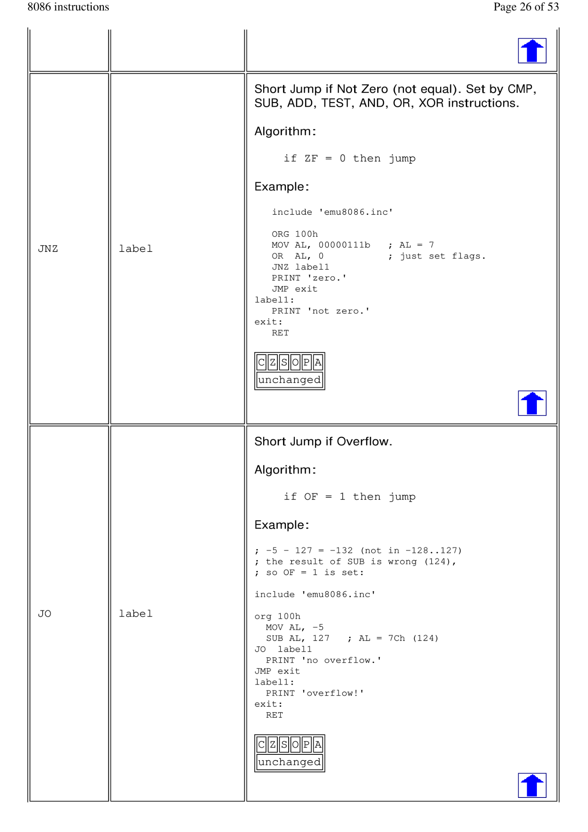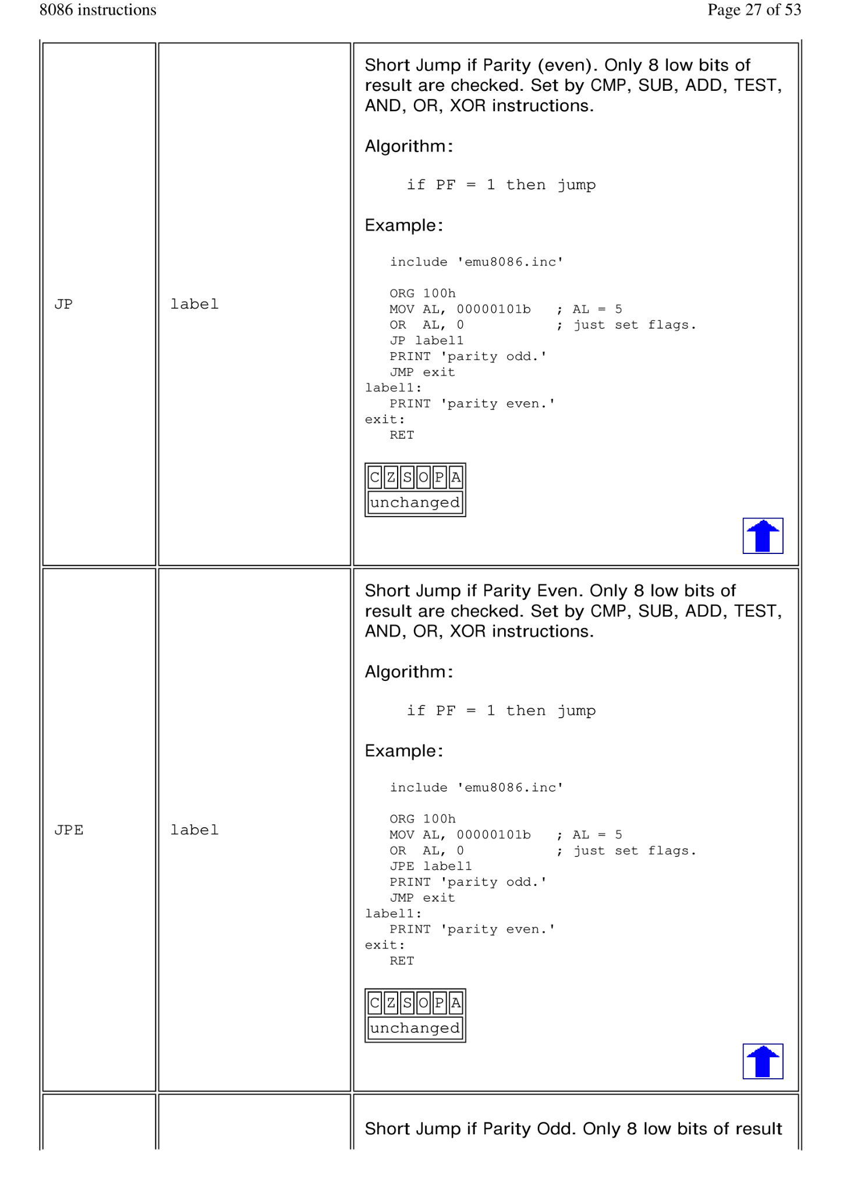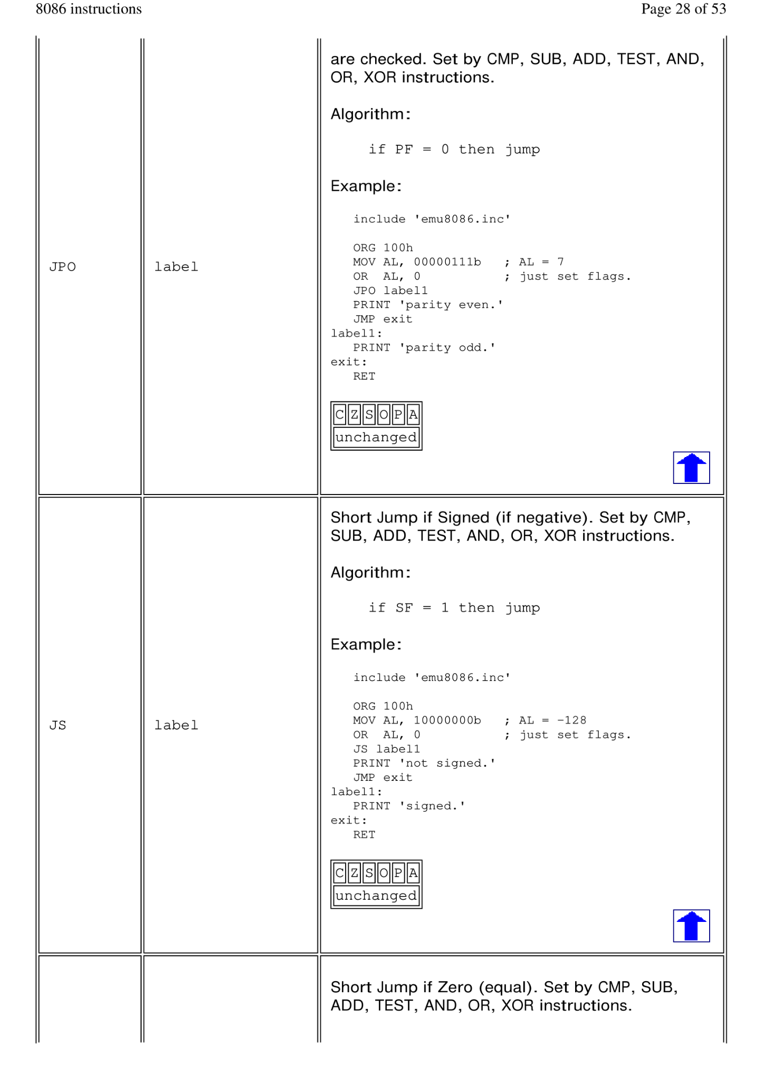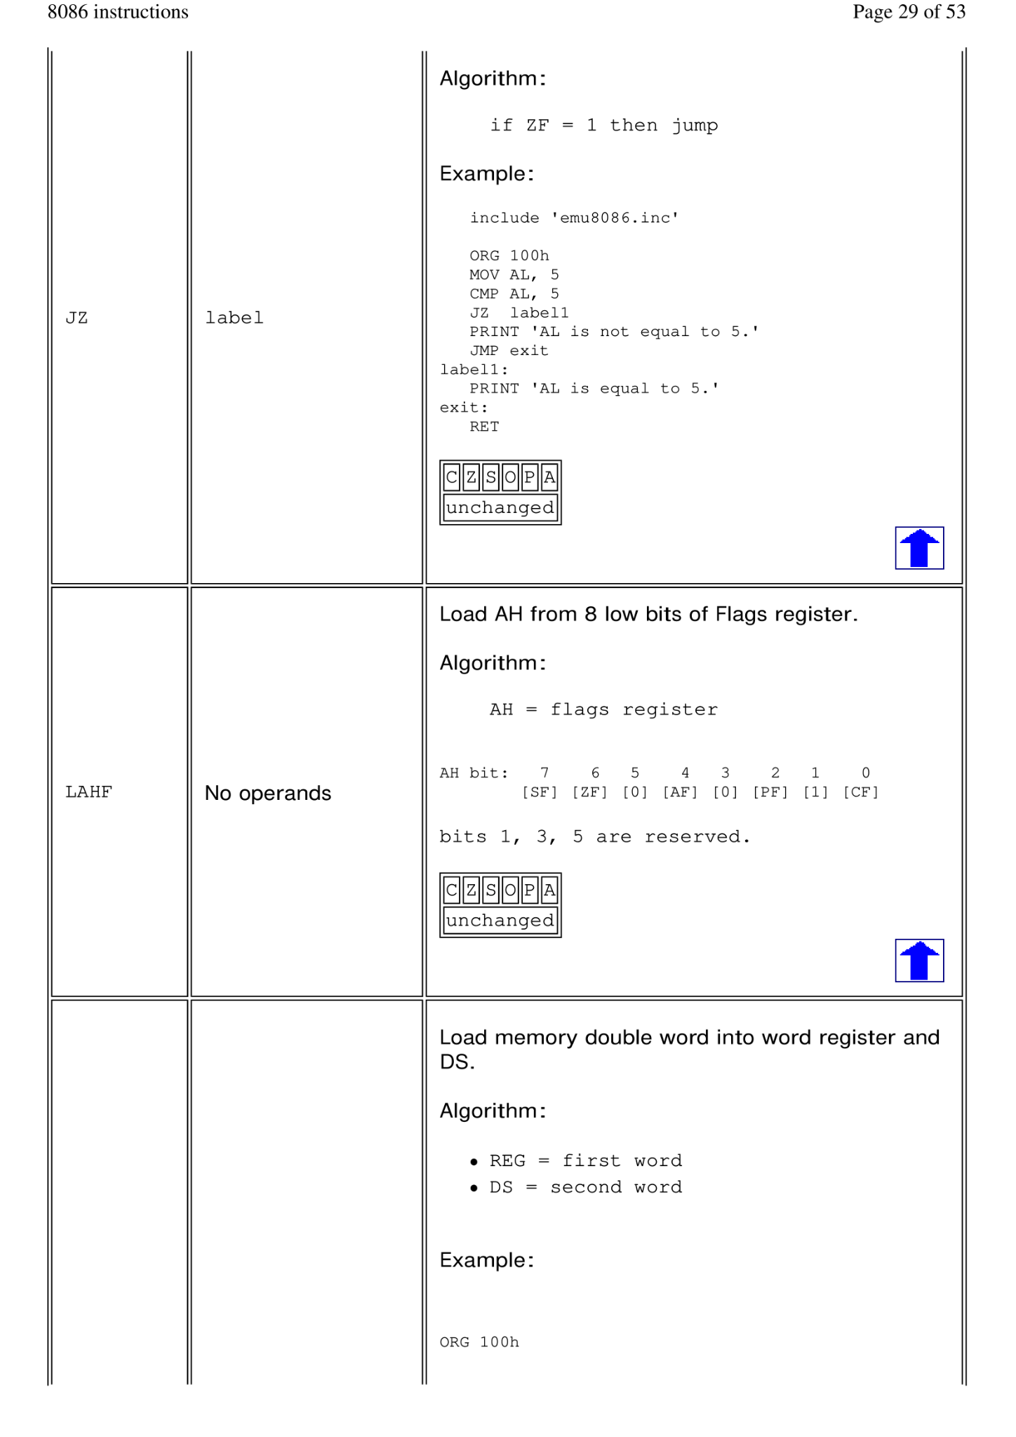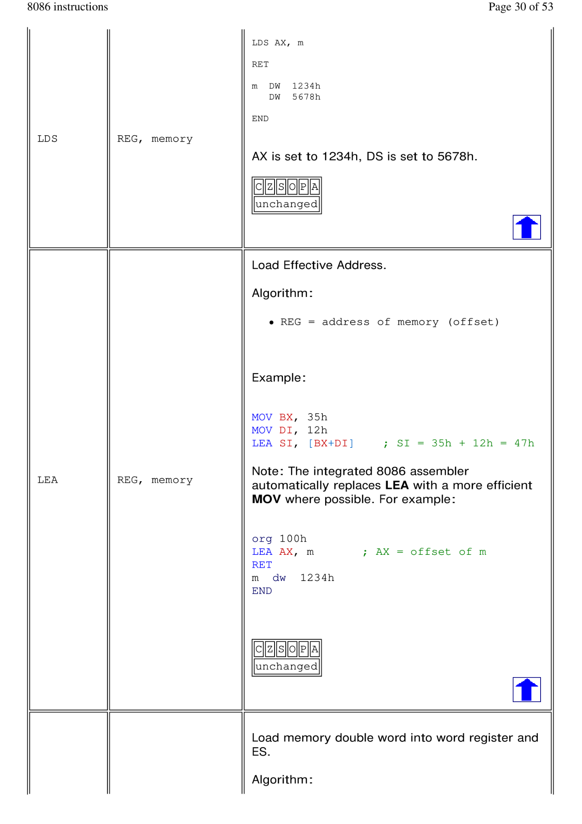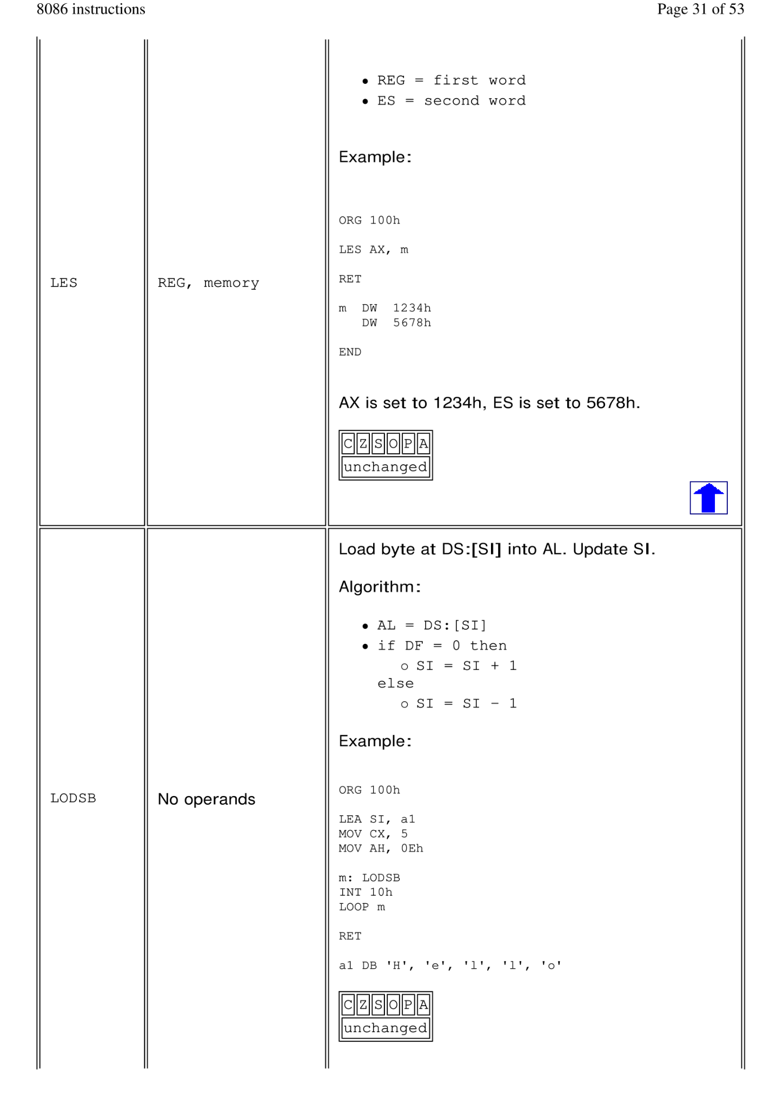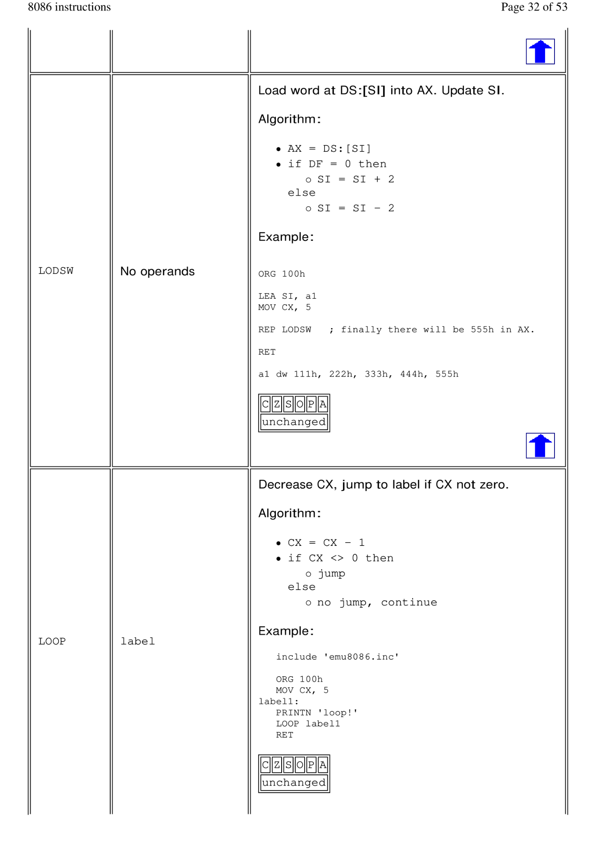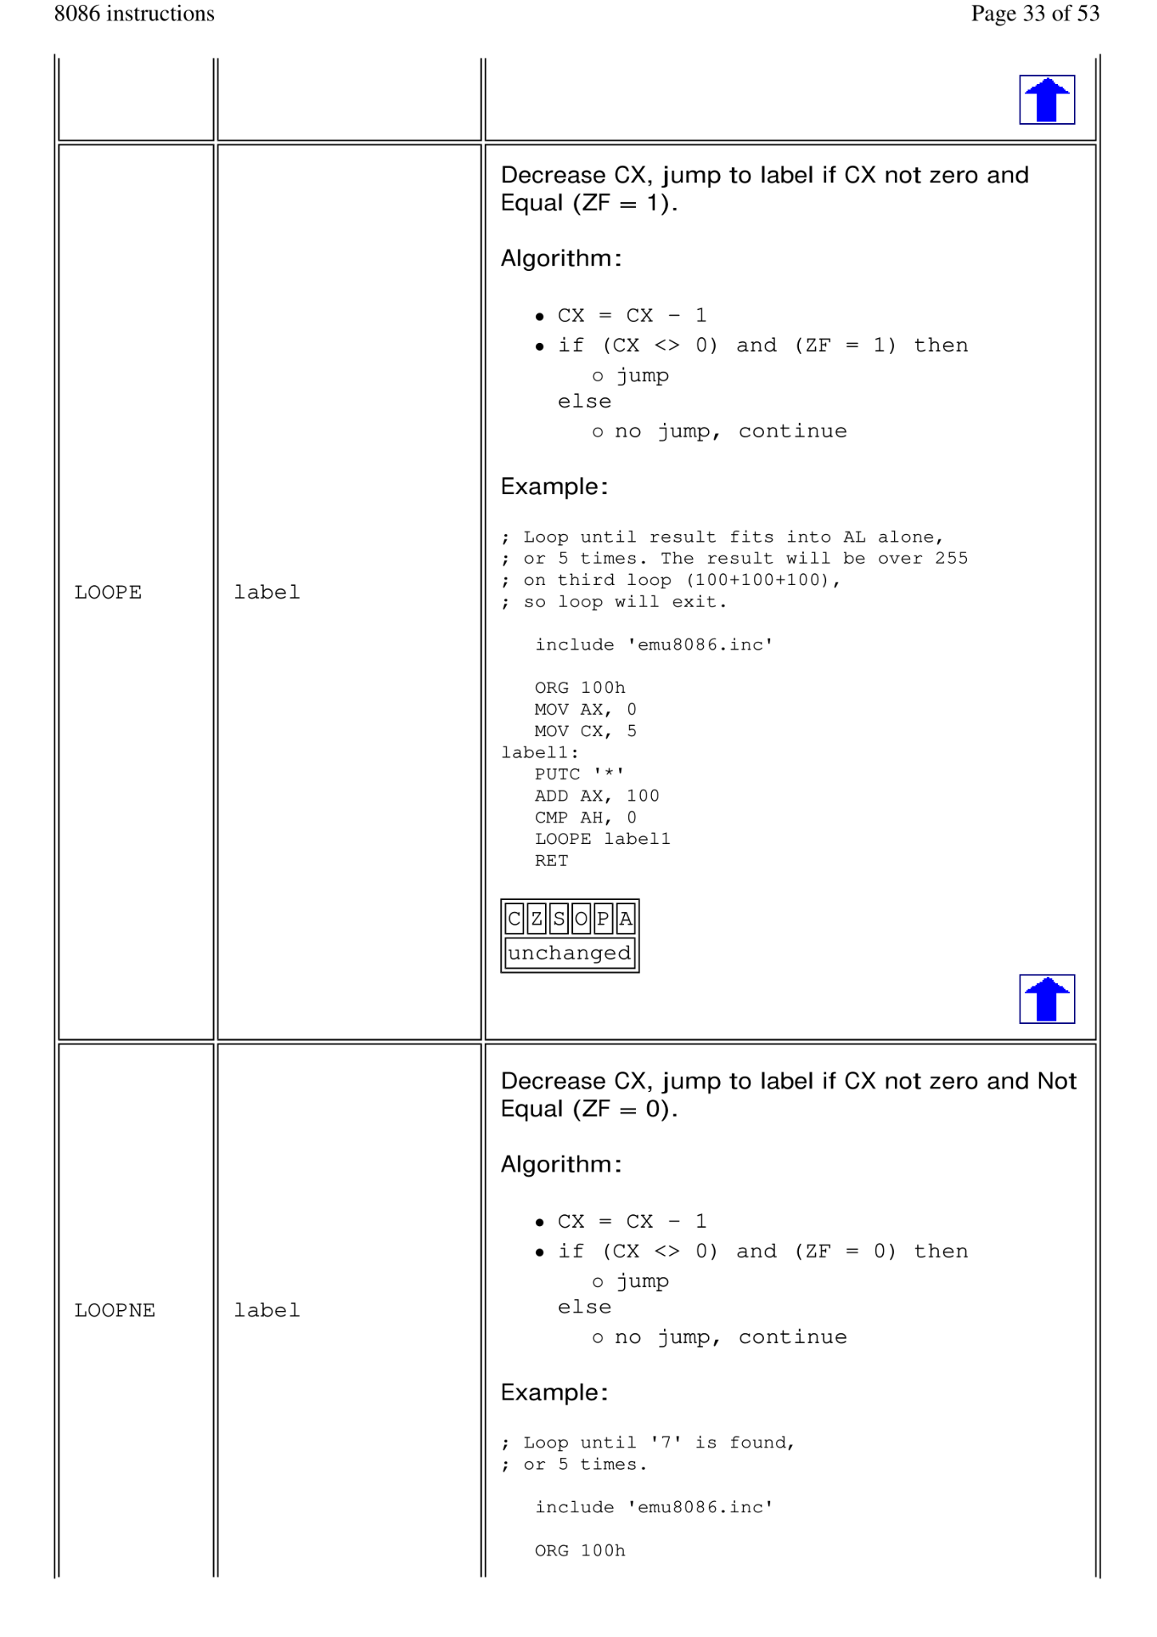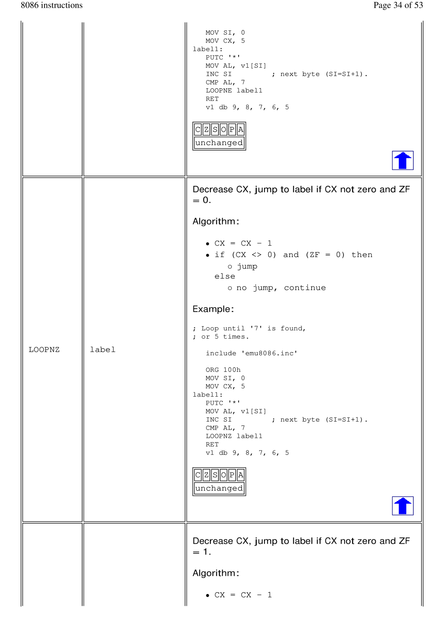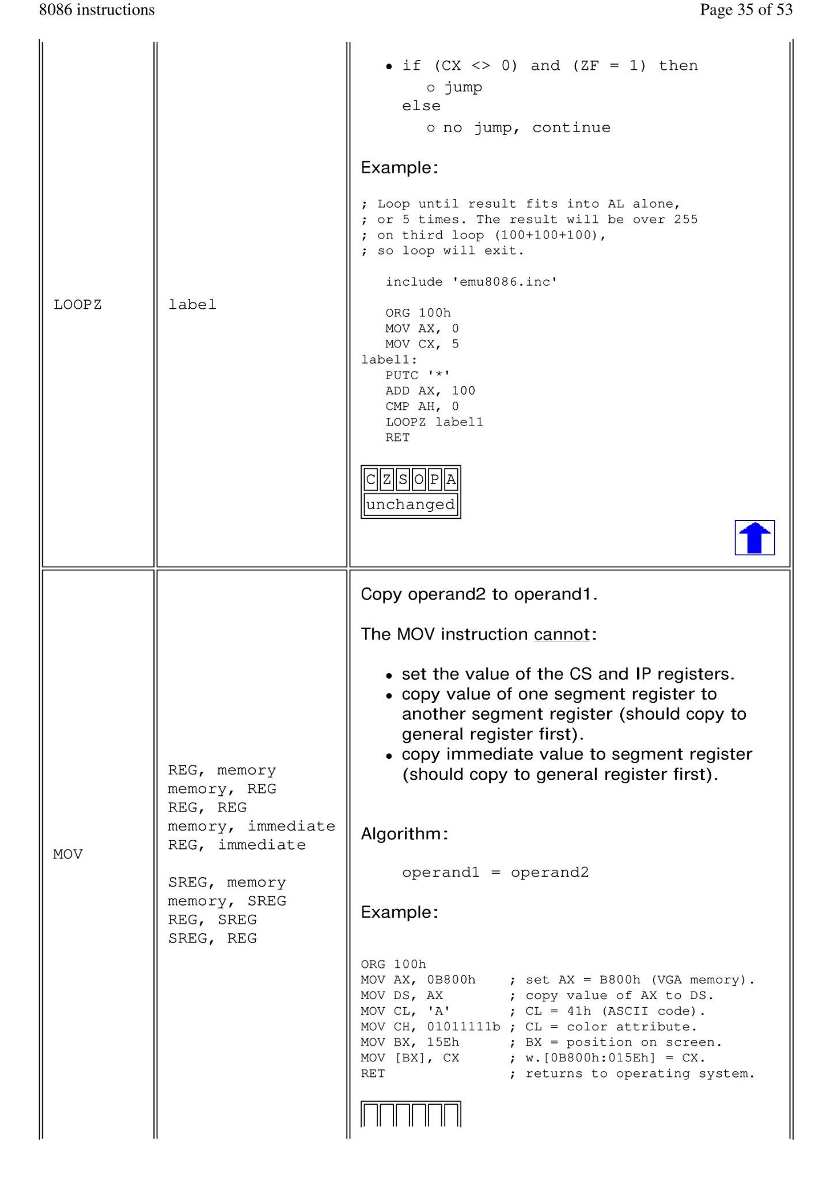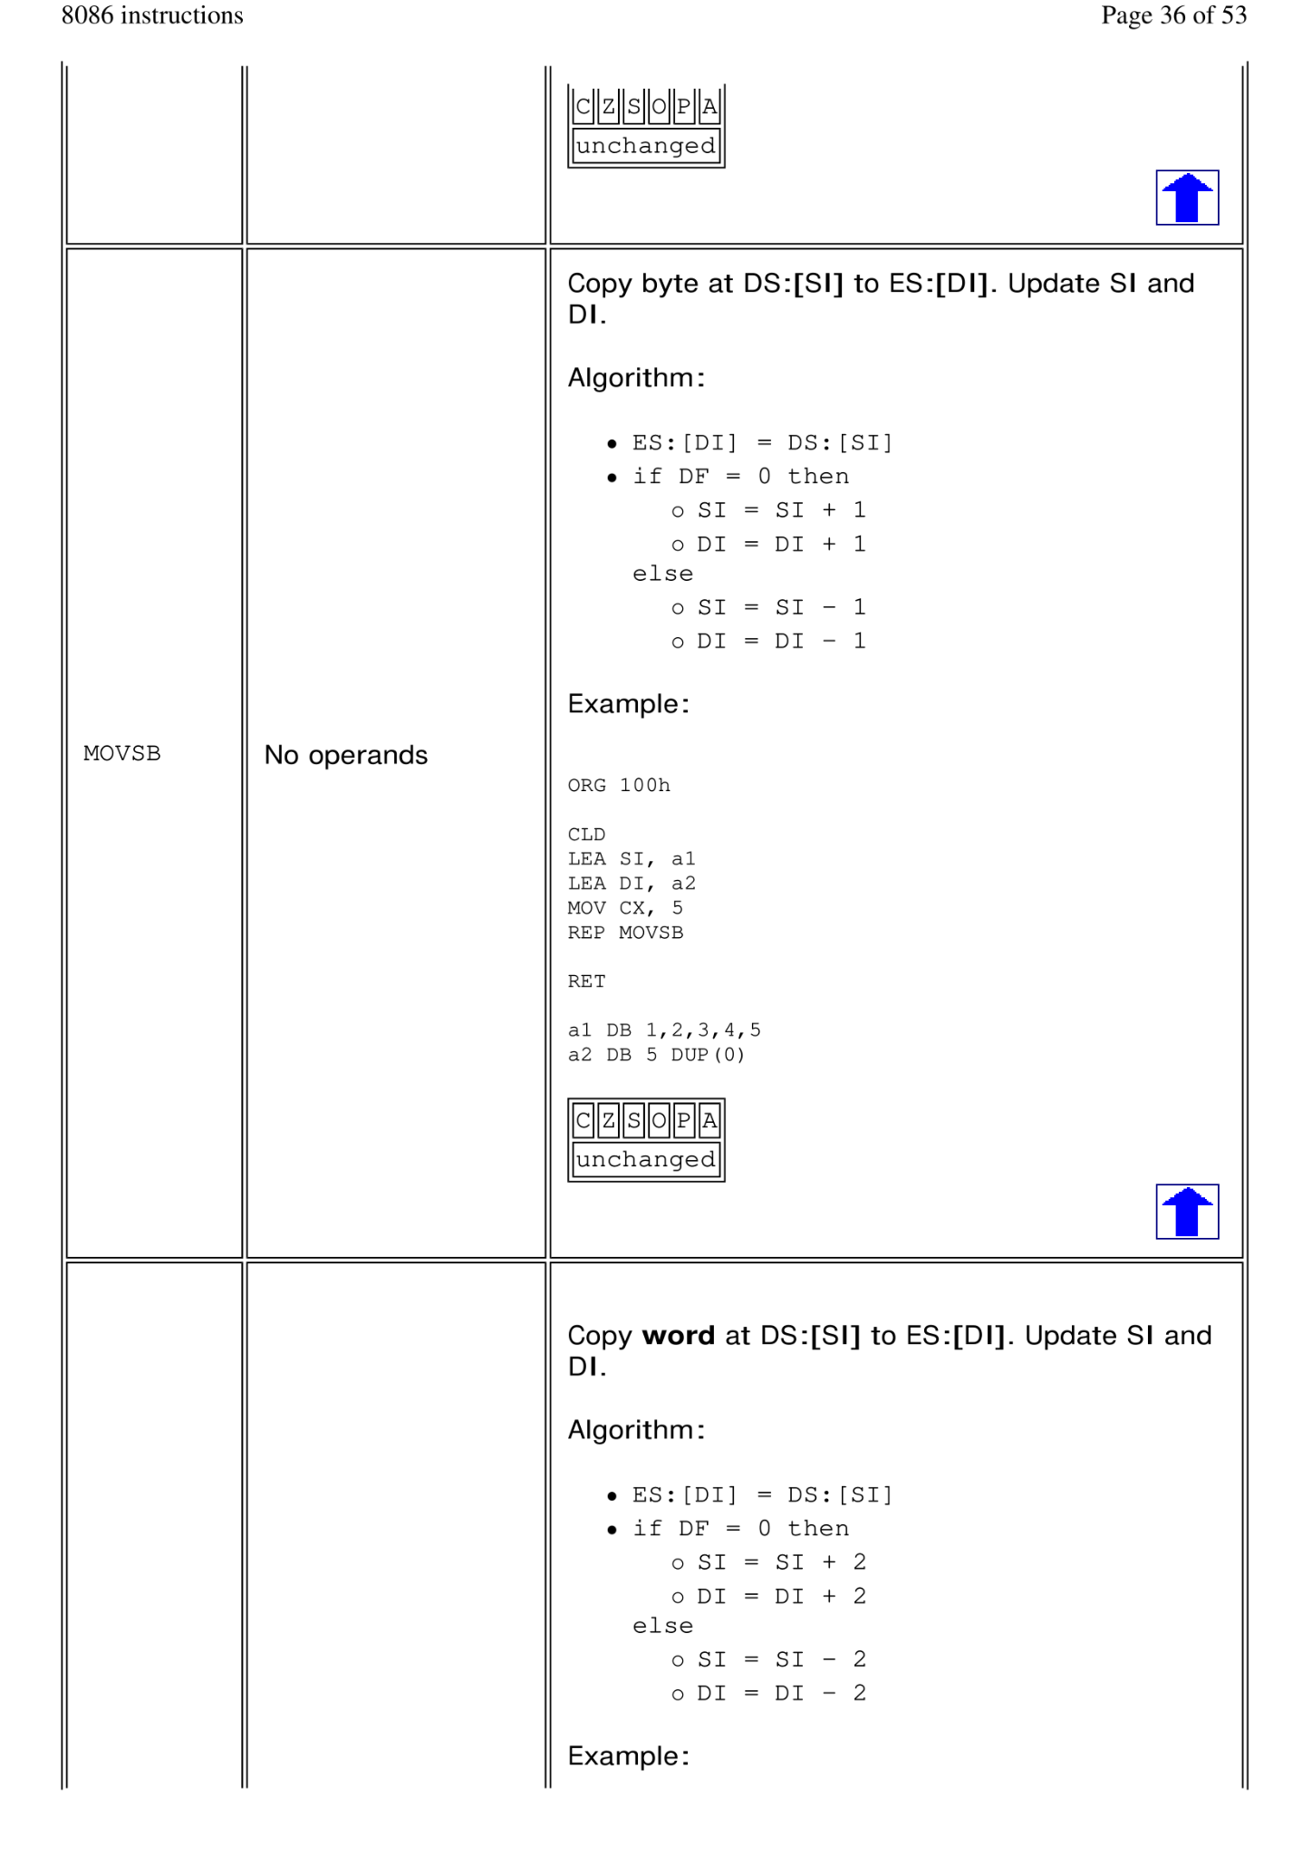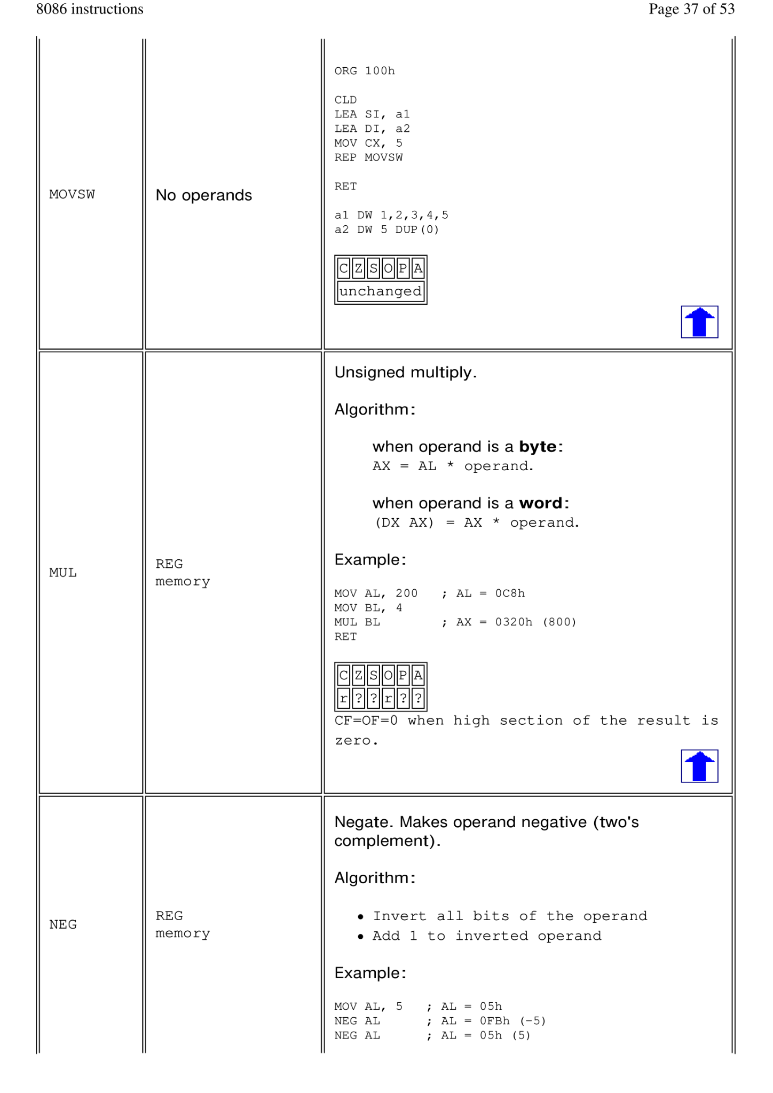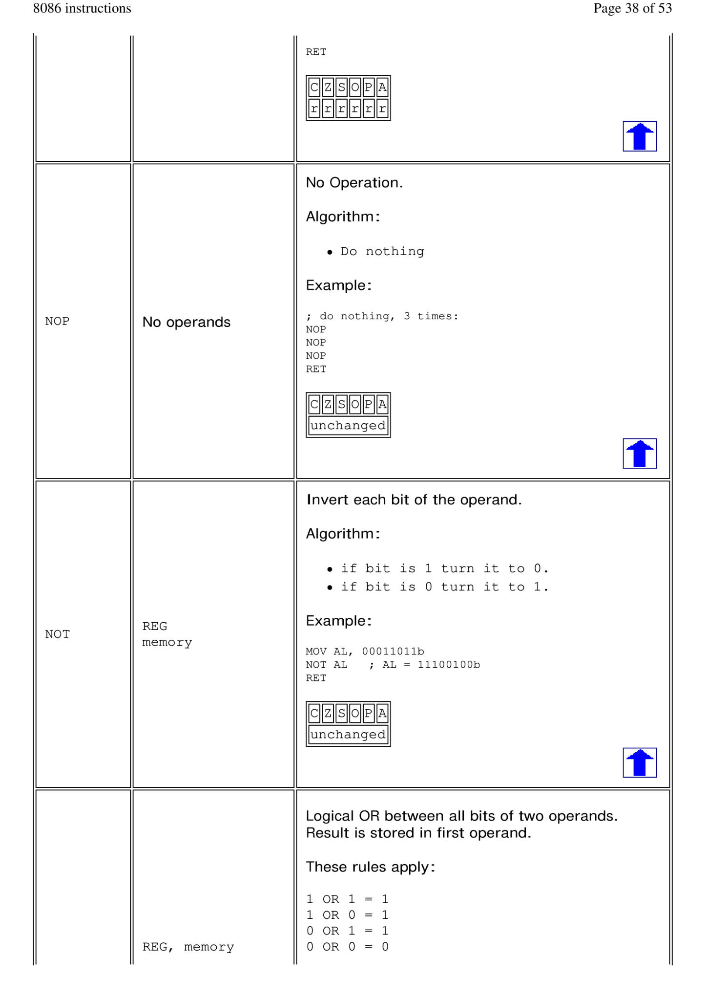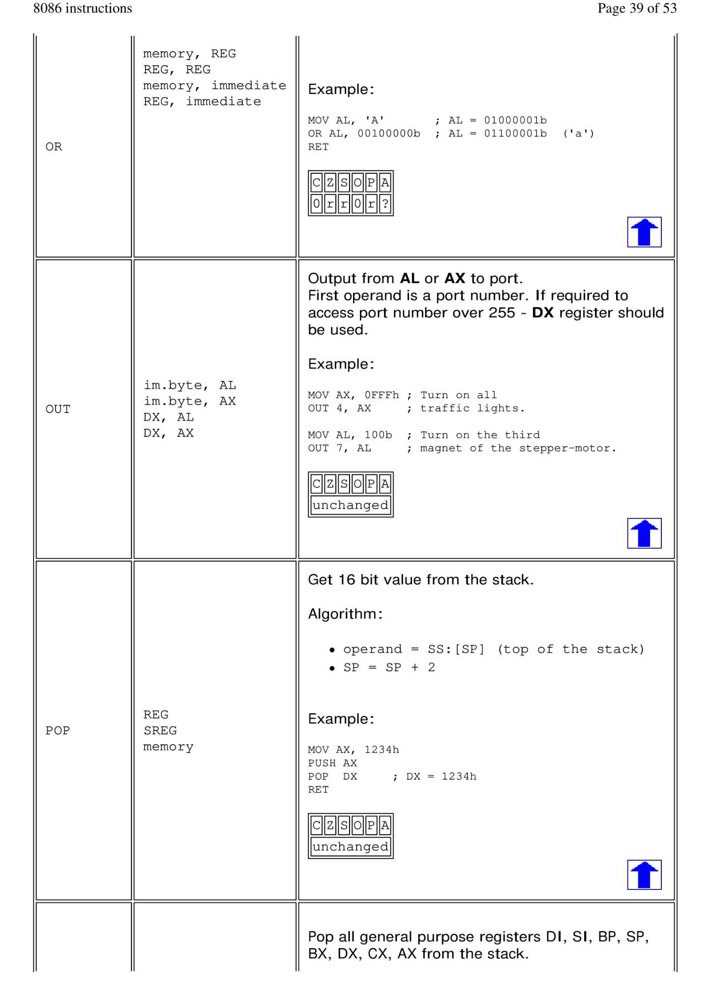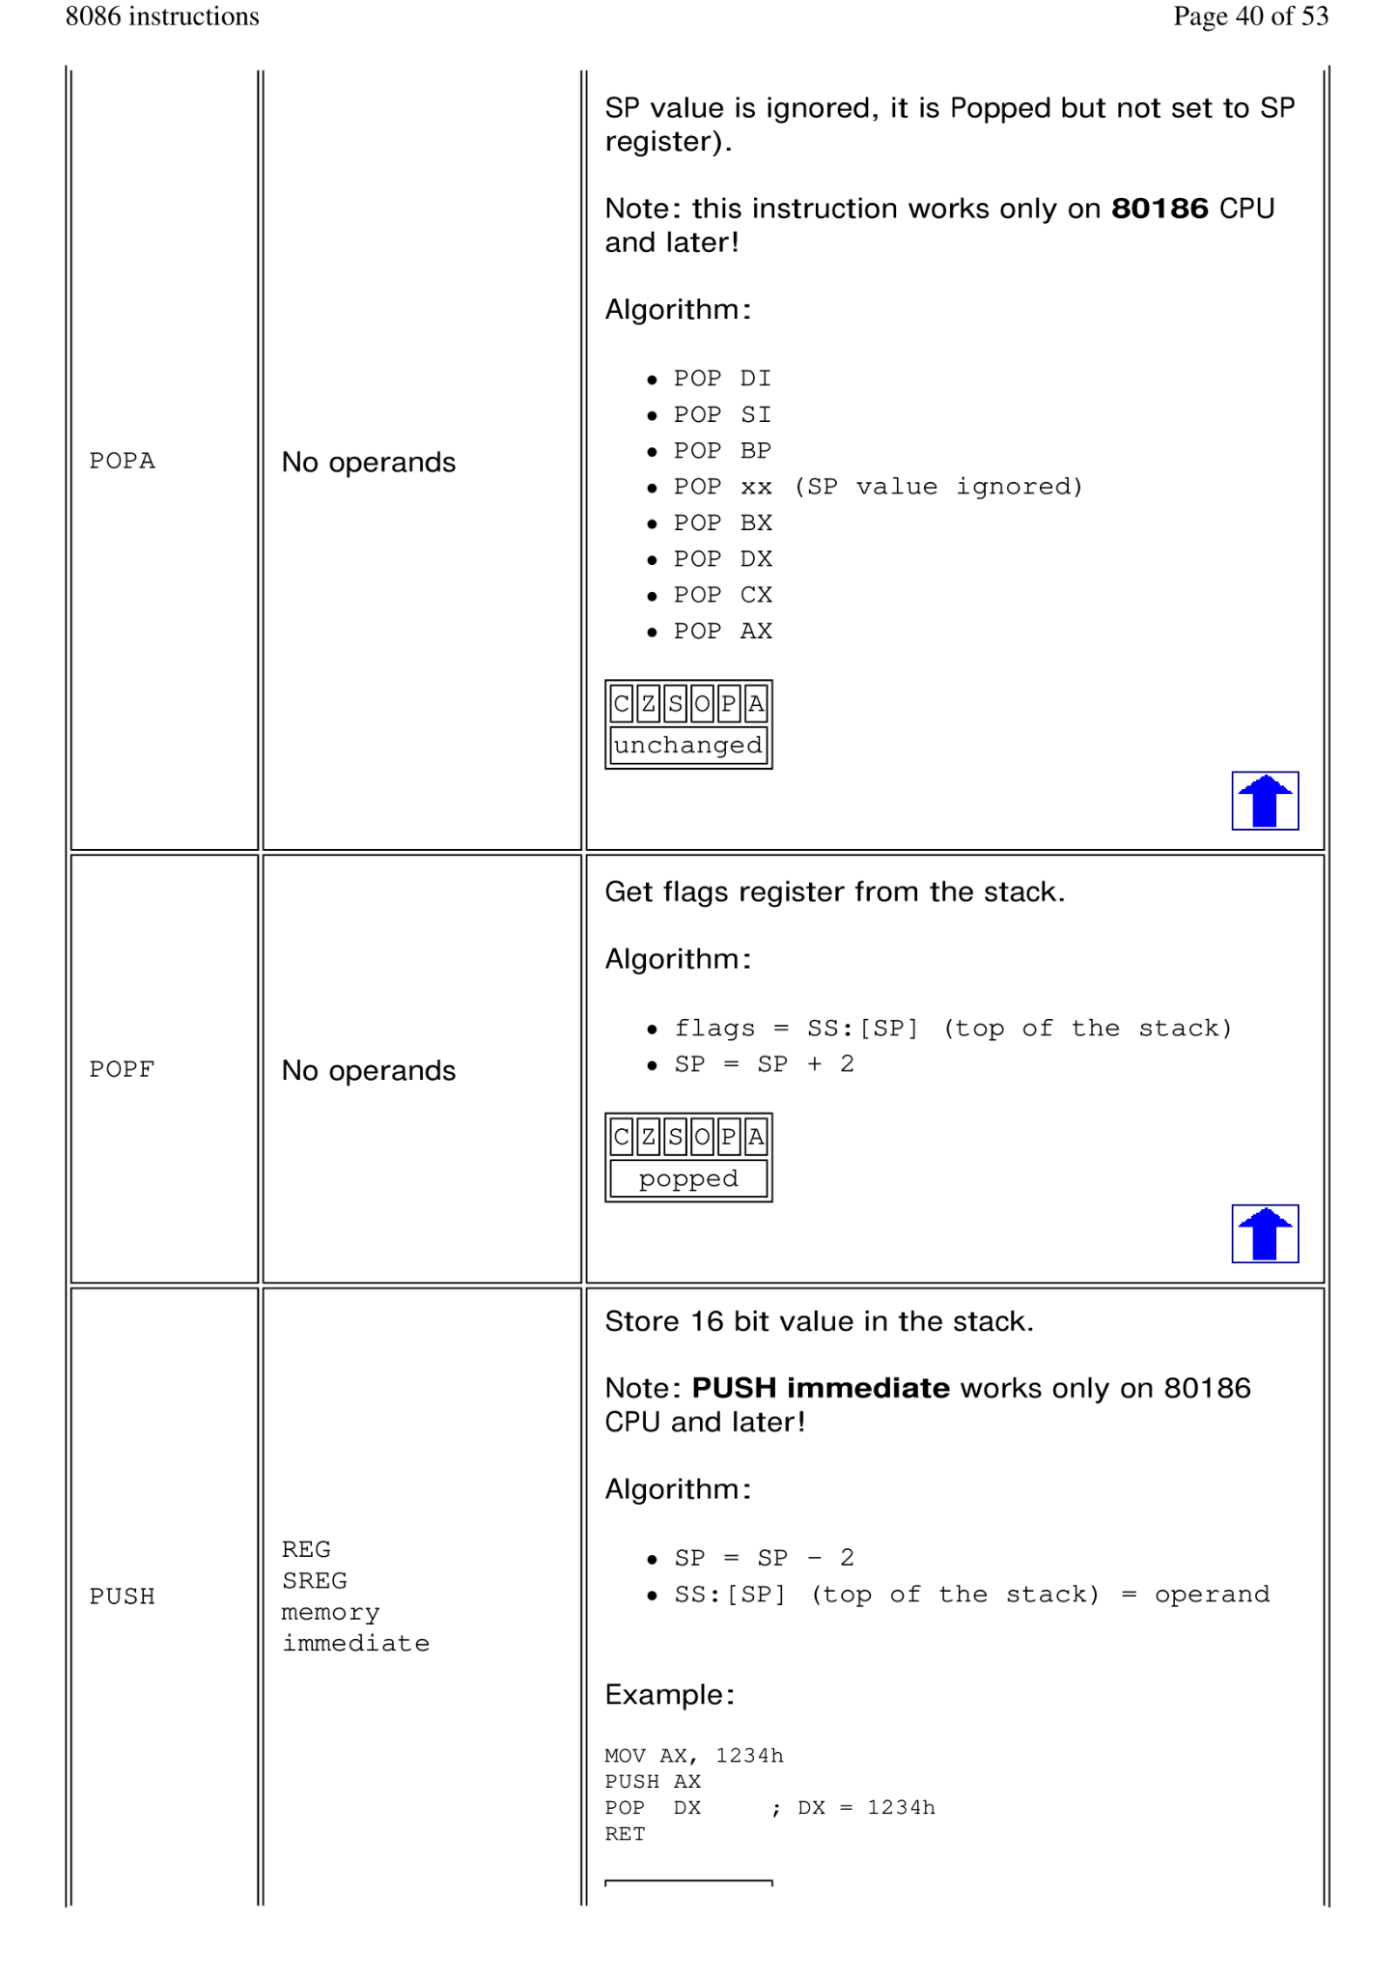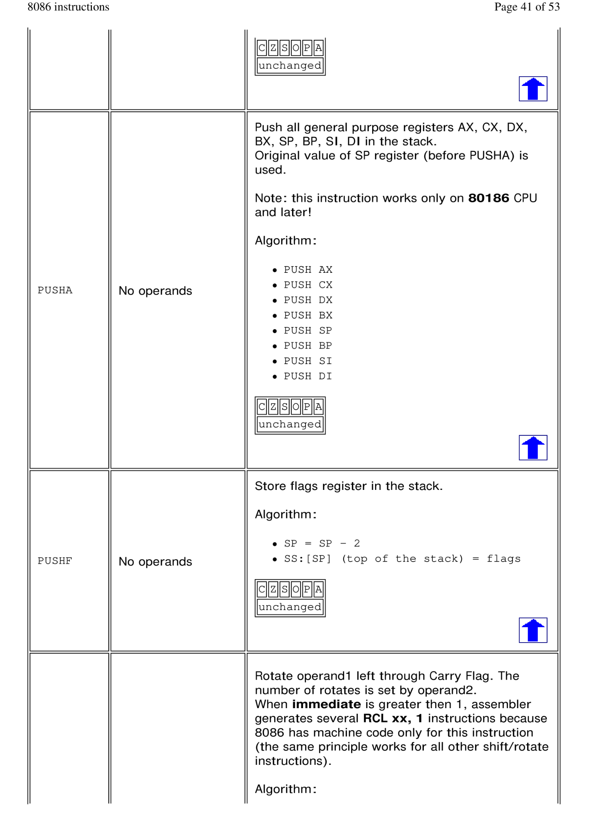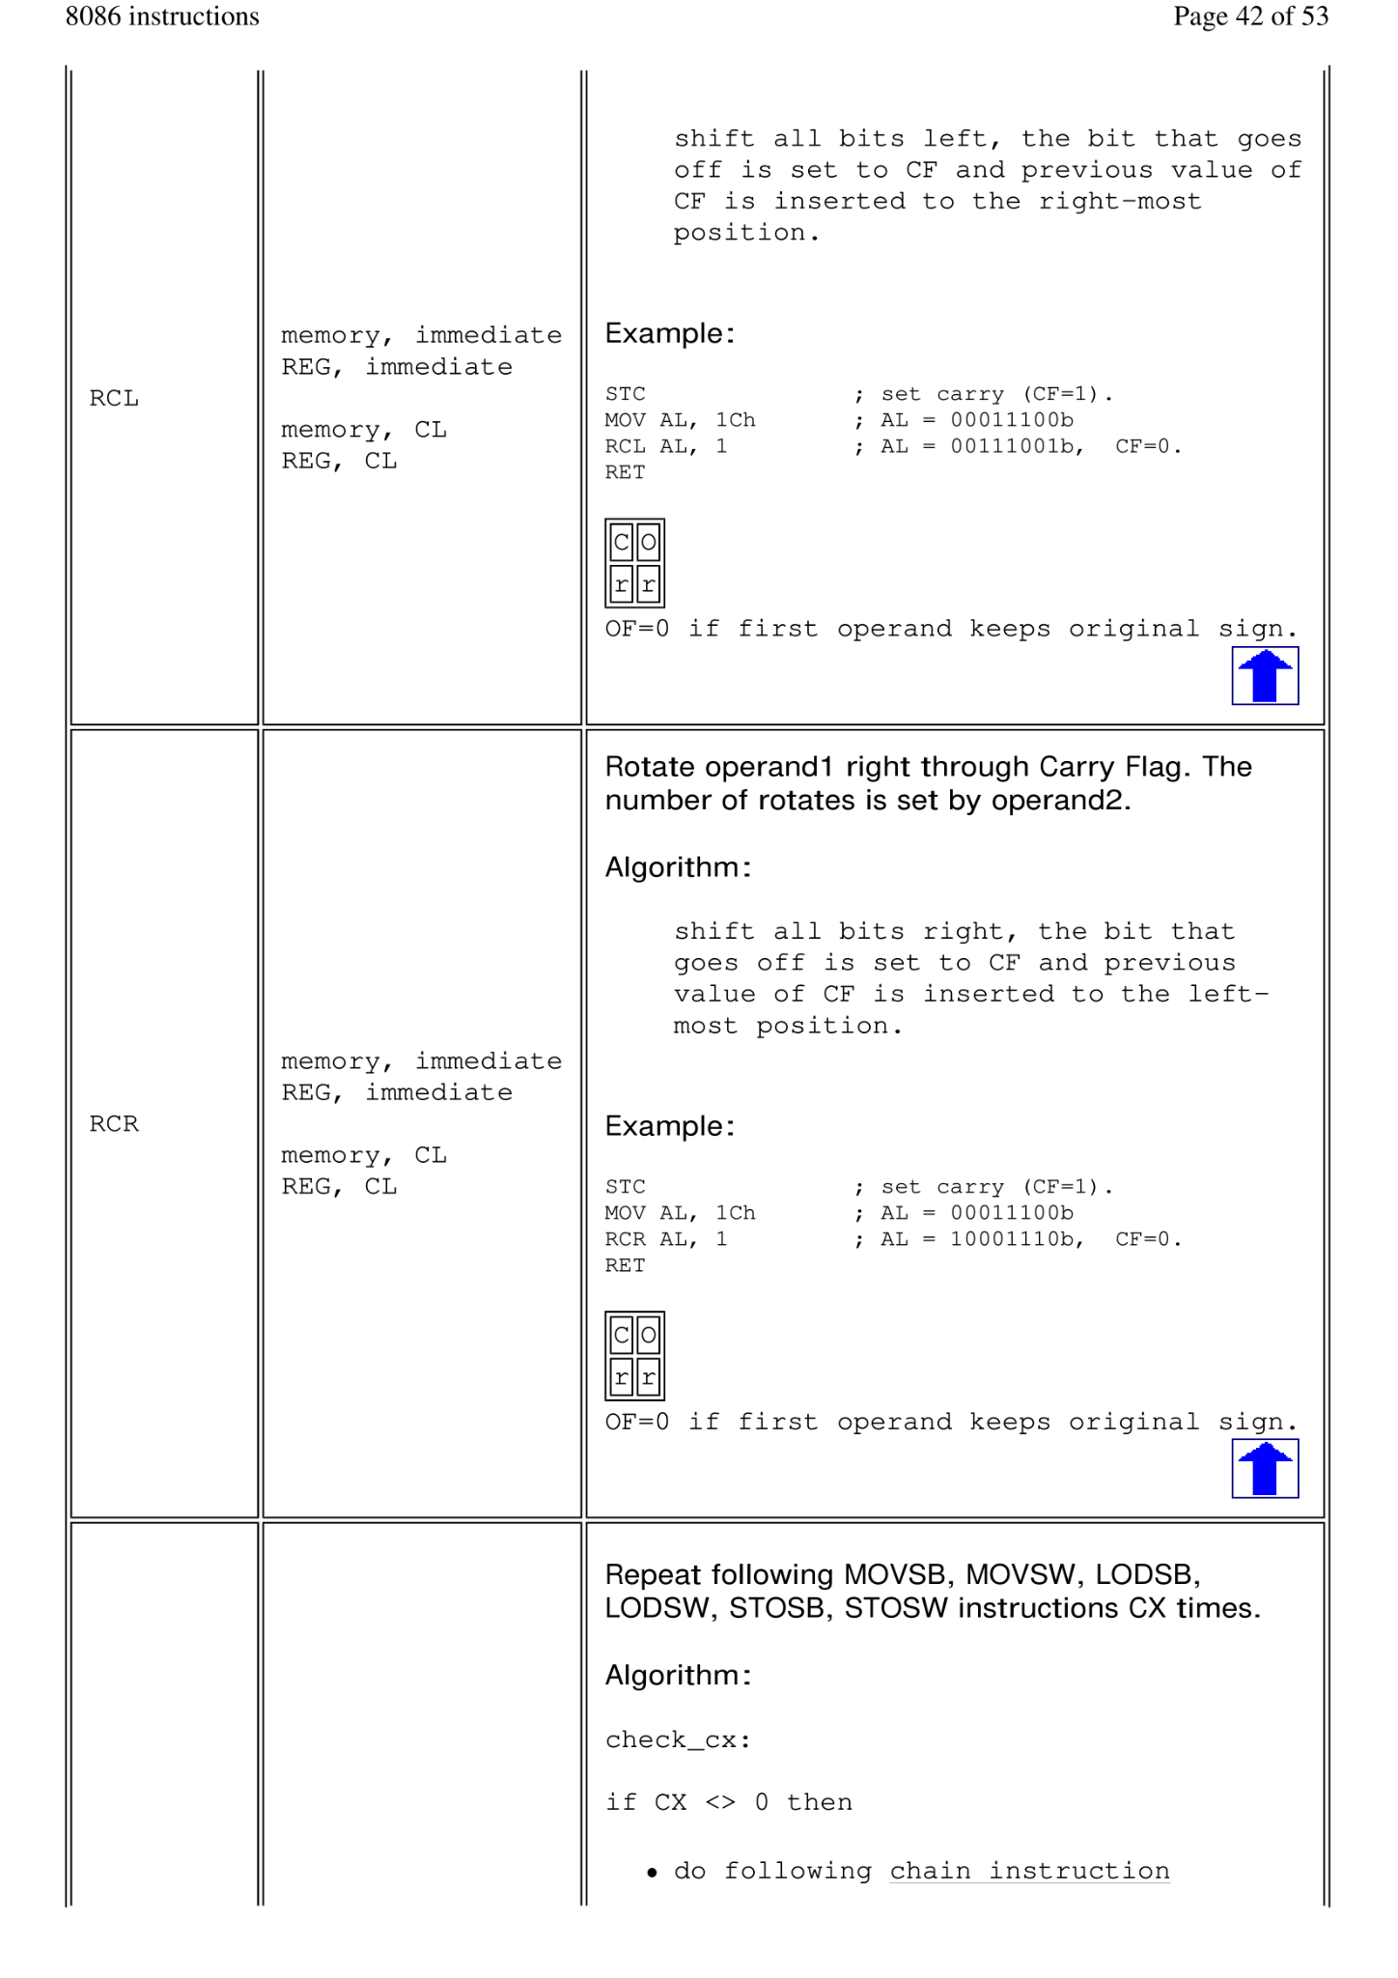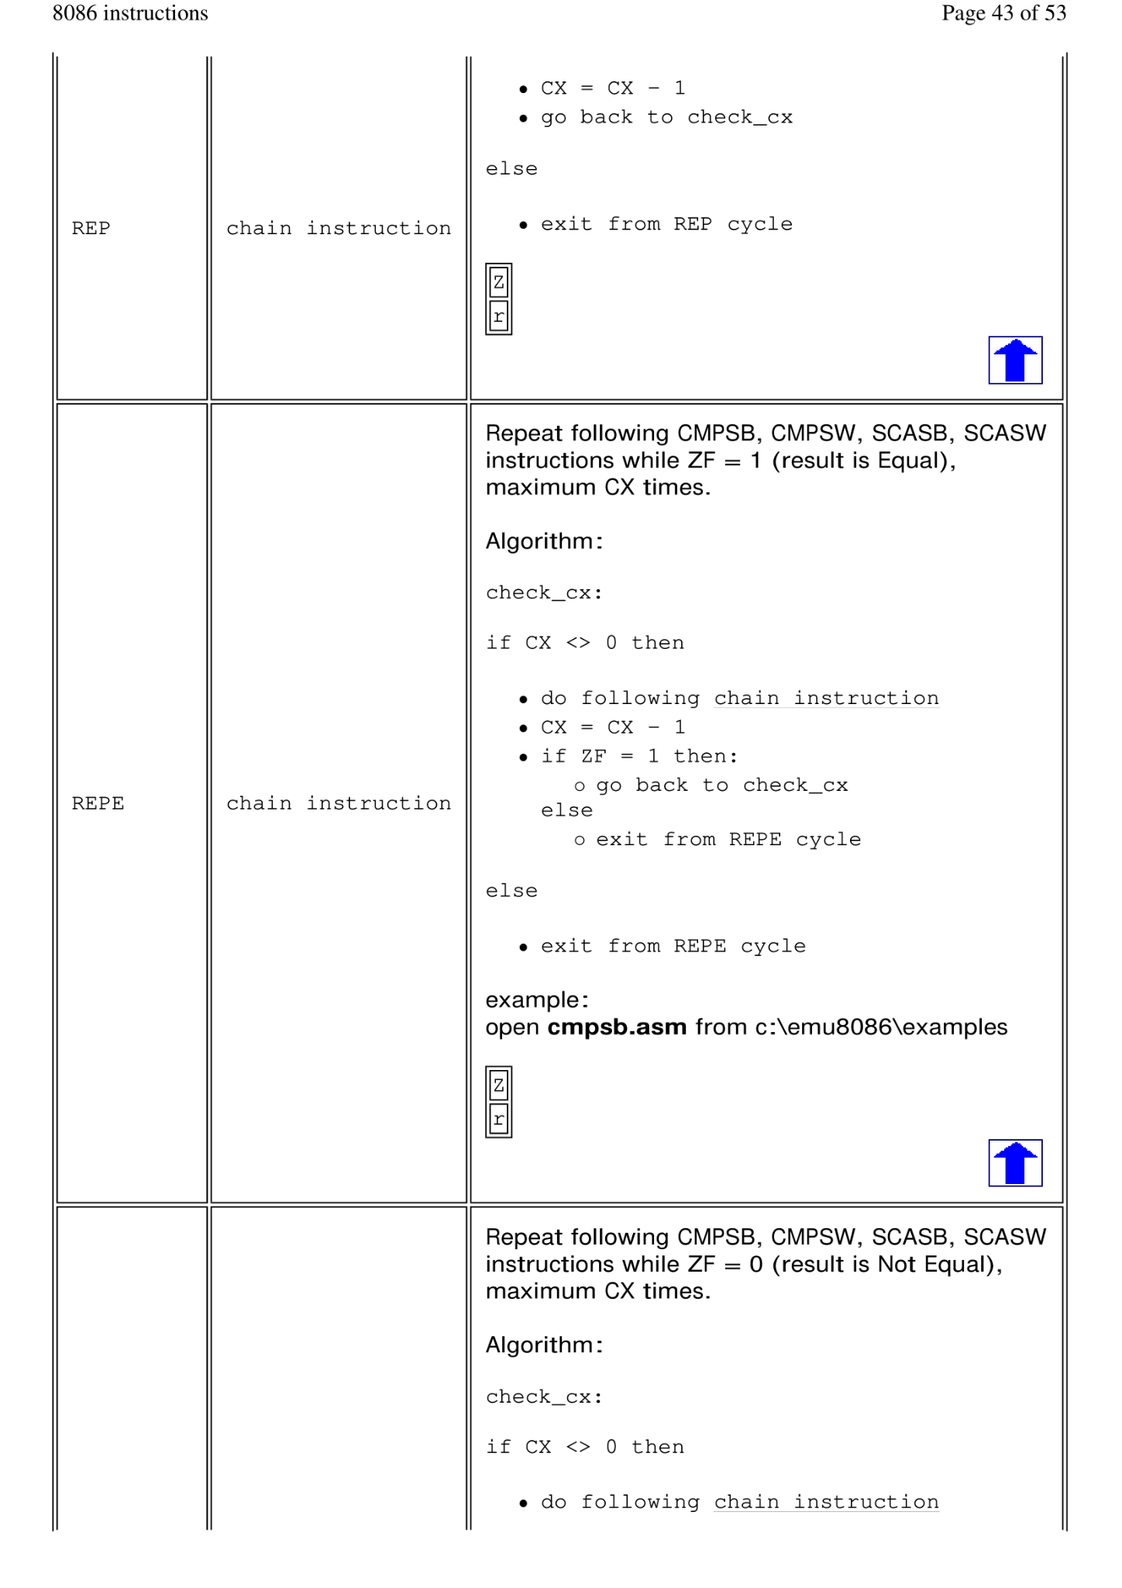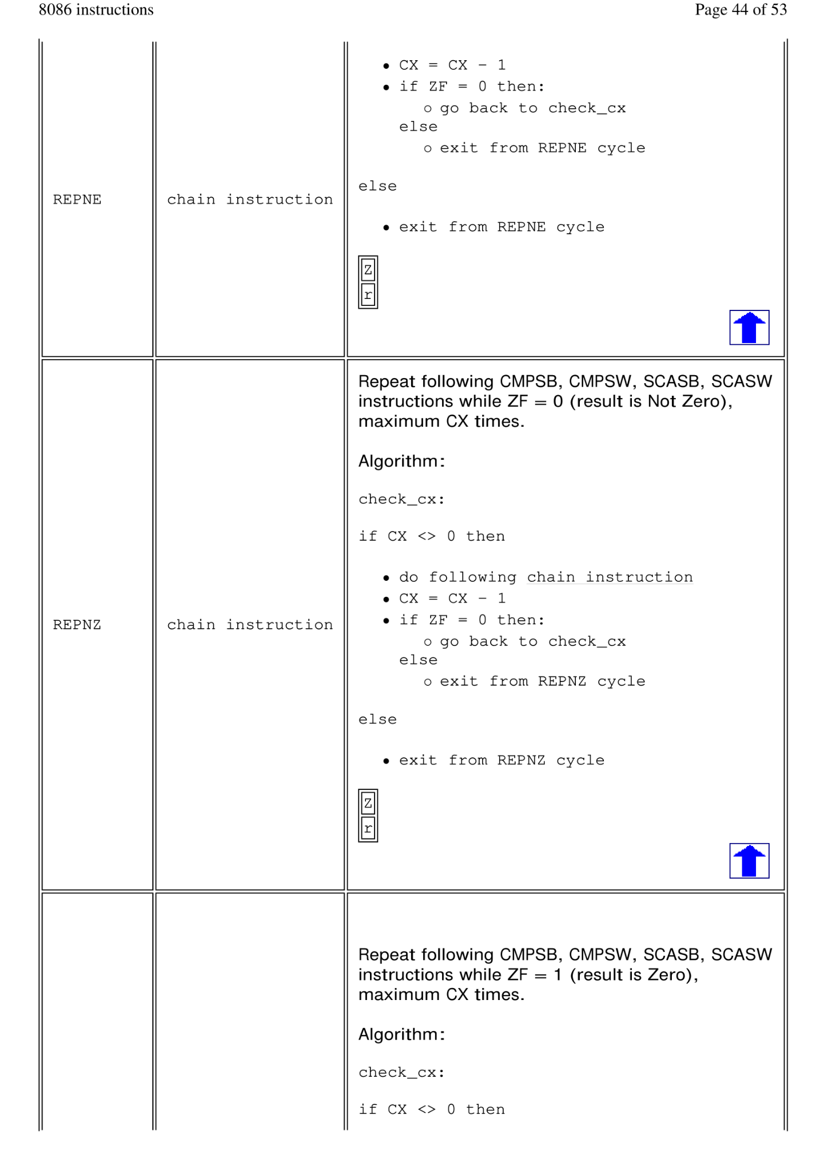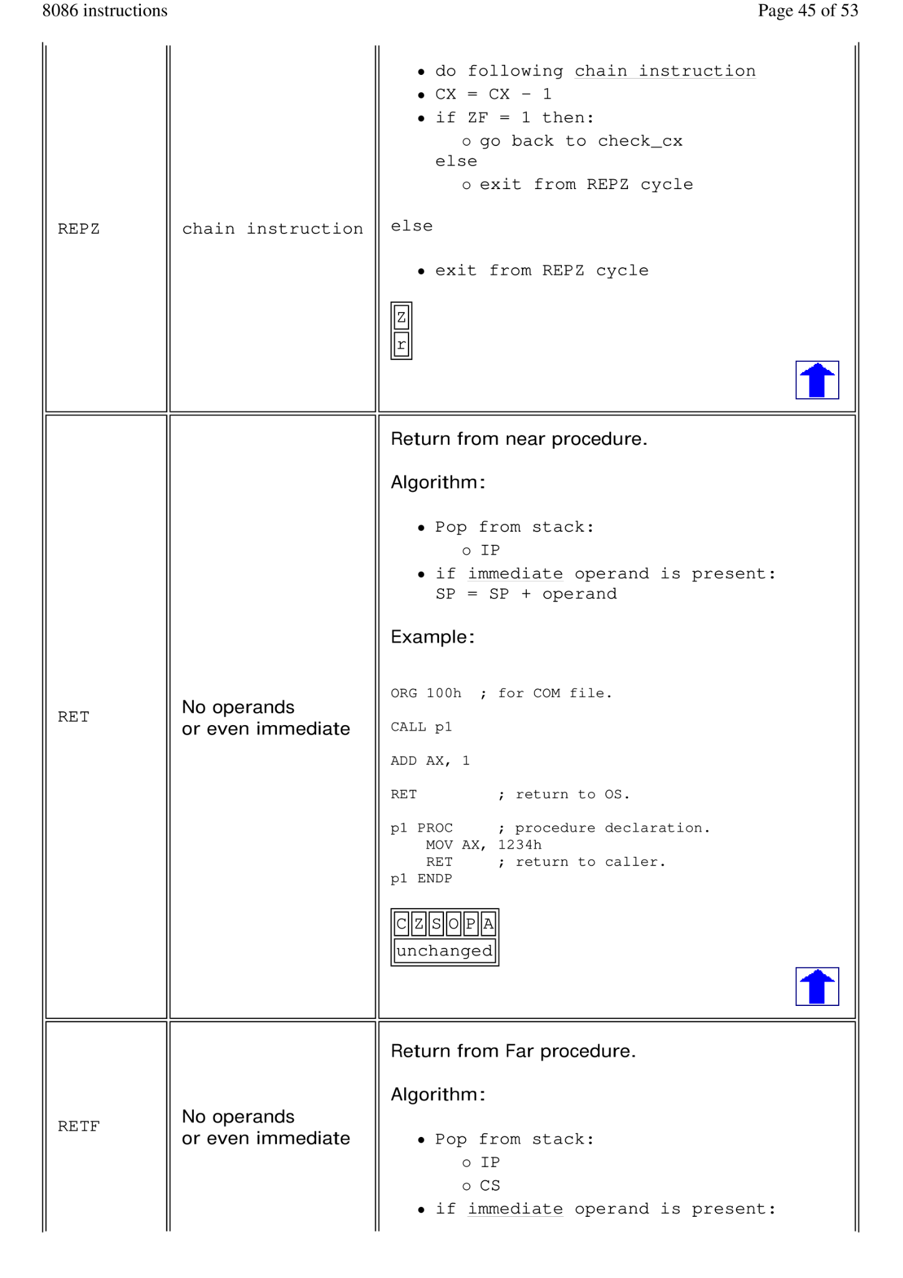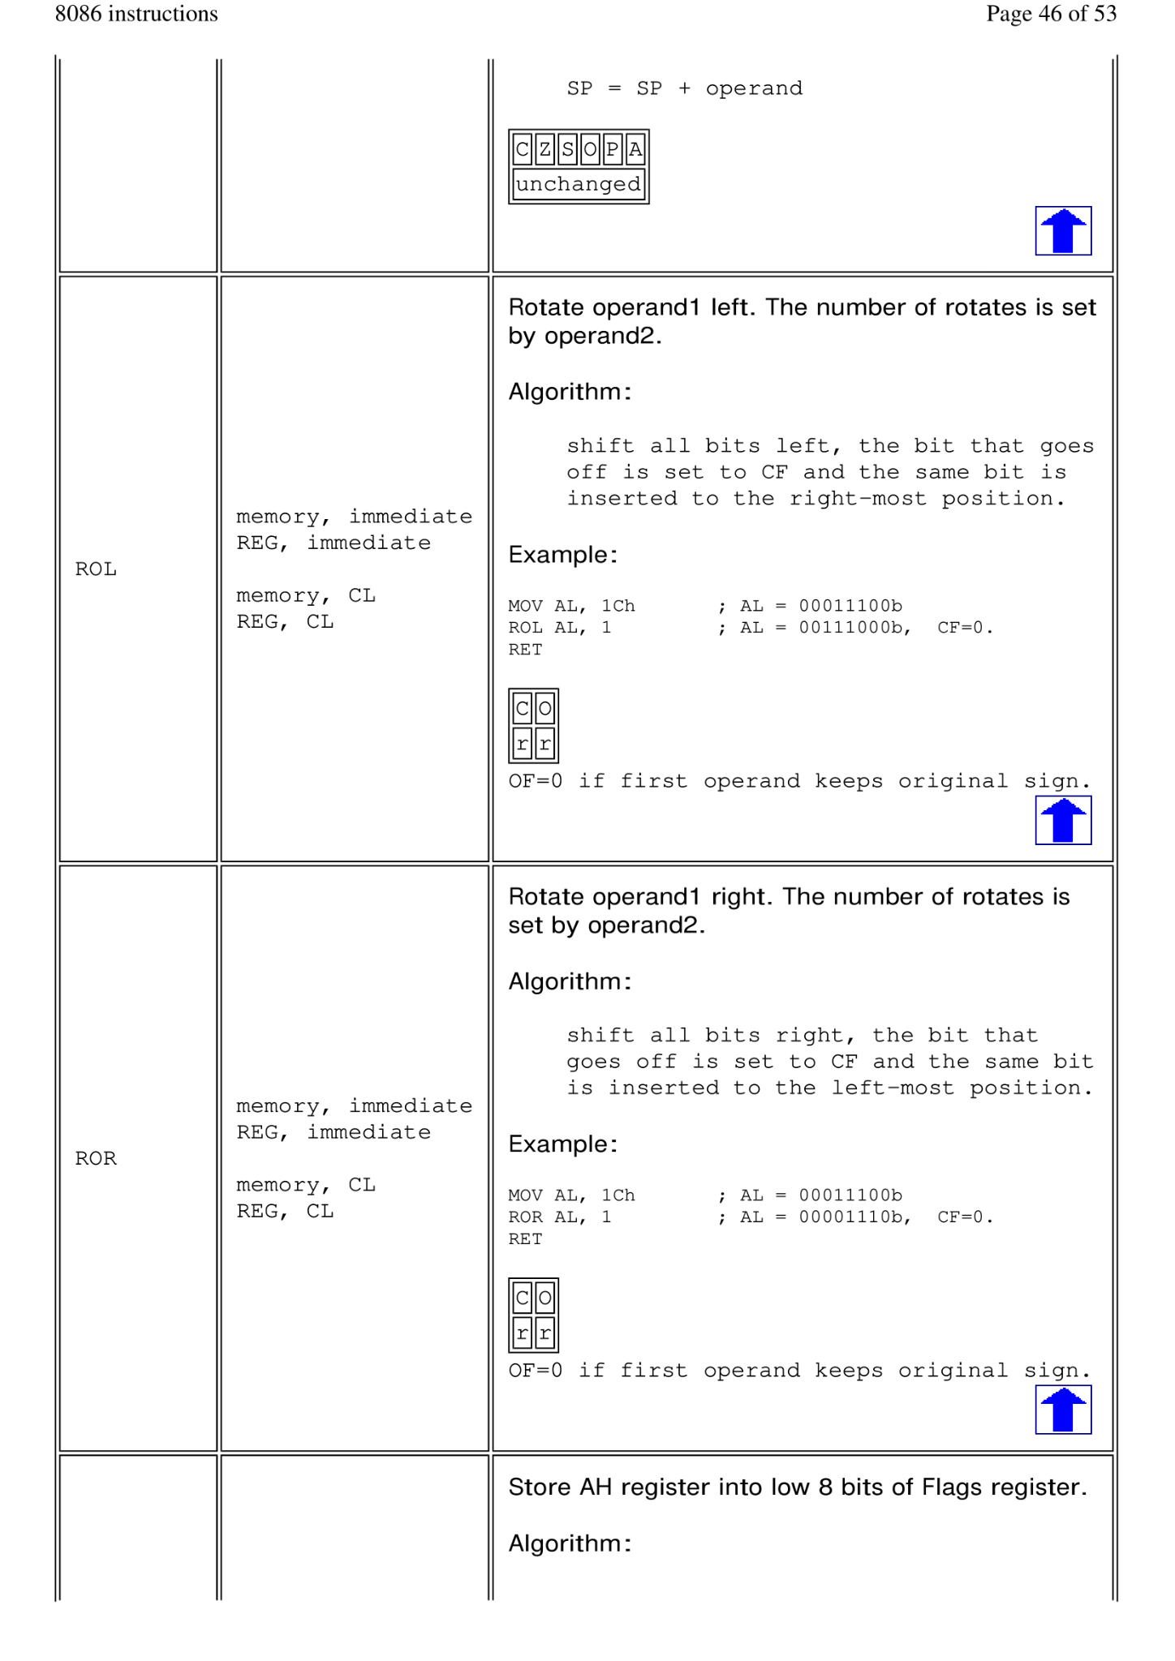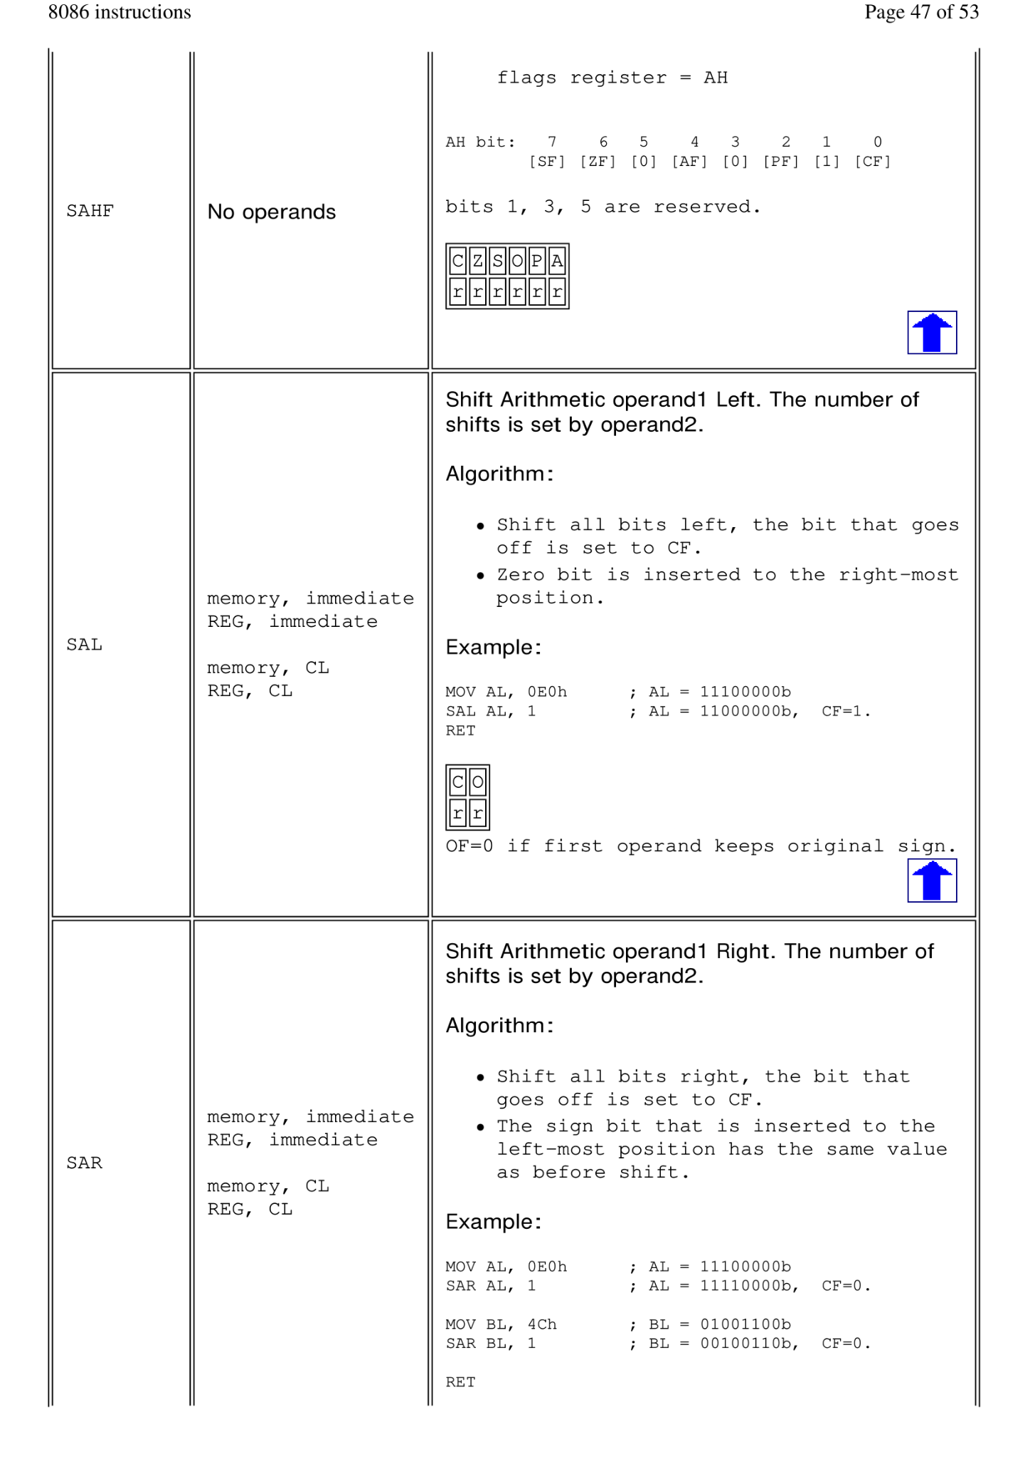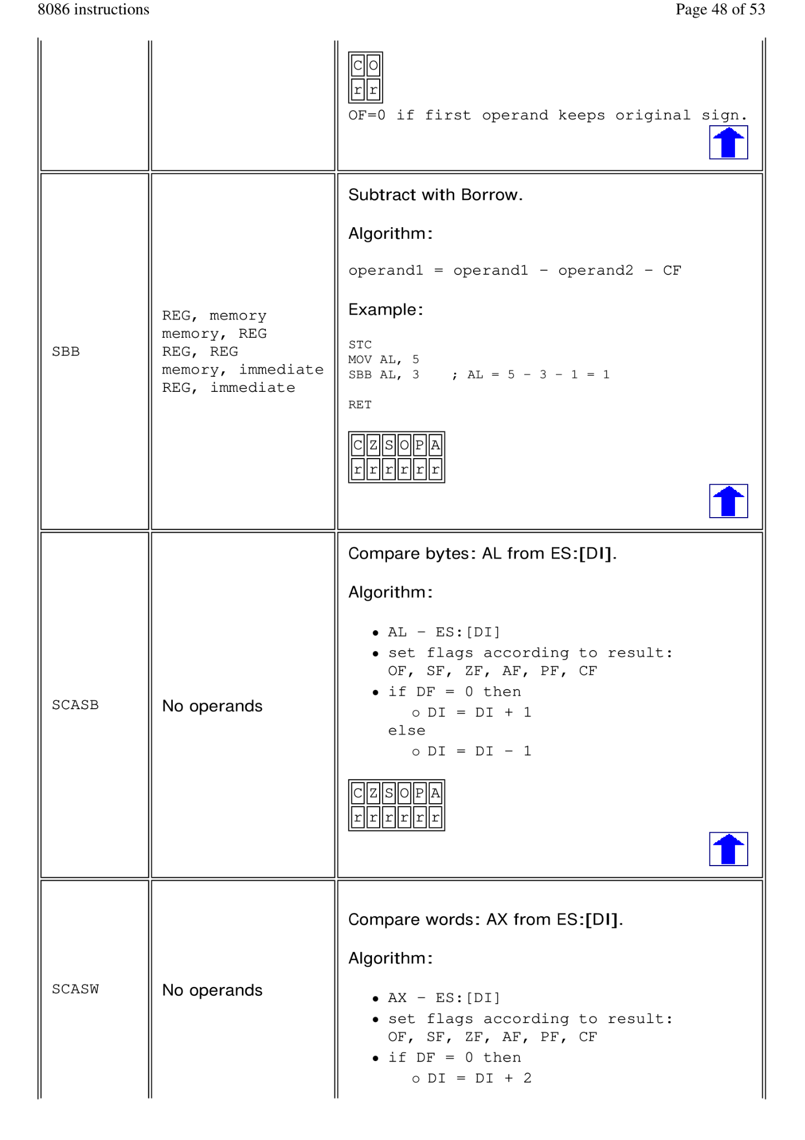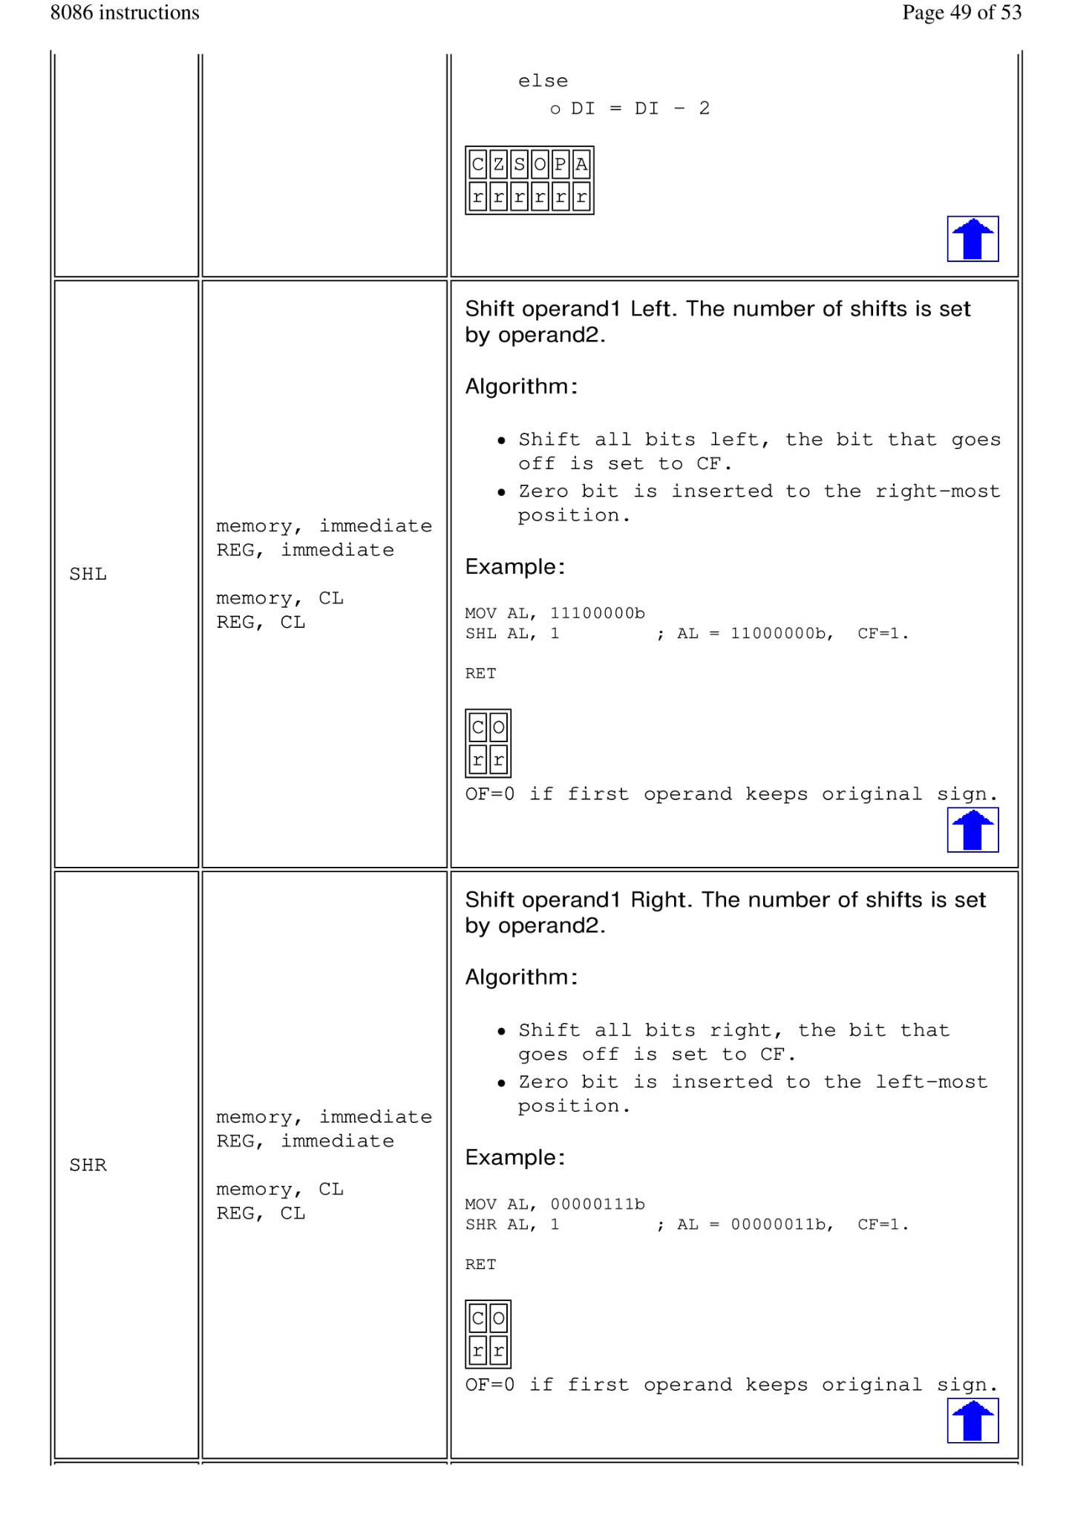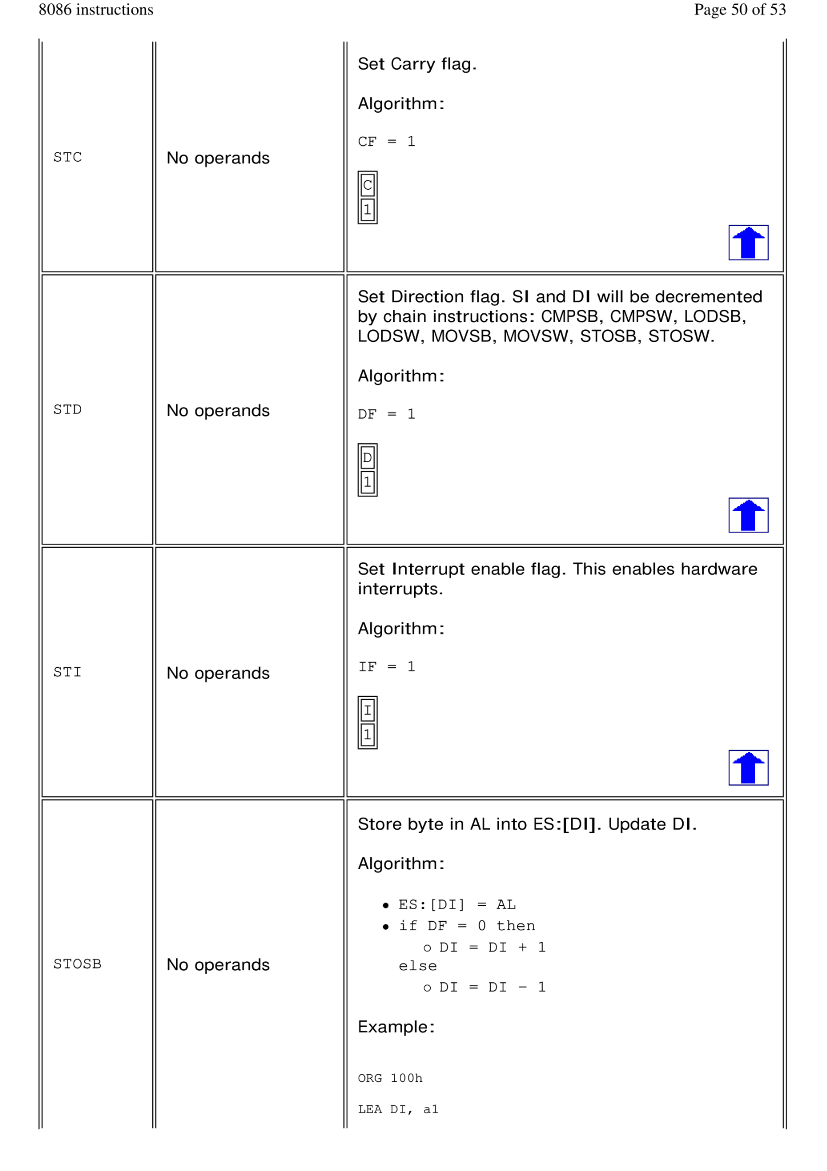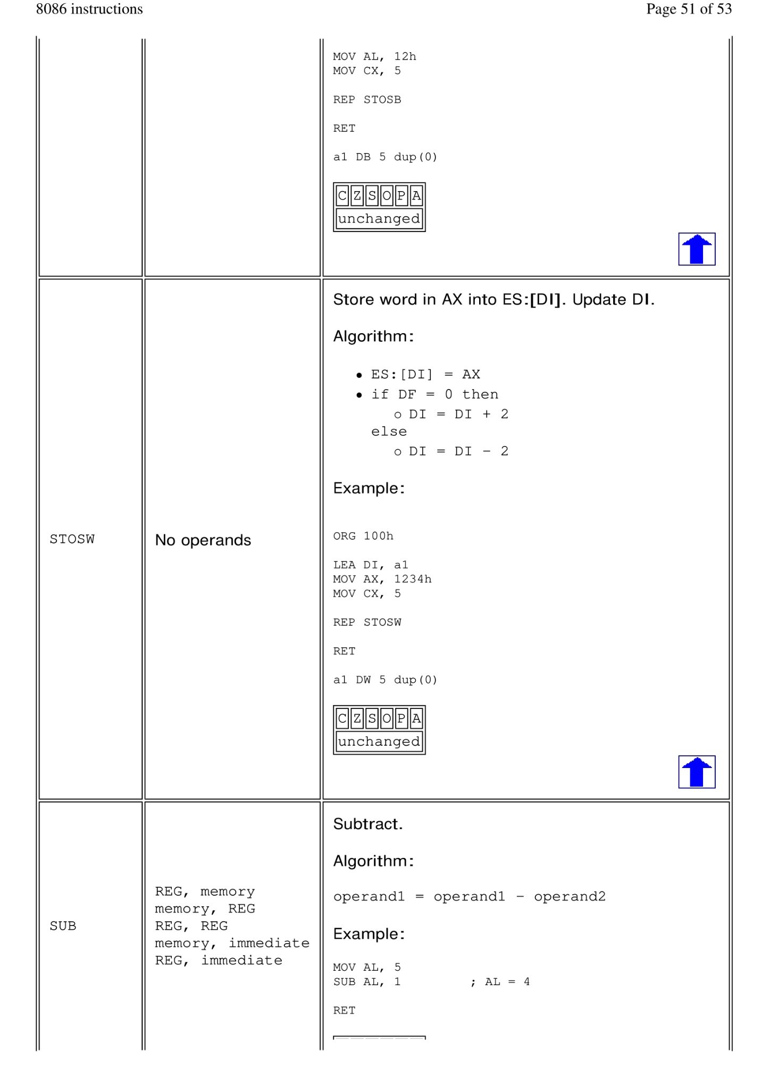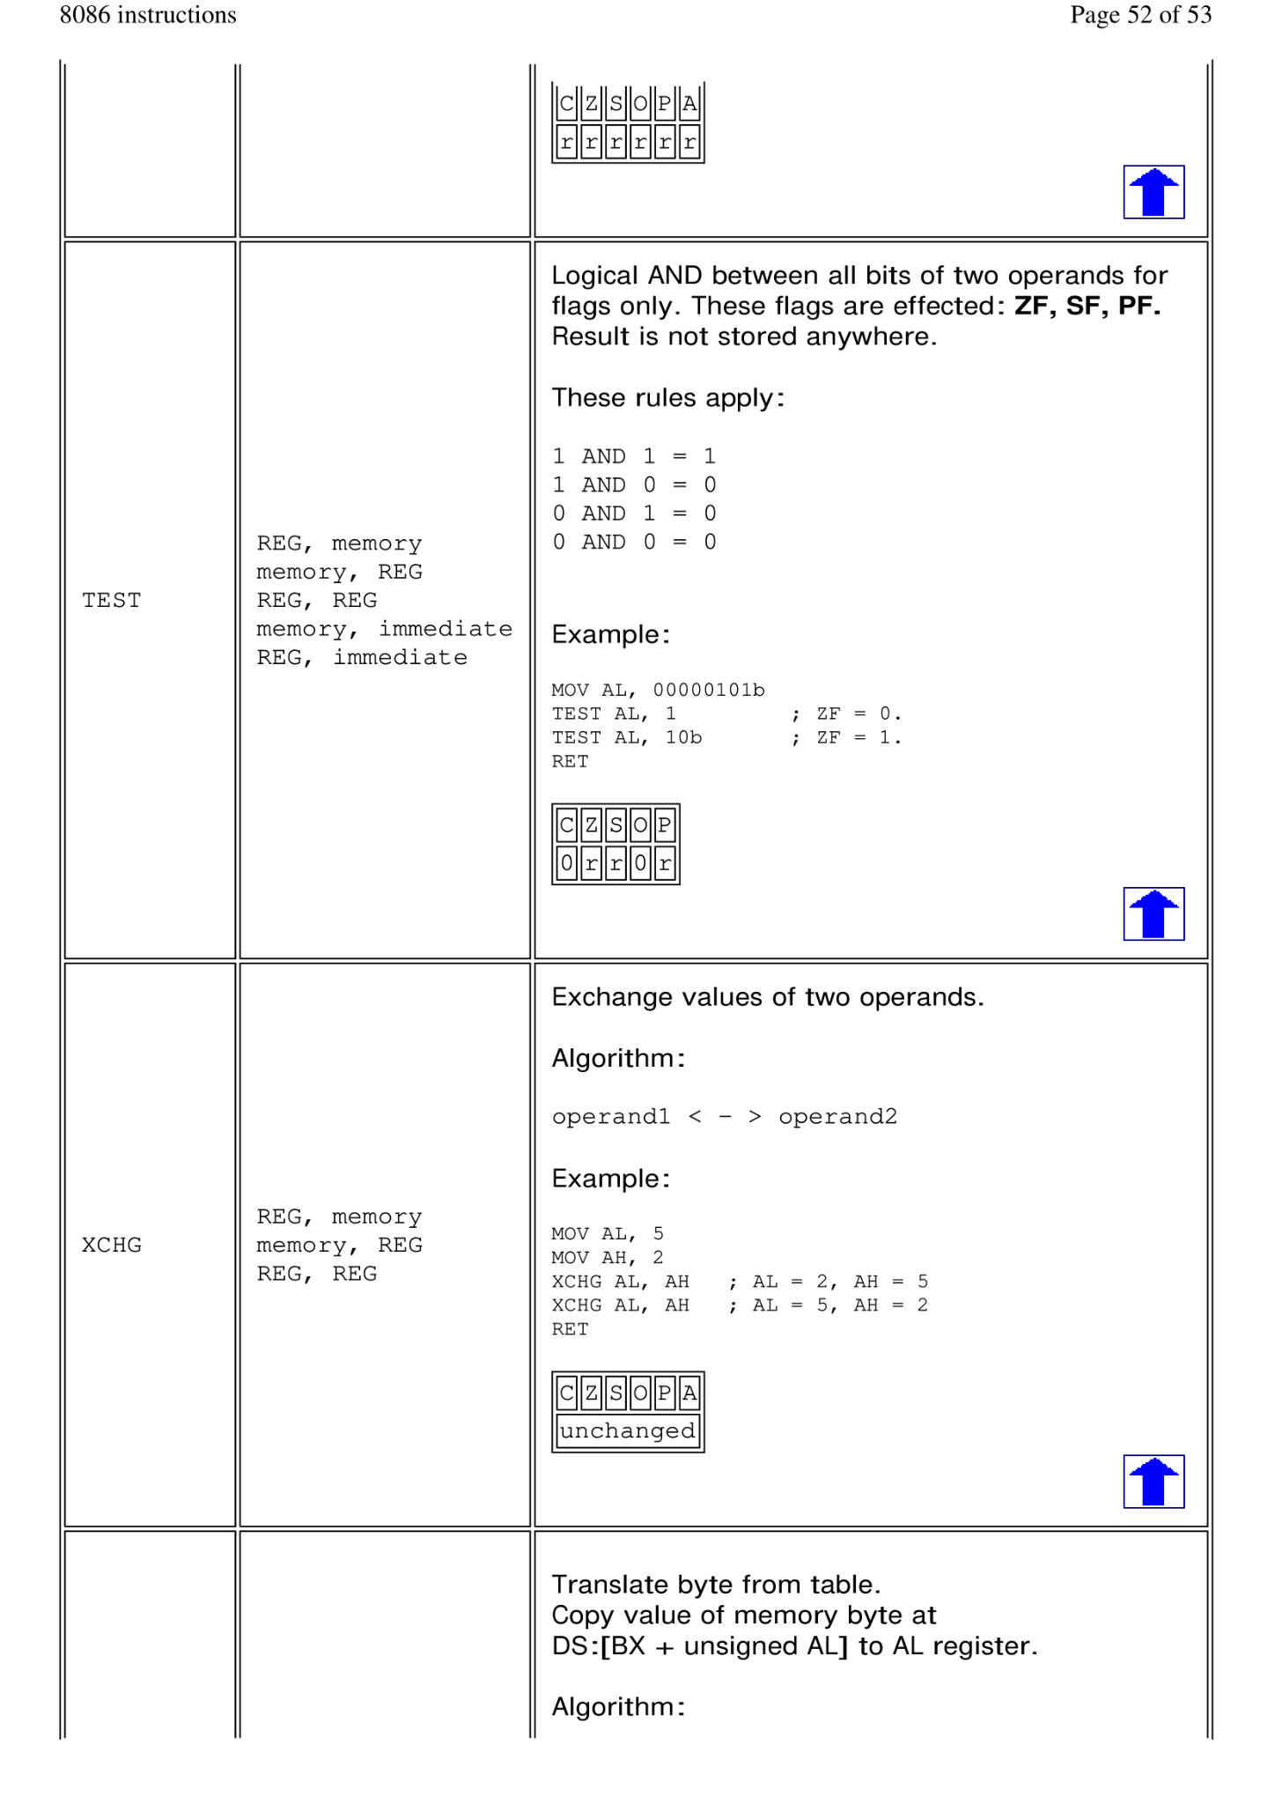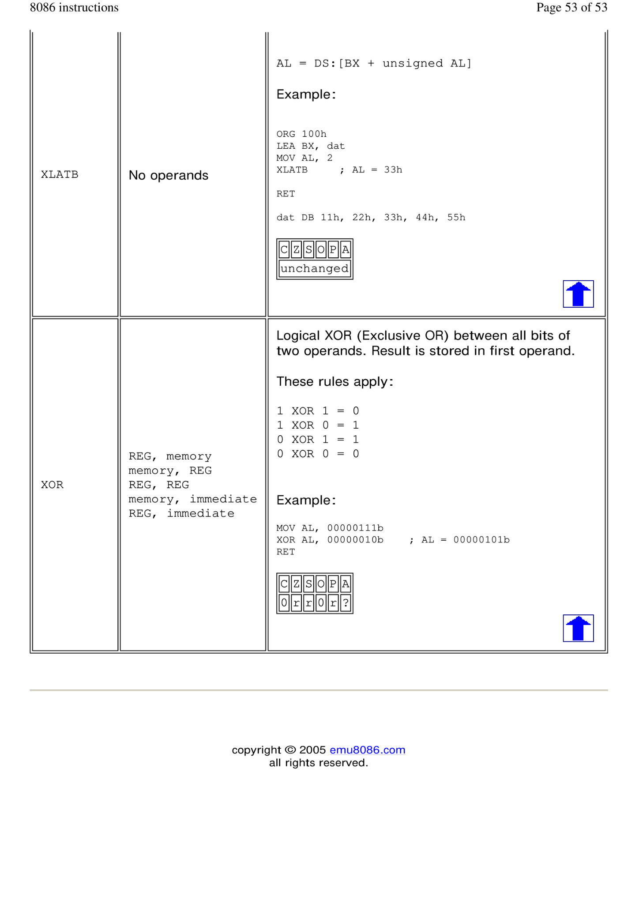

**Labs**

**Lab 2**

1. Write an Assembly Language Program (ALP) to read two decimal digits

both of which are less than 5 and display their summation in the next

line.

**CODE :**

**;SMALL MODEL HAS BEEN USED**

**.MODEL SMALL**

**;STACK HAS BEEN USED OF SIZE 100h**

**.STACK 100H**

**.DATA ;ALL VARIABLE HAS BEEN DECLARED HERE**

**MESSAGE_1 DB 'ENTER THE FIRST DIGIT : $'**

**MESSAGE_2 DB 'ENTER THE SECOND DIGIT : $'**

**MESSAGE_3 DB 'SUMMATION RESULT : $'**

**.CODE ;CODE SEGMENT SECTION**

**MAIN PROC ;MAIN SECTION LIKE INT MAIN() IN C**

**;STATEMENT SECTION**

**;INSTRUCTION DESTINATION, SOURCE <- COMMAND MECHANISM**

**MOV AX, @DATA ; IMPORT ALL DATA**

**MOV DS, AX**

**LEA DX, MESSAGE_1 ;DISPLAY THE MESSAGE_1**

**MOV AH, 9 ;CALL THE FUNCTION**

**INT 21H**

**MOV AH, 1 ; READ THE FIRST INPUT FROM USER**

**INT 21H**

**MOV BL, AL ; SAVE FIRST DIGIT IN BL**

**SUB BL, 30H**

**;NEW LINE**

**MOV AH , 2**

**MOV DL , 0AH**

**INT 21H**

**MOV DL , 0DH**

**INT 21H**

**LEA DX, MESSAGE_2 ;DISPLAY THE MESSAGE_2**

**MOV AH, 9 ;CALL THE FUNCTION**

**INT 21H**

**MOV AH, 1 ; READ THE SECOND INPUT FROM USER**

**INT 21H**

**MOV BH, AL ; SAVE SECOND DIGIT IN BL**

**SUB BH, 30H**

**;NEW LINE**

**MOV AH , 2**

**MOV DL , 0AH**

**INT 21H**

**MOV DL , 0DH**

**INT 21H**

**LEA DX, MESSAGE_3 ;DISPLAY THE MESSAGE_2**

**MOV AH, 9 ;CALL THE FUNCTION**

**INT 21H**

**; SUMMATION OF TWO INPUT DIGITS**

**ADD BL, BH ;ADDITION -> BL = BL + BH**

**ADD BL, 30H**

**;DISPLAY THE RESULT**

**MOV AH, 2**

**MOV DL, BL**

**INT 21H**

**; RETURN CONTROL TO OS / RETURNS ALL THE ALLOCATED SPACE TO THE SYSTEM**

**MOV AH, 4CH**

**INT 21H**

**MAIN ENDP**

**;EXIT FROM THE PROGRAM**

**END MAIN**

1. *Write an Assembly Language Program (ALP) to translate the following*

*high level language assignment statements into assembly language.*

*A= B - 2*A +1*

*Where the A, and B are byte variables. Your program does the following,*

*i. Keep the value of variable A as undefined and set the value of*

*variable B to 10D*

*ii. Display ‘?’*

*iii. Read the value of variable A in new line*

*iv. Display the updated value of A= B - 2*A -1 in new line*

**CODE :**

**.MODEL SMALL ;SMALL MODEL HAS BEEN USED**

**.STACK 100h ;STACK HAS BEEN USED OF SIZE 100h**

**.DATA ;ALL VARIABLE HAS BEEN DECLARED HERE**

**B DB 10D ;SET VALUE OF VARIABLE B TO 10D**

**A DB ? ;SET VALUE OF VARIABLE A AS UNDEFINED**

**.CODE ;CODE SEGMENT SECTION**

**MAIN PROC ;MAIN SECTION**

**;STATEMENT SECTION**

**;INSTRUCTION DESTINATION, SOURCE <- COMMAND MECHANISM**

**MOV AX, @DATA ;IMPORT THE DATA**

**MOV DS, AX**

**MOV AH,2 ;DISPLAYED '?'**

**MOV DL,'?'**

**INT 21h**

**;NEW LINE**

**MOV AH , 2**

**MOV DL , 0AH**

**INT 21H**

**MOV DL , 0DH**

**INT 21H**

**MOV AH,1 ;READ THE VALUE OF A IN NEW LINE**

**INT 21h**

**MOV A, AL**

**SUB A,30H**

**MOV BL, 2 ;SAVED THE VALE 2 IN REGISTER BL**

**MOV AL, BL ;MOVED VALUE OF 2 IN REGISTER AL**

**MUL A ; MULTIPLICATION -> AL = BL * A**

**ADD AL, 30H**

**MOV BL, B ;MOVED VALUE OF B IN REGISTER BL**

**SUB BL, AL ;SUBTRACTION -> BL = BL - AL**

**ADD BL, 30H**

**SUB BL, 1 ;SUBTRACTION = BL = BL - 1**

**ADD BL, 30H**

**;NEW LINE**

**MOV AH , 2**

**MOV DL , 0AH**

**INT 21H**

**MOV DL , 0DH**

**INT 21H**

**MOV AH, 2 ;DISPLAYED THE OUTPUT**

**MOV DL,BL**

**INT 21H**

**MOV AH , 4CH ; RETURN CONTROL TO OS / RETURNS ALL THE ALLOCATED SPACE To SYSTEM**

**INT 21H**

**MAIN ENDP**

**END MAIN ; RETURN 0**

1. *Write an Assembly Language Program (ALP) to read one of the hex*

*digits uppercase A-F and display it on the next line in decimal.*

**CODE :**

**.MODEL SMALL ;SMALL MODEL HAS BEEN USED**

**.STACK 100H ;STACK HAS BEEN USED OF SIZE 100H**

**.DATA ;ALL VARIABLE HAS BEEN DECLARED HERE**

**MESSAGE_1 DB 'Enter a hex digit: $'**

**MESSAGE_2 DB 'In decimal it is: $'**

**.CODE ;CODE SEGMENT SECTION**

**MAIN PROC ;MAIN SECTION**

**;STATEMENT SECTION**

**;INSTRUCTION DESTINATION, SOURCE <- COMMAND MECHANISM**

**MOV AX, @DATA ;IMPORT ALL DATA**

**MOV DS, AX**

**;DISPLAY THE MESSAGE_1**

**MOV AH, 9**

**LEA DX, MESSAGE_1**

**INT 21H**

**MOV AH, 1 ;HEX DIGIT INPUT**

**INT 21H**

**MOV BH, AL**

**SUB BH, 17D ;EQUIVALENT DECIMAL VALUE BY SUBTRACTING 17D.**

**;NEW LINE**

**MOV AH , 2**

**MOV DL , 10**

**INT 21H**

**MOV DL , 13**

**INT 21H**

**;DISPLAY THE MESSAGE_2**

**MOV AH, 9**

**LEA DX, MESSAGE_2**

**INT 21H**

**MOV DL, 49D ;DISPLAY ASCII REPRESENTATION OF THE DECIMAL DIGIT "1"**

**MOV AH, 2**

**INT 21H**

**MOV DL, BH ;DISPLAYED CONVERTED DECIMAL DIGIT**

**MOV AH, 2**

**INT 21H**

**MOV AH , 4CH ; RETURN CONTROL TO OS / RETURNS ALL THE ALLOCATED SPACE TO SYSTEM**

**INT 21H**

**MAIN ENDP**

**END MAIN**

1. *Write an ALP to*

*v. Display ‘?’*

*vi. Read three initials*

*vii. Display them in the middle of an 7*7 box of asterisk*

*viii. Beep the computer*

**CODE :**

**.MODEL SMALL ;SMALL MODEL HAS BEEN USED**

**.STACK 100H ;STACK HAS BEEN USED OF SIZE 100H**

**;ALL VARIABLE HAS BEEN DECLARED HERE**

**.DATA**

**A DB '*******',10,13,'$' ;STRING OF 7 * ASTERIK SYMBOL IS DECLARED (WITH NEW LINE)**

**B DB '**$' ;STRING OF 2 * ASTERIK SYMBOL IS DECLARED**

**.CODE ;CODE SEGMENT SECTION**

**MAIN PROC ;MAIN SECTION**

**;STATEMENT SECTION**

**;INSTRUCTION DESTINATION, SOURCE <- COMMAND MECHANISM**

**MOV AX, @DATA ; IMPORT ALL DATA**

**MOV DS, AX**

**MOV AH, 2 ;DISPLAYED SYMBOL '?'**

**MOV DL, '?'**

**INT 21H**

**MOV AH, 1 ; 'a' INPUT TAKEN**

**INT 21H**

**MOV BL, AL ;SAVED IN REGISTER BL**

**MOV AH, 1 ; 'b' INPUT TAKEN**

**INT 21H**

**MOV BH, AL ;SAVED IN REGISTER BH**

**MOV AH, 1 ; 'c' INPUT TAKEN**

**INT 21H**

**MOV CL, AL ;SAVED IN REGISTER CL**

**;NEW LINE**

**MOV AH, 2**

**MOV DL, 10**

**INT 21H**

**MOV DL, 13**

**INT 21H**

**LEA DX, A ;DISPLAYED 7 * ASTERIK SYMBOL**

**MOV AH, 9**

**INT 21H ;INTERUPT FOR 1ST ROW**

**INT 21H ;INTERUPT FOR 2ND ROW**

**INT 21H ;INTERUPT FOR 3RD ROW**

**MOV AH, 9 ;DISPLAYED 2 * ASTERIK SYMBOL FOR 4TH ROW**

**LEA DX, B**

**INT 21H**

**;DISPLAYED 'abc; IN THE MIDDLE SECTION OF 4TH ROW OF 7*7 ASTERIK BOX**

**MOV AH, 2 ;DISPLAYED 'a'**

**MOV DL, BL**

**INT 21H**

**MOV AH, 2 ;DISPLAYED 'b'**

**MOV DL, BH**

**INT 21H**

**MOV AH, 2 ;DISPLAYED 'c'**

**MOV DL, CL**

**INT 21H**

**MOV AH, 9 ;DISPLAYED LAST 2 * ASTERIK SYMBOL FOR 4TH ROW**

**LEA DX, B**

**INT 21H**

**;NEW LINE**

**MOV AH, 2**

**MOV DL, 10**

**INT 21H**

**MOV DL, 13**

**INT 21H**

**LEA DX, A ;DISPLAYED 7 * ASTERIK SYMBOL**

**MOV AH, 9**

**INT 21H ;INTERUPT FOR 5TH ROW**

**INT 21H ;INTERUPT FOR 6TH ROW**

**INT 21H ;INTERUPT FOR 7TH ROW**

**MOV AH, 2**

**MOV DL, 07H**

**INT 21H ;INTERUPT TO BEEP THE COMPUTER**

**MOV AH , 4CH**

**INT 21H**

**MAIN ENDP**

**END MAIN ; RETURN 0**

**Lab 03**

*1. Write an assembly language program section which puts the product of the first 6 terms of the arithmetic sequence 1, 3, 5, 7 ... in DX. Use a looping structure to produce the product.*

**CODE :**

**.MODEL SMALL**

**.STACK 100H**

**.DATA**

**.CODE**

**MAIN PROC**

**MOV CX,6 ;THE LOOP WILL ITERATE 6 TIMES**

**MOV AX,1 ;ASSIGNED THE INITIAL VALUE OF AX TO 1**

**MOV BX,1 ;ASSIGNED THE INITIAL VALUE OF BX TO1**

**JCXZ SKIP ;JUMP IF CX IS ZERO**

**TOP:**

**MUL BX ;MULTIPLYING BX WITH AX**

**ADD BX,2 ;INCREMENTING BX BY 2**

**LOOP TOP ;DECREMENT COUNTER AND AGAIN GO TO TOP TILL COUNTER BECOMES 0**

**SKIP:**

**MOV DX,AX ;MOVING THE RESULT OF AX INTO DX**

**MOV AH,4CH ;EXIT FUNCTION**

**INT 21H ;TRANSFERING THE CONTROL TO OS**

**MAIN ENDP ;END MAIN PROCEDURE**

**END MAIN ;RETURN 0**

*2. Write a. program that prompts the user to enter two unsigned hex numbers, 0 to FFFFh, and*

*prints their sum in hex on the next line. Each input ends with a carriage return. Define two*

*procedures called ‘INHEX’ and ‘OUTHEX’ respectively for handling hexadecimal input and*

*hexadecimal output.*

*Sample execution:*

*Type a HEX Number, 0 - FFEF: 21AB*

*Type a HEX Number, 0 - FFFF: 5E03*

*The SUM is: 7FAE*

**CODE :**

.**MODEL SMALL**

**.STACK 100H**

**.DATA**

**STR1 DB "Type a HEX Number, 0 - FFEF:$"**

**STR2 DB "The SUM is:$"**

**INP1 DW ?**

**.CODE**

**MAIN PROC**

**MOV AX,@DATA ;MOVING THE DATA SEGMENT INTO AX**

**MOV DS,AX ;INITIALIZE DS**

**CALL INHEX ;TAKING THE FIRST INPUT**

**MOV INP1,BX ;STORING THE VALUE TO INP1 VARIABLE**

**;NEW LINE**

**MOV AH,2 ;DISPLAY FUNCTION**

**MOV DL,0AH ;LINE FEED**

**INT 21H ;GO TO BEGINNING OF THE LINE**

**MOV DL,0DH ;CARRIAGE RETURN**

**INT 21H ;GO TO NEW LINE**

**CALL INHEX ;TAKING THE SECOND INPUT**

**;NEW LINE**

**MOV AH,2 ;DISPLAY FUNCTION**

**MOV DL,0AH ;LINE FEED**

**INT 21H ;GO TO BEGINNING OF THE LINE**

**MOV DL,0DH ;CARRIAGE RETURN**

**INT 21H ;GO TO NEW LINE**

**CALL OUTHEX ;SHOWING THE RESULT OF THE ADDITION OF TWO INPUT**

**MOV AH,4CH ;EXIT FUNCTION**

**INT 21H ;TRANSFERING THE CONTROL TO OS**

**MAIN ENDP**

**INHEX PROC**

**MOV AH,9 ;DISPLAT STRING FUNCTION**

**LEA DX,STR1 ;GETTING THE STR1**

**INT 21H ;DISPLAY MESSAGE**

**MOV AH,1 ;INPUT FUNCTION**

**MOV CX,4 ;SETTING THE CX VALUE TO 4**

**XOR BX,BX ;CLEARING THE BX**

**INP:**

**INT 21H ;TAKE INPUT**

**CMP AL,0DH ;CHECKING IF ENTER IS PRESSED OR NOT ( 0DH=NEW LINE )**

**JE SKIP ;IF ENTER IS PRESSED THEN JUMP TO SKIP**

**CMP AL,41H ;CHECKING IF THE GIVEN INPUT IS BETWEEN A TO F**

**JGE HEXA ;IF TRUE THEN JUMP TO HEXA**

**SUB AL,30H ;CONVERTING TO DIGIT**

**JMP SHIFT ;JUMP TO SHIFT**

**HEXA:**

**SUB AL,37H ;CONVERTING TO HEXA**

**SHIFT:**

**SHL BX,4 ;SHIFTING THE VALUE IN THE BX REGISTER LEFT BY 4 BITS**

**OR BL,AL ;CONCATING THE DIGITS**

**LOOP INP ;DECREMENT COUNTER AND AGAIN GO TO INP TILL COUNTER BECOMES 0**

**SKIP:**

**RET ;POPS THE RETURN ADDRESS OFF THE STACK AND RETURNS THE CONTROL in LOCATION**

**INHEX ENDP**

**OUTHEX PROC**

**MOV AH,9 ;DISPLAT STRING FUNCTION**

**LEA DX,STR2 ;GETTING THE STR1**

**INT 21H ;DISPLAY MESSAGE**

**XOR DX,DX ;CLEARING DX**

**XOR CX,CX ;CLEARING CX**

**MOV CX,4 ;SET THE COUNTER TO 4**

**ADD BX,INP1 ;ADDING TWO INPUTS**

**JNC CARRY_ZERO;IF CARRY ZERO THEN JUMP TO THIS LABEL**

**MOV AH,2 ;DISPLAY FUNCTION**

**MOV DL,31H ;DISPLAYING 1 IF CARRY EXISTS**

**INT 21H ;DISPLAY**

**CARRY_ZERO:**

**MOV AH,2 ;DISPLAY FUNCTION**

**MOV DL,BH ;GETTING THE BH VALUE**

**SHR DL,4 ;SHIFTING THE VALUE IN THE DL RIGHT BY 4 BITS**

**SHL BX,4 ;SHIFTING THE VALUE IN THE BX LEFT BY 4 BITS**

**CMP DL,9 ;CHECKING IF IT IS A LETTER OR NOT**

**JG LETTER ;IF IT IS GREATER THAN 9 THE JUMP TO LETTER**

**ADD DL,30H;IF IT IS NOT THEN ADD 30H TO GET THE ASCII VALUE OF THAT DIGIT ;**

**JMP PRINT ;GO TO PRINT**

**LETTER:**

**ADD DL,37H;ADDING 37H TO GET THE ASCII VALUE OF A TO F CHARACTER**

**PRINT:**

**INT 21H ;DISPLAY**

**LOOP CARRY_ZERO**

**;DECREMENT COUNTER AND AGAIN GO TO CARRY_ZERO TILL COUNTER BECOMES 0**

**OUTHEX ENDP ;END PROCEDURE OUTHEX**

**END MAIN ;RETURN 0**

*3. Write a program that prompts the user to enter two binary numbers of up to 8 digits each, and*

*prints their sum on the next line in binary. Each input ends with a carriage return. Define two*

*procedures called ‘INBIN’ and ‘OUTBIN’ respectively for handling binary input and binary output.*

*Sample execution:*

*TYPE 'A BINARY NUMBER, UP TO 8 DIGITS: 11001010*

*TYPE 'A BINARY NUMBER, UP TO 8 DIGITS: 00011100*

*THE BINARY SUM IS: 11100110*

**CODE :**

**.MODEL SMALL**

**.STACK 100H**

**.DATA**

**STR1 DB "TYPE 'A BINARY NUMBER, UP TO 8 DIGITS:$"**

**STR2 DB "THE BINARY SUM IS:$"**

**INP1 DB ?**

**.CODE**

**MAIN PROC**

**MOV AX,@DATA ;MOVING THE DATA SEGMENT INTO AX**

**MOV DS,AX ;INITIALIZE DS**

**CALL INBIN ;TAKING THE FIRST INPUT**

**MOV INP1,BH ;STORING IT INTO THE INP1 VARIABLE**

**;NEW LINE**

**MOV AH,2 ;DISPLAY FUNCTION**

**MOV DL,0AH ;LINE FEED**

**INT 21H ;GO TO BEGINNING OF THE LINE**

**MOV DL,0DH ;CARRIAGE RETURN**

**INT 21H ;GO TO NEW LINE**

**CALL INBIN ;TAKING THE SECOND INPUT**

**;NEW LINE**

**MOV AH,2 ;DISPLAY FUNCTION**

**MOV DL,0AH ;LINE FEED**

**INT 21H ;GO TO BEGINNING OF THE LINE**

**MOV DL,0DH ;CARRIAGE RETURN**

**INT 21H ;GO TO NEW LINE**

**CALL OUTBIN ;DISPLAYING THE OUTPUT OF THE ADDITION**

**MOV AH,4CH ;EXIT FUNCTION**

**INT 21H ;TRANSFERING THE CONTROL TO THE OS**

**MAIN ENDP**

**INBIN PROC**

**MOV AH,9 ;DISPLAY STRING FUNCTION**

**LEA DX,STR1 ;GETTING THE STR1**

**INT 21H ;DISPLAY**

**XOR BX,BX ;CLEARING BX**

**XOR CX,CX ;CLEARING CX**

**MOV AH,1 ;INPUT FUNCTION**

**MOV CX,8 ;SET THE COUNTER TO 8**

**INP:**

**INT 21H ;TAKE INPUT**

**SUB AL,30H ;CONVERTING IT INTO BINARY**

**SHL BH,1 ;SHIFTING THE VALUE IN THE BH REGISTER LEFT BY 1 BITS**

**OR BH,AL ;CONCATING THE DIGITS**

**LOOP INP ;DECREMENT COUNTER AND AGAIN GO TO INP TILL COUNTER BECOMES 0**

**RET**

**;POPS THE RETURN ADDRESS OFF THE STACK AND RETURNS THE CONTROL TO THAT LOCATION**

**INBIN ENDP ;END INBIN PROCEDURE**

**OUTBIN PROC**

**MOV AH,9 ;DISPLAY STRING FUNCTION**

**LEA DX,STR2 ;GET STR2**

**INT 21H ;DISPLAY**

**ADD BH,INP1 ;ADD THE TWO INPUTS**

**MOV AH,2 ;DISPLAY FUNCTION**

**MOV CX,8 ;SET THE COUNTER**

**OUTPUT:**

**SHL BH,1 ;SHIFTING THE VALUE IN THE BH REGISTER LEFT BY 1 BITS**

**JC CARRY ;IF CARRY EXISTS THE GO TO CARRY**

**MOV DL,'0' ;IF NOT THEN GET '0'**

**INT 21H ;DISPLAY '0'**

**JMP END ;GO TO END**

**CARRY:**

**MOV DL,'1' ;GET '1'**

**INT 21H ;DISPLAY '1'**

**END:**

**LOOP OUTPUT**

**;DECREMENT COUNTER AND AGAIN GO TO OUTPUT TILL COUNTER BECOMES 0**

**OUTBIN ENDP ;END OUTBIN PROC**

**END MAIN ;RETURN 0**

**\*\*\*\*\*\*\*\*\*\*\*\*\*\*\*\*\*\*\*\*\*\*\*\*\*\*\*\*\*\*\*\*\*\*\*\*\*\*\*\*\*\*\*\*\*\*\*\*\*\*\*\*\*\*\*\*\*\*\*\*\*\*\*\*\*\*\*\*\*\*\*\*\*\*\*\*\*\*\*\*\*\*\*\*\*\*\*\*\*\*\*\*\*\*\*\*\*\*\*\*\*\*\*\*\*\*\*\*\*\*\*\*\*\*\*\*\*\***

**INDEC, INHEX, OUTDEC, OUTHEX procedural codes provided by sir pasted below :**

**INDEC :**

***INDEC PROC***

***;READ NUMBER IN RANGE -32768 TO 32767***

***;input :none***

***;output :AX =binary equivalent of number***

***PUSH BX***

***PUSH CX***

***PUSH DX***

***;print prompt***

***@BEGIN:***

***MOV AH,2***

***MOV DL,'?'***

***INT 21H ;print '?'***

***;total =0***

***XOR BX,BX ;BX hold total***

***;negative =false***

***XOR CX,CX ;CX hold sign***

***;read char.***

***MOV AH,1***

***INT 21H***

***;case char. of***

***CMP AL,'-' ;minus sign***

***JE @MINUS ;yes,set sign***

***CMP AL,'+' ;plus sign***

***JE @PLUS ;yes,get another char.***

***JMP @REPEAT2 ;start processing char.***

***@MINUS:***

***MOV CX,1***

***@PLUS:***

***INT 21H***

***;end case***

***@REPEAT2:***

***;if char. is between '0' and '9'***

***CMP AL,'0' ;char >='0'?***

***JNGE @NOT_DIGIT ;illegal char.***

***CMP AL,'9' ;char<='9' ?***

***JNLE @NOT_DIGIT***

***;then convert char to digit***

***AND AX,000FH***

***PUSH AX ;Save on stack***

***;total =total *10 +digit***

***MOV AX,10***

***MUL BX ;AX= total * 10***

***POP BX ;retrive degit***

***ADD BX,AX ;total= total * 10 + degit***

***;Read a char***

***MOV AH,1***

***INT 21H***

***CMP AL,0DH ;carriage return?***

***JNE @REPEAT2 ;no, keep going***

***;Untill CR***

***MOV AX,BX ;store number in AX***

***;if negetive***

***OR CX,CX***

***JE @EXIT ;NO, EXIT***

***;THEN***

***NEG AX ; YES, NEG***

***;END_IF***

***@EXIT:***

***POP DX ; RESTORE REGISTERS***

***POP CX***

***POP BX***

***RET***

***;HERE IF ILLIGAL CHAR ENTERED***

***@NOT_DIGIT:***

***;MOVE CURSORE TO A NEW LINE***

***MOV AH,2***

***MOV DL,0DH***

***INT 21H***

***MOV DL,0AH***

***INT 21H***

***JMP @BEGIN ;GO TO BEGININIG***

***INDEC ENDP***

**INHEX :**

***INHEX PROC***

***XOR BX,BX ; clear BX***

***;input character***

***MOV CX,4***

***MOV AH,1***

***INT 21H***

***LOOP1:***

***;check if inout is within 0 to 9***

***CMP AL,0DH***

***JE END1***

***CMP AL,39H***

***JG A_TO_F***

***CMP AL, 30H***

***JL A_TO_F***

***AND AL,0FH***

***JMP REPEAT1***

***A_TO_F: ;check for input A to F***

***SUB AL,37H***

***REPEAT1:***

***SHL BX,CL***

***OR BL,AL***

***INT 21H***

***JMP LOOP1***

***END1:***

***RET***

***INHEX ENDP***

**OUTDEC :**

***OUTDEC PROC***

***;prints AX as a signed decimal integer***

***; input : AX***

***;output: none***

***PUSH AX ;save registers***

***PUSH BX***

***PUSH CX***

***PUSH DX***

***OR AX,AX ;ax<0 ?***

***JGE @END_IF1 ;no , >0***

***PUSH AX ;save numbers***

***MOV DL,'-' ;get '-'***

***MOV AH,2***

***INT 21H ; PRINT '-'***

***POP AX ; GET AX BACK***

***NEG AX ;AX = -AX***

***@END_IF1:***

***;Get decimal degits***

***XOR CX,CX ;CX counts digits***

***MOV BX,10D ;BX has Divisor***

***@REPEAT1:***

***XOR DX,DX ;Prepare high word of divident***

***DIV BX ;AX= quitent DX= remainder***

***PUSH DX ;save remainder in stack***

***INC CX ; count++***

***;until***

***OR AX,AX ;quitent =0 ?***

***JNZ @REPEAT1 ;no, keep going***

***;convert digits to caracter and print***

***MOV AH,2***

***;for count times do***

***@PRINT_LOOP:***

***POP DX ;digit in DL***

***OR DL,30H ; convert to char***

***INT 21H ;print digit***

***LOOP @PRINT_LOOP ;loop until done***

***;end for***

***POP DX ;restore registers***

***POP CX***

***POP BX***

***POP AX***

***RET***

***OUTDEC ENDP***

**OUTHEX :**

***OUTHEX PROC***

***MOV COUNT,0***

***LOOP2:***

***;seperate digits***

***MOV CX,0***

***MOV DL,BH***

***MOV CL,4***

***SHR DL,CL***

***;display digits***

***CMP DL,9***

***JG SHOW_A_TO_F***

***ADD DL,48D***

***JMP OUTPUT***

***SHOW_A_TO_F: ;display A to F***

***ADD DL,55D***

***JMP OUTPUT***

***OUTPUT:***

***MOV AH,2***

***INT 21H***

***INC COUNT***

***CMP COUNT,4***

***JGE END2***

***MOV CL,4***

***ROL BX,CL***

***JMP LOOP2***

***END2:***

***RET***

***OUTHEX ENDP***

**Lab 04**

*1. Write an assembly language program which converts an integer number i (0 – 255) from*

*Fahrenheit degrees to Celsius degrees. Use C = (5/9) * (F - 32) as conversion formula. Where the*

*i is entered by user.*

*Sample Execution:*

*Enter Temperature in Fahrenheit (0 – 255):*

*212*

*Temperature in Celsius:*

*100*

**CODE :**

**INCLUDE "EMU8086.INC" ; INCLUDE EMU8086 LIBRARY**

**.MODEL SMALL ; MODEL SMALL**

**.STACK 100H ; STACK SIZE 100H**

**.DATA ; DATA SECTION**

**FAHRENHEIT DW ?**

**CELSIUS DW ?**

**.CODE**

**; MAIN PROGRAM**

**MAIN PROC**

**MOV AX, @DATA ; MOVE DATA SEGMENT ADDRESS TO AX**

**MOV DS, AX ; SET DS TO DATA SEGMENT**

**PRINTN "ENTER TEMPERATURE IN FAHRENHEIT (0-255):"**

**; READ INPUT FAHRENHEIT TEMPERATURE**

**CALL INDEC**

**MOV FAHRENHEIT, AX**

**;CALL OUTDEC**

**;CONVERSION OF FAHRENHEIT TO CELSIUS**

**MOV BX, FAHRENHEIT**

**SUB BX, 32**

**MOV AX, 5**

**MUL BX**

**MOV BX, 9**

**DIV BX**

**MOV CELSIUS, AX**

**PRINTN ; NEW LINE**

**PRINTN "TEMPERATURE IN CELSIUS:"**

**; DISPLAY OUTPUT CELSIUS TEMPERATURE**

**MOV AX, CELSIUS**

**CALL OUTDEC**

**; EXIT PROGRAM**

**MOV AH, 4CH**

**INT 21H**

**MAIN ENDP**

**INDEC PROC**

**;READ INPUT**

**;OUTPUT BINARY EQUIVALENT OF NUMBER**

**PUSH BX**

**PUSH CX**

**PUSH DX**

**;PRINT**

**@BEGIN:**

**XOR BX,BX ;REGISTER BX HOLDS TOTAL**

**XOR CX,CX ;CX HOLD NEGATIVE SIGN**

**;CHARACTER READ**

**MOV AH,1**

**INT 21H**

**CMP AL,'-' ;MINUS SIGN IN CASE OF NEGATIVE**

**JE @MINUS ;WHEN SET SIGN**

**CMP AL,'+' ;WHEN PLUS SIGN**

**JE @PLUS ;GET ANOTHER CHARACTER**

**JMP @REPEAT2 ;START PROCESSING CHARACTER**

**@MINUS:**

**MOV CX,1**

**@PLUS:**

**INT 21H**

**;END CASE**

**@REPEAT2:**

**;IF CHARACTER IS BETWEEN '0' AND '9'**

**CMP AL,'0' ;WHEN CHARACTER >='0'?**

**JNGE @NOT_DIGIT ;WHEN ILLEGAL CHARACTER**

**CMP AL,'9' ;WHEN CHARACTER <='9' ?**

**JNLE @NOT_DIGIT**

**;THEN CONVERT CHARACTER TO DIGIT**

**AND AX,000FH**

**PUSH AX ;STORED ON THE STACK**

**;TOTAL = TOTAL *10 + DIGIT**

**MOV AX,10**

**MUL BX ;AX = TOTAL * 10**

**POP BX ;RETRIVE DEGIT**

**ADD BX,AX ;TOTAL= TOTAL * 10 + DIGIT**

**;READ A CHARACTER**

**MOV AH,1**

**INT 21H**

**CMP AL,0DH ;WHEN CARRIAGE RETURN**

**JNE @REPEAT2 ;IF NO MOVE ON**

**;UNTILL CHARACTER**

**MOV AX,BX ;STORE NUMBER IN AX**

**;IF NUMBER IS NEGETIVE**

**OR CX,CX**

**JE @EXIT ;ELSE EXIT**

**;THEN**

**NEG AX ;YES IF NEGATIVE**

**;END_IF**

**@EXIT:**

**POP DX ; RESTORE REGISTERS**

**POP CX**

**POP BX**

**RET**

**;HERE IF ILLIGAL CHARACTER ENTERED**

**@NOT_DIGIT:**

**;MOVE CURSOR TO A NEW LINE**

**MOV AH,2**

**MOV DL,0DH**

**INT 21H**

**MOV DL,0AH**

**INT 21H**

**JMP @BEGIN ;GO TO THE TOP**

**INDEC ENDP**

**OUTDEC PROC**

**;PRINTS AX AS A SIGNED DECIMAL INTEGER**

**;INPUT IN AX**

**;OUTPUT**

**PUSH AX ;SAVE REGISTERS**

**PUSH BX**

**PUSH CX**

**PUSH DX**

**OR AX,AX ;IS AX < 0 ?**

**JGE @END_IF1 ;NO IF > 0**

**PUSH AX ;SAVE NUMBERS**

**MOV DL,'-' ;GET '-' SIGN**

**MOV AH,2**

**INT 21H ; PRINT '-'**

**POP AX ; GET AX BACK**

**NEG AX ;AX = -AX**

**@END_IF1:**

**;GET DECIMAL DEGITS**

**XOR CX,CX ;CX COUNTS DIGITS**

**MOV BX,10D ;BX HAS DIVISOR**

**@REPEAT1:**

**XOR DX,DX ;PREPARE HIGH WORD OF DIVIDENT**

**DIV BX ;AX = QUITENT DX = REMAINDER**

**PUSH DX ;SAVE REMAINDER IN STACK**

**INC CX ;COUNT++ UNTIL QUITENT = 0 ?**

**OR AX,AX**

**JNZ @REPEAT1 ;ELSE MOVE ON**

**;CONVERT DIGITS TO CARACTER AND PRINT**

**MOV AH,2**

**@PRINT_LOOP:**

**POP DX ;DIGIT IN DL**

**OR DL,30H ; CONVERT TO CHARACTER**

**INT 21H ;PRINT DIGIT**

**LOOP @PRINT_LOOP ;LOOP UNTIL NOT FINISHED**

**;END FOR LOOP**

**POP DX ;RESTORE REGISTERS**

**POP CX**

**POP BX**

**POP AX**

**RET**

**OUTDEC ENDP**

**END**

*2 Modify the Task-1 to let the user to enter 6 integer numbers (0–255) as 6 Fahrenheit degrees*

*separated by a carriage return. Then the program puts the summation of these numbers in*

*Celsius degrees in DX register. Use a looping structure to display the summation. Use separate*

*procedure named “Fahrenheit_to_Celsius” for conversion.*

*Sample Execution:*

*Enter 6 Temperature in Fahrenheit (0 – 255):*

*212*

*5*

*100*

*120*

*21*

*33*

*Temperature Summation in Celsius:*

*255*

**CODE :**

**INCLUDE "EMU8086.INC" ; INCLUDE EMU8086 LIBRARY**

**.MODEL SMALL ; SMALL MODEL**

**.STACK 100H ; STACK SIZE 100H**

**; DATA SECTION**

**.DATA**

**FAHRENHEIT DW 6 DUP (?)**

**CELSIUS DW ?**

**SUM DW 0**

**.CODE**

**; MAIN PROGRAM**

**MAIN PROC ; MOVE DATA SEGMENT ADDRESS to AX**

**MOV AX, @DATA ; SET DS TO DATA SEGMENT**

**MOV DS, AX**

**; READ INPUT FAHRENHEIT TEMPERATURE**

**PRINTN "ENTER TEMPERATURE IN FAHRENHEIT (0-255):"**

**MOV CX, 6**

**MOV SI, 0**

**LEA DX, FAHRENHEIT ; LOAD OFFSET OF ARRAY INTO DX**

**READ_INPUT:**

**CALL INDEC**

**MOV FAHRENHEIT, AX**

**MOV BX, DX ; MOVE THE CONTENTS OF DX TO BX**

**ADD BX, SI ; ADD THE CONTENTS OF SI TO BX**

**MOV [BX], AX ; STORE AX INTO MEMORY AT ADDRESS BX**

**; CALL OUTDEC**

**ADD SUM, AX**

**PRINTN ; NEW LINE**

**MOV AX, [BX]**

**; CALL OUTDEC**

**LOOP READ_INPUT**

**PRINTN ; NEW LINE**

**MOV AX, SUM**

**CALL OUTDEC**

**;CONVERT FAHRENHEIT TO CELSIUS**

**MOV BX, SUM**

**CALL FAHRENHEIT_TO_CELSIUS**

**;SUB BX, 32**

**;MOV AX, 5**

**;MUL BX**

**;MOV BX, 9**

**;DIV BX**

**MOV CELSIUS, AX**

**PRINTN**

**PRINTN "Temperature Summation in Celsius "**

**MOV AX, CELSIUS**

**CALL OUTDEC**

**; EXIT PROGRAM**

**MOV AH, 4CH**

**INT 21H**

**MAIN ENDP**

**FAHRENHEIT_TO_CELSIUS PROC**

**; CONVERT FAHRENHEIT TO CELSIUS**

**; INPUT: BX = FAHRENHEIT TEMPERATURE**

**; OUTPUT: AX = CELSIUS TEMPERATURE**

**SUB BX, 32 ; SUBTRACT 32 FROM FAHRENHEIT TEMPERATURE**

**MOV AX, 5 ; MULTIPLY BY 5**

**MUL BX**

**MOV BX, 9 ; DIVIDE BY 9**

**DIV BX**

**RET**

**FAHRENHEIT_TO_CELSIUS ENDP**

**INDEC PROC**

**;READ NUMBER IN RANGE -32768 TO 32767**

**;INPUT :NONE**

**;OUTPUT :AX =BINARY EQUIVALENT OF NUMBER**

**PUSH BX**

**PUSH CX**

**PUSH DX**

**;PRINT PROMPT TO THE USER**

**@BEGIN:**

**;TOTAL = 0**

**XOR BX,BX ;BX HOLD TOTAL**

**;NEGATIVE =FALSE**

**XOR CX,CX ;CX HOLD SIGN**

**;READ CHAR.**

**MOV AH,1**

**INT 21H**

**;CASE CHAR. OF**

**CMP AL,'-' ;MINUS SIGN**

**JE @MINUS ;YES,SET SIGN**

**CMP AL,'+' ;PLUS SIGN**

**JE @PLUS ;ELSE GET ANOTHER CHAR.**

**JMP @REPEAT2 ;START PROCESSING CHAR.**

**@MINUS:**

**MOV CX,1**

**@PLUS:**

**INT 21H**

**;END CASE**

**@REPEAT2:**

**;IF CHARACTER IS BETWEEN '0' AND '9'**

**CMP AL,'0' ;CHAR >= '0'?**

**JNGE @NOT_DIGIT ;ILLEGAL CHARACTER**

**CMP AL,'9' ;CHARACTER <= '9' ?**

**JNLE @NOT_DIGIT**

**;THEN CONVERT CHAR TO DIGIT**

**AND AX,000FH**

**PUSH AX ;SAVE ON STACK**

**;TOTAL =TOTAL *10 +DIGIT**

**MOV AX,10**

**MUL BX ;AX = TOTAL * 10**

**POP BX ;RETRIVE DEGIT**

**ADD BX,AX ;TOTA = TOTAL * 10 + DIGIT**

**;READ A CHAR**

**MOV AH,1**

**INT 21H**

**CMP AL,0DH ;CARRIAGE RETURN?**

**JNE @REPEAT2 ;NO, KEEP GOING**

**;UNTILL CR**

**MOV AX,BX ;STORE NUMBER IN AX**

**;IF NEGETIVE**

**OR CX,CX**

**JE @EXIT ;ELSE EXIT**

**;THEN**

**NEG AX ;IF NEGATIVE**

**;END_IF**

**@EXIT:**

**POP DX ; RESTORE REGISTERS**

**POP CX**

**POP BX**

**RET**

**;HERE IF ILLIGAL CHAR ENTERED**

**@NOT_DIGIT:**

**;MOVE CURSOR TO A NEW LINE**

**MOV AH,2**

**MOV DL,0DH**

**INT 21H**

**MOV DL,0AH**

**INT 21H**

**JMP @BEGIN ;GO TO BEGININIG**

**INDEC ENDP**

**OUTDEC PROC**

**;PRINTS AX AS A SIGNED DECIMAL INTEGER**

**;INPUT IN AX**

**PUSH AX ;SAVE REGISTERS**

**PUSH BX**

**PUSH CX**

**PUSH DX**

**OR AX,AX ;AX <0 ?**

**JGE @END_IF1 ;ELSE >0**

**PUSH AX ;SAVE NUMBERS**

**MOV DL,'-' ;GET '-'**

**MOV AH,2**

**INT 21H ;PRINT '-' FOR NEGATIVE**

**POP AX ;GET AX BACK**

**NEG AX ;AX = -AX**

**@END_IF1:**

**;GET DECIMAL DEGITS**

**XOR CX,CX ;CX COUNTS DIGITS**

**MOV BX,10D ;BX HAS DIVISOR**

**@REPEAT1:**

**XOR DX,DX ;PREPARE HIGH WORD OF DIVIDENT**

**DIV BX ;AX STORES QUITENT, DX STORES REMAINDER**

**PUSH DX ;SAVE REMAINDER IN STACK**

**INC CX ; COUNT++ UNTILL QUITENT = 0**

**OR AX,AX**

**JNZ @REPEAT1 ;ELSE KEEP GOING**

**;CONVERT DIGITS TO CARACTER AND PRINT**

**MOV AH,2**

**;FOR COUNT TIMES DO**

**@PRINT_LOOP:**

**POP DX ;DIGIT IN DL**

**OR DL,30H ;CONVERT TO CHARACTER**

**INT 21H ;PRINT DIGIT**

**LOOP @PRINT_LOOP ;LOOP UNTIL DONE**

**;END FOR LOOP**

**POP DX ;RESTORE REGISTERS**

**POP CX**

**POP BX**

**POP AX**

**RET**

**OUTDEC ENDP**

**END**

**OF DIVIDENT**

**DIV BX ;AX STORES QUITENT DX STORES REMAINDER**

**PUSH DX ;SAVE REMAINDER IN STACK**

**INC CX ;COUNT++**

**;UNTIL QUITENT =0 ?**

**OR AX,AX**

**JNZ @REPEAT1 ;ELSE KEEP GOING**

**;CONVERT DIGITS TO CARACTER AND PRINT**

**MOV AH,2**

**;FOR COUNT TIMES DO**

**@PRINT_LOOP:**

**POP DX ;DIGIT IN DL**

**OR DL,30H ;CONVERT TO CHARACTER**

**INT 21H ;PRINT DIGIT**

**LOOP @PRINT_LOOP ;LOOP UNTIL DONE**

**;END FOR LOOP**

**POP DX ;RESTORE REGISTERS**

**POP CX**

**POP BX**

**POP AX**

**RET**

**OUTDEC ENDP**

**END**

*3. Modify the Task-2 to store this 6 integer numbers as 6 Fahrenheit degrees in an array and print*

*the array.*

*Sample Execution:*

*Enter 6 Temperature in Fahrenheit (0 – 255):*

*212*

*5*

*100*

*120*

*21*

*33*

*The Array:*

*212*

*5*

*100*

*120*

*21*

*33*

**CODE :**

**INCLUDE "EMU8086.INC" ; INCLUDE EMU8086 LIBRARY**

**.MODEL SMALL ; SMALL MODEL**

**.STACK 100H ; STACK SIZE 100H**

**; DATA SECTION**

**.DATA**

**FAHRENHEIT DW 6 DUP (?)**

**CELSIUS DW ?**

**SUM DW 0**

**.CODE**

**; MAIN PROGRAM**

**MAIN PROC**

**MOV AX, @DATA ; MOVE DATA SEGMENT ADDRESS TO AX**

**MOV DS, AX ; SET DS TO DATA SEGMENT**

**; READ INPUT FAHRENHEIT TEMPERATURE**

**PRINTN "ENTER TEMPERATURE IN FAHRENHEIT (0-255):"**

**MOV CX, 6**

**MOV SI, 0**

**LEA DX, FAHRENHEIT ; LOAD OFFSET OF ARRAY INTO DX**

**; STORE THE VALUES 1 TO 10 IN THE ARRAY**

**MOV CX, 6 ; SET THE LOOP COUNTER TO 10**

**MOV BX, 0 ; SET THE BASE OFFSET OF THE ARRAY**

**MOV AX, 1 ; SET THE STARTING VALUE**

**READ_INPUT:**

**CALL INDEC**

**ADD SUM, AX**

**MOV [FAHRENHEIT+BX], AX ; STORE THE VALUE IN THE ARRAY**

**ADD BX, 2 ; INCREMENT THE OFFSET BY 2 (I.E., THE SIZE OF A WORD)**

**ADD AX, 1 ; INCREMENT THE VALUE BY 1**

**PRINTN ; NEW LINE**

**LOOP READ_INPUT ; CONTINUE UNTIL THE LOOP COUNTER REACHES 0**

**; DISPLAY THE CONTENTS OF THE ARRAY**

**MOV CX, 6 ; SET THE LOOP COUNTER TO 10**

**MOV BX, 0 ; RESET THE BASE OFFSET OF THE ARRAY**

**PRINTN ; NEW LINE**

**PRINT_INPUT:**

**MOV AX, [FAHRENHEIT+BX] ; LOAD THE VALUE FROM THE ARRAY INTO AX**

**CALL OUTDEC ; DISPLAY THE VALUE IN AX (E.G., USING INT 21H)**

**ADD BX, 2 ; INCREMENT THE OFFSET BY 2**

**PRINTN ; NEW LINE**

**LOOP PRINT_INPUT ; CONTINUE UNTIL THE LOOP COUNTER REACHES 0**

**PRINTN ; NEW LINE**

**MOV AX, SUM**

**CALL OUTDEC**

**;CONVERT FAHRENHEIT TO CELSIUS**

**MOV BX, SUM**

**CALL FAHRENHEIT_TO_CELSIUS**

**MOV CELSIUS, AX**

**; DISPLAY OUTPUT CELSIUS TEMPERATURE**

**PRINTN**

**PRINTN "TEMPERATURE IN CELSIUS:"**

**MOV AX, CELSIUS**

**CALL OUTDEC**

**; EXIT PROGRAM**

**MOV AH, 4CH**

**INT 21H**

**MAIN ENDP**

**FAHRENHEIT_TO_CELSIUS PROC**

**; CONVERT FAHRENHEIT TO CELSIUS**

**; INPUT: BX = FAHRENHEIT TEMPERATURE**

**; OUTPUT: AX = CELSIUS TEMPERATURE**

**SUB BX, 32 ; SUBTRACT 32 FROM FAHRENHEIT TEMPERATURE**

**MOV AX, 5 ; MULTIPLY BY 5**

**MUL BX**

**MOV BX, 9 ; DIVIDE BY 9**

**DIV BX**

**RET**

**FAHRENHEIT_TO_CELSIUS ENDP**

**INDEC PROC**

**;READ NUMBER**

**;INPUT :NONE**

**;OUTPUT :AX =BINARY EQUIVALENT OF NUMBER**

**PUSH BX**

**PUSH CX**

**PUSH DX**

**;PRINT PROMPT TO THE USER**

**@BEGIN:**

**;TOTAL = 0**

**XOR BX,BX ;BX HOLD TOTAL**

**;NEGATIVE =FALSE**

**XOR CX,CX ;CX HOLD SIGN**

**;READ CHARACTER**

**MOV AH,1**

**INT 21H**

**;CASE CHARACTER OF ;MINUS SIGN**

**CMP AL,'-'**

**JE @MINUS ;YES,SET SIGN**

**CMP AL,'+' ;PLUS SIGN**

**JE @PLUS ;YES,GET ANOTHER CHARACTER.**

**JMP @REPEAT2 ;START PROCESSING CHARACTER**

**@MINUS:**

**MOV CX,1**

**@PLUS:**

**INT 21H**

**;END CASE**

**@REPEAT2:**

**;IF CHAR. IS BETWEEN '0' AND '9'**

**CMP AL,'0' ;CHAR >='0'?**

**JNGE @NOT_DIGIT ;ILLEGAL CHAR.**

**CMP AL,'9' ;CHAR<='9' ?**

**JNLE @NOT_DIGIT**

**;THEN CONVERT CHAR TO DIGIT**

**AND AX,000FH**

**PUSH AX ;SAVE ON STACK**

**;TOTAL =TOTAL *10 +DIGIT**

**MOV AX,10**

**MUL BX ;AX= TOTAL * 10**

**POP BX ;RETRIVE DEGIT**

**ADD BX,AX ;TOTAL= TOTAL * 10 + DEGIT**

**;READ A CHAR**

**MOV AH,1**

**INT 21H**

**CMP AL,0DH ;CARRIAGE RETURN?**

**JNE @REPEAT2 ;NO, KEEP GOING**

**;UNTILL CR**

**MOV AX,BX ;STORE NUMBER IN AX**

**;IF NEGETIVE**

**OR CX,CX**

**JE @EXIT ;NO, EXIT**

**;THEN**

**NEG AX ; YES, NEG**

**;END_IF**

**@EXIT:**

**POP DX ; RESTORE REGISTERS**

**POP CX**

**POP BX**

**RET**

**;HERE IF ILLIGAL CHAR ENTERED**

**@NOT_DIGIT:**

**;MOVE CURSORE TO A NEW LINE**

**MOV AH,2**

**MOV DL,0DH**

**INT 21H**

**MOV DL,0AH**

**INT 21H**

**JMP @BEGIN ;GO TO BEGININIG**

**INDEC ENDP**

**OUTDEC PROC**

**;PRINTS AX AS A SIGNED DECIMAL INTEGER**

**; INPUT : AX**

**;OUTPUT: NONE**

**PUSH AX ;SAVE REGISTERS**

**PUSH BX**

**PUSH CX**

**PUSH DX**

**OR AX,AX ;AX < 0 ?**

**JGE @END_IF1 ;NO > 0**

**PUSH AX ;SAVE NUMBERS**

**MOV DL,'-' ;GET '-'**

**MOV AH,2**

**INT 21H ; PRINT '-'**

**POP AX ; GET AX BACK**

**NEG AX ;AX = -AX**

**@END_IF1:**

**;GET DECIMAL DEGITS**

**XOR CX,CX ;CX COUNTS DIGITS**

**MOV BX,10D ;BX HAS DIVISOR**

**@REPEAT1:**

**XOR DX,DX ;PREPARE HIGH WORD OF DIVIDENT**

**DIV BX ;AX = QUITENT DX= REMAINDER**

**PUSH DX ;SAVE REMAINDER IN STACK**

**INC CX ; COUNT++ UNTIL QUITENT = 0**

**OR AX,AX**

**JNZ @REPEAT1 ;ELSE KEEP GOING**

**;CONVERT DIGITS TO CARACTER AND PRINT**

**MOV AH,2**

**;FOR COUNT**

**PRINT "The Array Element:"**

**@PRINT_LOOP:**

**POP DX ;DIGIT STORED IN DL**

**OR DL,30H ; CONVERT TO CHARACTER**

**INT 21H ;PRINT DIGIT**

**LOOP @PRINT_LOOP ;LOOP UNTIL DONE**

**;END FOR LOOP**

**POP DX ;RESTORE REGISTERS**

**POP CX**

**POP BX**

**POP AX**

**RET**

**OUTDEC ENDP**

**END**

*4. Modify the Task-3 to Find the Largest element in this array. Print the Largest element in*

*Hexadecimal form if the element is an odd number. To check a number is even or odd, you must*

*use a logic instruction which does bit wise operation.*

*Sample Execution:*

*Enter 6 Temperature in Fahrenheit (0 – 255):*

*212*

*5*

*100*

*120*

*21*

*33*

*The Largest element of this Array (in Hexadecimal):*

*D4*

**CODE :**

**INCLUDE "EMU8086.INC" ; INCLUDE EMU8086 LIBRARY**

**.MODEL SMALL ; SMALL MODEL**

**.STACK 100H ; STACK SIZE 100H**

**; DATA SEGMENT**

**.DATA**

**FAHRENHEIT DW 6 DUP (?)**

**CELSIUS DW ?**

**SUM DW 0**

**LARGEST DW ?**

**COUNT DB ?**

**.CODE**

**MAIN PROC ; MAIN PROGRAM**

**MOV AX, @DATA ; MOVE DATA SEGMENT ADDRESS to AX**

**MOV DS, AX ; SET DS TO DATA SEGMENT**

**; READ INPUT FAHRENHEIT TEMPERATURE**

**PRINTN "ENTER 6 TEMPERATURE IN FAHRENHEIT (0-255):"**

**MOV CX, 6**

**MOV SI, 0**

**LEA DX, FAHRENHEIT ; LOAD OFFSET OF ARRAY INTO DX**

**; STORE THE VALUES 1 TO 10 IN THE ARRAY**

**MOV CX, 6 ; SET THE LOOP COUNTER TO 10**

**MOV BX, 0 ; SET THE BASE OFFSET OF THE ARRAY**

**MOV AX, 1 ; SET THE STARTING VALUE**

**READ_INPUT:**

**CALL INDEC**

**ADD SUM, AX**

**MOV [FAHRENHEIT+BX], AX ; STORE THE VALUE IN THE ARRAY**

**; FIND THE LARGEST ELEMENT IN THE ARRAY**

**CMP AX, LARGEST**

**JLE NOT_LARGEST**

**MOV LARGEST, AX**

**NOT_LARGEST:**

**ADD BX, 2 ; INCREMENT THE OFFSET BY 2**

**ADD AX, 1 ; INCREMENT THE VALUE BY 1**

**PRINTN ; NEW LINE**

**LOOP READ_INPUT ; CONTINUE UNTIL THE LOOP COUNTER REACHES 0**

**PRINTN ; NEW LINE**

**PRINTN "The Largest element of this Array (in Hexadecimal):"**

**MOV BX, LARGEST**

**CALL OUTHEX**

**PRINTN**

**; DISPLAY THE CONTENTS OF THE ARRAY**

**MOV CX, 6 ; SET THE LOOP COUNTER TO 10**

**MOV BX, 0 ; RESET THE BASE OFFSET OF THE ARRAY**

**PRINTN ; NEW LINE**

**PRINT_INPUT:**

**MOV AX, [FAHRENHEIT+BX] ; LOAD THE VALUE FROM THE ARRAY INTO AX**

**CALL OUTDEC ; DISPLAY THE VALUE IN AX**

**ADD BX, 2 ; INCREMENT THE OFFSET BY 2**

**PRINTN ; NEW LINE**

**LOOP PRINT_INPUT ; CONTINUE UNTIL THE LOOP COUNTER REACHES 0**

**PRINTN ; NEW LINE**

**MOV AX, SUM**

**CALL OUTDEC**

**;CONVERT FAHRENHEIT TO CELSIUS**

**MOV BX, SUM**

**CALL FAHRENHEIT_TO_CELSIUS**

**MOV CELSIUS, AX**

**; DISPLAY OUTPUT CELSIUS TEMPERATURE**

**PRINTN**

**PRINTN "TEMPERATURE IN CELSIUS:"**

**MOV AX, CELSIUS**

**CALL OUTDEC**

**; EXIT PROGRAM**

**MOV AH, 4CH**

**INT 21H**

**MAIN ENDP**

**FAHRENHEIT_TO_CELSIUS PROC**

**; CONVERT FAHRENHEIT TO CELSIUS**

**; BX = FAHRENHEIT TEMPERATURE**

**; AX = CELSIUS TEMPERATURE**

**SUB BX, 32 ; SUBTRACT 32 FROM FAHRENHEIT TEMPERATURE**

**MOV AX, 5 ; MULTIPLY BY 5**

**MUL BX**

**MOV BX, 9 ; DIVIDE BY 9**

**DIV BX**

**RET**

**FAHRENHEIT_TO_CELSIUS ENDP**

**INDEC PROC**

**;READ NUMBER INPUT**

**;INPUT WBEN NONE**

**;OUTPUT IN AX = BINARY EQUIVALENT OF NUMBER**

**PUSH BX**

**PUSH CX**

**PUSH DX**

**;PRINT PROMPT TO THE USER**

**@BEGIN:**

**;TOTAL = 0**

**XOR BX,BX ;BX HOLD TOTAL**

**;NEGATIVE =FALSE**

**XOR CX,CX ;CX HOLD SIGN**

**;READ CHAR.**

**MOV AH,1**

**INT 21H**

**;CASE CHAR. OF**

**CMP AL,'-' ;MINUS SIGN**

**JE @MINUS ;YES,SET SIGN**

**CMP AL,'+' ;PLUS SIGN**

**JE @PLUS ;YES,GET ANOTHER CHAR.**

**JMP @REPEAT2 ;START PROCESSING CHAR.**

**@MINUS:**

**MOV CX,1**

**@PLUS:**

**INT 21H**

**;END CASE**

**@REPEAT2:**

**;IF CHAR. IS BETWEEN '0' AND '9'**

**CMP AL,'0' ;CHAR >='0'?**

**JNGE @NOT_DIGIT ;ILLEGAL CHAR.**

**CMP AL,'9' ;CHAR<='9' ?**

**JNLE @NOT_DIGIT**

**;THEN CONVERT CHAR TO DIGIT**

**AND AX,000FH**

**PUSH AX ;SAVE ON STACK**

**;TOTAL =TOTAL *10 +DIGIT**

**MOV AX,10**

**MUL BX ;AX= TOTAL * 10**

**POP BX ;RETRIVE DEGIT**

**ADD BX,AX ;TOTAL= TOTAL * 10 + DEGIT**

**;READ A CHAR**

**MOV AH,1**

**INT 21H**

**CMP AL,0DH ;CARRIAGE RETURN?**

**JNE @REPEAT2 ;NO, KEEP GOING**

**;UNTILL CR**

**MOV AX,BX ;STORE NUMBER IN AX**

**;IF NEGETIVE**

**OR CX,CX**

**JE @EXIT ;NO, EXIT**

**;THEN**

**NEG AX ; YES, NEG**

**;END_IF**

**@EXIT:**

**POP DX ; RESTORE REGISTERS**

**POP CX**

**POP BX**

**RET**

**;HERE IF ILLIGAL CHAR ENTERED**

**@NOT_DIGIT:**

**;MOVE CURSOR TO A NEW LINE**

**PRINTN**

**JMP @BEGIN ;GO TO BEGININIG**

**INDEC ENDP**

**OUTDEC PROC**

**;PRINTS AX AS A SIGNED DECIMAL INTEGER**

**; INPUT : AX**

**;OUTPUT: NONE**

**PUSH AX ;SAVE REGISTERS**

**PUSH BX**

**PUSH CX**

**PUSH DX**

**OR AX,AX ;AX<0 ?**

**JGE @END_IF1 ;NO , >0**

**PUSH AX ;SAVE NUMBERS**

**MOV DL,'-' ;GET '-'**

**MOV AH,2**

**INT 21H ; PRINT '-' FOR NEGATIVE SIGN**

**POP AX ; GET AX BACK**

**NEG AX ;AX = -AX**

**@END_IF1:**

**;GET DECIMAL DEGITS**

**XOR CX,CX ;CX COUNTS DIGITS**

**MOV BX,10D ;BX HAS DIVISOR**

**@REPEAT1:**

**XOR DX,DX ;PREPARE HIGH WORD OF DIVIDENT**

**DIV BX ;AX= QUITENT DX= REMAINDER**

**PUSH DX ;SAVE REMAINDER IN STACK**

**INC CX ; COUNT++**

**;UNTIL**

**OR AX,AX ;QUITENT =0 ?**

**JNZ @REPEAT1 ;NO, KEEP GOING**

**;CONVERT DIGITS TO CARACTER AND PRINT**

**MOV AH,2**

**;FOR COUNT TIMES DO**

**@PRINT_LOOP:**

**POP DX ;DIGIT IN DL**

**OR DL,30H ; CONVERT TO CHAR**

**INT 21H ;PRINT DIGIT**

**LOOP @PRINT_LOOP ;LOOP UNTIL DONE**

**;END FOR**

**POP DX ;RESTORE REGISTERS**

**POP CX**

**POP BX**

**POP AX**

**RET**

**OUTDEC ENDP**

**OUTHEX PROC**

**MOV COUNT,0**

**LOOP2:**

**MOV CX,0**

**MOV DL,BH**

**MOV CL,4**

**SHR DL,CL**

**;DISPLAY THE DIGITS**

**CMP DL,9**

**JG SHOW_A_TO_F**

**ADD DL,48D**

**JMP OUTPUT**

**SHOW_A_TO_F: ;DISPLAY HEX CARACTERS - > A TO F**

**ADD DL,55D**

**JMP OUTPUT**

**OUTPUT:**

**MOV AH,2**

**INT 21H**

**INC COUNT**

**CMP COUNT,4**

**JGE END2**

**MOV CL,4**

**ROL BX,CL**

**JMP LOOP2**

**END2:**

**RET**

**OUTHEX ENDP**

**END**

*5. An assembly language program is written in L4_T3.asm, which is a modification of program*

*PGM8_1.ASM in section 8.2 of “Assembly Language Programming and Organization of the IBM*

*PC”, Author: Ythe Yu, Charles Marut.*

*This program lets the user type some text, consisting of words separated by blanks, ending with*

*a carriage return, and displays the text in a specified order.*

*a) Run the program and analyze the output*

*b) Write the detailed algorithm of this program*

***\*\*\* No L4_T.asm file was given in the classroom, so worked with the PGM8_1.ASM file of book \*\*\****

a)

**CODE :**

**.MODEL SMALL**

**.STACK 100h**

**.DATA**

**.CODE**

**MAIN PROC**

**;display user prompt**

**MOV AH, 2**

**MOV DL, '?'**

**INT 21H**

**;initialize character count**

**XOR CX, CX**

**; prepare to read a character**

**MOV AH, 1**

**INT 21H**

**;while character is not a carriage return do**

**WHILE_:**

**CMP AL, 0DH**

**JE END_WHILE**

**;save character on the stack and increment count**

**PUSH AX**

**INC CX**

**;read a character**

**INT 21H**

**JMP WHILE_**

**END_WHILE:**

**;go to a new line**

**MOV AH,2**

**MOV DL,0DH**

**INT 21H**

**MOV DL,0AH**

**;CR?**

**;yes, exit loop**

**INT 21H**

**JCXZ EXIT**

**;for count times**

**TOP:**

**;pop a character**

**POP DX**

**;display it**

**INT 21H**

**LOOP TOP**

**EXIT:**

**MOV AH, 4CH**

**INT 21H**

**ENDP**

**END MAIN**

**Explanation :**

**In this task, I was asked to Run the program and analyze the output :**

**● A MODEL SMALL and .STACK 100h, is used here.**

**● No data is stored in .DATA section**

**● The .CODE section contains the actual program code.**

**● The MOV AH, 2 and MOV DL, '?' lines display a prompt to the user**

**● The XOR CX, CX instruction sets the value of the CX register to zero**

**● Character are read using the MOV AH, 1 and INT 21H instructions**

**● The WHILE_ label begins a loop that continues until the user enters a carriage**

**return (0DH).**

**● The CMP AL, 0DH instruction compares the value in the AL register to the value**

**of a carriage return. The program jumps to END_WHILE if they are equal,**

**● The PUSH AX instruction saves the input character on the stack while the CX**

**increments the character count.**

**● The JMP WHILE_ instruction jumps back to the WHILE_ label to check if the**

**input character is a carriage return.**

**● When the user enters a carriage return The END_WHILE label is reached**

**● The MOV DL,0AH instruction moves the cursor to the beginning of the line.**

**● If character count is zero, the program jumps to EXIT.**

**● The TOP label begins a loop that continues for CX iterations. Each iteration, the**

**program pops a character off the stack and displays it.**

**● The LOOP TOP instruction decrements the CX register and jumps back to the**

**TOP label until the CX register is zero.**

**● END MAIN labels show the end of the main program.**

b)

**- Display a question mark to prompt the user.**

**- Initialize a count variable to zero.**

**- Read a character from the user.**

**- While the character is not a carriage return:**

**- Push the character onto a stack.**

**- Increment the count variable.**

**- Read another character from the user.**

**- Go to a new line.**

**- For each character in the stack (count number of times):**

**- Pop a character from the stack.**

**- Display the character.**

**- End the program**

**Lab 5**

***\*\*\* Lab taken by imtiaj sir in group B ( interfacing lab )\*\*\*\****

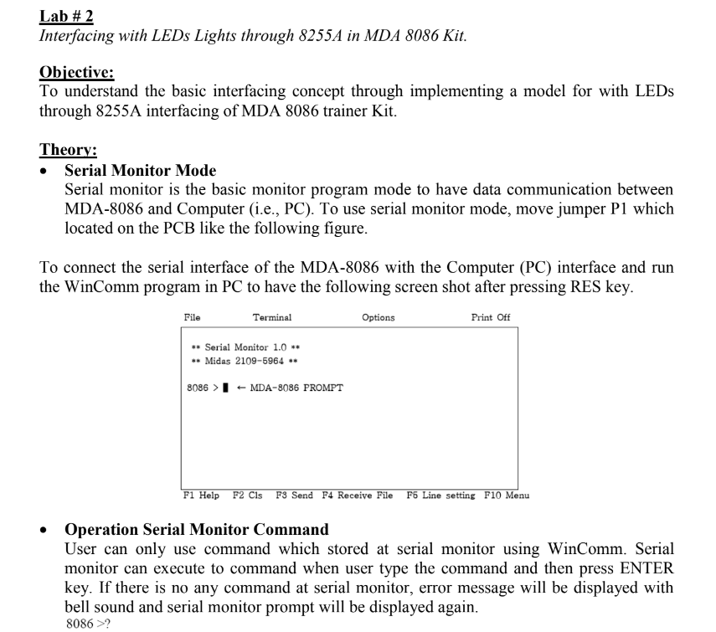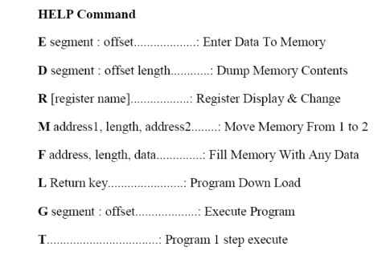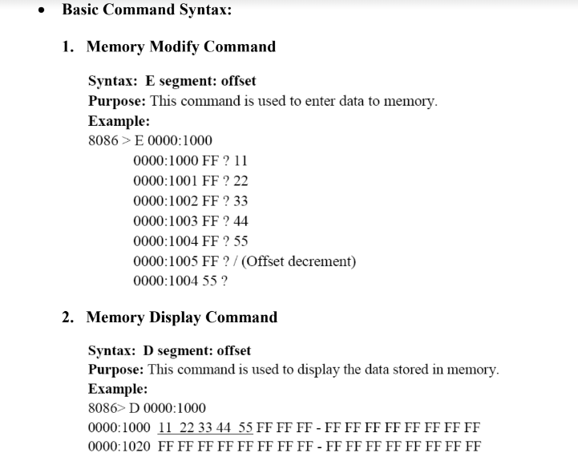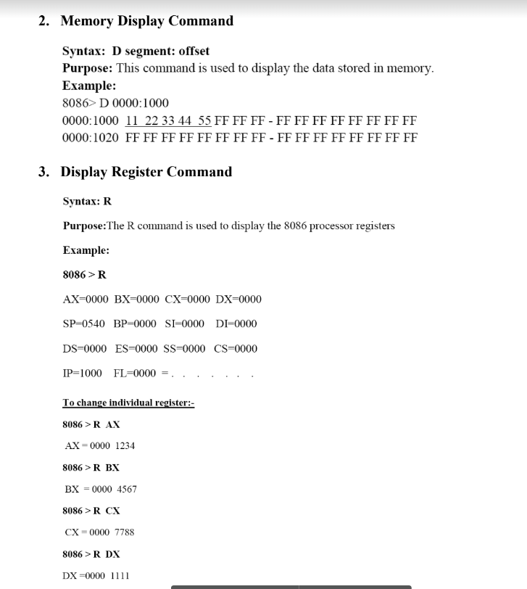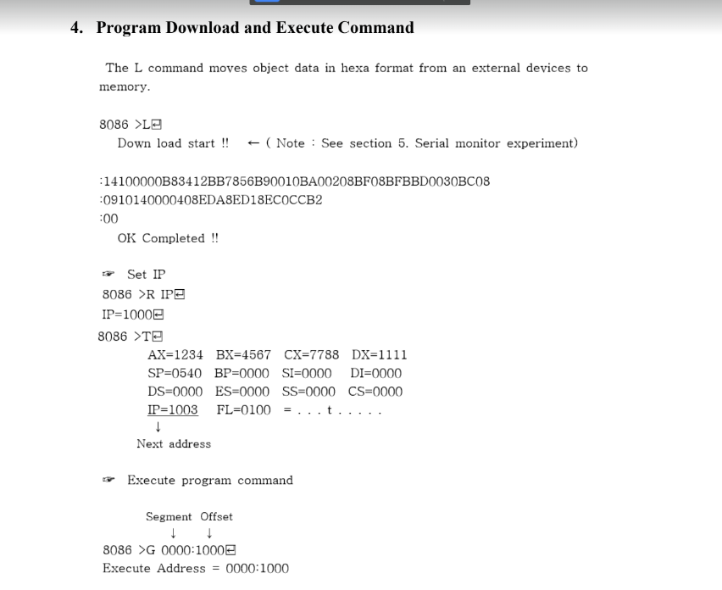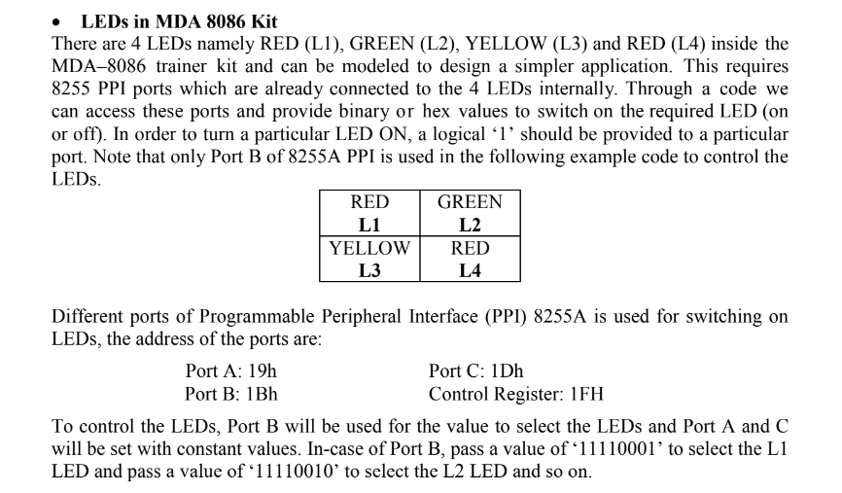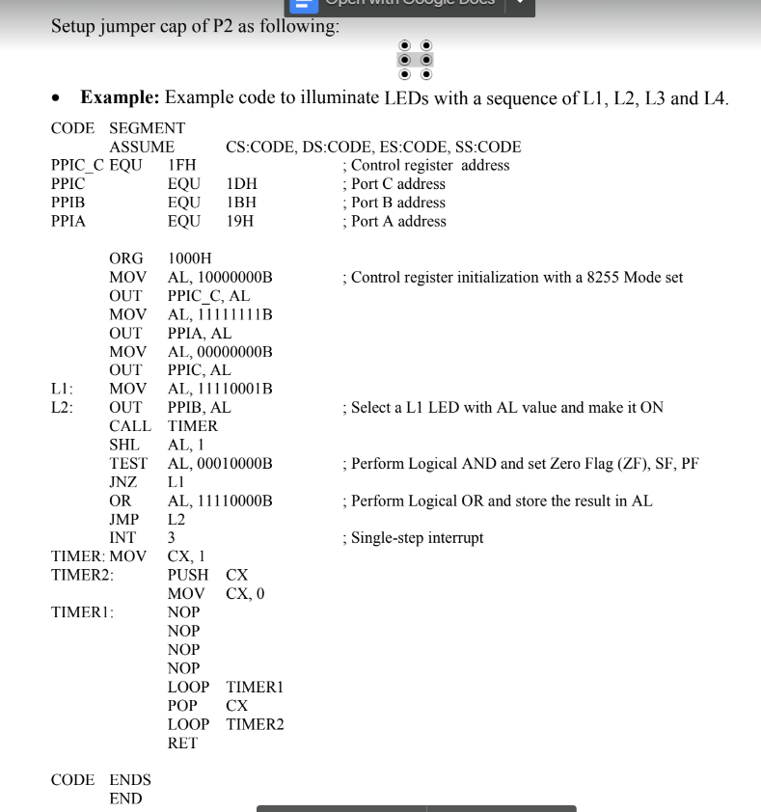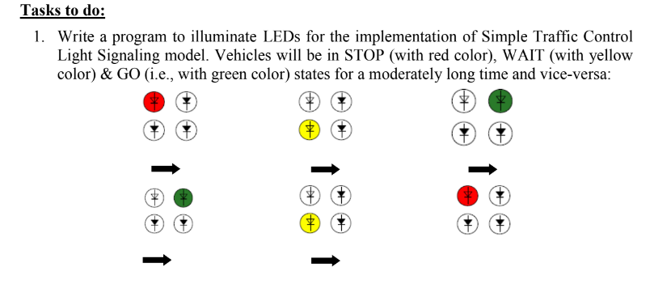

**BOOK + CSE - EXERCISE (extras)**

* *STACK AND PROCEDURE SECTION :*

**.MODEL SMALL**

**.STACK 200H**

**.DATA**

**Default_Stack_SP DW ? ; Stack Pointer (or Top) Offset of Default Stack**

**Stack2_SP DW 0100h ; Stack Pointer (or Top) Offset of (Temporary)Stack_2**

**InPrompt DB "Input: $"**

**OutPrompt DB "Output: $"**

**Str_len DW ? ;String length of input string**

**Word_len DW 0 ;WORD length**

**.CODE**

**MAIN PROC**

**;Load Data Segment**

**MOV AX,@DATA**

**MOV DS,AX**

**;display user prompt**

**MOV AH,9**

**LEA DX,InPrompt**

**INT 21H**

**;initialize character count**

**XOR CX,CX**

**;read a char**

**MOV AH,1**

**INT 21H**

**;input string untill carriage return**

**WHILE:**

**CMP AL,0DH**

**JE END_WHILE**

**PUSH AX**

**INC CX**

**INT 21H**

**JMP WHILE**

**END_WHILE:**

**;Push a Blank space(ASCII: 0020H) at top of default stack,**

**;it is used for word finding, while generating output**

**MOV AX,0020H**

**PUSH AX ;push at top of the default stack**

**;String length = String length + 1 (for 1 additional space)**

**INC CX**

**MOV Str_len,CX**

**JCXZ EXIT_ ; if string length is zero,**

**; then avoid infinite loop by LOOP operation**

**;print new line**

**MOV AH,2**

**MOV DL,0DH**

**INT 21H**

**MOV DL,0AH**

**INT 21H**

**;display Output prompt**

**MOV AH,9**

**LEA DX,InPrompt**

**INT 21H**

**; Following loop exchanges the contents of default stack to stack2**

**; by popping from default stack and pushing it into stack2**

**Loop_DefaultStack_to_Stack2_TransferContent:**

**;pop from Default_Stack**

**POP DX**

**;SAVE Stack Pointer (offset address) of Default_Stack**

**MOV Default_Stack_SP, SP**

**;LOAD Stack Pointer (offset address) of Stack2**

**MOV SP, Stack2_SP**

**;PUSH at Stack 2**

**PUSH DX**

**;SAVE Stack Pointer (offset address) of Stack2**

**MOV Stack2_SP, SP**

**;LOAD Stack Pointer (offset address) of Stack2**

**MOV SP, Default_Stack_SP**

**LOOP Loop_DefaultStack_to_Stack2_TransferContent**

**;Set the string length for loop counter of following loop**

**MOV CX,Str_len**

**JCXZ EXIT_**

**Loop_Stack2_to_DefaultStack_TransferContent_and_Word_Parse:**

**;LOAD Stack Pointer (offset address) of Stack2**

**MOV SP, Stack2_SP**

**;pop from Stack 2**

**POP BX**

**;SAVE Stack Pointer (offset address) of Stack2**

**MOV Stack2_SP, SP**

**INC Word_len**

**;LOAD Stack Pointer (offset address) of Default_Stack**

**MOV SP, Default_Stack_SP**

**;chck space**

**CMP BL,20h**

**JNE Continue_push**

**;if space found(word complete), then pop the all contents of**

**;default stack which hold the compete word.**

**;Poped chars are printed one by one.**

**Complete_Word_Found:**

**MOV AH,2 ;For INT 21H DOS Routine, AH is set to print char**

**;inside the following loop**

**;deduct the space from word length**

**; since space would be printed manually**

**DEC Word_len**

**Loop_Print_word:**

**;POP**

**POP DX**

**INT 21h ;print the poped char**

**;word terminate or not?**

**DEC Word_len**

**CMP Word_len,0**

**JE Print_Space ;if word printing terminates,**

**;then skip Pushing and Go for Popping from Stack2 again**

**JMP Loop_Print_word**

**Continue_push:**

**;PUSH at Default_Stack Again**

**PUSH BX**

**;SAVE offset address of Default_Stack_SP**

**MOV Default_Stack_SP, SP**

**JMP Skip_Printing_Space**

**Print_Space:**

**CMP Word_len,0**

**JNE Skip_Printing_Space**

**;Print_Space**

**MOV DL,20h**

**INT 21h**

**Skip_Printing_Space:**

**;do nothing here, just go to next itaration of this loop**

**LOOP Loop_Stack2_to_DefaultStack_TransferContent_and_Word_Parse**

**;DOS Exit**

**EXIT_:**

**MOV AH,4CH**

**INT 21H**

**MAIN ENDP**

**END MAIN**

*Analyze and explain this STACK and PROC based code statements :*

**Analyze :**

The program takes a set of strings separated by space. In the output, each of those strings are reversed and displayed separated by spaces.

INPUT : CSE CIVIL

OUTPUT: ESC LIVIC

Explain :

1. Declare mode and stack

2. Declare variables in Data Segment:

a. 1 for default stack offset

b. 1 for temporary stack offset

c. Message for input and output

d. Variable to calculate word and string length

3. Load Data Segment in Code

4. Display User prompt using interrupt 21H

5. Clear CX using XOR

6. Read a character using interrupt 21H

7. Begin loop WHILE

a. Push value of AX to Stack

b. Increase value of CX (this will indicate the length of the string entered

c. Repeat if not carriage return

8. If input is carriage return, go to END_WHILE

a. Move a space to AX and push to stack

b. Increase value of CX

c. If CX is zero, go to

i. Return control to DOS with interrupt 21H

9. Print a new line using 0DH (carriage return) and 0AH (line feed)

10. Display Output Prompt using interrupt 21H

11. Begin Loop_DefaultStack_to_Stack2_TransferContent: (this will continue until CX = 0)

a. Pop Default Stack Value to DX

b. Move value of Stack Pointer to Default_Stack_SP (Save SP value to Default Stack)

c. Move the starting point of Stack2_SP to SP

d. Push the Value of DX in Stack 2

e. Move the Stack Pointer to Stack2_SP

f. Move Default_Stack_SP back to SP

12. Move the value of Str_len to CX

13. Begin Loop Loop_Stack2_to_DefaultStack_TransferContent_and_Word_Parse: (continues until CX = 0)

a. Move the starting address of Stack2_SP to SP (load stack2 in SP)

b. Pop the current value of SP to BX

c. Move the current value of SP to Stack2_SP (save the SP value in Stack2)

d. Increase Word_len

e. Move the start of Default_Stack_SP to SP (Load Default Stack in SP)

f. Compare BL to 20H (Black Space)

g. If BL != 20H, go to Continue_Push

i. Push the current value of default stack in BX

ii. Move SP value to Default_Stack_SP (Save SP value in Default Stack)

iii. Jump to Skip_Printing_Space

1. Do nothing, just go to next iteration

iv. Go to Print_Space:

1. Compare Word_Len to 0

2. If word length is not zero, go to Skip_Printing_Space

3. Print space

h. If BL == 20H, go to Complete_Word_Found:

i. Move 2 o AH for character read

ii. Decrease Word_len

iii. Go to Loop_Print_Word:

1. Pop value to DX

2. Print character

3. Decrease Word_len

4. Compare Word_len to 0

5. If Word_len == 0, go to Print_Space

6. Jump to Loop_Print_Word

* *ARRAY SECTION*

1. Write a program to multiply two 16-bit decimal signed numbers where starting address is 2000 and the numbers are at 3000 and 3002 memory address and store result into 3004 and 3006 memory address

CODE :

**.MODEL SMALL**

**.STACK 100H**

**.DATA**

**PROMPT1 DB 'First Number: $'**

**PROMPT2 DB 'Second Number: $'**

**NUM1 DW ?**

**NUM2 DW ?**

**PROMPT3 DB 'Product: $'**

**.CODE**

**MAIN PROC**

**MOV AX,@DATA**

**MOV DS,AX**

**LEA DX,PROMPT1**

**MOV AH,9**

**INT 21H**

**CALL INDEC**

**MOV 3000H,AX**

**CALL LINEBREAK**

**LEA DX,PROMPT2**

**MOV AH,9**

**INT 21H**

**CALL INDEC**

**MOV 3002H,AX**

**CALL LINEBREAK**

**LEA DX,PROMPT3**

**MOV AH,9**

**INT 21H**

**; CALCULATION**

**MOV AX, [3000H]**

**MOV BX, [3002H]**

**MUL BX**

**MOV [3004H], AX**

**MOV [3006H], AX**

**;output**

**CALL OUTDEC**

**MOV AH,4CH**

**INT 21H**

**MAIN ENDP**

**; FOLDER PATH**

**INCLUDE C: \Codes\INDEC.ASM**

**INCLUDE C:\Codes\OUTDEC.ASM**

**INCLUDE C:\Codes\LINEBREAK.ASM**

**END MAIN**

1. Write a program in 8086 microprocessor to find out the product of two arrays of 8-bit n numbers, where size “n” is stored at offset 500 and the numbers of first array are stored from offset 501 and the numbers of second array are stored from offset 601 and store the result numbers into first array i.e offset 501.

CODE :

**.MODEL SMALL**

**.STACK 100h**

**.DATA**

**ARR DB 50 DUP(?) ; declare array with null value initially**

**PROMPT1 DB 'ENTER SIZE OF ARRAY: $'**

**PROMPT2 DB 'ENTER VALUES FOR ARRAY 1: $'**

**PROMPT4 DB 'ENTER VALUES FOR ARRAY 2: $'**

**PROMPT3 DB 'OUTPUT: $'**

**COUNT DW ?**

**.CODE**

**MAIN PROC**

**MOV AX,@DATA**

**MOV DS,AX**

**LEA DX, PROMPT1**

**MOV AH, 9**

**INT 21H**

**CALL INDEC**

**MOV COUNT,AX**

**MOV SI,501H**

**CALL LINEBREAK**

**LEA DX, PROMPT2**

**MOV AH, 9**

**INT 21H**

**CALL LINEBREAK**

**MOV CX, COUNT**

**INPUT:**

**CALL INDEC**

**MOV [SI], AL**

**INC SI**

**CALL LINEBREAK**

**LOOP INPUT**

**CALL LINEBREAK**

**MOV SI,601H**

**CALL LINEBREAK**

**LEA DX, PROMPT4**

**MOV AH, 9**

**INT 21H**

**CALL LINEBREAK**

**MOV CX, COUNT**

**INPUT2:**

**CALL INDEC**

**MOV [SI], AL**

**INC SI**

**CALL LINEBREAK**

**LOOP INPUT2**

**CALL LINEBREAK**

**LEA DX, PROMPT3**

**MOV AH, 9**

**INT 21H**

**MOV CX, COUNT**

**MOV SI, 601H**

**MOV DI, 501H**

**MULDIV:**

**MOV AL, [DI]**

**MOV BL, [SI]**

**MUL BL**

**MOV [DI], AL**

**INC SI**

**INC DI**

**LOOP MULDIV**

**MOV CX,COUNT**

**MOV SI, 501H**

**MOV AH,2**

**OUTPUT:**

**MOV AH, 0**

**MOV AL,[SI]**

**CALL OUTDEC**

**INC SI**

**CALL LINEBREAK**

**LOOP OUTPUT**

**MOV AH, 4CH**

**INT 21H**

**MAIN ENDP**

**; FOLDER PATH**

**INCLUDE C: \Codes\INDEC.ASM**

**INCLUDE C:\Codes\OUTDEC.ASM**

**INCLUDE C:\Codes\LINEBREAK.ASM**

**END MAIN**

1. Write a procedure FIND_IJ that returns the offset address of the element in row i and column j in a two-dimensional M x N word array A stored in row-major order. The procedure receives i in AX, j in BX, N in CX, and the offset of A in DX. It returns the offset address of the element in DX.

CODE :

**.MODEL SMALL**

**.STACK 100H**

**.DATA**

**PROMPT1 DW 'ROW(M): $'**

**ROW DW ?**

**PROMPT2 DW 'COLUMN(N): $'**

**COLUMN DW ?**

**PROMPT3 DW 'I: $'**

**ROWINDEX DW ?**

**PROMPT4 DW 'J: $'**

**COLINDEX DW ?**

**SIZE DW 2**

**PROMPT5 DW 'OFFSET ADDRESS : $'**

**ARRAY DW 50 DUP(?)**

**.CODE**

**MAIN PROC**

**MOV AX, @DATA**

**MOV DS, AX**

**LEA DX, PROMPT1**

**MOV AH, 9**

**INT 21H**

**CALL INDEC**

**MOV ROW, AX**

**CALL LINEBREAK**

**LEA DX, PROMPT2**

**MOV AH, 9**

**INT 21H**

**CALL INDEC**

**MOV COLUMN, AX**

**CALL LINEBREAK**

**LEA SI, ARRAY**

**MOV CX, ROW**

**@L_1:**

**MOV BX, COLUMN**

**@L_2:**

**CALL INDEC**

**MOV [SI], AX**

**CALL LINEBREAK**

**ADD SI, 2**

**DEC BX**

**JNZ @L_2**

**CALL LINEBREAK**

**LOOP @L_1**

**;TAKING I, J**

**LEA DX, PROMPT3**

**MOV AH, 9**

**INT 21H**

**CALL INDEC**

**MOV ROWINDEX, AX**

**CALL LINEBREAK**

**LEA DX, PROMPT4**

**MOV AH, 9**

**INT 21H**

**CALL INDEC**

**MOV COLINDEX, AX**

**CALL LINEBREAK**

**;FIND_IJ**

**MOV AX, ROWINDEX**

**MOV BX, COLINDEX**

**MOV CX, COLUMN**

**LEA SI, ARRAY**

**MOV DX, SI**

**CALL FIND_IJ**

**MOV SI,DX**

**LEA DX, PROMPT5**

**MOV AH, 9**

**INT 21H**

**MOV AX,SI**

**CALL OUTDEC**

**MOV AH, 4CH**

**INT 21H**

**MAIN ENDP**

**; FOLDER PATH**

**INCLUDE C: \Codes\INDEC.ASM**

**INCLUDE C:\Codes\OUTDEC.ASM**

**INCLUDE C:\Codes\LINEBREAK.ASM**

**INCLUDE C:\Codes\FIND_IJ.ASM**

**END MAIN**

1. Write an assembly language program which load 12 decimal numbers in a 3 x 4 word array in row-major order from user input.

a) Display the Matrix

b) Display the highest decimal on each column

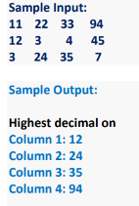

**.MODEL SMALL**

**.STACK 100H**

**.DATA**

**PROMPT1 DB 'Highest decimal on',0DH,0AH,'$'**

**PROMPT2 DB 'Column $'**

**COLNO DB 49**

**PROMPT3 DB ' : $'**

**TEMP DW 0**

**COUNT DW 0**

**SIZE1 DW 2**

**SIZE2 DW 8**

**MIN DW 0**

**ARRAY DW 4 DUP(?)**

**DW 4 DUP(?)**

**DW 4 DUP(?)**

**.CODE**

**MAIN PROC**

**MOV AX, @DATA**

**MOV DS, AX**

**LEA SI, ARRAY**

**MOV CX, 3**

**ROW_INPUT:**

**MOV BX, 4**

**READ:**

**CALL INDEC**

**MOV [SI], AX**

**CALL LINEBREAK**

**ADD SI, 2**

**DEC BX**

**JNZ READ**

**CALL LINEBREAK**

**LOOP ROW_INPUT**

**; SHOW OUTPUT MATRIX**

**LEA SI, ARRAY**

**MOV CX, 3**

**ROW_OUTPUT:**

**MOV BX, 4**

**PRINT:**

**MOV AX, [SI]**

**CALL OUTDEC**

**MOV DL, ' '**

**MOV AH, 2**

**INT 21H**

**ADD SI, 2**

**DEC BX**

**JNZ PRINT**

**CALL LINEBREAK**

**LOOP ROW_OUTPUT**

**; LARGEST NUMBER**

**CALL LINEBREAK**

**LEA DX, PROMPT1**

**MOV AH, 9**

**INT 21H**

**LEA SI, ARRAY**

**MOV TEMP, SI**

**MOV CX, 4**

**COMPARE:**

**MOV SI, TEMP**

**MOV AX, CX**

**NEG AX**

**ADD AX, 4**

**MUL SIZE1**

**MOV COUNT, AX**

**ADD SI, COUNT**

**MOV BX, 3**

**SET_MAX:**

**MOV AX, [SI]**

**CMP AX, MIN**

**JG IF**

**JMP ELSE**

**IF:**

**MOV MIN, AX**

**JMP ELSE**

**ELSE:**

**ADD SI, SIZE2**

**DEC BX**

**JNZ SET_MAX**

**LEA DX, PROMPT2**

**MOV AH, 9**

**INT 21H**

**MOV AH, 2**

**MOV DL, COLNO**

**INT 21H**

**INC COLNO**

**LEA DX, PROMPT3**

**MOV AH, 9**

**INT 21H**

**MOV AX, MIN**

**CALL OUTDEC**

**MOV MIN, 0**

**CALL LINEBREAK**

**LOOP COMPARE**

**MOV AH, 4CH**

**INT 21H**

**MAIN ENDP**

**; FOLDER PATH**

**INCLUDE C: \Codes\INDEC.ASM**

**INCLUDE C:\Codes\OUTDEC.ASM**

**INCLUDE C:\Codes\LINEBREAK.ASM**

**END MAIN**

* EXTRA CODES
* ***2-D ARRAY_TRAVAERSE***

**.MODEL SMALL**

**.STACK 100H**

**.DATA**

**PROMPT_1 DB 'The contents of the array:',0DH,0AH,'$'**

**ARRAY_DATA_SIZE EQU 2 ;1: for Byte Variable , 2: for Word Variable**

**;following ARRAY variable is a 3x4 array**

**Row_Count EQU 3**

**Column_Count EQU 4**

**ARRAY DW 1,2,3,4**

**DW 5,6,7,8**

**DW 9,10,11,12**

**;for calculating row and column memory displacement form array base address**

**Row_Adjustment DW ?**

**Column_Adjustment DW ?**

**;for Loop control**

**R DW 1 ;loop control variable for traversing each Row,initially 1**

**C DW 1 ;loop control variable for traversing each Column,initially 1**

**.CODE**

**MAIN PROC**

**MOV AX, @DATA ; initialize DS**

**MOV DS, AX**

**LEA DX, PROMPT_1 ; load and display the string PROMPT_1**

**MOV AH, 9**

**INT 21H**

**; PRINT_ARRAY Procedure Requires no Input setting**

**CALL PRINT_2D_ARRAY ; call the procedure PRINT_ARRAY**

**; return control to DOS**

**MOV AH, 4CH**

**INT 21H**

**MAIN ENDP**

**PRINT_2D_ARRAY PROC**

**; this procedure will print the elements of a given array**

**; input : none**

**; output : none**

**; Preserve the Contents**

**PUSH AX ; push AX onto the STACK**

**PUSH CX ; push CX onto the STACK**

**PUSH DX ; push DX onto the STACK**

**PUSH SI ; push SI onto the STACK**

**PUSH BX ; push BX onto the STACK**

**MOV R,1**

**@PRINT_ROW: ; loop label**

**PUSH R ;Preserve the Current Row index into a STACK,**

**;now R can be use locally here**

**;update Displacement for current Row**

**DEC R ;R=R-1**

**MOV AX,Column_Count**

**MUL R ; AX=(R-1)*Column_Count**

**MOV R,AX ;Preserve the result AX=(R-1)*Column_Count in R**

**MOV AX,ARRAY_DATA_SIZE**

**MUL R ;(R-1)*Column_Count*ARRAY_DATA_SIZE**

**MOV Row_Adjustment,AX**

**MOV SI,Row_Adjustment ;For Based and Indexed Addressing Mode**

**;Load the Preserved Row index (R) from STACK after local use**

**POP R**

**MOV C,1**

**@PRINT_COLUMN:**

**PUSH C ;Preserve the Current Column index into a STACK,**

**;now C can be use locally here**

**;update Displacement for current Column**

**DEC C ;C=C-1**

**MOV AX,ARRAY_DATA_SIZE**

**MUL C ;(C-1)*ARRAY_DATA_SIZE**

**MOV Column_Adjustment,AX**

**MOV BX,Column_Adjustment ;For Based and Indexed Addressing Mode**

**;Load the Preserved Row index (R) from STACK after local use**

**POP C**

**XOR AX,AX**

**;SI=Row_Adjustment**

**;BX=Column_Adjustment**

**MOV AX, ARRAY[SI][BX] ; Based and Indexed Addressing MODE**

**CALL OUTDEC ; call the procedure OUTDEC**

**; print a Space**

**MOV AH, 2 ; set output function**

**MOV DL, 20H ; set DL=20H**

**INT 21H ; print a character**

**CMP C,Column_Count ;@PRINT_COLUMN Loop Continues as Column Times**

**JE Next_Row_**

**INC C ;Increment the Column index by 1**

**JMP @PRINT_COLUMN**

**Next_Row_:**

**;PRINT_NEW_LINE**

**MOV AH, 2 ; set output function**

**MOV DL, 0DH ;**

**INT 21H ; print a NewLine**

**MOV AH, 2 ; set output function**

**MOV DL, 0AH ;**

**INT 21H ; print a NewLine**

**CMP R,Row_Count**

**JE Procedure_Exit_**

**INC R ;Increment the Row index**

**JMP @PRINT_ROW ; jump to label @PRINT_ROW while CX!=0**

**Procedure_Exit_:**

**; Load the Preserved Contents**

**POP BX ; push BX onto the STACK**

**POP SI ; push SI onto the STACK**

**POP DX ; pop a value from STACK into DX**

**POP CX ; pop a value from STACK into CX**

**POP AX ; pop a value from STACK into AX**

**; return control to the calling procedure**

**RET**

**PRINT_2D_ARRAY ENDP**

**INCLUDE C:\TEST\OUTDEC.ASM**

**INCLUDE C:\TEST\INDEC.ASM**

**END MAIN**

* ***SEARCH ‘N’ IN STRING***

**.MODEL SMALL**

**.STACK 100H**

**.DATA**

**STRING DW 'Hello$'**

**Char_ DW 'o'**

**Prompt_found DB 'Found at Position: String + $'**

**String_Len DW 5**

**STRING_Data_type DB 2 ; for Word array**

**.CODE**

**MAIN PROC**

**MOV AX, @DATA**

**MOV DS, AX**

**; check if the char is found in string**

**; or not**

**CALL Search_Char**

**;interrupt to exit**

**MOV AH, 4CH**

**INT 21H**

**MAIN ENDP**

**Search_Char PROC**

**PUSH AX**

**PUSH BX**

**PUSH SI**

**; load the starting address**

**; of the string**

**;MOV SI,OFFSET STRING**

**LEA SI,STRING**

**; traverse to the end of the String;**

**; and find the Char_**

**MOV BX,0 ;initally BX=0,if Found_ set BX=1**

**MOV CX,0 ;loop index**

**LOOP1:**

**XOR AH,AH**

**MOV AX, [SI]**

**CMP AL, BYTE PTR Char_**

**JNE Continue_**

**;Since Found_, so set BX=1**

**MOV BX,1**

**;;Calculate the found_index = CX * STRING_Data_type**

**MOV AL,STRING_Data_type**

**MUL CL ;Calculate found index = CX * STRING_Data_type**

**PUSH AX ;Actually no need to push/preserve found index CX here**

**;but done for extra safety**

**JMP Exit_Loop1**

**Continue_:**

**INC SI ; to point the next byte in string**

**INC CX ;loop index increment**

**CMP CX,String_Len**

**JE Exit_Procedure**

**JMP LOOP1**

**;;**

**Exit_Loop1:**

**CMP BX,1**

**JNE Exit_Procedure**

**;if Char found then**

**POP CX**

**;print prompt**

**MOV AH,9**

**LEA DX,Prompt_found**

**INT 21h**

**;print found index**

**MOV AX,CX**

**CALL OUTDEC**

**Exit_Procedure:**

**POP SI**

**POP BX**

**POP AX**

**RET**

**Search_Char ENDP**

**INCLUDE C:\TEST\OUTDEC.ASM**

**;INCLUDE C:\TEST\INDEC.ASM**

**END MAIN**

* ***SORT***

**.MODEL SMALL**

**.STACK 100H**

**.DATA**

**PROMPT_1 DB 'The contents of the array before sorting : $'**

**PROMPT_2 DB 0DH,0AH,'The contents of the array after sorting : $'**

**ARRAY DB 5,3,9,0,2,6,1,7,8,4**

**.CODE**

**MAIN PROC**

**MOV AX, @DATA ; initialize DS**

**MOV DS, AX**

**MOV BX, 10 ; set BX=10**

**LEA DX, PROMPT_1 ; load and display the string PROMPT_1**

**MOV AH, 9**

**INT 21H**

**LEA SI, ARRAY ; set SI=offset address of ARRAY**

**CALL PRINT_ARRAY ; call the procedure PRINT_ARRAY**

**LEA SI, ARRAY ; set SI=offset address of the ARRAY**

**CALL SELECT_SORT ; call the procedure SELECT_SORT**

**LEA DX, PROMPT_2 ; load and display the string PROMPT_2**

**MOV AH, 9**

**INT 21H**

**LEA SI, ARRAY ; set SI=offset address of ARRAY**

**CALL PRINT_ARRAY ; call the procedure PRINT_ARRAY**

**MOV AH, 4CH ; return control to DOS**

**INT 21H**

**MAIN ENDP**

**PRINT_ARRAY PROC**

**; this procedure will print the elements of a given array**

**; input : SI=offset address of the array**

**; : BX=size of the array**

**; output : none**

**PUSH AX ; push AX onto the STACK**

**PUSH CX ; push CX onto the STACK**

**PUSH DX ; push DX onto the STACK**

**MOV CX, BX ; set CX=BX**

**@PRINT_ARRAY: ; loop label**

**XOR AH, AH ; clear AH**

**MOV AL, [SI] ; set AL=[SI]**

**CALL OUTDEC ; call the procedure OUTDEC**

**MOV AH, 2 ; set output function**

**MOV DL, 20H ; set DL=20H**

**INT 21H ; print a character**

**INC SI ; set SI=SI+1**

**LOOP @PRINT_ARRAY ; jump to label @PRINT_ARRAY while CX!=0**

**POP DX ; pop a value from STACK into DX**

**POP CX ; pop a value from STACK into CX**

**POP AX ; pop a value from STACK into AX**

**RET ; return control to the calling procedure**

**PRINT_ARRAY ENDP**

**SELECT_SORT PROC**

**; this procedure will sort the array in ascending order**

**; input : SI=offset address of the array**

**; : BX=array size**

**; output :none**

**PUSH AX ; push AX onto the STACK**

**PUSH BX ; push BX onto the STACK**

**PUSH CX ; push CX onto the STACK**

**PUSH DX ; push DX onto the STACK**

**PUSH DI ; push DI onto the STACK**

**CMP BX, 1 ; compare BX with 1**

**JLE @SKIP_SORTING ; jump to label @SKIP_SORTING if BX<=1**

**DEC BX ; set BX=BX-1**

**MOV CX, BX ; set CX=BX**

**MOV AX, SI ; set AX=SI**

**@OUTER_LOOP: ; loop label**

**MOV BX, CX ; set BX=CX**

**MOV SI, AX ; set SI=AX**

**MOV DI, AX ; set DI=AX**

**MOV DL, [DI] ; set DL=[DI]**

**@INNER_LOOP: ; loop label**

**INC SI ; set SI=SI+1**

**CMP [SI], DL ; compare [SI] with DL**

**JNG @SKIP ; jump to label @SKIP if [SI]<=DL**

**MOV DI, SI ; set DI=SI**

**MOV DL, [DI] ; set DL=[DI]**

**@SKIP: ; jump label**

**DEC BX ; set BX=BX-1**

**JNZ @INNER_LOOP ; jump to label @INNER_LOOP if BX!=0**

**MOV DL, [SI] ; set DL=[SI]**

**XCHG DL, [DI] ; set DL=[DI] , [DI]=DL**

**MOV [SI], DL ; set [SI]=DL**

**LOOP @OUTER_LOOP ; jump to label @OUTER_LOOP while CX!=0**

**@SKIP_SORTING: ; jump label**

**POP DI ; pop a value from STACK into DI**

**POP DX ; pop a value from STACK into DX**

**POP CX ; pop a value from STACK into CX**

**POP BX ; pop a value from STACK into BX**

**POP AX ; pop a value from STACK into AX**

**RET ; return control to the calling procedure**

**SELECT_SORT ENDP**

**OUTDEC PROC**

**; this procedure will display a decimal number**

**; input : AX**

**; output : none**

**PUSH BX ; push BX onto the STACK**

**PUSH CX ; push CX onto the STACK**

**PUSH DX ; push DX onto the STACK**

**XOR CX, CX ; clear CX**

**MOV BX, 10 ; set BX=10**

**@OUTPUT: ; loop label**

**XOR DX, DX ; clear DX**

**DIV BX ; divide AX by BX**

**PUSH DX ; push DX onto the STACK**

**INC CX ; increment CX**

**OR AX, AX ; take OR of Ax with AX**

**JNE @OUTPUT ; jump to label @OUTPUT if ZF=0**

**MOV AH, 2 ; set output function**

**@DISPLAY: ; loop label**

**POP DX ; pop a value from STACK to DX**

**OR DL, 30H ; convert decimal to ascii code**

**INT 21H ; print a character**

**LOOP @DISPLAY ; jump to label @DISPLAY if CX!=0**

**POP DX ; pop a value from STACK into DX**

**POP CX ; pop a value from STACK into CX**

**POP BX ; pop a value from STACK into BX**

**RET ; return control to the calling procedure**

**OUTDEC ENDP**

**END MAIN**

* ***Take input and search N in String***

**.MODEL SMALL**

**.STACK 100H**

**.DATA**

**STRING DW 'Hello$'**

**Char_ DW 'o'**

**Prompt_found DB 'Found at Position: String + $'**

**String_Len DW 5**

**STRING_Data_type DB 2 ; for Word array**

**.CODE**

**MAIN PROC**

**MOV AX, @DATA**

**MOV DS, AX ;Initalize the Data Segment**

**MOV ES, AX ;and Extra Segment**

**; check if the char is found in string**

**; or not**

**CLD ;Clear Direction Flag, Now SI and DI moves in increasing address**

**LEA DI,STRING**

**MOV AL,BYTE PTR Char_**

**MOV CX,String_Len**

**REPNE SCASB ;scan Char_ in a byte of STRING**

**JNZ Exit_**

**;Since Found_,**

**MOV AH,9**

**LEA DX,Prompt_found**

**INT 21h**

**;print : found_index in string**

**SUB String_Len,CX**

**DEC String_Len ; String_Len holds the Found_index since 1st element is String+0, so deduct 1**

**MOV AX,String_Len ;multiply by the STRING_Data_type**

**MUL STRING_Data_type**

**;AX hold the product**

**CALL OUTDEC**

**;interrupt to exit**

**Exit_:**

**MOV AH, 4CH**

**INT 21H**

**MAIN ENDP**

**INCLUDE C:\TEST\OUTDEC.ASM**

**;INCLUDE C:\TEST\INDEC.ASM**

**END MAIN**

* ***Translate characters in a given string using a translation table and display the translated string***

**.MODEL SMALL**

**.STACK 100H**

**.DATA**

**table DB 48 DUP (' '), "0123456789", 7 DUP (' ')**

**DB "abcdefghijklmnopqrstuvwxyz", 6 DUP (' ')**

**DB "abcdefghijklmnopqrstuvwxyz", 133 DUP (' ')**

**string1 DB "THIS IS#1,One"**

**strLength DB 23**

**.CODE**

**MAIN PROC**

**MOV AX,@DATA ;Initialize Data Segment**

**MOV DS,AX**

**mov cx, WORD PTR strLength ; string length**

**lea bx, table ; addr of translation table**

**lea si, string1 ; address of string**

**lea di, string1 ; destination also string**

**mov ah,2 ; INT 21h; function for display**

**forIndex:**

**lodsb ; copy next character to AL**

**xlat ; translate character**

**mov dl,al**

**int 21h ;display char**

**stosb ; copy character back into string**

**loop forIndex ; repeat for all characters**

**exit_:**

**MOV AH,4CH ;return DOS**

**INT 21H**

**MAIN ENDP**

**END MAIN**

* ***1-D ARRAY***

**.MODEL SMALL**

**.STACK 100H**

**.DATA**

**PROMPT_1 DB 'Enter the Array elements :',0DH,0AH,'$'**

**PROMPT_2 DB 'The Array elements are : $'**

**ARRAY DW 10 DUP(0)**

**.CODE**

**MAIN PROC**

**MOV AX, @DATA**

**MOV DS, AX**

**MOV BX, 10**

**LEA DX, PROMPT_1**

**MOV AH, 9**

**INT 21H**

**LEA SI, ARRAY**

**CALL IN1DARRAY**

**LEA DX, PROMPT_2**

**MOV AH, 9**

**INT 21H**

**LEA SI, ARRAY**

**CALL OUT1DARRAY**

**MOV AH, 4CH**

**INT 21H**

**MAIN ENDP**

**INCLUDE D:\Codes\IN1DARRAY.ASM**

**INCLUDE D:\Codes\OUT1DARRAY.ASM**

**END MAIN**

* ***TAKE INPUT AND DISPLAY (2-D ARRAY)***

**.MODEL SMALL**

**.STACK 100H**

**.DATA**

**ARRAY DB 3,3 DUP(0) ; Define a 3x3 array of bytes**

**PROMPT1 DB 'Enter array elements:', 0AH,0DH,'$'**

**PROMPT2 DB 'The array elements are:', 0AH,0DH,'$'**

**NEWLINE DB 0AH,0DH,'$'**

**.CODE**

**MAIN PROC**

**MOV AX, @DATA ; Initialize data segment**

**MOV DS, AX**

**LEA DX, PROMPT1 ; Display prompt for input**

**MOV AH, 9**

**INT 21H**

**; Take input for the array**

**MOV CX, 3 ; Number of rows**

**MOV DX, 3 ; Number of columns**

**LEA DI, ARRAY ; Point to start of array**

**FOR_ROW:**

**FOR_COL:**

**MOV AH, 1 ; Read a character**

**INT 21H**

**SUB AL, 30H ; Convert from ASCII to decimal**

**MOV [DI], AL ; Store in array**

**INC DI ; Move to next element**

**LOOP FOR_COL**

**ADD DI, 3 ; Move to start of next row**

**LOOP FOR_ROW**

**; Display the contents of the array**

**LEA DX, PROMPT2 ; Display prompt for output**

**MOV AH, 9**

**INT 21H**

**LEA DI, ARRAY ; Point to start of array**

**FOR_ROW2:**

**FOR_COL2:**

**MOV AL, [DI] ; Load element from array**

**ADD AL, 30H ; Convert from decimal to ASCII**

**MOV AH, 2 ; Display character**

**INT 21H**

**INC DI ; Move to next element**

**LOOP FOR_COL2**

**LEA DX, NEWLINE ; Display newline character**

**MOV AH, 9**

**INT 21H**

**LOOP FOR_ROW2**

**MOV AH, 4CH ; Return control to DOS**

**INT 21H**

**MAIN ENDP**

**END MAIN**

***#(without input)***

**.MODEL SMALL**

**.STACK 100H**

**.DATA**

**ROWS DB 3**

**COLS DB 3**

**TWO_D_ARRAY DB 3, 3, 1, 2, 3, 4, 5, 6, 7, 8, 9**

**PROMPT DB '2D Array:',13,10,'$'**

**.CODE**

**MAIN PROC**

**MOV AX, @DATA**

**MOV DS, AX**

**LEA DX, PROMPT**

**MOV AH, 9**

**INT 21H**

**MOV CL, COLS ; initialize loop counter for columns**

**MOV BX, 0 ; initialize index into array**

**OUTER_LOOP:**

**PUSH CX ; save column counter value**

**MOV CL, COLS ; initialize loop counter for rows**

**INNER_LOOP:**

**MOV AL, TWO_D_ARRAY[BX] ; load value from array**

**ADD AL, 30H ; convert to ASCII**

**MOV DL, AL ; prepare to display**

**MOV AH, 2**

**INT 21H**

**INC BX ; increment array index**

**DEC CL ; decrement row counter**

**JNZ INNER_LOOP ; repeat for all rows**

**POP CX ; restore column counter value**

**DEC CX ; decrement column counter**

**JNZ OUTER_LOOP ; repeat for all columns**

**MOV AH, 4CH**

**INT 21H**

**MAIN ENDP**

**END MAIN**

* ***Take input in 1-d array and display***

**.MODEL SMALL**

**.STACK 100H**

**.DATA**

**ARR DW 10 DUP(0)**

**MSG1 DB 'Enter 10 integer values:',13,10,'$'**

**MSG2 DB 'The values entered are:',13,10,'$'**

**.CODE**

**MAIN PROC**

**MOV AX, @DATA**

**MOV DS, AX**

**LEA DX, MSG1**

**MOV AH, 9**

**INT 21H**

**LEA SI, ARR**

**MOV CX, 10**

**MOV BX, 2 ; set offset to 2 since DW is 2 bytes**

**MOV AH, 1 ; set input function to read character**

**READ_LOOP:**

**INT 21H**

**CMP AL, 0DH ; check if carriage return is entered**

**JE READ_DONE**

**SUB AL, '0' ; convert character to integer**

**MOV [SI+BX], AL ; store the value in the array**

**INC BX**

**LOOP READ_LOOP**

**READ_DONE:**

**LEA DX, MSG2**

**MOV AH, 9**

**INT 21H**

**LEA SI, ARR**

**MOV CX, 10**

**MOV BX, 2 ; set offset to 2 since DW is 2 bytes**

**MOV AH, 2 ; set output function to display character**

**DISP_LOOP:**

**MOV DL, [SI+BX] ; load the value from the array**

**ADD DL, '0' ; convert integer to character**

**INT 21H**

**MOV DL, ',' ; separate values with comma**

**INT 21H**

**ADD BX, 2 ; move offset to next element**

**LOOP DISP_LOOP**

**MOV AH, 4CH ; return control to DOS**

**INT 21H**

**MAIN ENDP**

**END MAIN**

***#(without input)***

**.MODEL SMALL**

**.STACK 100H**

**.DATA**

**arr DB 1, 2, 3, 4, 5 ; declare the array**

**.CODE**

**MAIN PROC**

**MOV AX, @DATA ; set up data segment**

**MOV DS, AX**

**MOV CX, 5 ; set counter to the number of elements in the array**

**LEA SI, arr ; load the starting address of the array into SI**

**displayLoop:**

**MOV DL, [SI] ; move the value of the array element into DL**

**ADD DL, 30h ; convert the value to ASCII**

**MOV AH, 02h ; display the character in DL**

**INT 21h**

**INC SI ; increment SI to point to the next element in the array**

**LOOP displayLoop ; loop until all elements have been displayed**

**MOV AH, 4Ch ; exit program**

**INT 21h**

**MAIN ENDP**

**END MAIN**

* ***fibonacci series n-terms input and display n-terms***

**.MODEL SMALL**

**.STACK 100h**

**.DATA**

**message DB 'Enter the number of terms:', 0AH, 0DH, '$'**

**fib_msg DB 'The Fibonacci sequence is:', 0AH, 0DH, '$'**

**fib DB 20 DUP (0)**

**.CODE**

**MAIN PROC**

**MOV AX, @DATA**

**MOV DS, AX**

**; Display message to enter number of terms**

**LEA DX, message**

**MOV AH, 09h**

**INT 21h**

**; Read input value of n**

**MOV AH, 01h**

**INT 21h**

**SUB AL, 30h ; Convert ASCII digit to integer**

**MOV BL, AL ; Store n in BL for later use**

**; Initialize the Fibonacci sequence**

**MOV CX, 0 ; Current term**

**MOV AX, 0 ; First term**

**MOV BX, 1 ; Second term**

**MOV [fib+CX], AX ; Store first term in array**

**INC CX**

**MOV [fib+CX], BX ; Store second term in array**

**INC CX**

**; Generate the Fibonacci sequence up to the nth term**

**FIB_LOOP:**

**CMP CX, BL ; Check if we have generated enough terms**

**JGE FIB_DONE**

**MOV DX, [fib+CX-2] ; Get the previous term**

**ADD DX, [fib+CX-1] ; Add it to the current term**

**MOV [fib+CX], DX ; Store the sum in the array**

**INC CX**

**JMP FIB_LOOP**

**FIB_DONE:**

**; Display the Fibonacci sequence**

**LEA DX, fib_msg**

**MOV AH, 09h**

**INT 21h**

**MOV CX, BL ; Set loop counter to n**

**MOV SI, 0 ; Set array index to 0**

**FIB_DISPLAY_LOOP:**

**MOV DX, [fib+SI] ; Get the current term from the array**

**CALL DISPLAY_NUMBER ; Display the current term**

**INC SI ; Increment array index**

**LOOP FIB_DISPLAY_LOOP**

**; Terminate program**

**MOV AH, 4Ch**

**INT 21h**

**MAIN ENDP**

**; Display a number in decimal format**

**; Input: DX = number to display**

**DISPLAY_NUMBER PROC**

**MOV BX, 10 ; Set divisor to 10**

**XOR CX, CX ; Set digit count to 0**

**DISPLAY_LOOP:**

**XOR DX, DX ; Clear high word of DX**

**DIV BX ; Divide DX:AX by BX**

**PUSH DX ; Save remainder on stack**

**INC CX ; Increment digit count**

**TEST AX, AX ; Check if quotient is zero**

**JNZ DISPLAY_LOOP**

**DISPLAY_LOOP2:**

**POP DX ; Get remainder from stack**

**ADD DL, 30h ; Convert to ASCII digit**

**MOV AH, 02h ; Set display function**

**INT 21h ; Display digit**

**LOOP DISPLAY_LOOP2**

**MOV DL, ' ' ; Display a space after the number**

**MOV AH, 02h ; Set display function**

**INT 21h ; Display space**

**RET**

**DISPLAY_NUMBER ENDP**

**END MAIN**

* ***(#using array)***

**.MODEL SMALL**

**.STACK 100H**

**.DATA**

**arr DW 12 DUP(?)**

**n DW 12 ; number of terms to generate**

**index DW ?**

**term DW ?**

**i DW 02h**

**j DW 0**

**k DW 1**

**.CODE**

**MAIN PROC**

**MOV AX, @DATA**

**MOV DS, AX**

**; get the number of terms to generate**

**MOV AH, 01h**

**INT 21h**

**SUB AL, 30h ; convert character to number**

**MOV BL, AL**

**MOV CX, 0**

**MOV AX, 0**

**; initialize the first two terms of the series**

**MOV arr[0], AX**

**MOV arr[2], CX**

**MOV arr[4], CX**

**MOV arr[6], CX**

**MOV arr[8], CX**

**MOV arr[10], CX**

**MOV arr[12], CX**

**MOV arr[14], CX**

**MOV arr[16], CX**

**MOV arr[18], CX**

**MOV arr[20], CX**

**; generate the Fibonacci series and store in the array**

**MOV DX, OFFSET arr**

**MOV SI, 2**

**MOV BX, 1**

**L1:**

**MOV AX, i**

**ADD AX, j**

**MOV k, AX**

**MOV AX, k**

**MOV term, AX**

**MOV index, SI**

**MOV [DX][index], term**

**ADD SI, 2**

**MOV AX, j**

**MOV i, AX**

**MOV AX, k**

**MOV j, AX**

**DEC BL**

**JNZ L1**

**; display the Fibonacci series stored in the array**

**MOV DX, OFFSET arr**

**MOV SI, 0**

**MOV CX, n**

**L2:**

**MOV AX, [DX][SI]**

**CALL DISPLAY_NUM**

**ADD SI, 2**

**LOOP L2**

**MOV AH, 4Ch**

**INT 21h**

**MAIN ENDP**

**; display a number on the screen**

**DISPLAY_NUM PROC**

**PUSH AX**

**PUSH BX**

**PUSH CX**

**PUSH DX**

**XOR CX, CX**

**MOV BX, 10**

**MOV AX, 0**

**MOV DX, 0**

**DIV BX**

**PUSH DX**

**INC CX**

**L1:**

**XOR DX, DX**

**DIV BX**

**PUSH DX**

**INC CX**

**CMP AX, 0**

**JNZ L1**

**L2:**

**POP DX**

**OR DL, 30h**

**MOV AH, 02h**

**INT 21h**

**LOOP L2**

**POP DX**

**POP CX**

**POP BX**

**POP AX**

**RET**

**DISPLAY_NUM ENDP**

**END MAIN**

**PREVIOUS QUESTIONS AND ANSWERS**

* In the microprocessor, what is the function of IP and ALU?

IP : contains the address of the next instruction to be executed by the EU.

ALU : perform arithmetic & logic operation

* What determines whether a microprocessor is considered an 8 bit, a 16 bit, or a 32 bit device?

The number of bits a microprocessor’s ALU can work with at a time determines whether the microprocessor is considered an 8-bit, 16-bit or 2-bit system.

Or,

The number of bits in a microprocessor's data bus determines its classification as an 8-bit, 16-bit, or 32-bit device, with wider data buses allowing for more data to be transferred at once. The width of the data bus also affects the microprocessor's ability to access memory and execute instructions. Wider data buses generally lead to increased processing power and the ability to handle more complex tasks.

* What types of programs are usually written in assembly language?

Programs which require a lot of hardware control or programs which must run as quickly as possible are usually best written in assembly language.

* Consider a machine language instruction that moves a copy of the contents of register BX in the CPU to a memory word. What happens during it?

i. the fetch cycle?

ii. the execution cycle?

i) • Fetch an instruction from memory.

• Decode the instruction to determine the operation.

ii) • Perform the operation if needed.

• Store the results in memory

* If the stack segment register contains 56C0H and the stack pointer register contains 1358H, what is the physical address of the top of the stack?

57F58

* Write the 8086 instruction which will perform the indicated operation

i. Divide DL by BL

MOV AL, DL

DIV BL

ii. Set the most significant bit of AX to a 1, and invert the lower 4 bits, but do not affect the other bits

OR AX,80H

XOR AX,0FH

* Perform the indicated operation on the following number

0111 1001 BCD + 1001 0101 BCD = 0001 0110 0001 0100 BCD

* In order to avoid hand keying programs into an SDK-86 board, we wrote a program to send machine code programs from IBM PC to an SDK-86 board through a serial link. As part of this program, we had to convert each byte of the machine code program to ASCII codes for the two nibbles in the byte. In other word, a byte of 7AH has to be sent as 37H, the ASCII code for 7, and 41H, the ASCII code for A. Once you separate the nibble of the byte, this conversion is a simple IF-THEN-ELSE situation. Write an assembly language program section which does the needed conversion.

CODE :

**.MODEL SMALL**

**.DATA**

**num db ?**

**num1 db ?**

**num2 db ?**

**.CODE**

**MAIN PROC**

**MOV AX,@DATA**

**MOV DS,AX**

**MOV AL,7BH**

**MOV num1,AL**

**MOV num2,AL**

**MOV BL,num1**

**AND BL,11110000b**

**MOV CL,4**

**SHR BL,CL**

**MOV CX,2**

**begin_:**

**CMP BL,9d**

**JL digit_**

**cmp BL,0Fh**

**JG print_**

**ADD BL,37h**

**JMP print_**

**digit_:**

**OR BL,00110000b**

**print_:**

**MOV AH,2**

**MOV DL,BL**

**INT 21h**

**MOV BL,num2**

**AND BL,00001111b**

**loop begin_**

**;dos return**

**MOV AH,4CH**

**INT 21H**

**MAIN ENDP**

**END MAIN**

* Write one or more instructions to multiply the content of DL by 16D without using MUL or IMUL instruction’

**.MODEL SMALL**

**.DATA**

**.CODE**

**MAIN PROC**

**MOV AX,@DATA**

**MOV DS,AX**

**MOV DL,00000110b**

**MOV CL,4**

**SHL DL,CL**

**;dos return**

**MOV AH,4CH**

**INT 21H**

**MAIN ENDP**

**END MAIN**

* Discuss the result of following instruction in brief.

i. MOV AX , [DX]

* How do we detect when a signed overflow does occur? Discuss three effective methods in brief.
* Write an assembly language program section which puts the product of the first 6 terms of the arithmetic sequence 1, 3, 5, 7 … in DX. Use a looping structure to produce the product

**.MODEL SMALL**

**.DATA**

**product dw 1**

**num dw 1**

**.CODE**

**MAIN PROC**

**MOV AX,@DATA**

**MOV DS,AX**

**MOV CX,5**

**LOOP_:**

**MOV AX,product**

**ADD num,2**

**MOV DX,num**

**MUL DX**

**MOV product, AX**

**loop Loop_**

**;dos return**

**MOV AH,4CH**

**INT 21H**

**MAIN ENDP**

**END MAIN**

* Write an assembly language program section which clears ZF if DX contains an even number.

***.MODEL SMALL***

**.DATA**

**product dw 1**

**num dw 1**

**.CODE**

**MAIN PROC**

**MOV AX,@DATA**

**MOV DS,AX**

**MOV BX,5d**

**AND BX,0001h**

**JNZ exit_**

**exit_:**

**;dos return**

**MOV AH,4CH**

**INT 21H**

**MAIN ENDP**

**END MAIN**

**—--------------------------------------------------------------------------------------------**

**Table of Contents**

**Interrupt system 1**

**Interrupts in 8086 2**

Hardware Interrupts 2

Software Interrupts 3

**Interrupts in 8085 4**

Types of Interrupts in 8085 4

Instruction for Interrupts 6

Uses of Interrupts in 8085 microprocessor 7

Issues of Interrupts in 8085 microprocessor 7

**Exercises from Book (Marut) 7**

**Programming Exercises from Book (Marut) 10**

**Other Important Questions (Quiz, Exams, Assignments) 16**

# **Interrupt system**

**An interrupt is a condition that halts the microprocessor temporarily to work on a different task and then return to its previous task. Interrupt is an event or signal that requests the attention of the CPU. This halt allows peripheral devices to access the microprocessor.**

Interrupt can work for both 8085 and 8086

If we think of a system without any interrupt -

There will be a driver that will be dedicated for a system or hardware ( let’s say keyboard), then while performing other tasks, it will also go to the driver dedicated to the keyboard and will pull from the keyboard to check if any key is pressed or not.

**Disadvantages of this system can be -**

* inefficient
* unnecessary pulling ( if there is no input but the driver still pulls for input)
* Suppose there is an input device that prepares the inputs every 10 milliseconds but the system's driver pulls from that input device after every 20 milliseconds , at this situation the whole system becomes slow

To handle an interrupt there is an interrupt controller that can be an internal or an external device.

To handle an interrupt there is a routine that is called Interrupt Service Routine. When the service routine is triggered then the microprocessor is interrupted. Then the microprocessor stops its regular task and serves the interrupt service routine . Interrupt service routine is generally a set of functions.

**The processor can be interrupted in the following ways**

* by an external signal generated by a peripheral,
* by an internal signal generated by a special instruction in the program,
* by an internal signal generated due to an exceptional condition which occurs while executing an instruction

# **Interrupts in 8086**

Interrupts are 2 types-

* Hardware interrupt
* Software interrupt

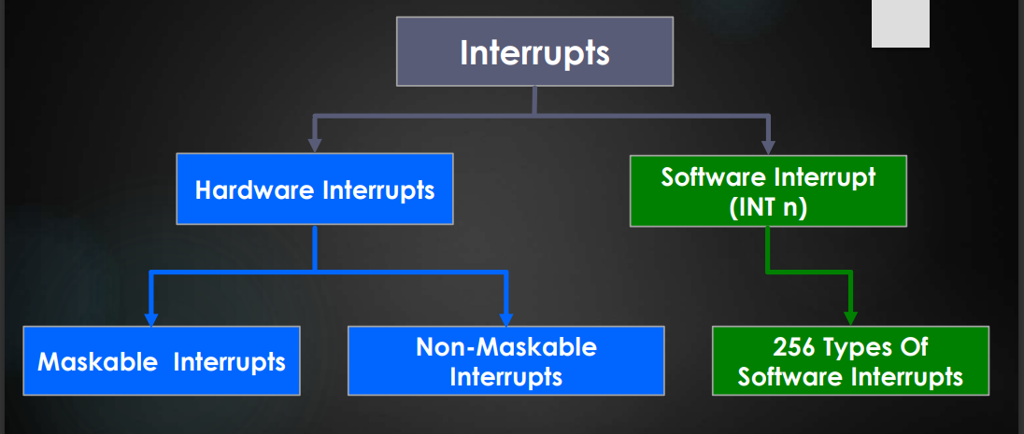

## **Hardware Interrupts**

**Maskable:** **The processor has the facility for accepting or rejecting hardware interrupts.** Programming the processor to reject an interrupt is referred to as masking or disabling and programming the processor to accept an interrupt is referred to as unmasking or enabling. In 8086 the interrupt flag (IF) can be set to one to unmask or enable all hardware interrupts and IF is cleared to zero to mask or disable a hardware interrupts except NMI. The interrupts whose request can be either accepted or rejected by the processor are called maskable interrupts

**Non-Maskable: The interrupts whose request has to be definitely accepted (or cannot be rejected) by the processor are called non-maskable interrupts.** Whenever a request is made by non-maskable interrupt, the processor has to definitely accept that request and service that interrupt by suspending its current program and executing an ISR. In 8086 processor all the hardware interrupts initiated through INTR pin are maskable by clearing the interrupt flag (IF). The interrupt initiated through NMI(Non-Maskable Interrupt) pin and all software interrupts are non-maskable.

Non-Maskable Interrupts

* Used during power failure
* Used during critical response time
* Used during non-recoverable hardware errors
* Used watchdog interrupt
* Used during memory parity errors

## **Software Interrupts**

The software interrupts are program instructions. These instructions are inserted at desired locations in a program. While running a program, if software interrupt instruction is encountered then the processor initiates an interrupt. **The 8086 processor has 256 types of software interrupts.** **The software interrupt instruction is INT n, where n is the type number in the range 0 to 255.**

Software Interrupt (INT n)

* Used by operating systems to provide hooks into various function
* Used as a communication mechanism between different parts of the program

## 

**256 INTERRUPTS OF 8086 ARE DIVIDED IN TO 3 GROUPS**

**1. TYPE 0 TO TYPE 4 INTERRUPTS**

These Are Used For Fixed Operations And Hence Are Called Dedicated Interrupts

* **Type – 0** **Divide Error Interrupt**

Quotient Is Large Cant Be Fit In Al/Ax Or Divide By Zero

* **Type –1 Single Step Interrupt**

Used For Executing The Program In Single Step Mode By Setting Trap Flag

* **Type – 2 Non Maskable Interrupt**

This Interrupt Is Used For Execution Of NMI Pin.

* **Type – 3 Break Point Interrupt**

Used For Providing Break Points In The Program

* **Type – 4 Over Flow Interrupt**

Used To Handle Any Overflow Error.

**2. TYPE 5 TO TYPE 31 INTERRUPTS**

Not Used By 8086,reserved For Higher Processors Like 80286 80386 Etc

**3. TYPE 32 TO 255 INTERRUPTS**

Available For User, called User Defined Interrupts These Can Be H/W Interrupts And Activated Through Intr Line Or Can Be S/W Interrupts.

# **Interrupts in 8085**

## **Types of Interrupts in 8085**

**There are five interrupt signals in the 8085 microprocessor:**

**TRAP:** The TRAP interrupt is a non-maskable interrupt that is generated by an external device, such as a power failure or a hardware malfunction. The TRAP interrupt has the highest priority and cannot be disabled.

**RST 7.5:** The RST 7.5 interrupt is a maskable interrupt that is generated by a software instruction. It has the second highest priority.

**RST 6.5:** The RST 6.5 interrupt is a maskable interrupt that is generated by a software instruction. It has the third highest priority.

**RST 5.5:** The RST 5.5 interrupt is a maskable interrupt that is generated by a software instruction. It has the fourth highest priority.

**INTR:** The INTR interrupt is a maskable interrupt that is generated by an external device, such as a keyboard or a mouse. It has the lowest priority and can be disabled.

Interrupts can be classified into various categories based on different parameters:

**Hardware and Software Interrupts –** When microprocessors receive interrupt signals through pins (hardware) of microprocessors, they are known as Hardware Interrupts. There are 5 Hardware Interrupts in 8085 microprocessors. They are – INTR, RST 7.5, RST 6.5, RST 5.5, TRAP Software Interrupts are those which are inserted in between the program which means these are mnemonics of microprocessor. There are 8 software interrupts in the 8085 microprocessor. They are – RST 0, RST 1, RST 2, RST 3, RST 4, RST 5, RST 6, RST 7.

**Vectored and Non-Vectored Interrupts –** Vectored Interrupts are those which have a fixed vector address (starting address of sub-routine) and after executing these, program control is transferred to that address. Vector Addresses are calculated by the formula 8 * TYPE

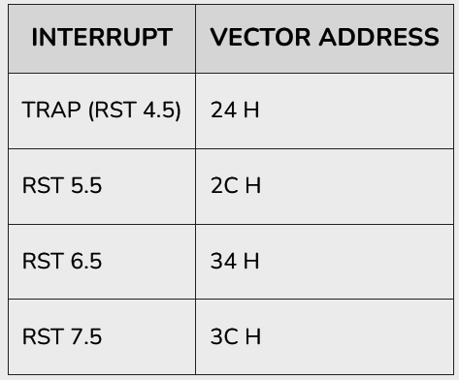

For Software interrupts vector addresses are given by:

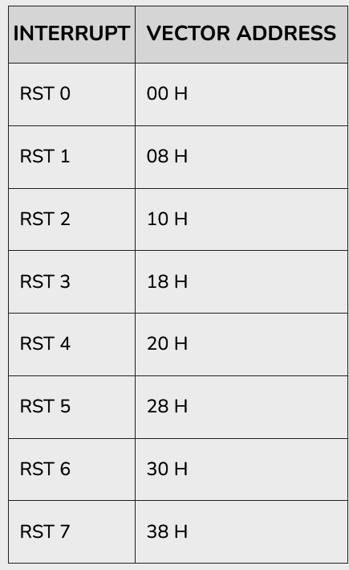

Non-Vectored Interrupts are those in which the vector address is not predefined. The interrupting device gives the address of the sub-routine for these interrupts. INTR is the only non-vectored interrupt in an 8085 microprocessor.

**Maskable and Non-Maskable Interrupts –** Maskable Interrupts are those which can be disabled or ignored by the microprocessor. These interrupts are either edge-triggered or level-triggered, so they can be disabled. INTR, RST 7.5, RST 6.5, RST 5.5 are maskable interrupts in 8085 microprocessor. Non-Maskable Interrupts are those which cannot be disabled or ignored by microprocessor. TRAP is a non-maskable interrupt. It consists of both level as well as edge triggering and is used in critical power failure conditions.

Priority of Interrupts – When microprocessor receives multiple interrupt requests simultaneously, it will execute the interrupt service request (ISR) according to the priority of the interrupts.

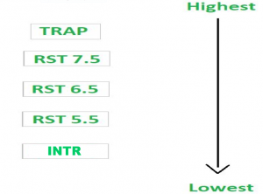

## **Instruction for Interrupts**

**Enable Interrupt (EI) –** The interrupt enable flip-flop is set and all interrupts are enabled following the execution of next instruction followed by EI. No flags are affected. After a system reset, the interrupt enable flip-flop is reset, thus disabling the interrupts. This instruction is necessary to enable the interrupts again (except TRAP).

**Disable Interrupt (DI) –** This instruction is used to reset the value of enable flip-flop hence disabling all the interrupts. No flags are affected by this instruction.

**Set Interrupt Mask (SIM) –** It is used to implement the hardware interrupts (RST 7.5, RST 6.5, RST 5.5) by setting various bits to form masks or generate output data via the Serial Output Data (SOD) line. First the required value is loaded in accumulator then SIM will take the bit pattern from it.

**Read Interrupt Mask (RIM) –** This instruction is used to read the status of the hardware interrupts (RST 7.5, RST 6.5, RST 5.5) by loading into the A register a byte which defines the condition of the mask bits for the interrupts. It also reads the condition of SID (Serial Input Data) bit on the microprocessor.

## **Uses of Interrupts in 8085 microprocessor**

Interrupts in the 8085 microprocessor are used for various purposes, including:

* Real-time processing
* Multi-tasking
* Input/output operations
* Error handling
* Power management

## **Issues of Interrupts in 8085 microprocessor**

There are several issues that need to be considered when using interrupts in the 8085 microprocessor:

* Priority conflicts
* Race conditions
* Interrupt latency
* Interrupt nesting
* Interrupt overhead

# **Exercises from Book (Marut)**

**1.Compute the location of the interrupt vector for interrupt 20h.**

**Ans:** The interrupt vector table is a table of addresses that the CPU uses to jump to the appropriate interrupt service routine (ISR) when an interrupt is triggered.

In the case of interrupt 20h, the ISR address is located at offset 20h * 4 in the interrupt vector table, since each entry in the table is 4 bytes long.

Therefore, to compute the location of the interrupt vector for interrupt 20h, we need to multiply the interrupt number (20h) by 4 to get the offset in the interrupt vector table.

20h * 4 = 80h

So the interrupt vector for interrupt 20h is located at offset 80h in the interrupt vector table.

**2. Use DEBUG to find the value of the interrupt vector for Interrupt 0.**

**Ans:** In DOS, we can use the DEBUG program to examine the contents of memory. To find the value of the interrupt vector for Interrupt 0, we can follow these steps:

Open a command prompt in DOS. Type "debug" and press Enter to start the DEBUG program. Type the following commands, pressing Enter after each line:

**-d 0:0**

This will display the first 16 bytes of memory, starting at address 0:0.

Look for the entry for Interrupt 0, which is located at offset 00h * 4 in the interrupt vector table. The value at this location is the interrupt vector for Interrupt 0.

Note that Interrupt 0 is the divide-by-zero interrupt, so its ISR address is critical for handling errors in the CPU's arithmetic operations.

On most x86 systems, the interrupt vector for Interrupt 0 is set to the default ISR address of 0000:0472h. So if we follow the above steps and examine memory at address 0:0, we should see the value 0472h at offset 00h * 4, indicating that this is the interrupt vector for Interrupt 0.

**3. Write instructions that use the BIOS interrupt 17h to print the message "Hello".**

**Ans:**

.MODEL SMALL

.STACK 100h

.DATA

message DB 'Hello$'

.CODE

MAIN PROC

MOV AX, 0Eh

MOV DX, OFFSET message

INT 17h

MOV AH, 4Ch

INT 21h

MAIN ENDP

END MAIN

**4.Write instructions that use the INT 2lh, function 2Ah, to display the current date.**

**Ans:**

.model tiny

.code

org 100h

main proc near

mov ah,2ah

int 21h

push dx

mov ax,cx

mov si,offset year

call hexToAsc

pop dx

push dx

mov ah,00

mov al,dh

mov si,offset month

call hexToAsc

pop dx

push dx

mov ah,00

mov al,dl

mov si,offset day

call hexToAsc

pop dx

mov ah,09h

mov dx,offset messagecurrentdate

int 21h

mov ah,4ch

mov al,00

int 21h

messagecurrentdate db 0ah,0dh,"Current Date : "

day db ' '

separator1 db '/'

month db ' '

separator2 db '/'

year db " $"

endp

hexToAsc proc near ;AX input , si point result storage addres

mov cx,00h

mov bx,0ah

hexloop1:

mov dx,0

div bx

add dl,'0'

push dx

inc cx

cmp ax,0ah

jge hexloop1

add al,'0'

mov [si],al

hexloop2:

pop ax

inc si

mov [si],al

loop hexloop2

ret

endp

end main

# **Programming Exercises from Book (Marut)**

**5. Write a program that will output the message "Hello" once every half second to the screen.**

**Ans: (not sure about this)**

.MODEL SMALL

.STACK 100h

.DATA

message DB 'Hello$'

.CODE

MAIN PROC

MOV AX, @DATA ; initialize DS register

MOV DS, AX

MOV AH, 0Ch ; set function 0Ch to print character

MOV CX, 0 ; set color to default

MOV DX, 0 ; set cursor position to current position

MOV BL, 07h ; set attribute to normal (white on black)

LOOP_START:

MOV AH, 0Eh ; set function 0Eh to print string

MOV DX, OFFSET message ; set DX to the offset of the message

INT 10h ; print the message to the screen

MOV AH, 86h ; set function 86h to wait for a short period of time

MOV CX, 5000 ; set CX to the number of microseconds to wait

INT 15h ; call interrupt 15h to wait for a short period of time

JMP LOOP_START ; jump back to the start of the loop

MOV AH, 4Ch ; set function 4Ch to exit program

INT 21h ; call interrupt 21h to exit program

MAIN ENDP

END MAIN

**6. Modify PGMIS_Z.ASM so that INT 21h, function 9, Is called to display the time only when the seconds change.**

**Ans:**  (not sure)

TITLE PGM15_2: DISPLAY_TIME_VR

; program that displays the current time

; and updates the time 18.2 times a second

EXTRN GET_TIME:NEAR,SETUP_INT:NEAR

.stackseg segment stack '100h'

; stack segment definition

.stackseg ends

.data

TIME_BUF DB '00:00:00$' ; time buffer hr:min:sec

CURSOR_POS DW ? ; cursor position (row:col)

NEW_VEC DW ? ; new interrupt vector

OLD_VEC DW ? ; old interrupt vector

.code

MAIN PROC

mov ax, @data

mov ds, ax ; initialize data segment

; save cursor position

mov ah, 3 ; function 3, get cursor

mov bh, 0 ; page 0

int 10h ; get cursor position

mov CURSOR_POS, dx ; save it

; set up interrupt procedure by placing segment of SET_TIME_INT in NEW_VEC

mov NEW_VEC, OFFSET SET_TIME_INT ; offset

mov NEW_VEC+2, SEG SET_TIME_INT ; segment

lea di, OLD_VEC ; DI points to vector buffer

lea si, NEW_VEC ; SI points to new vector

mov al, 0Ch ; timer interrupt

call SETUP_INT

; read keyboard

mov ah, 0

int 16h

; restore old interrupt

lea di, NEW_VEC

lea si, OLD_VEC

mov al, 0Ch ; timer interrupt

call SETUP_INT

mov ah, 4Ch

int 21h ; return to DOS

MAIN ENDP

SET_TIME_INT PROC

; interrupt procedure

; activated by the timer

push ds

mov ax, @data

mov ds, ax ; set data segment

; get new time

lea bx, TIME_BUF

call GET_TIME

; display time

cmp TIME_BUF+6, '0' ; check if seconds changed

je skip_display ; if not, skip display

lea dx, TIME_BUF

mov ah, 09h ; function 9, display string

int 21h

skip_display:

; restore cursor position

mov ah, 02h ; function 2, move cursor

mov bh, 0 ; page 0

mov dx, CURSOR_POS ; cursor position

int 10h

pop ds

iret

SET_TIME_INT ENDP

END MAIN

**7. Write a memory resident program similar to PGM15_3.ASM using INT 2lh, function 3lh.**

**Ans:** TITLE PGM15_2: DISPLAY_TIME_VR

; program that displays the current time

; and updates the time 18.2 times a second

EXTRN GET_TIME:NEAR,SETUP_INT:NEAR

.stackseg segment stack '100h'

; stack segment definition

.stackseg ends

.data

TIME_BUF DB '00:00:00$' ; time buffer hr:min:sec

CURSOR_POS DW ? ; cursor position (row:col)

NEW_VEC DW ? ; new interrupt vector

OLD_VEC DW ? ; old interrupt vector

.code

MAIN PROC

mov ax, @data

mov ds, ax ; initialize data segment

; save cursor position

mov ah, 3 ; function 3, get cursor

mov bh, 0 ; page 0

int 10h ; get cursor position

mov CURSOR_POS, dx ; save it

; set up interrupt procedure by placing segment of SET_TIME_INT in NEW_VEC

mov NEW_VEC, OFFSET SET_TIME_INT ; offset

mov NEW_VEC+2, SEG SET_TIME_INT ; segment

lea di, OLD_VEC ; DI points to vector buffer

lea si, NEW_VEC ; SI points to new vector

mov al, 0Ch ; timer interrupt

call SETUP_INT

; read keyboard

mov ah, 0

int 16h

; restore old interrupt

lea di, NEW_VEC

lea si, OLD_VEC

mov al, 0Ch ; timer interrupt

call SETUP_INT

mov ah, 4Ch

int 21h ; return to DOS

MAIN ENDP

SET_TIME_INT PROC

; interrupt procedure

; activated by the timer

push ds

mov ax, @data

mov ds, ax ; set data segment

; get new time

lea bx, TIME_BUF

call GET_TIME

; display time

cmp TIME_BUF+6, '0' ; check if seconds changed

je skip_display ; if not, skip display

lea dx, TIME_BUF

mov ah, 09h ; function 9, display string

int 21h

skip_display:

; restore cursor position

mov ah, 02h ; function 2, move cursor

mov bh, 0 ; page 0

mov dx, CURSOR_POS ; cursor position

int 10h

pop ds

iret

SET_TIME_INT ENDP

END MAIN

# **Other Important Questions (Quiz, Exams, Assignments)**

**1. List the sequence of actions performed by the Intel 8086 microprocessor while handling a Software Interrupt.**

**Ans:** In 8086 microprocessor following tasks are performed when microprocessor encounters an interrupt:

1. The value of the flag register is pushed into the stack. It means that first the value of SP (Stack Pointer) is decremented by 2 then the value of flag register is pushed to the memory address of the stack segment.

2. The value of the starting memory address of CS (Code Segment) is pushed into the stack.

3. The value of IP (Instruction Pointer) is pushed into the stack.

4. IP is loaded from word location (Interrupt type) * 04.

5. CS is loaded from the next word location.

6. Interrupt and Trap flags are reset to 0.

**2.Analyze how the 8086 microprocessor handles interrupts and exceptions and how they affect its operation and reliability. (Assignment)**

**Ans:** The 8086 microprocessor handles interrupts and exceptions through its Interrupt Vector Table (IVT). The IVT is a table of 256 addresses, each representing a specific interrupt or exception. When an interrupt or exception occurs, the 8086 first saves the current state of the processor, including the contents of the registers, on the stack. It then looks up the address of the interrupt or exception handler in the IVT, jumps to that address, and executes the corresponding interrupt or exception routine.

Interrupts and exceptions can affect the operation and reliability of the 8086 microprocessor in several ways. On one hand, interrupts and exceptions are essential for the proper functioning of the microprocessor, as they allow it to handle external events and respond to unexpected conditions. For example, interrupts can be used to handle input/output operations, timer events, or other hardware interrupts, while exceptions can detect errors such as divide-by-zero, invalid opcode, or memory access violations.

On the other hand, interrupts and exceptions can also cause issues such as race conditions, resource conflicts, and reliability problems. For instance, if two interrupts occur simultaneously, the 8086 may have to deal with a race condition, where the order of execution is not well-defined and may depend on external factors. Moreover, interrupts and exceptions may also affect the performance and reliability of the microprocessor by introducing delays, conflicts, or other side effects.

To minimize these issues, the 8086 microprocessor implements several mechanisms, such as priority levels, interrupt masking, and error handling. Priority levels allow the microprocessor to handle interrupts in a predefined order, based on their importance or urgency. Interrupt masking allows the microprocessor to selectively enable or disable interrupts, depending on the current context or task. Error handling allows the microprocessor to detect and recover from errors, such as by resetting the system or signaling an error code.

Overall, the 8086 microprocessor's handling of interrupts and exceptions is crucial for its proper functioning and reliability. While these mechanisms can introduce some overhead and complexity, they are necessary to ensure that the microprocessor can handle external events and recover from unexpected conditions in a safe and efficient manner.

**Macro**

Macro is in-line functions.

A macro Is a block of text that has been given a name. When MASM(MASM stands for Microsoft Macro Assembler.) encounters the name during assembly, it inserts the block Into the program. The text may consist of Instructions, pseudo-ops, comments, or references to other macros. •

The syntax of macro definition is

**macro_name MACRO dl,d2,. . .dn**

**statements**

**ENDM**



